**Title :** Using Plastic Bottles to store household stuff

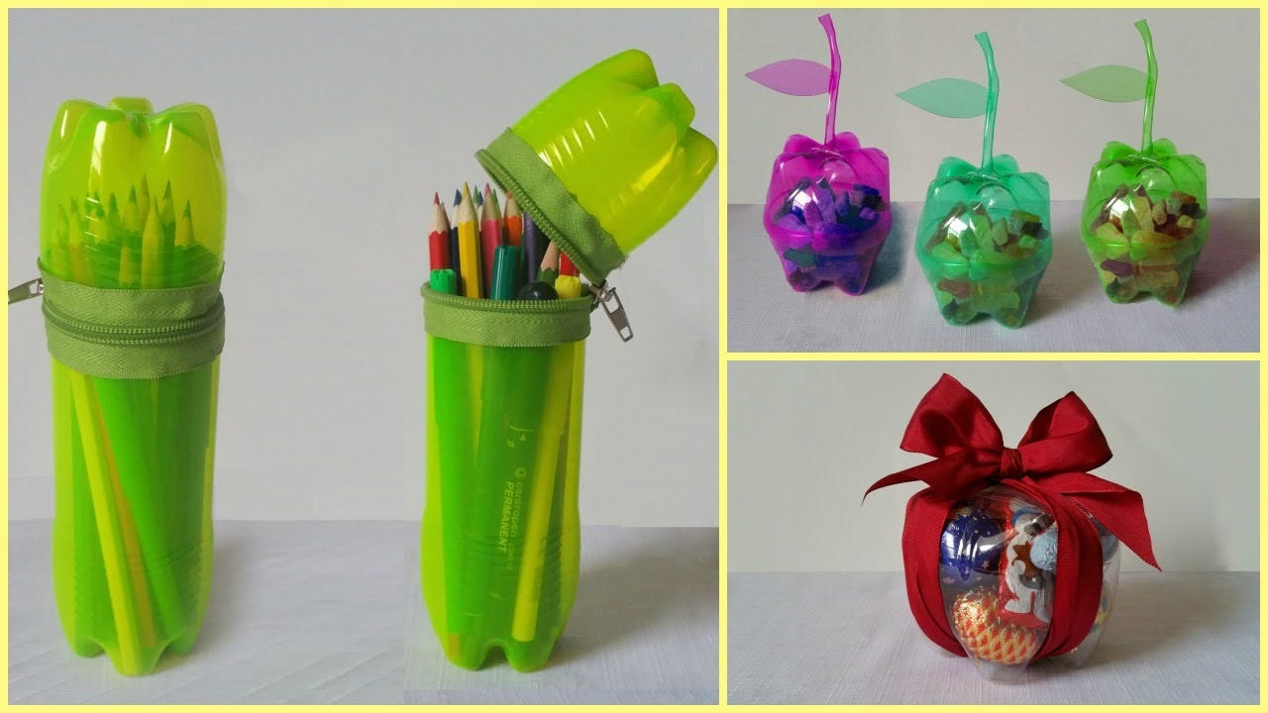

**Description :**

* Using plastic bottles to store household items is a quintessential example of Indian jugaad, showcasing resourcefulness and frugality in daily life.
* This clever hack transforms what would otherwise be waste into functional storage solutions.
* To implement this jugaad, one simply needs to thoroughly clean and dry an empty plastic bottle, remove any labels, and optionally cut off the top portion to create a wider opening.
* The bottle can then be repurposed to store a variety of items - from kitchen staples like rice, lentils, and spices to workshop essentials such as nails, screws, and bolts.
* This practice embodies the spirit of jugaad by solving storage problems without spending money on new containers, reducing plastic waste, and maximizing the utility of everyday objects.

**Title :** Drying clothes using Iron in emergency



**Description :**

* Drying clothes using an iron in an emergency is a classic example of Indian jugaad, demonstrating ingenuity in the face of unexpected challenges.
* This technique is particularly useful when time is of the essence, such as needing a specific garment dry quickly for an important event, or during monsoon season when natural drying is difficult.
* To employ this jugaad, one spreads the damp garment on an ironing board or a flat, heat-resistant surface.
* The iron is then set to a temperature appropriate for the fabric and carefully pressed over the damp areas, effectively using the heat to evaporate moisture.
* It's especially valuable in urban settings where space for drying might be limited, or in situations where electric dryers are unavailable or too expensive to run.
* This jugaad solution not only saves time but also demonstrates the resourcefulness ingrained in Indian middle-class households, where adaptability and creative problem-solving are highly valued skills in managing daily life.

**Title :** Using newspaper to wrap things

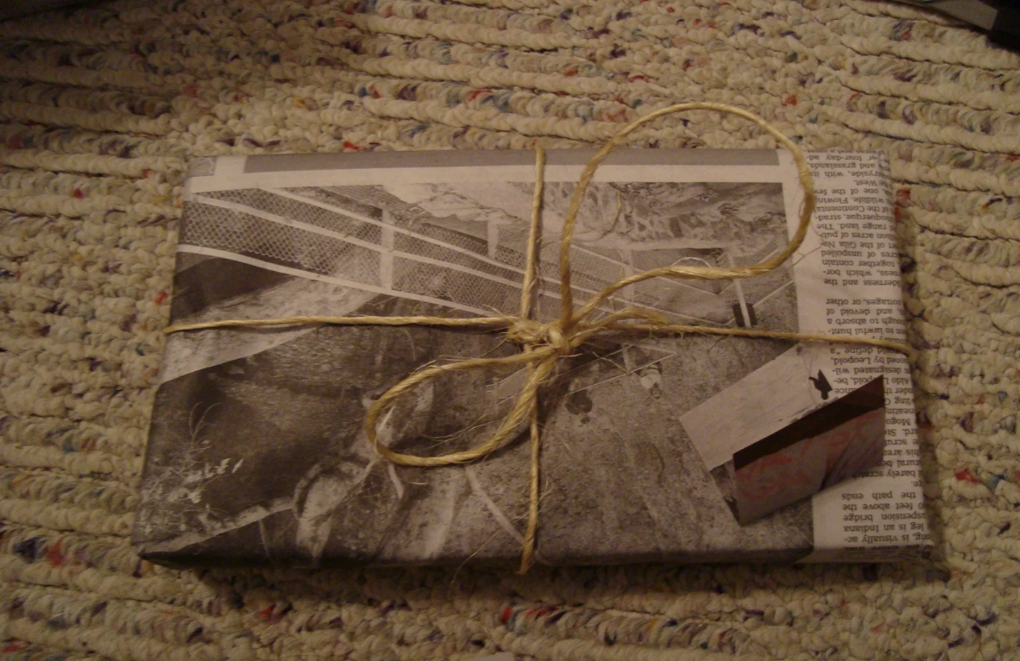

**Description :**

* Using newspaper to wrap things is a quintessential Indian middle-class jugaad that exemplifies resourcefulness and frugality.
* This practice involves repurposing old newspapers, which would otherwise be discarded, as a versatile wrapping material for various purposes.
* To implement this jugaad, one simply needs to collect old newspapers and use them creatively.
* The newspaper can be used to wrap gifts, providing an eco-friendly alternative to expensive wrapping paper.
* It's also commonly used to pack fragile items during moves or storage, offering a cost-effective substitute for bubble wrap or packing peanuts. In kitchens, newspaper is often used to wrap vegetables, helping to absorb excess moisture and extend their shelf life.
* Street food vendors frequently use newspaper cones to serve snacks, showcasing how this jugaad has permeated even small businesses.

**Title :** Using old toothbrush to clean hard to reach areas

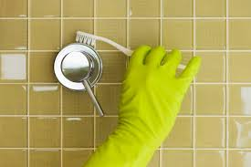

**Description :**

* Using an old toothbrush to clean hard-to-reach areas is a prime example of Indian jugaad, showcasing the ingenuity of repurposing everyday items for practical solutions.
* This clever hack transforms a discarded personal care item into a versatile cleaning tool, embodying the essence of frugality and resourcefulness.
* To implement this jugaad, one simply sets aside a toothbrush when it's no longer suitable for dental hygiene, instead of throwing it away.
* The small head and sturdy bristles of the toothbrush make it ideal for scrubbing tight spaces and intricate surfaces that are often challenging to clean with regular tools.
* It's particularly effective for cleaning grout between tiles, scrubbing around faucets, detailing car interiors, or removing grime from electronics' crevices.
* This jugaad solution is especially appealing to middle-class households as it costs nothing, reduces waste, and often proves more effective than expensive specialized cleaning tools.

**Title :** Using Rubber band to control leakage

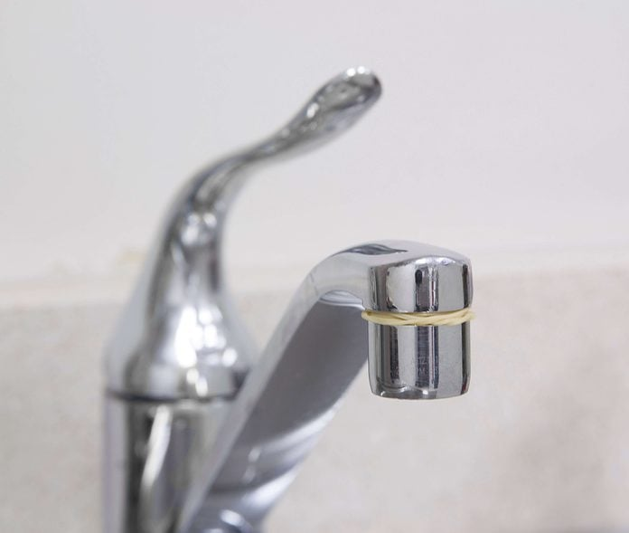

**Description :**

* Using a rubber band to control leakage on taps is a quintessential example of Indian jugaad, demonstrating resourcefulness and quick thinking in addressing everyday problems.
* This ingenious solution is particularly useful as a temporary fix for dripping faucets, especially when immediate professional repair is not feasible or affordable.
* To implement this jugaad, one simply wraps a thick rubber band around the mouth of the leaking tap, ensuring it covers the opening completely. The rubber band creates a flexible seal that helps redirect the water flow back into the tap, significantly reducing or even stopping the drip.
* This method works by using the water pressure to press the rubber band against the tap's opening, effectively blocking small leaks.