Task 1:
Declare four variables in Python: one integer (number of followers), one float (average rating), one string (your favorite app's name), and one boolean (is_premium_user). Print each variable and its type using the type() function.
Code:
num_Followers = 367
rating = 3.8
favourite_app = "Instagram"
premium_user = False
print(f" Number of Followers : {num_Followers}\n variable type : {type(num_Followers)}")
print(f" Average Rating : {rating}\n variable type : {type(rating)}")
print(f" Your favourite app's name : {favourite_app}\n variable type : {type(favourite_app)}")
print(f" is the user premium : {premium_user}\n variable type : {type(premium_user)}")

Output:
Number of Followers : 367
variable type : <class 'int'>
Average Rating : 3.8
variable type : <class 'float'>
Your favourite app's name : Instagram
variable type : <class 'str'>
is the user premium : False
variable type : <class 'bool'>

Screenshot:
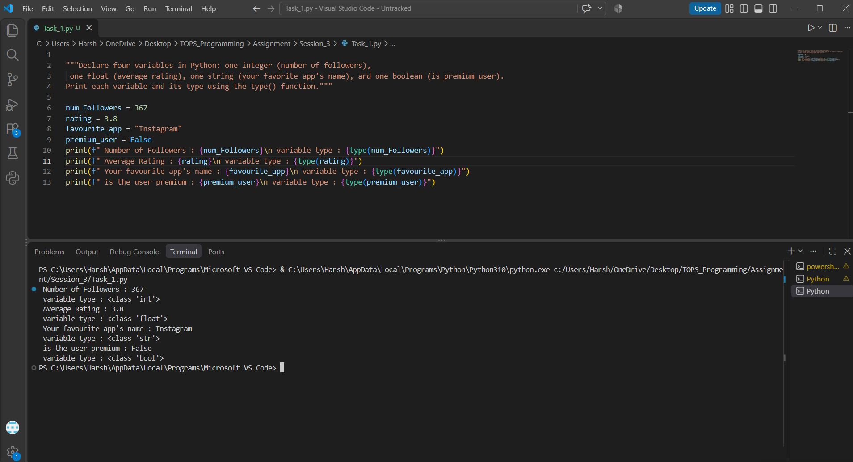

Task 2:
Write a Python program that takes a user's input for the price of a Zomato order as a string, converts it to a float using type casting, adds 18% GST, and prints the final bill amount.
Code:
user_input = input("Enter the price of your Zomato order : ")
user_input = float(user_input)
print(f"Your Final Bill is : {user_input+(user_input*18)/100}")

Output:
Enter the price of your Zomato order : 700
Your Final Bill is : 826.0

Screenshot: 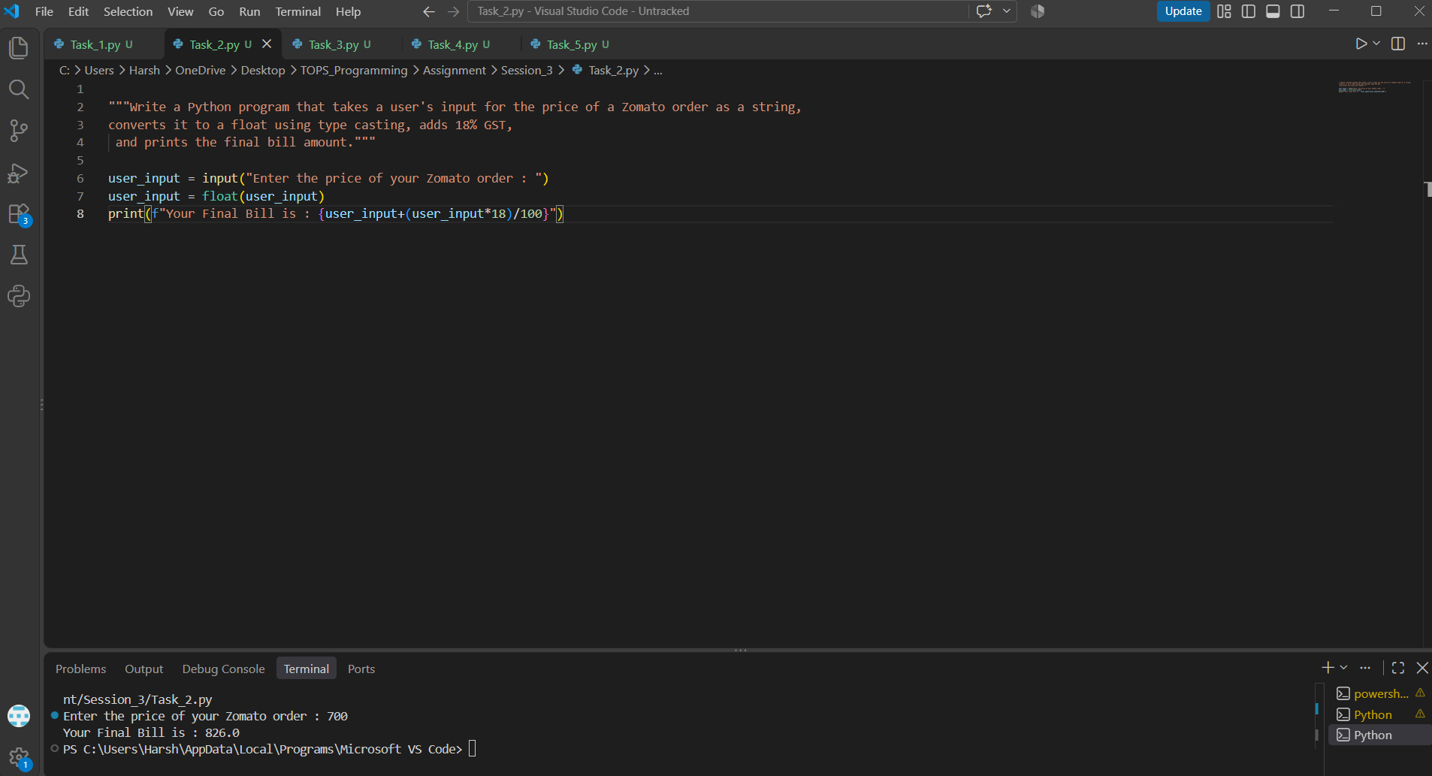

Task 3:
Given a list of strings representing product prices from Flipkart, like ['199.99', '299.50', '150'], convert all to floats and calculate the total cart value.
Code:
Flipkart_list = ['199.99','299.50','150']
Total_cart_value = 0.0
for price in Flipkart_list:
price = float(price)
Total_cart_value += price
print(f"Total Value of your Flipkart Cart is : {Total_cart_value:.2f}")
Output:
Total Value of your Flipkart Cart is : 649.49
Screenshot:
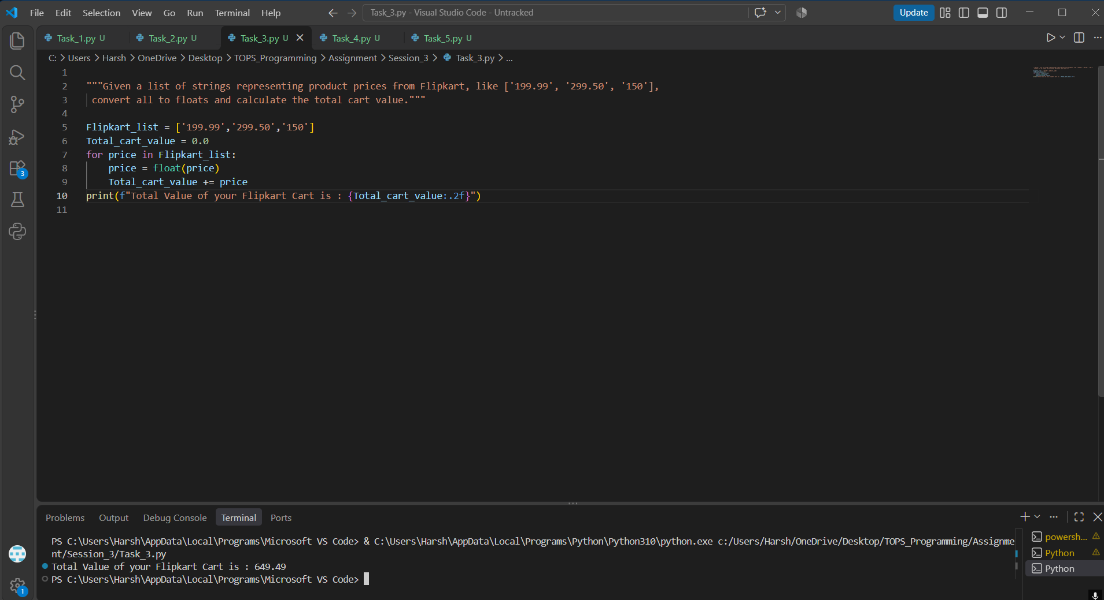

Task 4:
Build a function is_discount_applicable(order_amount) that takes a float and returns True if the amount is greater than 500, otherwise False. Print the result for order amounts 450 and 750.
Code:
def is_discount_applicable(order_amount):
if order_amount > 500:
return True
else:
return False

print(is_discount_applicable(450))
print(is_discount_applicable(750))
Output:
False
True
Screenshot:
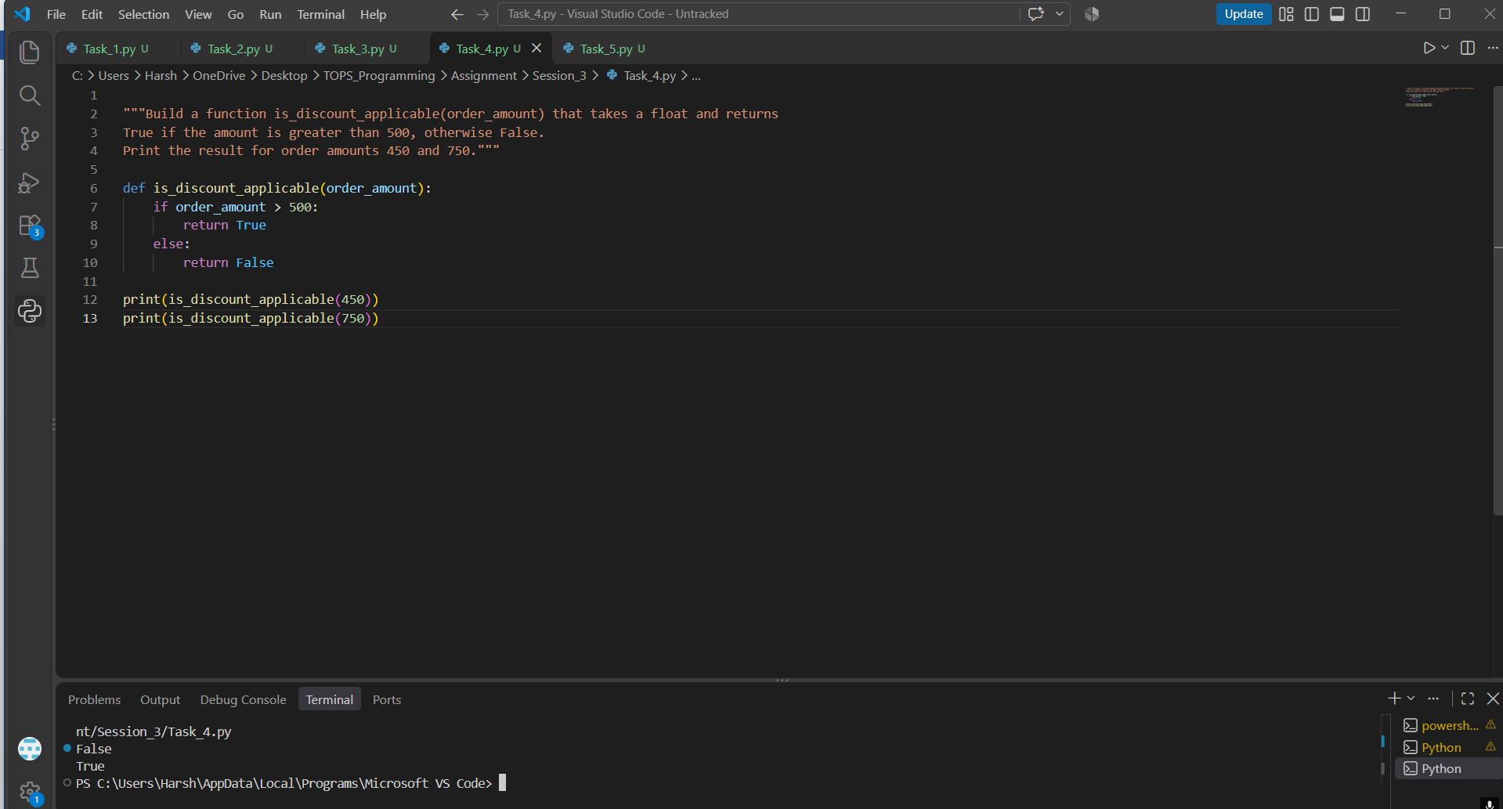

Task 5:
You received a dataset of ratings as strings from Spotify: ['4.5', '3.0', '5', '4.2']. Use type casting to convert these to floats, then find and print the highest rating.<br><br><em><strong>Hint:</strong> Use the float() function inside a loop or list comprehension.</em>
Code:
Spotify_Ratings = ['4.5','3.0','5','4.2']
print(f"List before type casting: {Spotify_Ratings}")
for value in range(len(Spotify_Ratings)):
Spotify_Ratings[value] = float(Spotify_Ratings[value])

print(f"Converted ratings: {Spotify_Ratings}")
print(f"Highest rating: {max(Spotify_Ratings)}")
Output:
List before type casting: ['4.5', '3.0', '5', '4.2']
Converted ratings: [4.5, 3.0, 5.0, 4.2]
Highest rating: 5.0
Screenshot: 