NAME: Harsh Shah
Batch: C-31
Roll No.: 2003154
EXPERIMENT NO. 1
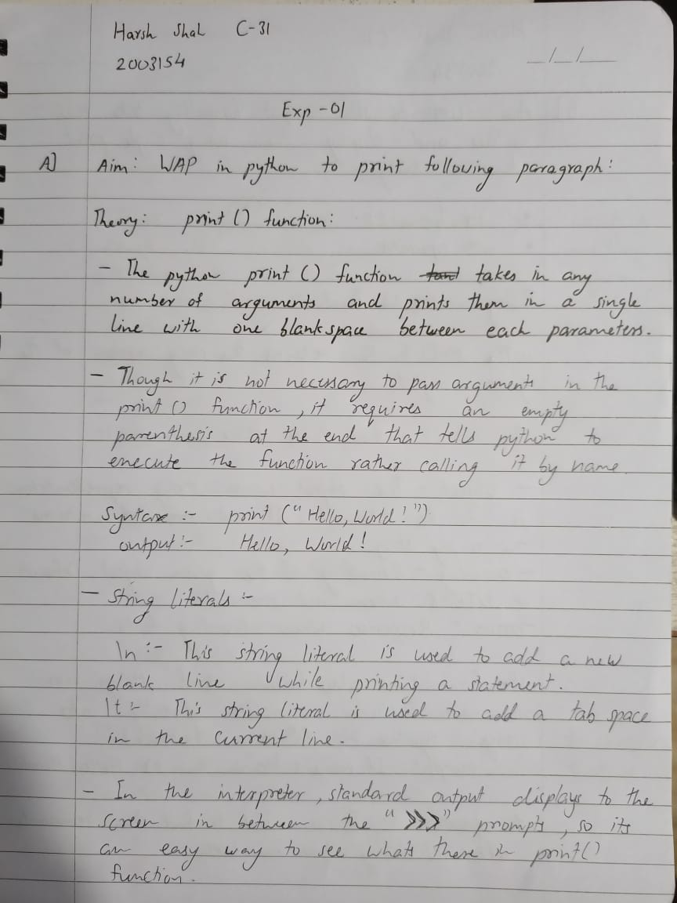

Program:

print("Twinkle, twinkle, little star,\n\t\"How I wonder what you are! \"\n\t\tUp above the world so high,\n\t\tLike a diamond in the sky.\nTwinkle, ' twinkle', little star,\n\tHow I wonder what you are")

Output:

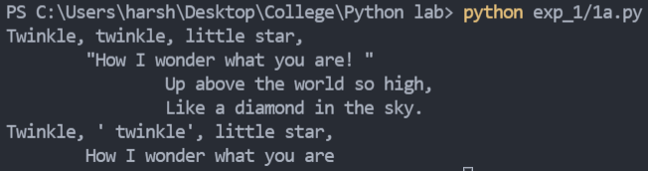

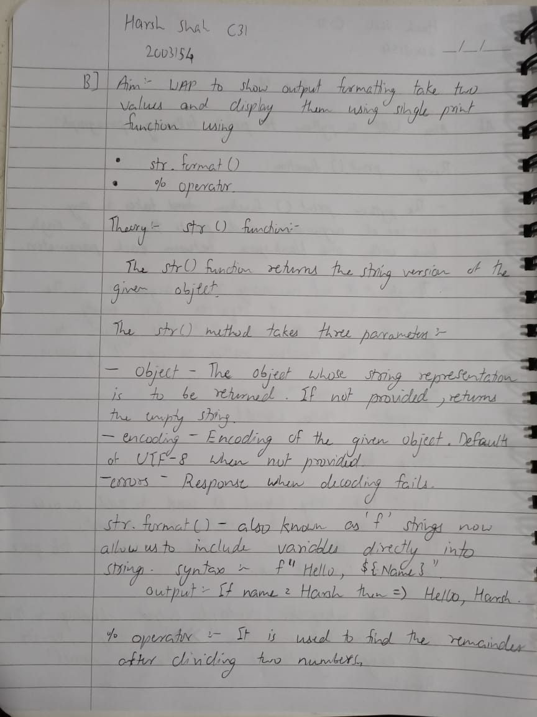
Program:

first = input("Enter the first number: ")
second = input("Enter the second number: ")
print("The first value is {} and second value is %d".format(first) % int(second))

Output:

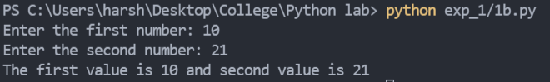

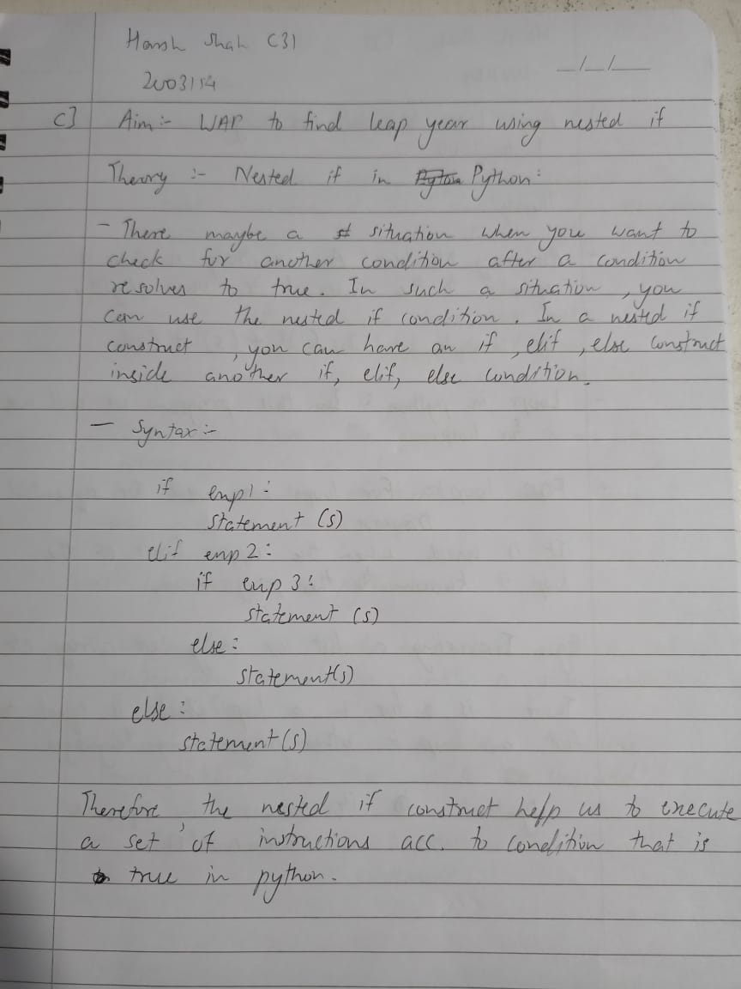
Program:

year = int(input("Enter the year: "))
if(year%4==0):
if(year%100==0):
if(year%400==0):
print("{} is a leap year".format(year))
else:
print("{} is not a leap year".format(year))
else:
print("{} is a leap year".format(year))
else:
print("{} is not a leap year".format(year))

Output:

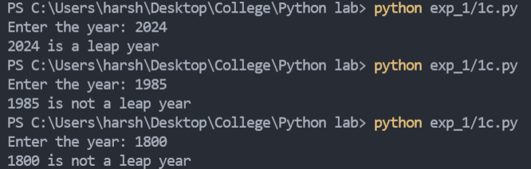

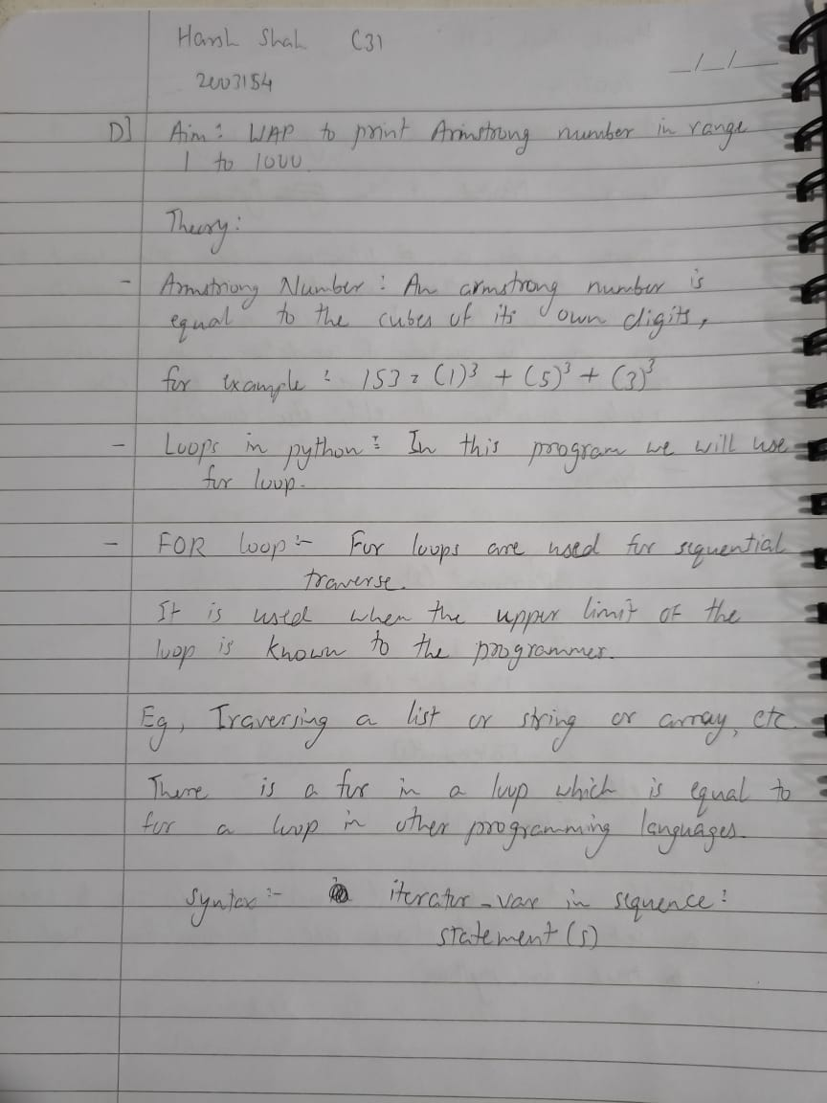
Program:

for i in range(1000):
temp = i
comp = 0
while i:
comp += (i % 10) ** 3
i //= 10
if temp == comp:
print(temp)

Output:

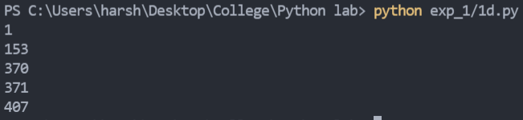

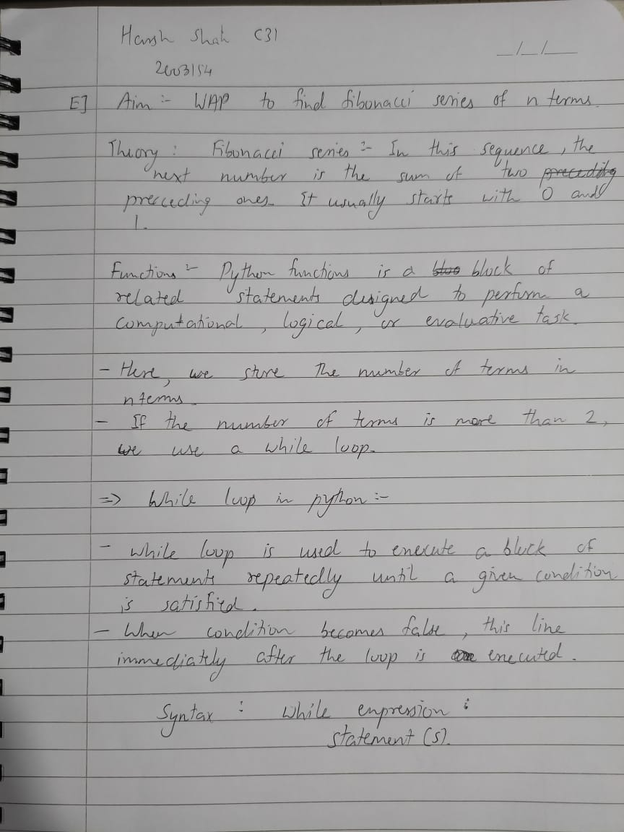

Program:

num = int(input("Enter the number: "))
a = 0
b = 1
for i in range(num):
print(a)
c = a + b
a = b
b = c

Output:

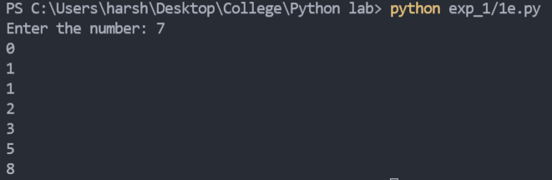

F) WAP to program the following pattern
Program:
# pattern drawing
terms = int(input("Enter the number of terms: "))

for i in range(terms):
for j in range(i+1):
print(chr(i+65), end="")
print()

for i in range(terms,0,-1):
for j in range(terms-i):
print(" ", end="")
for j in range(i):
print("*", end="")
print()

for i in range(terms):
for j in range(terms-i):
print(" ", end="")
for j in range(i+1):
print(j+1, end="")
for j in range(i,0,-1):
print(j, end="")
print()

for i in range(terms):
for j in range(terms-i):
print(" ", end="")
for j in range(i+1):
print(" *", end="")
print()

Output:

