Daily Ledger Management System
Complete Project Documentation
Digital Roj Mel for Indian Shopkeepers
Version 1.0 · Document Date: 07 August 2026
Frontend: React 19 + Vite · Backend: Django REST + JWT

1. Table of Contents
- 1. Introduction & Purpose
- 2. Technology Stack
- 3. System Architecture
- 4. Getting Started (Setup & Login)
- 5. Module-wise Features (with Screenshots)
- 6. Quick Actions, Modals & Website Tour
- 7. Theme Customization
- 8. Backend API Overview
- 9. Security & Authentication
- 10. Demo Credentials & Keyboard Shortcuts
- 11. Project Structure
- 12. Conclusion

2. Introduction & Purpose
Daily Ledger Management System is a full-stack web application designed as a digital Roj Mel (daily shop ledger) for Indian shopkeepers and traders. It helps shops track customer credit (udhaar), receive collections, generate GST-style invoices, manage expenses, send payment reminders, and close the day with a clear cash summary.
Core business goals:
- Replace paper-based daily ledgers with a reliable digital system
- Track customer balances, credit limits, and overdue accounts
- Record credit sales and payments (including partial payments)
- Create, share, and collect against tax invoices
- Provide dashboards, reports, and analytics for business decisions
- Support multi-channel owner alerts (in-app, email, SMS) and customer reminders

3. Technology Stack
Layer | Technologies
Frontend | React 19, Vite 8, React Router 7, Tailwind CSS v4, Framer Motion, Recharts, Context API
Backend | Django 6, Django REST Framework, SimpleJWT, django-filter, CORS, drf-spectacular
Database | SQLite (development) — ready for PostgreSQL/MySQL in production
Auth | JWT access + refresh tokens
Extras | Tesseract.js OCR for invoice upload, html2canvas + jsPDF for invoice PDF

4. System Architecture
The React SPA talks to the Django REST API under /api. In development, Vite proxies /api and /media to http://127.0.0.1:8000. After login, JWT tokens are stored in the browser and attached to authenticated requests. App state (customers, transactions, invoices, settings) is loaded from the API into React Context.
- Frontend (port 5173) → Vite proxy → Backend API (port 8000)
- Auth endpoints under /api/auth/
- Business modules: customers, transactions, invoices, notifications, core (dashboard/ledger/reports/analytics)
- Media files (logos) served from Django /media/

5. Getting Started

5.1 Backend setup
From the backend folder:
- python -m venv venv && activate the virtual environment
- pip install -r requirements.txt
- copy .env.example to .env and configure secrets if needed
- python manage.py migrate
- python manage.py seed_demo (optional demo data)
- python manage.py runserver 8000

5.2 Frontend setup
- npm install
- npm run dev
- Open http://localhost:5173

5.3 Login & Sign up
The auth screens use a split layout: branding on the left and form on the right. Users can register a new shop account or sign in with existing credentials.
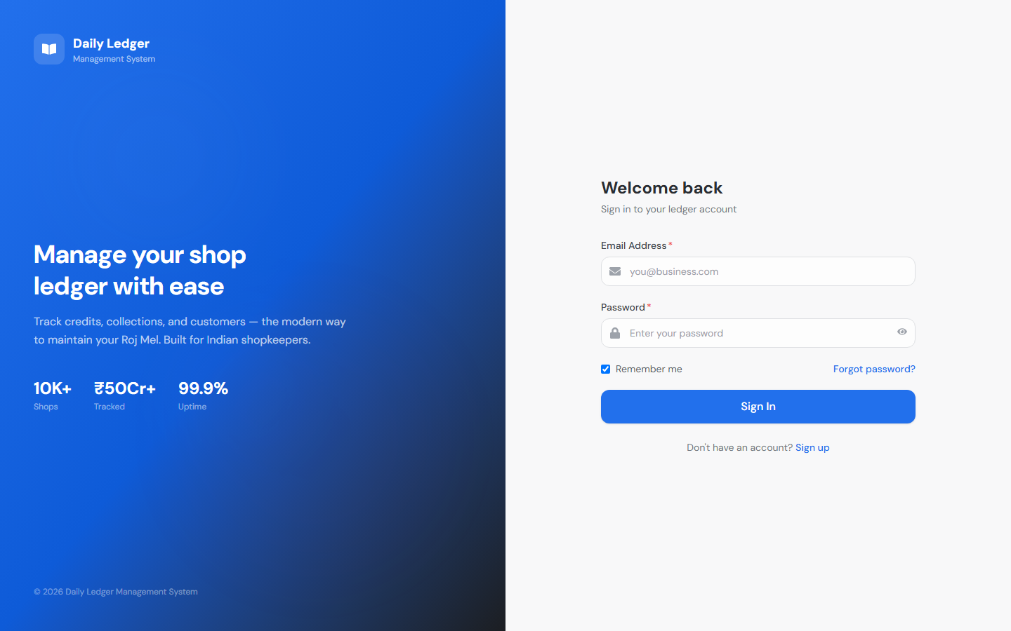
Figure: Login page — Welcome back / Sign In
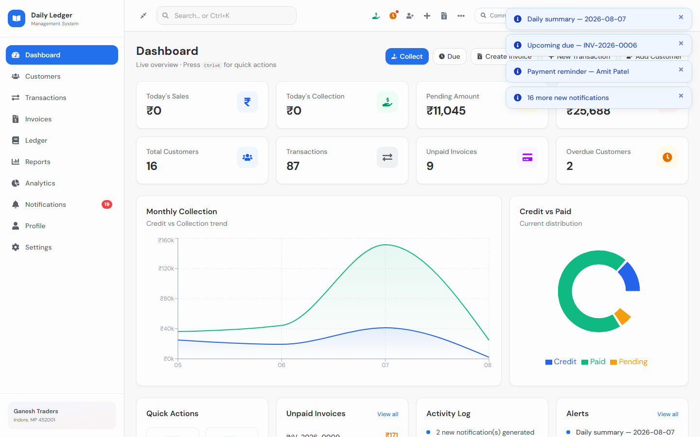
Figure: Sign up page — Create account

6. Module-wise Features (with Screenshots)

6.1 Dashboard
The dashboard is the home screen after login. It shows live KPIs (today’s sales, collection, pending amount, invoice due, customers, transactions, unpaid invoices, overdue customers), monthly collection charts, credit vs paid breakdown, unpaid invoices, activity log, and alerts. Quick buttons open Collect Payment and Due lists.
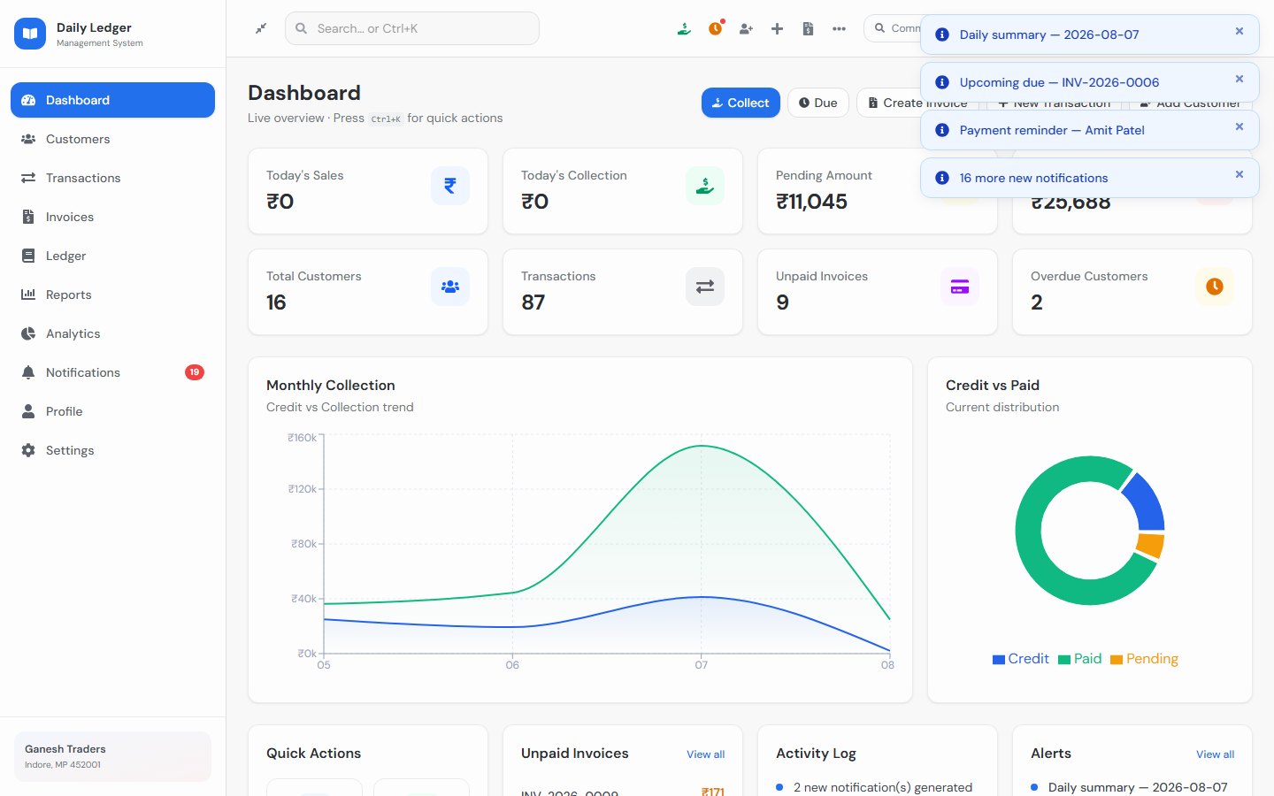
Figure: Dashboard — KPIs, charts, and live overview

6.2 Customers
Manage customer master data: name, business, mobile, GST, address, credit limit, and status (active / overdue). Customer details show utilization, ledger shortcuts, and record-payment actions.
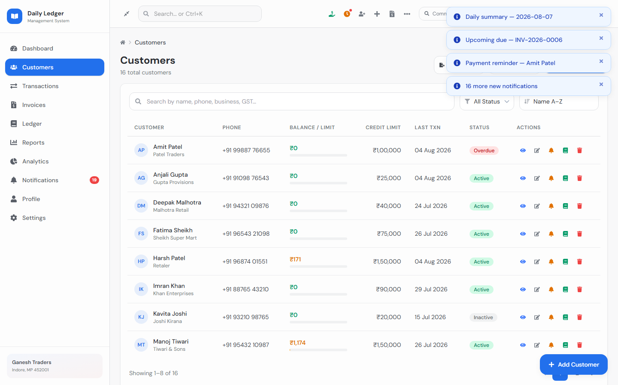
Figure: Customers module

6.3 Transactions
Daily ledger entries support Credit (Maal Diya), Payment Received, Return, Discount, and Expense. Forms capture date, customer, item description, qty/rate/amount, and payment method. Credit-limit warnings appear when a sale would exceed the limit.
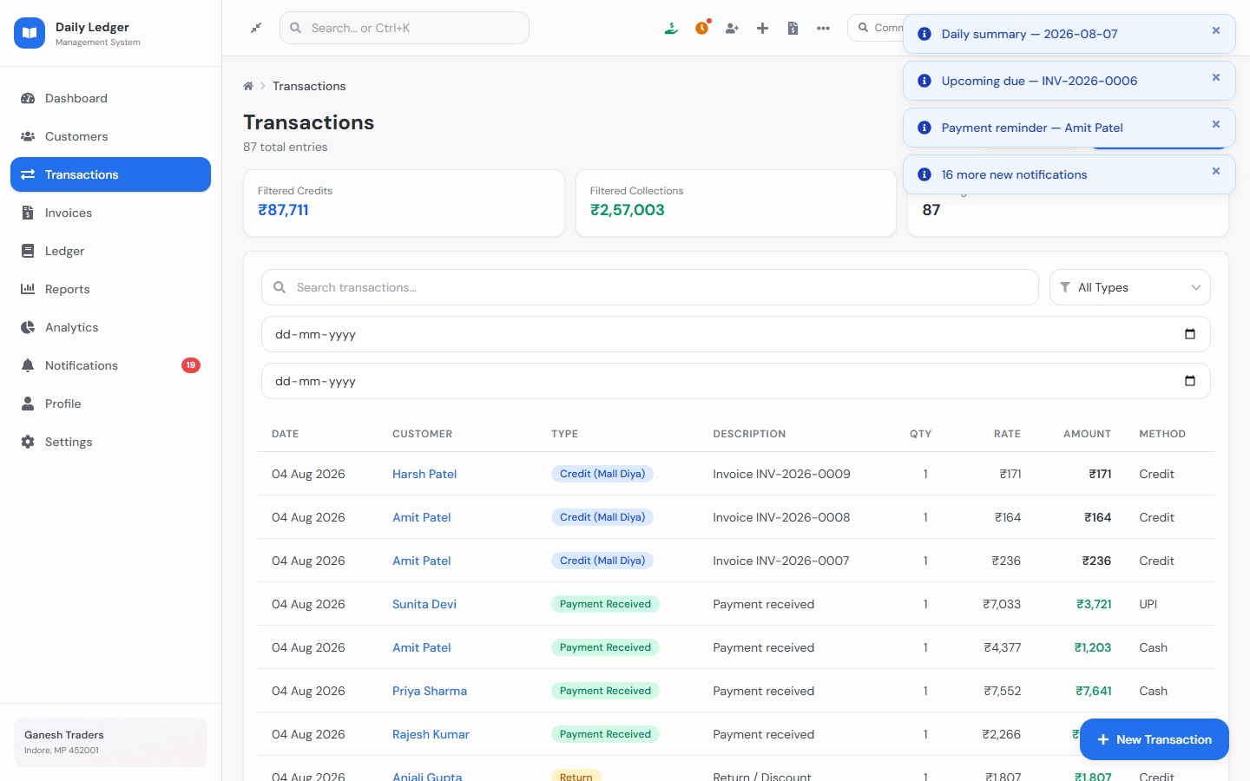
Figure: New Transaction form

6.4 Invoices
Create GST-style invoices with line items, discount, tax rate, notes, and terms. Features include multiple formats, PDF download/print, share, duplicate, mark paid (syncs ledger payment), record payment against an invoice, and OCR upload.
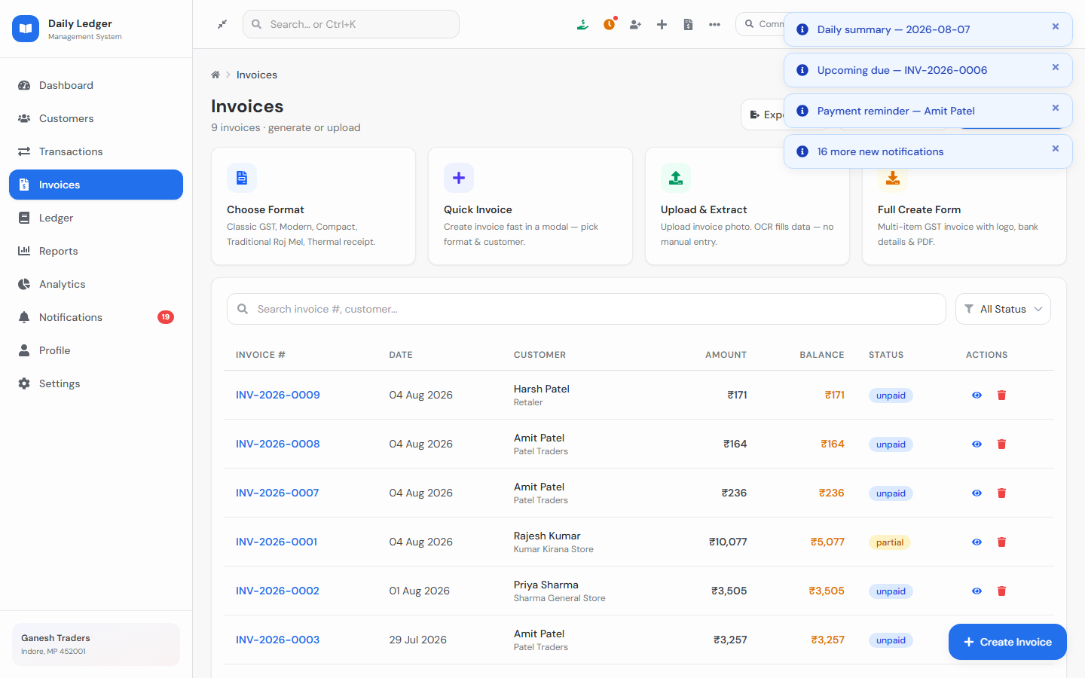
Figure: Invoices list
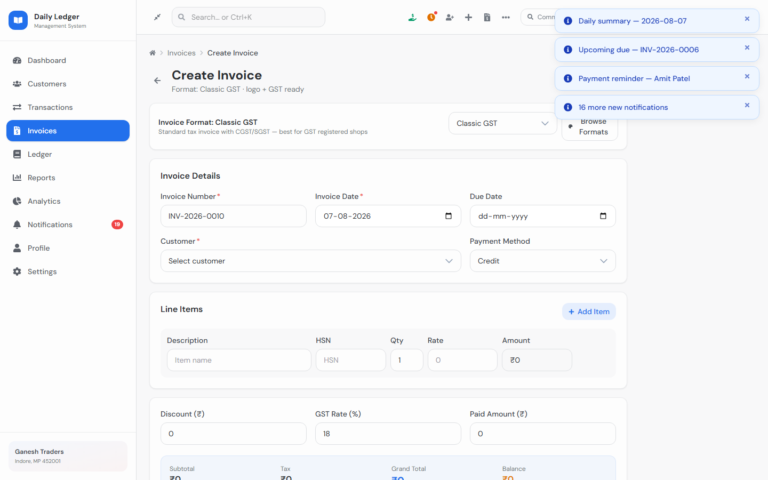
Figure: Create Invoice screen with line items and totals

6.5 Ledger
Per-customer running balance with timeline/table views. Useful before collecting dues or reviewing a customer’s full khata.
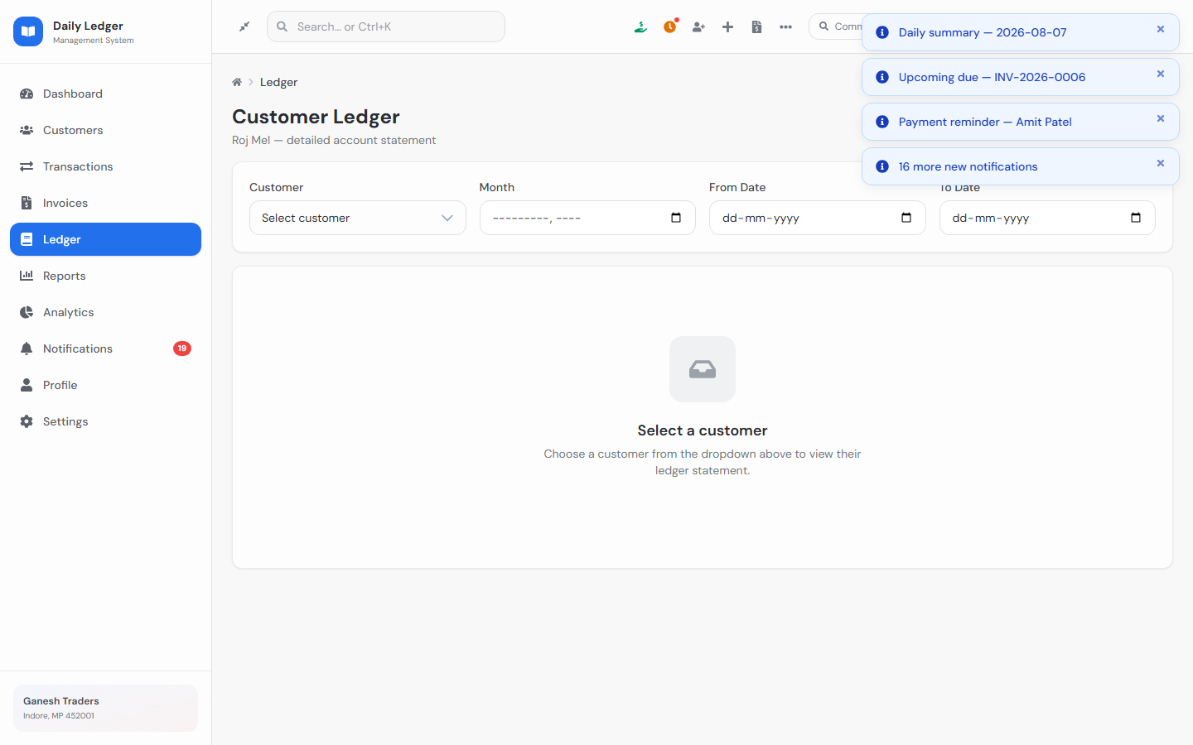
Figure: Customer Ledger

6.6 Reports & Analytics
Reports summarize credit, collection, expenses, and debtors for a period. Analytics shows multi-month trends using charts.
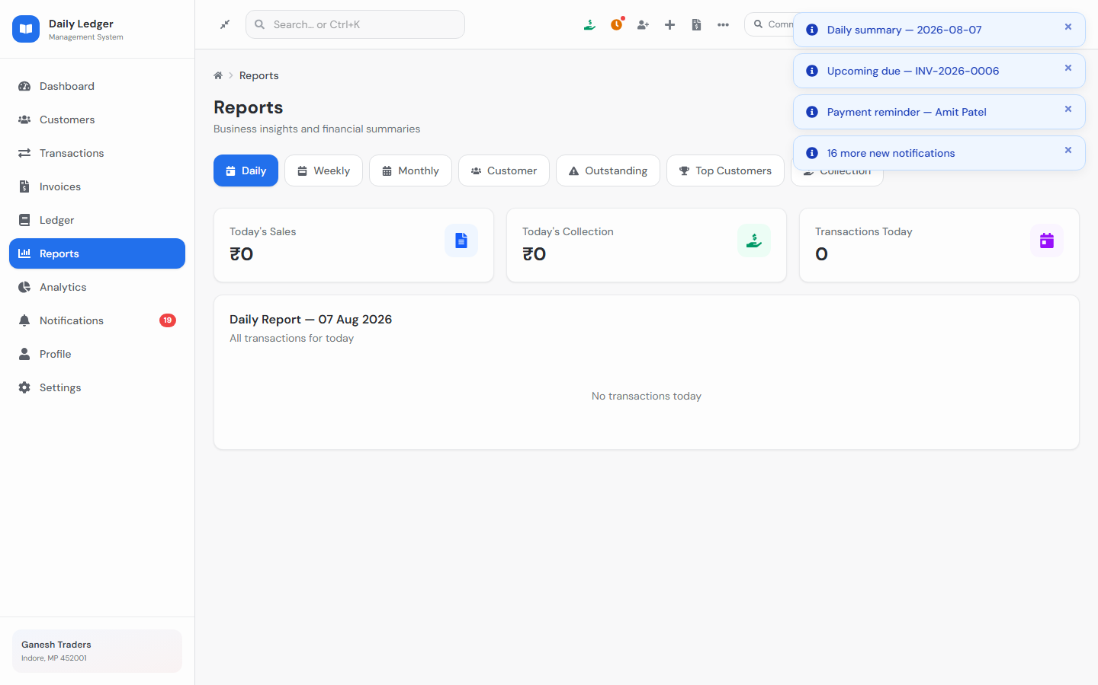
Figure: Reports
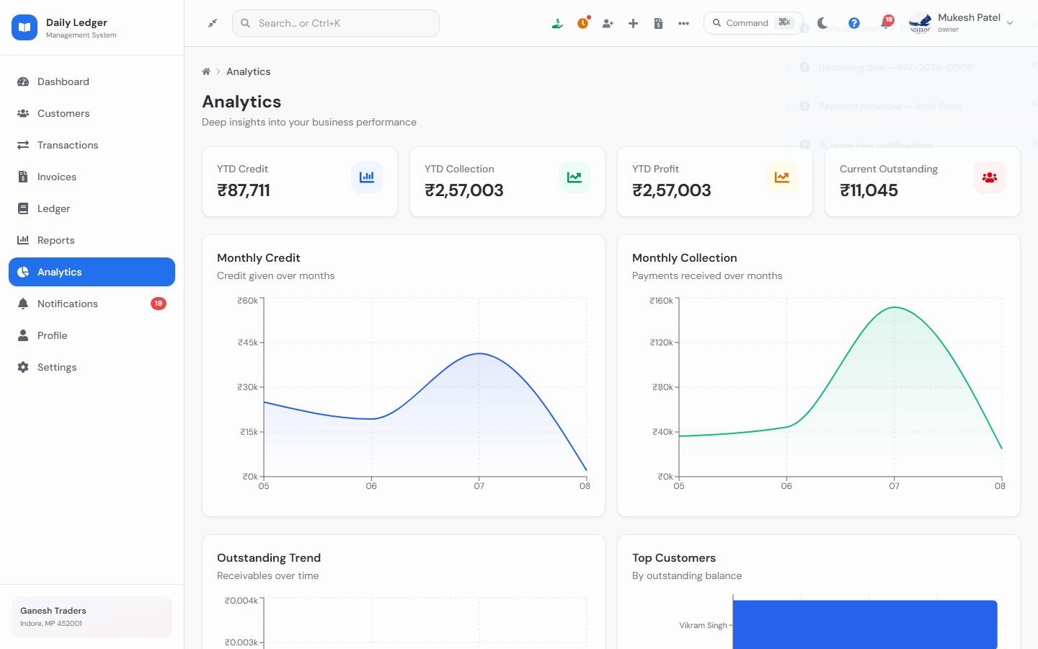
Figure: Analytics

6.7 Notifications
In-app alerts for payment due, overdue, daily summary, and invoice reminders. Users can refresh, filter by type, mark as read, and open customer reminders.
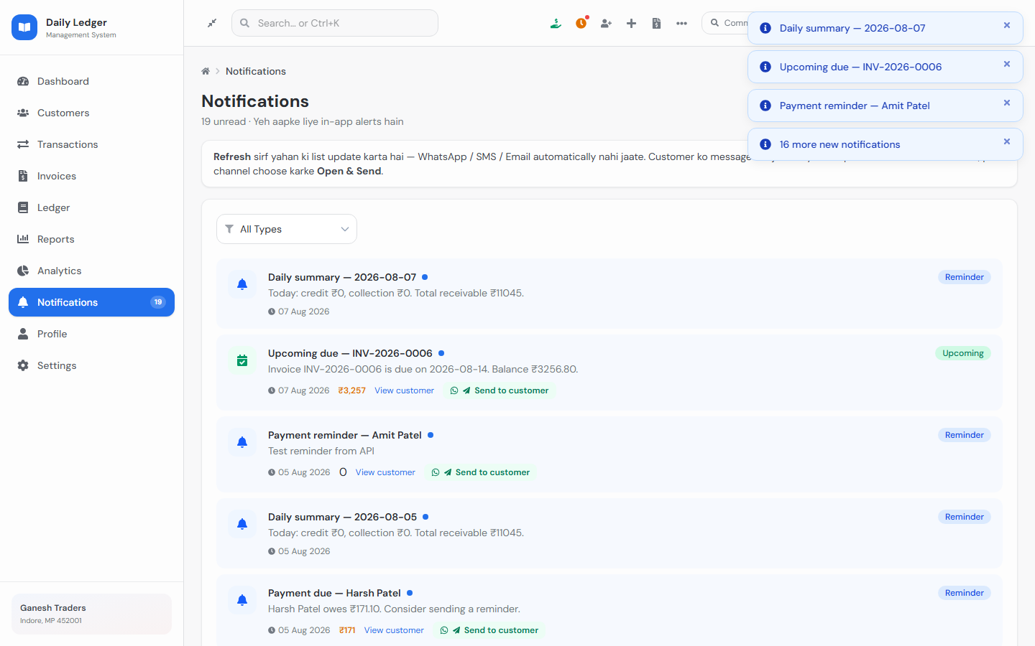
Figure: Notifications list
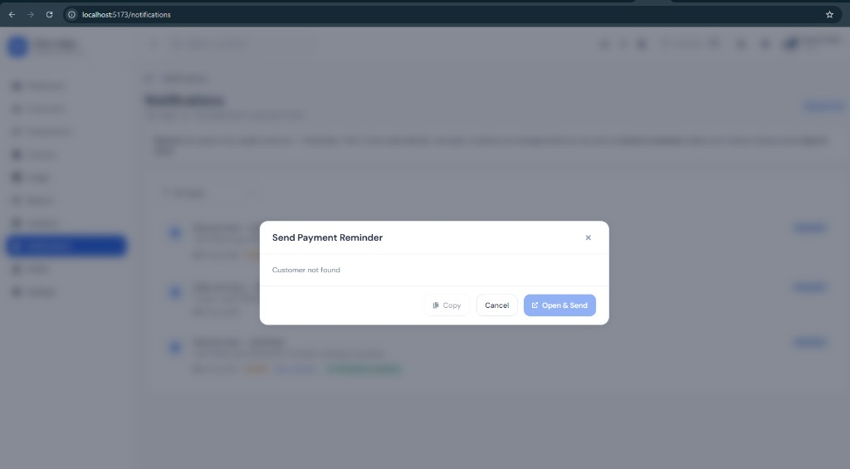
Figure: Send Payment Reminder modal

6.8 Profile
Shop owner profile: personal/business details, GST, invoice prefix, address, and shop logo used on invoices.
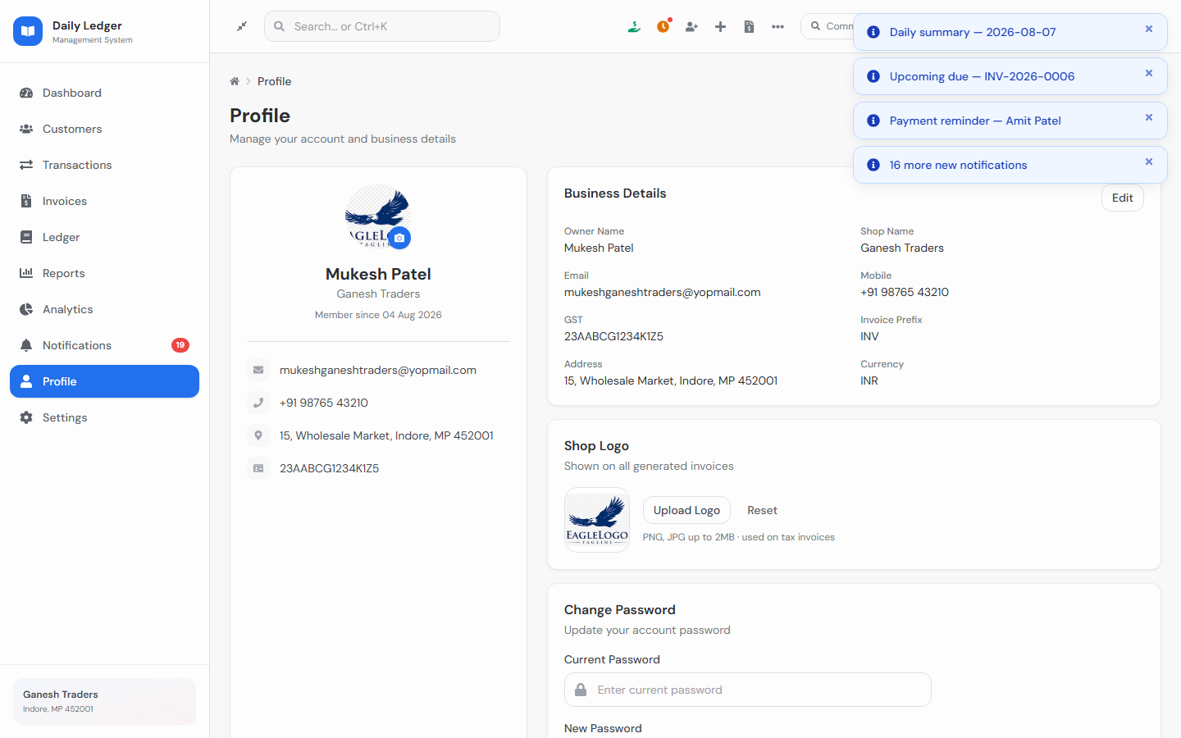
Figure: Profile — business details and shop logo

6.9 Settings
Business information, bank & UPI details (printed on invoices), preferences (currency, language, fiscal year), appearance (theme mode + color theme), owner alert toggles, backup/export, and website tour restart.
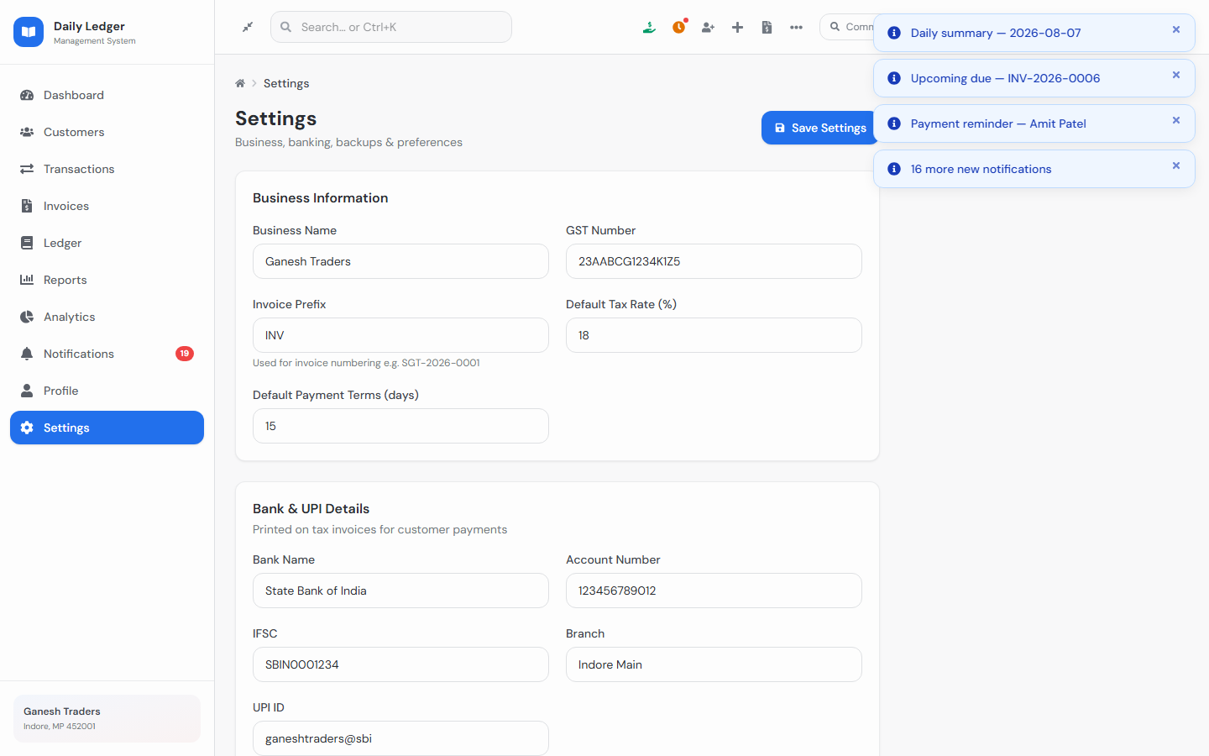
Figure: Settings — business and banking configuration
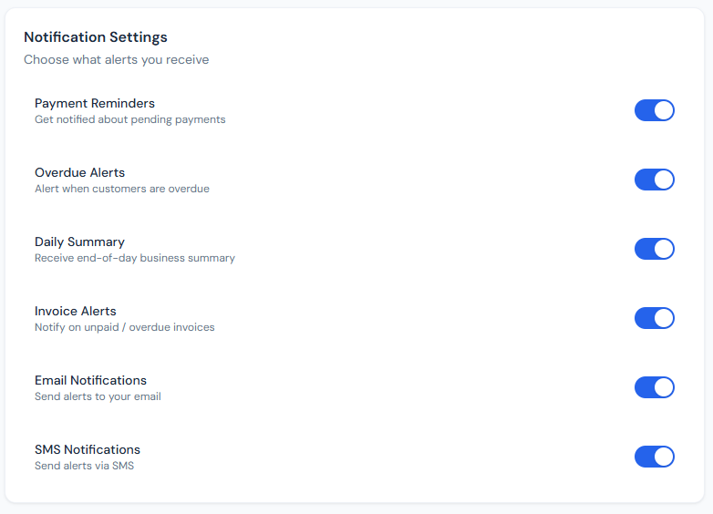
Figure: Owner alert / notification preference toggles

7. Quick Actions, Modals & Website Tour
Navbar quick actions (desktop) and mobile + menu include:
- Record Payment — collect from customers with 25% / 50% / Full chips
- Collections Due — overdue and pending customers + invoice due list
- Day Closing (Roj Mel) — today’s credit, collection, expense, method-wise summary (saved to server)
- Quick Expense — shop expenses by category
- Quick Customer / Transaction / Invoice
- Command Palette (Ctrl+K) for search and actions
Website Tour: first login auto-starts an 11-step guided tour. Users can replay it from the help (?) icon, profile menu, Settings → Help & Tour, or Ctrl+K → Start Website Tour. Content is in clear English with polished welcome/finish cards.
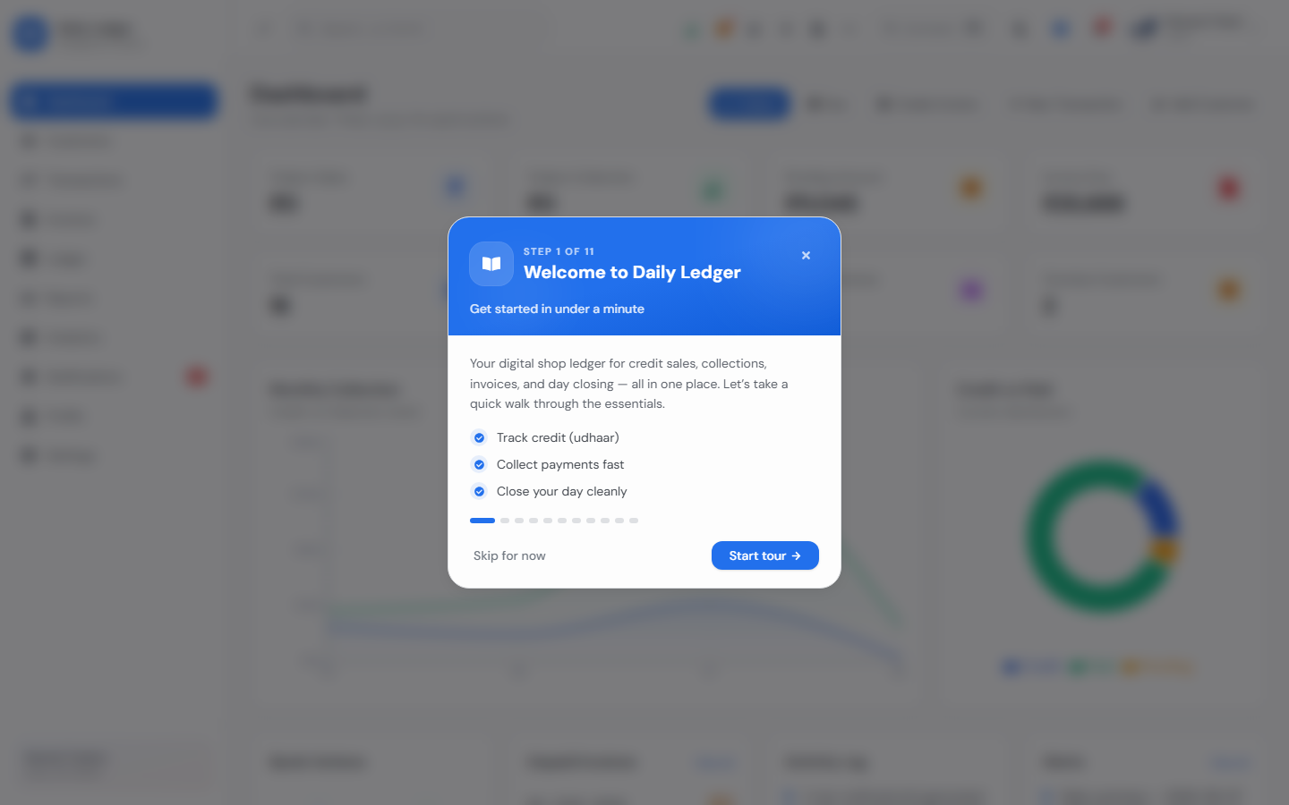
Figure: Website tour overlay on the dashboard

8. Theme Customization
Appearance settings support Light, Dark, and System modes, plus full color themes (Blue, Emerald, Teal, Indigo, Violet, Rose, Orange, Amber, Cyan, Slate). Selecting a color retints primary actions, backgrounds, surfaces, borders, and slate tones across the app. Preferences persist in localStorage and BusinessSettings (theme + accentColor).

9. Backend API Overview
Area | Base path | Key operations
Auth | /api/auth/ | login, register, refresh, profile, settings, OTP reset
Customers | /api/customers/ | CRUD, recalculate balance
Transactions | /api/transactions/ | CRUD, record-payment, summary, day-close
Invoices | /api/invoices/ | CRUD, next-number, duplicate, mark-paid
Notifications | /api/notifications/ | list, sync, reminders, activity, alerts
Core | /api/ | dashboard, ledger, reports, analytics, health

Interactive Swagger docs: http://127.0.0.1:8000/api/docs/

10. Security & Authentication
- JWT Bearer authentication on protected endpoints
- Refresh token rotation support via /api/auth/refresh/
- Password reset via email OTP flow
- CORS configured for local development and ngrok hosts
- Owner-only data scoping (each user sees only their shop records)

11. Demo Credentials & Shortcuts
Item | Value
Demo Email | mukesh@ganeshtraders.com
Demo Password | password123
Frontend | http://localhost:5173
Backend API | http://127.0.0.1:8000/api/
API Docs | http://127.0.0.1:8000/api/docs/
Command Palette | Ctrl+K / ⌘K
Website Tour | Navbar ? icon or Settings → Start Tour

12. Project Structure
Frontend (src/):
- pages/ — Dashboard, Customers, Transactions, Invoices, Ledger, Reports, Analytics, Notifications, Profile, Settings, Auth
- components/ — UI kit, layout (Navbar/Sidebar), modals, payments, tour, invoice templates
- context/ — Auth, App, Theme, Toast, Modal, Tour
- api/ — REST client modules for all backend domains
- data/ — defaults, theme presets, tour steps, invoice formats
Backend (backend/):
- accounts/ — users, profile, business settings, OTP
- customers/, transactions/, invoices/, notifications/, core/
- config/ — Django settings, URLs, JWT, CORS

13. Conclusion
Daily Ledger Management System delivers an end-to-end digital ledger for shops: from login and onboarding tour, through daily credit/collection workflows, invoices, reminders, day closing, theming, and reporting — backed by a proper Django REST API and a modern React frontend. This document, together with the embedded screenshots, serves as a complete reference for users, testers, and developers.
— End of Document —

