Lab 10 – MongoDB – Aggregation

Objective

In this lab, students learn how to transform and combine documents in a collection to do more complex analysis in a MongoDB database.
Students learn how to use the following operators:
$match: is used to filter documents.
$project: is used to select a field, rename a field, and apply some operations on the selected fields from documents.
$group: This operator groups documents base on a certain field.
$sort: This operator sorts documents based on a given field.
$limit: This operator returns first n documents as a result of a query. Skipping

Submission

For this lab, you should submit a file with the below exercises completed.
Your file should be called: L10–lastname-firstname (for example: L10-King-Les) Make sure to show your output for each command to demonstrate it works.

Getting Started
In this lab, you will use grades.json dataset. Download grades.json from Blackboard and store it in a folder named dataset.

Open your Windows command prompt and go the following directory where MongoDB is installed:

- cd C:\Program Files\MongoDB\Server\4.2\bin
To run MongoDB, execute mongod

- mongod

When MongoDB starts successfully, open another Windows command prompt and go the same
bin directory:

- cd C:\Program Files\MongoDB\Server\4.2\bin and execute mongo
- mongo

Or you execute a batch file to start up MongoDB.

You will import grades.json to the college database. To import data, go to the bin directory:

- cd C:\Program Files\MongoDB\Server\4.2\bin Execute the following command:
- mongoimport --db college --collection grades --file ..\dataset\grades.json

To import the json file, provide the full path to the grades.json. After executing the command, the data is imported to the college database. To make sure data is imported successfully, go to the MongoDB shell and execute the following command to see the imported documents:

- show dbs

You should see the database college added to the list of your databases. To see the documents inside the database:

- use college
- db.grades.find().forEach(printjson) or
- db.grades.find().pretty()

Tasks
- Write an aggregate statement to sort the documents in the grades collection based on students ID and class ID. Display only the student ID and the class ID for each document. Sort the result from high to low values for student ID and from low to high for class ID.
db.grades.aggregate({$project : {_id: 0, student_id: 1,
class_id: 1}}, {"$sort" : {"student_id" : 1, "class_id" : -1}})

- Revise the previous query to show the result for students with IDs between 10 and 12.
db.grades.aggregate({$project : {_id: 0, student_id: 1, class_id: 1}}, {$match:
{student_id: {$gte: 10, $lte: 12}}}, {"$sort" : {"student_id" : 1, "class_id" : -1}})

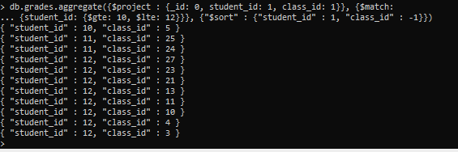

- Show only existing class IDs in the grades collection. (Do not show duplicates.)
db.grades.aggregate({$project : {_id: 0, class_id: 1}})

- Write a query to display student ID and class ID for students whose score are greater than 99.00. Sort the result based on student ID from high to low and class ID from low to high.
db.grades.aggregate({$unwind: "$scores"}, {$project : {_id: 0,
student_id: 1, class_id: 1, scores: 1}}, {$match:
{"scores.score": {$gt: 99}}}, {"$sort": {"student_id": 1,
"class_id": -1}})

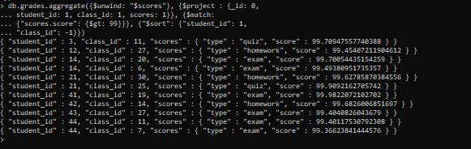

- Write a query to show the maximum and the minimum class ID for each student. Sort the result based on student ID from low to high. Show only the first 10 students.
See the following sample output:
db.grades.aggregate({$project : {_id: 0, student_id: 1, class_id: 1}}, {$group: {"_id":
"$student_id", "max_class_id": {"$max": "$class_id"}, "mn_class_id":{"$min":
"$class_id"}}}, {"$sort": {"_id": 1}}, {"$limit" : 10})

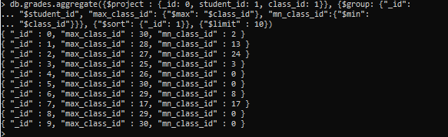
- write a query to find the number of failed exams for student with ID 48.
db.grades.aggregate({$unwind: "$scores"}, {$project : {_id: 0, student_id: 1, class_id: 1,
scores: 1}}, {$match: {student_id: 48, "scores.type": "exam", "scores.score": {$lt: 50}}},
{"$group": {"_id": "$student_id", "totalFailedExams": {"$sum": 1}}})

