|  |  |
| --- | --- |
| **Survival Island** | Abstract  In this survival adventure game, players are stranded on a deserted island after a shipwreck. To survive and escape, they must gather resources, craft essential tools, and solve puzzles. Players navigate environmental challenges, uncover hidden secrets, and manage their supplies to stay alive. The ultimate goal is to build a way off the island, using ingenuity and teamwork to overcome obstacles in a dynamic, ever-changing environment |

**Game Documentation: Survival Island**

1. **Project_Topic1: Invent a Puzzle**

**Concept**

Players find themselves stranded on a deserted island after a shipwreck. To survive and eventually escape, they must solve resource management puzzles, gather supplies, craft tools, and navigate various challenges.

**Key Features**

1. **Resource Management:**
   * Players collect resources like wood, stone, food, and water.
   * Puzzles involve efficient allocation of resources to build shelter, tools, and other necessities.
2. **Crafting System:**
   * Combine gathered items to create tools, traps, and weapons.
   * Crafting recipes can be unlocked through exploration or completing specific challenges.
3. **Dynamic Weather System:**
   * Weather conditions affect gameplay (e.g., rain can fill water containers but also cause flooding).
   * Players must adapt their strategies based on changing weather.
4. **Environmental Challenges:**
   * Encounter wildlife that can either help or hinder survival (e.g., finding food vs. avoiding predators).
   * Natural obstacles like cliffs, rivers, and caves create additional puzzle elements.
5. **Quests and Storyline:**
   * Engage in quests that unveil the island’s mysteries (e.g., ancient ruins, hidden treasures).
   * NPCs or other survivors can provide side quests or trade opportunities.
6. **Skill Development:**
   * As players progress, they can learn new survival skills (e.g., fishing, foraging, building).
   * Skills can be improved through repeated use, enhancing efficiency in puzzles.
7. **Escape Mechanism:**
   * The ultimate goal is to build a raft or signal for rescue, requiring players to solve a series of complex puzzles and gather specific resources.
   * Different endings based on how players manage resources and interact with the environment.
8. **Free-to-Play and Premium Model:**
   * Basic game is free with optional in-game purchases (e.g., cosmetic items, resource packs).
   * **Premium Version:** A one-time purchase version with additional levels, quests, and no ads.
9. **Community Features :**

* **Leaderboards:** Track progress against friends or global players.
* **Co-op Mode:** Team up with friends to solve puzzles together and share resources.

### Levels of Survival Island

### Level 1: Beach Base

* **Objective:** Gather basic resources (wood, coconuts, stones).
* **Puzzles:** Simple resource allocation puzzle to build a basic tool (e.g., a stone axe).
* **Challenges:** Environmental hazards include sun exposure and wild animals (e.g., crabs).

### Level 2: Forest Exploration

* **Objective:** Collect berries, logs, and find new crafting materials.
* **Puzzles:** Environmental puzzles involving navigating through dense foliage to find hidden items.
* **Challenges:** Weather changes (rain) affect visibility and resource gathering.

### Level 3: Cave Discovery

* **Objective:** Explore caves for rare minerals and ancient artifacts.
* **Puzzles:** Light-based puzzles that unlock deeper areas of the cave.
* **Challenges:** Dark environments require players to craft torches; cave creatures pose threats.

### Level 4: The Ancient Ruins

* **Objective:** Discover the history of the island and collect special resources.
* **Puzzles:** Multi-step puzzles that require combining items and clues found in the ruins.
* **Challenges:** Traps and environmental hazards within the ruins.

### Level 5: The Summit

* **Objective:** Reach the highest point of the island for a panoramic view and gather rare resources.
* **Puzzles:** Navigate through a series of climbing and navigation puzzles.
* **Challenges:** Harsh weather conditions (strong winds) that affect movement and visibility.

### Level 6: Escape Preparation

* **Objective:** Gather final resources to build a raft or signal for help.
* **Puzzles:** Complex crafting puzzles to combine materials into a seaworthy vessel.
* **Challenges:** A final environmental challenge where players must gather everything needed within a time limit before a storm hits.

### Rules of Survival Island

### Basic Rules

1. **Resource Gathering:**
   * Players can collect resources (wood, stone, food, etc.) from the environment.
   * Each resource type has a limited inventory space; players must manage their inventory wisely.
2. **Crafting:**
   * Players can craft tools, shelters, and other items using gathered resources.
   * Crafting recipes must be discovered or unlocked by solving puzzles.
3. **Health and Survival:**
   * Players must maintain health, hunger, and energy levels.
   * Eating food replenishes health and hunger; if health drops to zero, the game ends.
4. **Environmental Hazards:**
   * Players must navigate threats such as wild animals, weather changes, and environmental hazards (like storms).
   * Certain actions may attract dangers (e.g., fire may attract wild animals).
5. **Puzzle-Solving:**
   * Puzzles must be solved to unlock new areas, crafting recipes, or essential resources.
   * Some puzzles may require specific items or tools to complete.
6. **Day/Night Cycle:**
   * The game features a day/night cycle, impacting gameplay (e.g., certain creatures are more active at night).
   * Players should prepare for nighttime, as it can introduce dangers and limit visibility.

### Advanced Rules

1. **Crafting Combinations:**
   * Players can combine multiple resources to create more advanced tools and items.
   * Some advanced items require rare resources only found in specific locations.
2. **NPC Interactions:**
   * Players may encounter non-playable characters (NPCs) who provide quests, tips, or trades.
   * Completing NPC quests may unlock unique recipes or items.
3. **Exploration:**
   * Players can explore hidden areas, caves, and ancient ruins, which may contain valuable resources and puzzles.
   * Exploration rewards players with unique items, lore, or crafting recipes.

**Visual and Audio Design**

* **Art Style:** Vibrant, cartoonish graphics that emphasize the beauty and danger of the island.
* **Sound Design:** Immersive sounds of nature, crafting, and ambient music that change with the weather and time of day.
  1. **How to Change it from Puzzle to Game?**
* **Introduce Goals:** Players aim to build a raft to escape, requiring them to gather specific resources and complete challenges.
* **Narrative Elements:** Introduce backstory and quests related to the island’s mysteries (e.g., ancient ruins).
* **Challenges:** Incorporate environmental hazards like storms, wildlife threats, and limited time to gather resources.

1. **Project_Topic2: Game Description**
2. **Description**

**Survival Island** is an immersive puzzle and survival game where players find themselves stranded on a mysterious island after a shipwreck. As the sole survivor, players must navigate lush biomes—including sandy beaches, dense forests, and hidden caves—while gathering essential resources like wood, stone, and food.

The core gameplay revolves around resource management and crafting. Players solve intricate puzzles to unlock new crafting recipes and access vital tools that enhance their survival chances. The game features a dynamic weather system that impacts gameplay, introducing challenges like rainstorms that can flood areas or affect resource gathering.

The narrative unfolds as players explore, revealing the island’s secrets and the fate of previous inhabitants. Engaging with NPCs and completing quests adds depth to the storyline, creating a rich, immersive experience.

Visually, **Survival Island** boasts stunning graphics and a vibrant art style, accompanied by atmospheric sound design that immerses players in the island's environment. The game targets casual gamers and puzzle enthusiasts, promising an engaging blend of strategic thinking and creative problem-solving as players strive to survive and ultimately escape the island.

1. **Comparison**

* **Similar Games:**
  + *Minecraft* (resource management and crafting).
  + *The Witness* (environmental puzzles).
* **Unique Selling Point:** Combines survival gameplay with strategic puzzles, creating a unique blend of creativity and challenge.
* **Comparision with Minecraft**

**Overview:**

* **Gameplay:** An open-world sandbox game focused on building, exploration, and survival.
* **Crafting System:** Players gather resources to craft tools, build structures, and create intricate systems.

**Gameplay Mechanics:**

* **Resource Gathering:** Players collect a wide variety of materials, including wood, stone, and minerals, from the environment.
* **Building and Crafting:** Extensive crafting system allows players to create tools, structures, and even complex redstone machinery.
* **Game Modes:** Offers multiple modes (Survival, Creative, Adventure) catering to different play styles.

**Comparison:**

* **Similarities:**
  + Both emphasize resource management and crafting.
  + Players can explore a vast open world and gather resources to survive.
* **Differences:**
  + *Survival Island* features a linear narrative with specific objectives (escaping the island), while *Minecraft* allows for sandbox-style gameplay with no predefined goals.
  + *Survival Island* has structured puzzles that must be solved to progress, whereas *Minecraft* focuses on creativity and player-driven objectives.
* **Comparision with The Witness**

**Overview:**

* **Gameplay:**Players explore a vast, open island filled with line puzzles. The game encourages a methodical approach, requiring players to observe their surroundings to identify clues that help in solving puzzles.
* **Crafting System:The Witness** does not have a crafting system. Instead, all interactions are centered around solving puzzles. Players do not gather resources or create items; their primary focus is on understanding and solving the various challenges presented throughout the island.

**Gameplay Mechanics:**

* **Environmental Puzzles:** Players solve intricate line puzzles scattered across a beautiful, open-world island.
* **Non-linear Exploration:** The game allows players to approach puzzles in any order, encouraging exploration and discovery.

**Comparison:**

* **Similarities:**
  + Both games take place on mysterious islands filled with puzzles that require observation and critical thinking.
* **Differences:**
  + *The Witness* focuses purely on logic and observation puzzles without survival elements, while *Survival Island* incorporates resource management, crafting, and an overarching survival narrative.
  + *Survival Island* has a more hands-on approach to crafting and inventory management, creating a deeper survival experience.

1. **Project_Topic3: Game Ideation**
   * + 1. **Source of your idea**

The idea was inspired by a T.V. show MAN vs WILD featuring Bear Grylls where he is left alone stranded on an island or a place where he have to find shelter, gather food, manage resources, look out for danger, survive until hr finds a way to escape or is evacuated.

* + - 1. **Genre**
* **Genre:** Puzzle/Survival
* **Reason for Choosing It:** This genre allows for strategic gameplay that challenges players' problem-solving skills while immersing them in a survival scenario.
  + - 1. **Challenges**
* **Resource Scarcity:** Certain resources may become scarce over time or in specific seasons, forcing players to adapt their strategies for gathering and management. This could include finding alternative food sources or discovering new crafting materials.
* **Wildlife Encounters :**Players face aggressive wildlife, such as bears or snakes, which can attack when provoked. Developing strategies for avoiding or defending against these threats adds tension to exploration.
* **Weather Events:** Dynamic weather systems introduce challenges like storms, hurricanes, or extreme heat. Players must seek shelter or prepare for weather-related hazards that can damage their health or destroy resources.
* **Hunger and Thirst Mechanics:** Implement a more intricate system for managing hunger and thirst, where players must find fresh water sources or food types that provide different levels of sustenance. This encourages exploration and experimentation.
* **Survival Quests:** Introduce side quests or tasks given by NPCs or through environmental clues. These could involve finding specific items, rescuing stranded survivors, or completing challenges that yield valuable rewards.
* **Puzzle Complexity :**Increase the complexity of environmental puzzles, requiring players to combine multiple resources or tools to solve them. This could involve multi-step challenges that encourage critical thinking and exploration.
* **Building Stability:** Players must ensure their shelters are stable and well-constructed. Natural events (like heavy rain or strong winds) can weaken structures, requiring ongoing maintenance and resource allocation.
* **Mental Health Mechanic:** Introduce a mental health system that is affected by isolation and challenges faced. Players may need to find ways to boost morale (e.g., building a fire, making a friend, or completing tasks) to avoid penalties in gameplay.
  1. **Players :**

**Target Audience:**

* **Casual Gamers:** Players looking for an engaging yet relaxed experience in survival and exploration.
* **Puzzle Enthusiasts:** Individuals who enjoy solving environmental puzzles and challenges.
* **Adventure Seekers:** Gamers who appreciate open-world exploration and narrative-driven gameplay.
* **Survival Game Fans:** Those who enjoy resource management, crafting, and survival mechanics.

**Player Characters:**

* **Customizable Protagonist:** Players can create and customize their character, choosing attributes that affect gameplay (e.g., strength, intelligence, agility).
* **Diverse Backgrounds:** The game can offer a variety of backstories for the protagonist, which may influence interactions with NPCs and the environment, adding depth to the narrative.

### Goals

* **Escape the Island:** The ultimate objective is to gather the necessary resources, build a seaworthy raft or signal for rescue, and successfully escape the island. This overarching goal
* **Survive:** Maintain health, hunger, and energy levels while adapting to environmental challenges. This includes finding food, water, and shelter.
* **Explore:** Discover different biomes (beaches, forests, caves) and hidden areas, each offering unique resources and puzzles.
* **Solve Puzzles:** Complete environmental puzzles to unlock new crafting recipes, resources, and story elements that provide insight into the island's mysteries.
* **Craft and Build:** Gather resources to craft tools, traps, and shelters, improving survival chances and enabling players to progress.
* **Collect Lore:** Discover artifacts and documents that reveal the island’s history and previous inhabitants, enriching the narrative experience.
* **Complete Quests:** Engage with NPCs and complete side quests for additional rewards, enhancing the overall gameplay experience.
* **Enhance Skills:** Level up crafting and survival skills through practice and achievements, unlocking advanced crafting options and abilities.

### Rules

1. **Resource Gathering:**
   * Players can collect resources (wood, stone, food, etc.) from the environment.
   * Each resource type has a limited inventory space; players must manage their inventory wisely.
2. **Crafting:**
   * Players can craft tools, shelters, and other items using gathered resources.
   * Crafting recipes must be discovered or unlocked by solving puzzles.
3. **Health and Survival:**
   * Players must maintain health, hunger, and energy levels.
   * Eating food replenishes health and hunger; if health drops to zero, the game ends.
4. **Environmental Hazards:**
   * Players must navigate threats such as wild animals, weather changes, and environmental hazards (like storms).
   * Certain actions may attract dangers (e.g., fire may attract wild animals).
5. **Puzzle-Solving:**
   * Puzzles must be solved to unlock new areas, crafting recipes, or essential resources.
   * Some puzzles may require specific items or tools to complete.
6. **Day/Night Cycle:**
   * The game features a day/night cycle, impacting gameplay (e.g., certain creatures are more active at night).
   * Players should prepare for nighttime, as it can introduce dangers and limit visibility.

### Advanced Rules

1. **Crafting Combinations:**
   * Players can combine multiple resources to create more advanced tools and items.
   * Some advanced items require rare resources only found in specific locations.
2. **NPC Interactions:**
   * Players may encounter non-playable characters (NPCs) who provide quests, tips, or trades.
   * Completing NPC quests may unlock unique recipes or items.
3. **Exploration:**
   * Players can explore hidden areas, caves, and ancient ruins, which may contain valuable resources and puzzles.
   * Exploration rewards players with unique items, lore, or crafting recipes.
4. **Project_Topic3: Visualization**

* **Concept Art:** Visuals of the island's landscapes, character designs, and puzzle elements.
* **User Interface:** Design a clear and intuitive UI for inventory management, crafting, and quest tracking.

**PUZZLE and GAME visuals :**

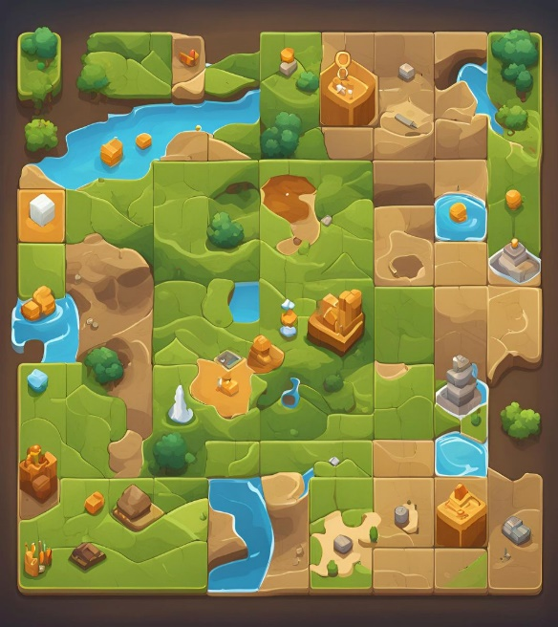 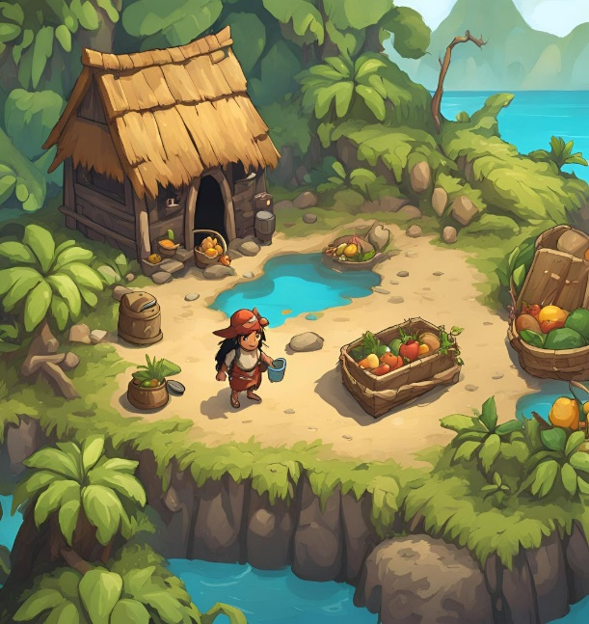

1. **Project_Topic3: Game Design Document**

### Overall Vision

**Game Title:** Survival Island

**Vision Statement:**  
**"Survival Island"** aims to immerse players in a rich, open-world survival experience that seamlessly blends exploration, resource management, and puzzle-solving. Players will navigate the challenges of isolation on a deserted island, uncovering its mysteries while fostering a deep sense of adventure and personal growth. The game emphasizes player agency and creativity, allowing for varied experiences tailored to different play styles, all within a beautifully crafted environment.

### Mechanics

1. **Resource Gathering:**
   * Players can collect various resources (wood, stone, food) through exploration and interaction with the environment. Resources are essential for crafting and survival.
2. **Crafting System:**
   * An intuitive crafting interface allows players to combine resources to create tools, shelters, and traps. Crafting recipes can be discovered through exploration and solving puzzles.
3. **Health and Survival Management:**
   * Players must manage health, hunger, and thirst levels. Neglecting these stats leads to penalties, creating urgency in resource management.
4. **Environmental Puzzles:**
   * Integrated puzzles require players to think critically and creatively, unlocking new areas and resources, and enhancing gameplay depth.
5. **Dynamic Weather and Day/Night Cycle:**
   * A responsive weather system and day/night cycle impact gameplay, altering visibility, resource availability, and player health.
6. **Inventory Management:**
   * Players manage a limited inventory space, necessitating strategic decisions about which items to carry based on current goals.
7. **Building Mechanics:**
   * Players can construct and upgrade shelters using gathered materials. Environmental factors affect the stability and durability of structures.
8. **NPC Interactions:**
   * Players encounter NPCs that provide quests, lore, and trading opportunities, enriching the narrative and gameplay experience.

### Dynamics

1. **Exploration and Discovery:**
   * The game encourages players to explore diverse biomes, uncovering secrets and hidden resources, which promotes a sense of adventure.
2. **Risk vs. Reward:**
   * Players must weigh potential rewards against risks, fostering strategic thinking and engagement with the environment.
3. **Player Agency:**
   * Emphasizing choice, the game allows players to approach survival and puzzles in ways that align with their play style.
4. **Progression and Skill Development:**
   * A progression system enables players to improve their crafting and survival skills, unlocking advanced options and enhancing a sense of achievement.
5. **Social Dynamics (for multiplayer):**
   * In multiplayer mode, players can collaborate or compete, introducing social dynamics that influence strategy and resource management.

### Aesthetics

1. **Visual Style:**
   * The game features a vibrant, stylized art style, showcasing the beauty of the island through lush landscapes and diverse environments.
2. **Environmental Design:**
   * Each biome is uniquely crafted, filled with distinct flora, fauna, and environmental storytelling elements, encouraging exploration and discovery.
3. **Sound Design:**
   * Immersive ambient sounds (waves, wildlife, rustling leaves) enhance the atmosphere, with dynamic audio cues alerting players to changes in their surroundings.
4. **User Interface (UI):**
   * An intuitive UI provides easy access to inventory, crafting menus, and health indicators, ensuring that players can focus on gameplay.
5. **Narrative Elements:**
   * Visual storytelling elements, such as artifacts and ruins, alongside NPC interactions, create a rich narrative that unfolds as players progress.

### Development

1. **Development Team:**
   * Outline the roles and responsibilities of the development team (e.g., game designers, artists, programmers, sound designers).
2. **Timeline:**
   * Create a project timeline with key milestones, including pre-production, production, and post-launch phases.
3. **Tools and Technologies:**
   * Specify the game engine (e.g., Unity, Unreal Engine) and any additional tools used for asset creation, sound design, and project management.
4. **Testing and Iteration:**
   * Detail the playtesting process, including alpha and beta phases, and how player feedback will be incorporated to improve gameplay and balance.
5. **Marketing and Release Strategy:**
   * Outline a marketing plan that includes promotional strategies (e.g., trailers, social media) and the intended platforms for release (PC, consoles).
6. **Post-Launch Support:**
   * Discuss plans for ongoing support, updates, and potential expansions or DLCs to enhance the game's longevity and player engagement.
7. **Project_Topic3: Prototyping**

* **Prototype Development:** Build a basic version of the game focusing on core mechanics such as resource gathering and puzzle-solving.
* **Testing Features:** Ensure that resource management and crafting systems function effectively.

1. **Project_Topic3: Play Testing**

* **Gather Feedback:** Conduct playtests with diverse player groups to gather insights on gameplay experience.
* **Iterate on Design:** Adjust gameplay mechanics and puzzles based on player feedback and testing results.

1. **Project_Topic3: References**

* Include articles, and games that influenced the project.
* Reference materials on game design principles, puzzle mechanics, and survival strategies.
* Television Show MAN vs WILD.