**Web Technology Lab**

**(KCS-652)**

**Student Name:** Harsh Maheshwari

**Roll No:** 2101611520020

**Faculty:** Mr. Madhukar



**Department of Artificial Intelligence**

**\*\*3rd Year\*\***

**KRISHNA ENGINEERING COLLEGE**

(AN ISO 9001:2000 CERTIFIED INSTITUTE)

95, Loni Road, Mohan Nagar, Ghaziabad (Uttar Pradesh), Pin-201007

**List of Practical’s**

**Web Technology LAB (KIT-501)**

|  |  |  |  |
| --- | --- | --- | --- |
| **S.No** | **Name of Practical** | **Date of Conduction** | **Date of Completion** |
| 1 | Write a program to Access Command Line Arguments in Java. |  |  |
| 2 | Write a program to print the elements of array, calculate sum of elements of array, calculate average of elements of array and also find out minimum and maximum element in the array. |  |  |
| 3 | Write a program to implement Method Overloading in java. |  |  |
| 4 | Write a Program to Implement Single Level Inheritance in java. |  |  |
| 5 | Write a Program to Implement Multi-Level Inheritance in java. |  |  |
| 6 | Write a Program to Implement Multiple Inheritance in Java. |  |  |
| 7 | Write a Program to Implement Method Overriding in Java. |  |  |
| 8 | Write a Program to Implement Abstract Class & Abstract Method  in Java. |  |  |
| 9 | Write a Program to Implement Exception Handling in Java. |  |  |
| 10 | Write a Program to find sum of two No’s in html using JavaScript. |  |  |
| 11 | Write a Program to calculate S.I. in html using JavaScript. |  |  |
| 12 | Design a Simple Student Registration Form in HTML. |  |  |
| 13 | Design a Simple Calculator in Html using JavaScript. |  |  |
| 14 | Program to find out Host name and IP address of a URL using INetAddress Class. |  |  |

**1.Write a program to Access Command Line Arguments in java**

public class CommandLineArgumentsExample {

public static void main(String[] args) {

// Checking if command-line arguments are provided

if (args.length == 0) {

System.out.println("No command-line arguments provided.");

} else {

System.out.println("Command-line arguments:");

// Iterating through command-line arguments and printing them

for (int i = 0; i < args.length; i++) {

System.out.println("Argument " + (i + 1) + ": " + args[i]);

}

}

}

}

**OUTPUT –**



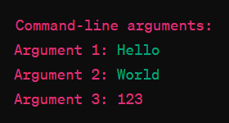

**2. Write a program to print the elements of array, calculate sum of elements of array, calculate average of elements of array and also find out minimum and maximum element in the array**

import java.io.*;

import java.util.*;

public class array

{

public static void main(String[] args)throws IOException

{

Scanner Sc=new Scanner(System.in);

double total=0;

System.out.println("Name: Harsh Maheshwari");

System.out.println("RollNo - 2101611520020");

System.out.println("Enter Size of Array");

int n=Sc.nextInt();

double a[] = new double[n];

System.out.println("Enter Array Elemnts");

for(int i=0;i<n;i++)

{

a[i]=Sc.nextInt();

}

System.out.println("\nThe Elements that you have entered are :\n");

for(int i=0;i<a.length;i++)

{

System.out.println((i+1)+" . "+a[i]);

}

for(int i=0;i<a.length;i++)

{

total=total+a[i];

}

System.out.println("\nTotal = "+total+"\n");

double average=total/a.length;

System.out.println("Average = "+average+"\n");

         double max=a[0];

for(int i=1;i<a.length;i++)

{

if(a[i]>max){

                max=a[i];}

          }

System.out.println("Max. is = "+max+"\n");

double min=a[0];

for(int i=1;i<a.length;i++)

{

if(a[i]<min)

{

min=a[i];

}

}

System.out.println("Min. is = "+min+"\n");

}

}

**OUTPUT –**

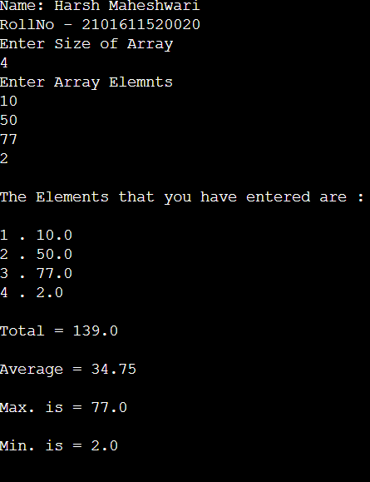

**3. Write a program to implement Method Overloading in java**

public class MethodOverloadingExample {

// Method with same name but different parameter list

public static int add(int a, int b) {

return a + b;

}

public static double add(double a, double b) {

return a + b;

}

public static String add(String a, String b) {

return a + b;

}

// Method with different number of parameters

public static int add(int a, int b, int c) {

return a + b + c;

}

public static void main(String[] args) {

System.out.println("Name: Harsh Maheshwari");

System.out.println("RollNo - 2101611520020");

System.out.println("Adding integers: " + add(10, 3));

System.out.println("Adding doubles: " + add(10.5, 8.5));

System.out.println("Concatenating strings: " + add("Hello ", "World"));

System.out.println("Adding three integers: " + add(2, 4, 6));

}

}

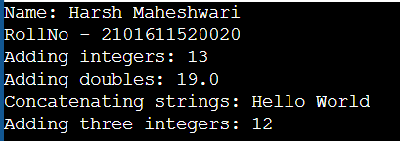

**4. Write a Program to Implement Single Level Inheritance in java.**

class Employee {

float salary = 40000;

}

class Programmer extends Employee {

int bonus = 10000;

public static void main(String args[]) {

Programmer p = new Programmer();

System.out.println("NAME: Harsh Maheshwari");

System.out.println("ROLL NO: 2101611520020");

System.out.println("Programmer salary is: " + p.salary);

System.out.println("Bonus of Programmer is: " + p.bonus);

}

}

**OUTPUT -**

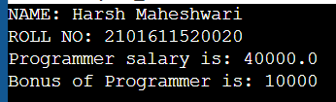

**5**.**Write a Program to Implement Multi-Level Inheritance in java**

class Shape {

public void display() {

System.out.println("DISPLAYING:");

}

}

class Rectangle extends Shape {

public void area() {

System.out.println("AREA");

}

}

class Cube extends Rectangle {

public void volume() {

System.out.println("VOLUME");

}

}

public class Multilvl {

public static void main(String[] arguments) {

System.out.println("NAME: Harsh Maheshwari");

System.out.println("ROLL NO: 2101611520020");

Cube cube = new Cube();

cube.display();

cube.area();

cube.volume();

} }

**OUTPUT -**

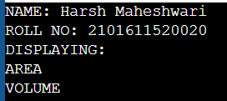

**6.Write a program to implement Multiple inheritance in java.**

// Import statements

import java.lang.System;

// Interfaces

interface PI1 {

default void printMessage() {

System.out.println("Default PI1");

}

}

interface PI2 {

default void printMessage() {

System.out.println("Default PI2");

}

}

// Implementation class

class TestClass implements PI1, PI2 {

// Overriding default printMessage method

public void printMessage() {

// use super keyword to call the printMessage

// method of PI1 interface

PI1.super.printMessage();

// use super keyword to call the printMessage

// method of PI2 interface

PI2.super.printMessage();

}

}

// Main class

public class HelloWorld {

public static void main(String[] args) {

System.out.println("Name:Harsh Maheshwari");

System.out.println("Roll No:2101611520020");

TestClass d = new TestClass();

d.printMessage();

}

}

**OUTPUT -**

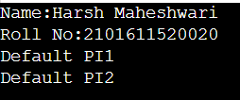

**7. Write a program to implement Method Overriding in java**

class HelloWorld {

public static void main(String[] args) {

System.out.println("Name:Harsh Maheshwari");

System.out.println("Roll No:2101611520020");

Boy obj = new Boy();

obj.eat();

}

}

class Human{

public void eat()

{

System.out.println("Human is eating");

}

}

class Boy extends Human{

//Overriding method

public void eat(){

System.out.println("Boy is eating");

super.eat();

}

}

**Output -**

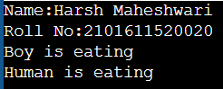

**8. Write a program to implement Abstract Class & Method in java**

class HelloWorld {

public static void main(String[] args) {

System.out.println("Name:Harsh Maheshwari");

System.out.println("Roll No:2101611520020");

Dog d1 = new Dog();

d1.makeSound();

Cat c1 = new Cat();

c1.makeSound();

}

}

abstract class Animal {

abstract void makeSound();

}

class Dog extends Animal {

public void makeSound() {

System.out.println("Bark bark.");

}

}

class Cat extends Animal {

public void makeSound() {

System.out.println("Meows ");

}

}

**OUTPUT -**

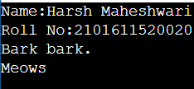

**9. Program to Implement Exception Handling in Java**

class HelloWorld {

public static void main(String[] args) {

System.out.println("Name:Harsh Maheshwari");

System.out.println("Roll No:2101611520020");

try{

//code that may raise exception

int data=100/0;

}

catch(ArithmeticException e){System.out.println(e);

}

//rest code of the program

System.out.println("rest of the code...");

}

}

**OUTPUT –**

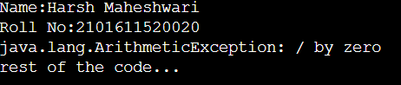

**10.Sum of 2 No’s using JavaScript in HTML**

<!DOCTYPE html>

<html>

<head>

<title>Calculate Sum of Given Numbers</title>

<nav style="background-color: lightblue; color: black;">

<h3 style="text-align: center;">NAME: Harsh Maheshwari<br>Roll No : 2101611520020</h3>

</nav>

<script type="text/javascript">

function Sum_Cal() {

var a, b, s;

a = parseInt(document.rdf_form.First_Number.value);

b = parseInt(document.rdf_form.Second_Number.value);

s = a + b;

alert(s);

document.rdf_form.Result.value = s;

}

</script>

</head>

<body>

<form name="rdf_form">

<table align="center" border="1" cellspacing="15" style="background-color:rgb(0, 179, 255);color:white;border-color:red;">

<tr>

<th colspan="2" style="background-color:pink;color:black;">Sum Calculator</th>

</tr>

<tr>

<th>Enter 1st Number :</th>

<th><input type="text" name="First_Number"></th>

</tr>

<tr>

<th>Enter 2nd Number :</th>

<th><input type="text" name="Second_Number"></th>

</tr>

<tr>

<th colspan="2"><input type="button" value="Sum" onclick="Sum_Cal()" style="background-color:green;color:white;width:100%;"></th>

</tr>

<tr>

<th>Calculated Result :</th>

<th><input type="text" name="Result"></th>

</tr>

</table>

</form>

</body>

</html>

**Output -**

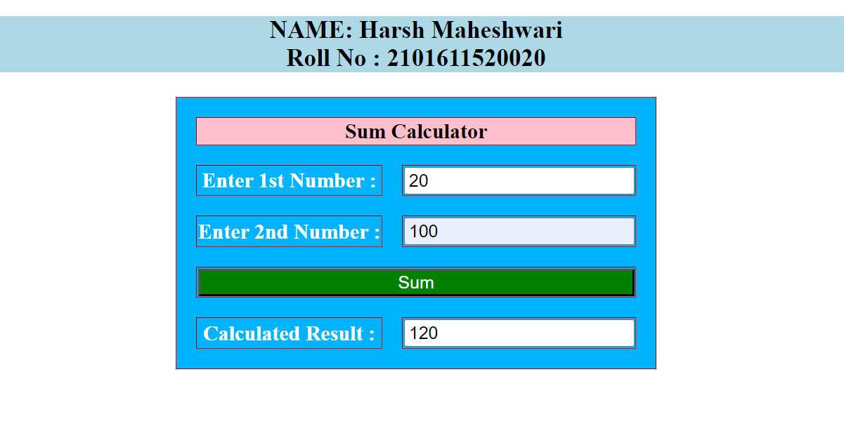

**11.Calculate S.I using JavaScript in HTML**

<!DOCTYPE html>

<html>

<head>

<title>Simple Interest Calculator</title>

<nav style="background-color: lightblue; color: black;">

<h3 style="text-align: center;">NAME: Harsh Maheshwari<br>Roll No : 2101611520020</h3>

</nav>

<script language="javascript">

function CalSum() {

var a, b, c, d;

a = parseInt(document.myform.principle.value);

b = parseInt(document.myform.rate.value);

d = parseInt(document.myform.time.value);

c = (a * b * d) / 100;

alert("The simple interest is " + c);

document.myform.SI.value = c;

}

</script>

</head>

<body>

<form name="myform">

<table border="1" align="center">

<tr>

<td>Enter principle:</td>

<td><input type="text" name="principle"></td>

</tr>

<tr>

<td>Enter rate:</td>

<td><input type="text" name="rate"></td>

</tr>

<tr>

<td>Enter time:</td>

<td><input type="text" name="time"></td>

</tr>

<tr>

<td colspan="2" align="center">

<input type="button" value="Calculate" onclick="CalSum();">

</td>

</tr>

<tr>

<td>The result is:</td>

<td><input type="text" name="SI"></td>

</tr>

</table>

</form>

</body>

</html>

**Output -**

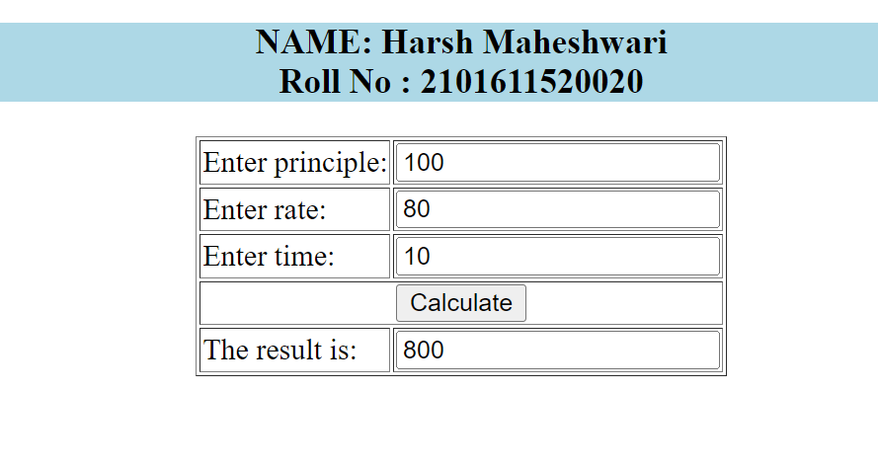

**12. Design a Student Registration Form in HTML**

<!-- Html Document Begins-->

<!DOCTYPE html>

<html>

<!-- Header Section-->

<head>

<meta charset="UTF-8" />

<meta http-equiv="X-UA-Compatible" content="IE=edge" />

<meta name="viewport" content="width=device-width, initial-scale=1.0" />

<title>

Student Registration Form

</title>

</head>

<!--Body of the Webpage-->

<body bgcolor="#33cccc">

<!--Start of Form-->

<div style="margin: auto;width: 30%;">

<form>

<h2>Student Registration Form</h2>

<p>Fill in this form to register</p>

<br>

<!--Input elemets for form-->

<label><b>First Name</b></label>

<input type="text" placeholder="Enter your first name" name="first_name" required>

<br>

<br>

<label><b>Last Name</b></label>

<input type="text" placeholder="Enter your last name" name="last_name" required>

<br>

<br>

<label><b>E-mail</b></label>

<input type="email" placeholder="Enter your e-mail" name="email" required>

<br>

<br>

<label><b>Date of Birth</b></label>

<input type="date" name="dob" required>

<br>

<br>

<label><b>Set Username</b></label>

<input type="text" placeholder="Set Username" name="username" required>

<br>

<br>

<label><b>Set Password</b></label>

<input type="password" placeholder="Set password" name="password" required>

<br>

<br>

<label><b>Gender</b></label><br>

<input type="radio" name="gender" value="Male">

<label for="Male">Male</label><br>

<input type="radio" name="gender" value="Female">

<label for="Female">Female</label><br>

<input type="radio" name="gender" value="Others">

<label for="Others">Others</label>

<br>

<br>

<label><b>Course :</b></label>

<select>

<option value="Course">Course</option>

<option value="CS">Computer Fundamentals</option>

<option value="AI">Artificial Intelligence</option>

<option value="ML">Machine Learning</option>

<option value="OOPS">Object Oriented Programming</option>

<option value="DBMS">Database Management System</option>

</select>

<br>

<br>

<input type="button" value="Register"/>

</form>

</div>

</body>

</html>

<!-- Html Document Ends-->

**Output -**

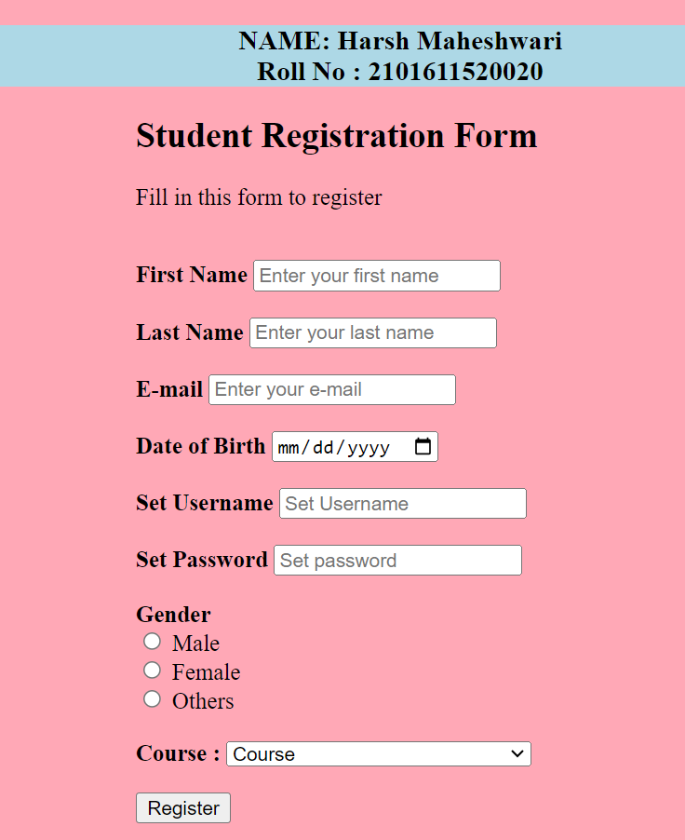

**13. Design a Simple Calculator in Html using JavaScript**

<!DOCTYPE html>

<html lang="en">

<head>

<title> JavaScript Calculator </title>

<style>

h1 {

text-align: center;

padding: 23px;

background-color: purple;

color: white;

}

#clear{

width: 270px;

border: 3px solid black;

border-radius: 3px;

padding: 20px;

background-color: #000000;

color: white;

}

.formstyle {

width: 300px;

height: 530px;

margin: auto;

border: 3px solid purple;

border-radius: 5px;

padding: 20px;

}

input {

width: 20px;

background-color: #8A2BE2;

color: white;

border: 3px solid black;

border-radius: 5px;

padding: 26px;

margin: 5px;

font-size: 15px;

}

#calc

width: 250px;

border: 5px solid black;

border-radius: 3px;

padding: 20px;

margin: auto;

}

</style>

</head>

<body>

<h1> JavaScript Simple Calculator</h1>

<div class="formstyle">

<form name="form1">

<!-- This input box shows the button pressed by the user in calculator. -->

<input id="calc" type="text" name="answer"> <br> <br>

<!-- Display the calculator button on the screen. -->

<!-- onclick() function display the number pressed by the user. -->

<input type="button" value="1" onclick="form1.answer.value += '1' ">

<input type="button" value="2" onclick="form1.answer.value += '2' ">

<input type="button" value="3" onclick="form1.answer.value += '3' ">

<input type="button" value="+" onclick="form1.answer.value += '+' ">

<br> <br>

<input type="button" value="4" onclick="form1.answer.value += '4' ">

<input type="button" value="5" onclick="form1.answer.value += '5' ">

<input type="button" value="6" onclick="form1.answer.value += '6' ">

<input type="button" value="-" onclick="form1.answer.value += '-' ">

<br> <br>

<input type="button" value="7" onclick="form1.answer.value += '7' ">

<input type="button" value="8" onclick="form1.answer.value += '8' ">

<input type="button" value="9" onclick="form1.answer.value += '9' ">

<input type="button" value="*" onclick="form1.answer.value += '*' ">

<br> <br>

<input type="button" value="/" onclick="form1.answer.value += '/' ">

<input type="button" value="0" onclick="form1.answer.value += '0' ">

<input type="button" value="." onclick="form1.answer.value += '.' ">

<!-- When we click on the '=' button, the onclick() shows the sum results on the calculator screen. -->

<input type="button" value="=" onclick="form1.answer.value = eval(form1.answer.value) ">

<br>

<!-- Display the Cancel button and erase all data entered by the user. -->

<input type="button" value="Clear All" onclick="form1.answer.value = '' " id="clear" >

<br>

</form>

</div>

</body>

</html>

**OUTPUT -**

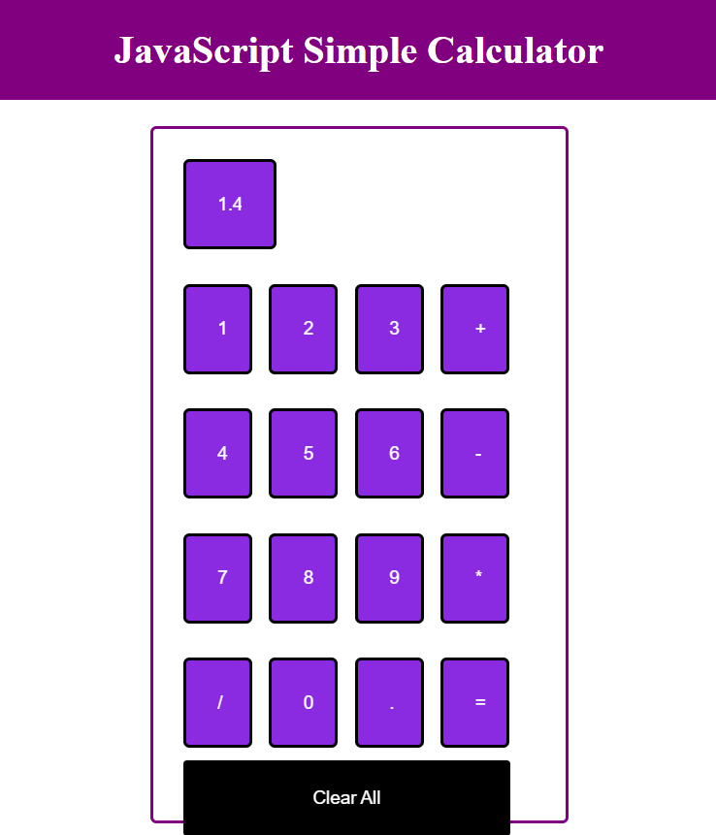

**14. Program to find Host Name & IP Address of URL using Java InetAddress Class**

import java.io.*;

import java.net.*;

public class Inet {

public static void main(String[] args) {

try {

InetAddress ip = InetAddress.getByName("www.amazon.in");

System.out.println("Host Name: " + ip.getHostName());

System.out.println("IP Address: " + ip.getHostAddress());

} catch (Exception e) {

System.out.println(e);

}

}

}

**Output -**

