DATA VISUALIZATION & ANALYTICS
Bank Term Deposit Campaign Intelligence
Finance / Bank Marketing | Project Report
This report analyses the UCI Bank Marketing dataset to identify which clients are most likely to subscribe to a term deposit, how campaign design affects conversion, and how Tableau dashboards can support operational targeting decisions.
Field | Details
Team ID | Sec-B G-2
Institute | Newton School of Technology, Rishihood University
Team members | Harshvardhan Gupta; Kartik Madaan; Dev Tyagi; Shitanshu Tiwari; Satwik Mani Tripathi; Siddharth Dangi
Dataset | UCI Bank Marketing (bank-full.csv)
Rows / columns | 45,211 / 22 raw columns
Submitted | 29 April 2026

At a glance
Metric | Value
Total contacts | 45,211
Subscriptions | 5,289
Subscription rate | 11.70%
Avg. campaign touches | 2.76
The report uses only repository-visible data and dashboard assets stored in this project workspace.

1. Executive Summary
One-page summary for decision makers
The dataset contains 45,211 client contacts and 5,289 term-deposit subscriptions, producing an overall subscription rate of 11.70%.
The strongest business signal is prior campaign history: previously contacted clients convert at 23.07%, compared with 9.16% for clients without prior contact.
Segment quality also matters. Students (28.68%), retirees (22.79%) and older clients aged 65+ (42.10%) respond well.
Repeated calling is inefficient: conversion falls from 14.60% on first touch to 5.81% for six or more contacts.
The report therefore recommends a warm-lead-first call queue, cellular-first outreach, a cap on repeated touches after three attempts, and a stronger focus on high-response months such as March, September, October, and December.
- Decision rule: prioritize warm leads before cold prospects.
- Campaign design rule: keep contact attempts short and targeted.
- Channel rule: use cellular-first routing for higher conversion.
- Timing rule: schedule the heaviest pushes in the best-performing months.

2. Sector Context and Problem Statement
Finance-sector lead generation is a prioritization problem, not a volume problem.
Retail banks run large outbound campaigns to sell term deposits. The challenge is that calling everyone wastes capacity, depresses conversion efficiency, and creates noise for low-propensity clients.
The decision-maker in this project is a campaign or CRM manager who needs a simple rule set: who to call first, how often to call, and which channels should be used for the best return on effort.
- Business question: which clients should be contacted first to maximize subscription probability?
- Operational question: how can the bank reduce wasted calls while protecting customer experience?
- Outcome: a Tableau dashboard and Python analysis that support segmentation-driven outreach.

3. Data Description
Source, structure, size, and known limitations
The analysis uses the UCI Machine Learning Repository's Bank Marketing dataset (`bank-full.csv`). The raw file is semicolon-delimited and has one row per client contact record.
Attribute | Details
Source | UCI Machine Learning Repository
Raw file | bank-full.csv
Rows | 45,211
Raw columns | 17
Cleaned columns | 22
Unit of analysis | One client contact record
Target variable | y (term-deposit subscription: 0/1)
Key limitations: the file uses the label `unknown` in several categorical fields rather than missing values; `duration` is informative for descriptive analysis but leaks information in a predictive setting; and the data represents one historical campaign period, so seasonality should be validated before operational use.
Important derived fields introduced for Tableau and analysis include `age_group`, `balance_band`, `campaign_band`, `previously_contacted`, and `duration_minutes`.

4. Data Cleaning and ETL Methodology
Python pipeline from raw file to Tableau-ready dataset
The ETL pipeline in `scripts/etl_pipeline.py` standardizes the raw file, validates required columns, preserves semantic labels, and adds business-friendly derived columns.
- Normalize headers to lowercase snake_case and standardize string values.
- Validate expected raw columns before further processing.
- Drop duplicates and preserve explicit `unknown` labels rather than silently imputing them.
- Create `previously_contacted` from `pdays != -1`.
- Bucket `age` into life-stage bands and `balance` into financial bands.
- Create `campaign_band` to distinguish first-touch, low-touch, and high-touch campaigns.
- Export the cleaned dataset and Tableau-ready subset with 22 columns.
Stage | What happens | Why it matters
Input | data/raw/bank-full.csv | Raw UCI source
Standardize | Lowercase / snake_case / strip spaces | Consistent joins and filtering
Derive | age_group, balance_band, campaign_band, etc. | Business segmentation
Validate | Required columns and yes/no target values | Data quality control
Output | cleaned_dataset.csv / Tableau-ready CSV | Analysis and dashboard consumption

5. KPI and Metric Framework
Metrics used to judge conversion, targeting quality, and financial context
KPI | Current value | Definition | Business meaning
Subscription rate | 11.70% | Subscribers / total contacts | North-star conversion metric
Total subscriptions | 5,289 | Count of y = 1 records | Absolute campaign success
Avg. contacts / client | 2.76 | Mean campaign touch count | Effort intensity
Previously contacted share | 18.26% | previously_contacted = 1 | Warm-lead prevalence
Avg. yearly balance | €1,362 | Mean balance across all clients | Financial capability
Default rate | 1.80% | Clients with default = yes | Credit risk context
Loan rate | 16.02% | Clients with loan = yes | Debt burden context
For campaign management, the most useful pairings are subscription rate versus contact intensity, and subscription rate versus prior contact history. These pairs reveal where the bank is gaining conversion and where it is wasting touches.

6. Exploratory Data Analysis
Visual patterns that shape segmentation and targeting
The EDA shows that subscription likelihood is not uniform. Certain customer groups respond materially better, and some outreach patterns are clearly inefficient.
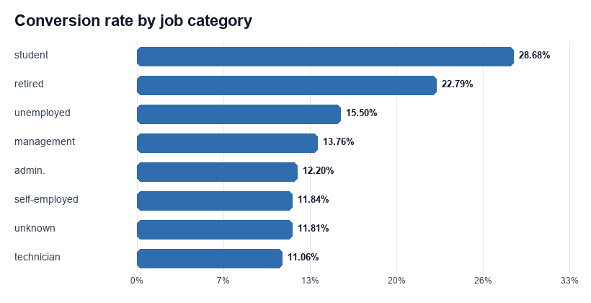
Figure 1. Conversion rate by job category.
Students and retirees lead the conversion table, while blue-collar, entrepreneur, and housemaid segments sit near the bottom. That makes occupation a practical prioritization filter rather than a descriptive label.
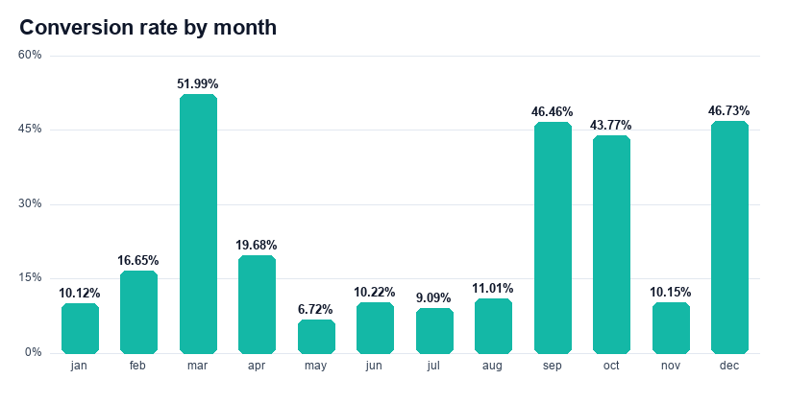
Figure 2. Seasonality of conversion across months.
Campaign response spikes in March, December, September, and October. Timing matters, so calendar windows should be treated as a campaign lever rather than an afterthought.

7. Statistical Analysis Results
Association strength and decision relevance
The goal of this section is not to produce a machine-learning model, but to quantify which variables are most strongly associated with the subscription outcome.
Driver | Chi-square | Cramér's V | Interpretation
poutcome | 4,391.5 | 0.312 | Strongest relationship; prior success is highly informative.
previously_contacted | 1,264.9 | 0.167 | Warm leads materially outperform cold leads.
contact | 1,035.7 | 0.151 | Cellular contact clearly outperforms telephone.
age_group | 1,008.8 | 0.149 | Older bands convert materially better.
job | 836.1 | 0.136 | Occupation is a useful segmentation feature.
balance_band | 367.5 | 0.090 | Higher balances align with better conversion.
campaign_band | 341.6 | 0.087 | Conversion decays as touches increase.
education | 238.9 | 0.073 | Education matters, but less than contact history.
marital | 196.5 | 0.066 | Useful as a secondary segmentation feature.
Key descriptive contrasts: subscribers have a higher average balance (€1,804) than non-subscribers (€1,304), and they receive fewer campaign touches on average (2.14 versus 2.85).
Previously contacted clients convert at 23.07% versus 9.16% for clients with no prior contact, a lift of roughly 151.9%.

8. Dashboard Design
Screenshots and what each view is meant to answer
The workbook is intentionally split into an executive view and operational views so that leadership can read one story while campaign owners can drill into targeting rules.
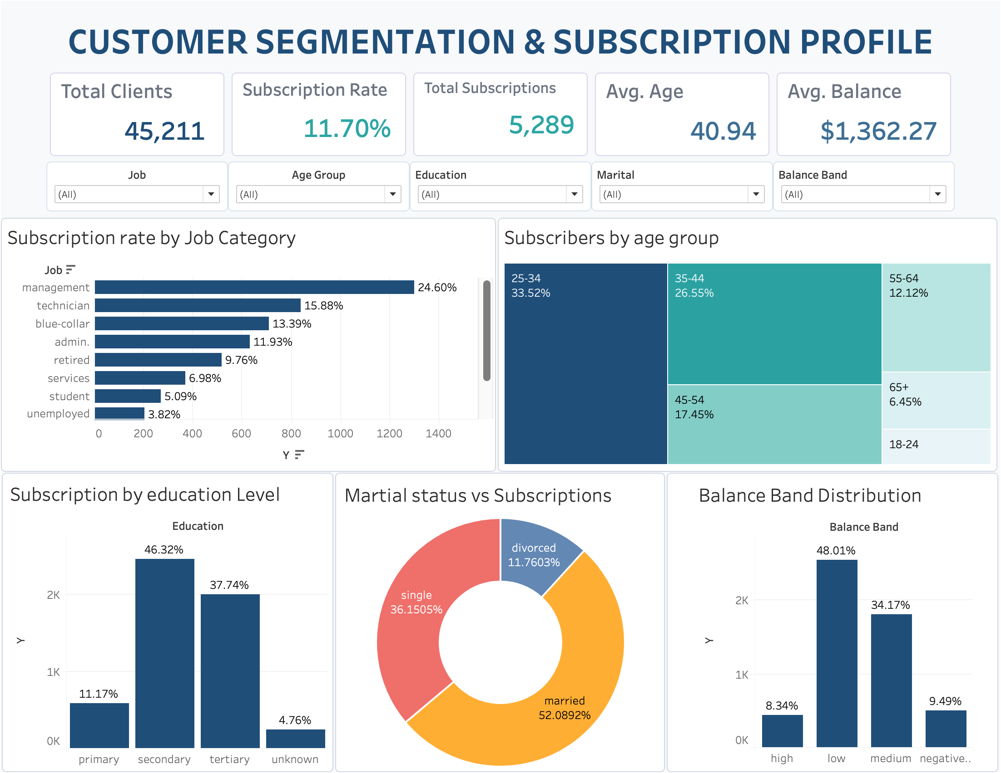
Dashboard 1. Executive overview.
- Shows headline KPIs, high-level segments, and balance distribution.
- Best for leadership reporting and fast portfolio review.
- Main filters: job, age group, education, marital status, balance band.

8. Dashboard Design (continued)
Operational lens one
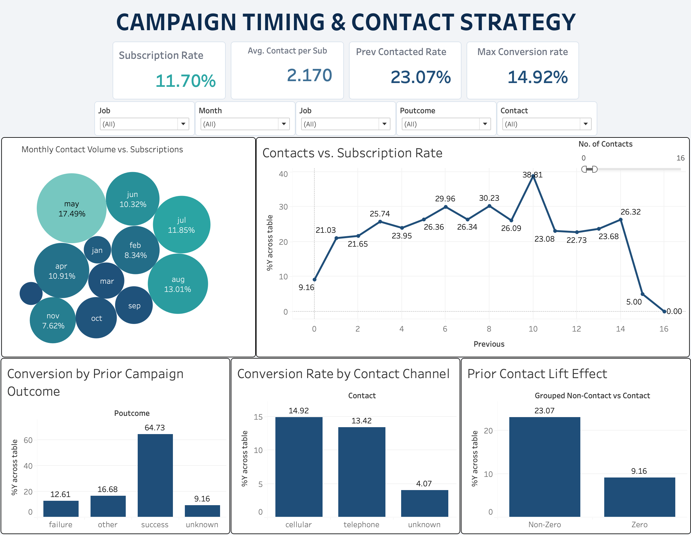
Dashboard 2. Contact strategy and conversion lens.
- Focuses on contact volume, channel performance, prior-contact lift, and campaign touch effects.
- Best for CRM managers deciding how to route the next batch of leads.
- Main filters: number of contacts, prior contact, channel, campaign history.

8. Dashboard Design (continued)
Operational lens two
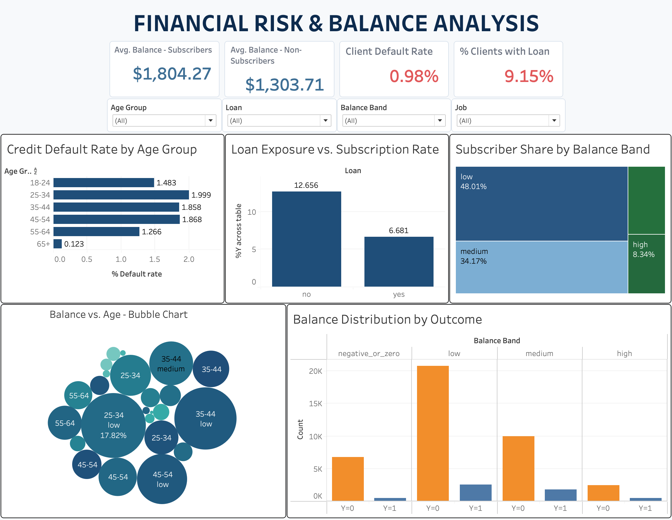
Dashboard 3. Risk and balance lens.
- Brings credit risk context into the story through default, loan, and balance bands.
- Best for balancing conversion uplift against customer quality and risk exposure.
- Main filters: age group, balance band, loan, default, and outcome.

9. Key Insights and Recommendations
Decision language, not chart captions
# | Insight | Business implication
1 | Prioritize students and retirees first. | They deliver the highest conversion and deserve the first call queue.
2 | Treat 65+ and 18-24 as high-response age bands. | Age is a practical targeting dimension, not just a descriptive one.
3 | Use prior contact history as a primary routing rule. | Warm leads convert far better than cold leads.
4 | Cap repeated outreach after three touches. | Conversion falls sharply after touch count increases.
5 | Prefer cellular-first contact plans. | Cellular outperforms telephone and unknown channels are weak.
6 | Push campaigns in March, September, October, and December. | Response is materially stronger in these windows.
7 | Give medium and high balance clients higher priority. | Higher balance bands outperform low and negative bands.
8 | Use prior success as a premium routing signal. | Successful previous outcomes dominate all other signals.
9 | De-emphasize blue-collar and services segments for premium outreach. | These groups sit near the bottom of the response table.
10 | Keep unknown contact records out of prime call queues. | Missing channel context lowers conversion and should be cleaned.
Recommended actions:
Recommendation | What to do | Expected impact
Prioritize warm leads | Route previously contacted leads and prior-success records first. | Highest immediate conversion gain
Apply touch caps | Stop repeating low-yield calls after three touches. | Lower wasted call volume
Use cellular-first routing | Make cellular the default channel where possible. | Stronger response rate
Seasonal campaign bursts | Concentrate spend in peak months. | Better calendar efficiency

10. Impact Estimation, Limitations, and Future Scope
What this work can realistically change
If 10,000 contacts are routed from the cold baseline to previously contacted leads, the expected incremental lift is about 1,391 extra subscriptions.
Using a conservative illustrative contribution of INR 50 per incremental subscription, the same shift implies roughly INR 69,570 in value per 10,000 contacted leads.
- Limitation 1: no call-cost or offer-cost data, so ROI is estimated rather than exact.
- Limitation 2: `duration` is useful for analysis but leaks outcome information and should not be used as a pre-call predictor.
- Limitation 3: the dataset captures one campaign period, so seasonality should be revalidated before deployment.
- Limitation 4: unknown categories are explicit labels, not absent rows, which is useful for analysis but imperfect for modeling.
Future scope should include a cost-per-touch model, a propensity scoring layer, and A/B-tested routing rules that compare warm-lead targeting against broader outreach mixes.

11. Contribution Matrix
Team member | Git history status | Repository-visible contribution
Harshvardhan Gupta | 14 commits | Raw data, cleaning, EDA, statistical analysis, workbook updates
Kartik Madaan | 8 commits | Statistical analysis, Tableau dashboard, report writing, PPT
Dev Tyagi | 4 commits | Tableau dashboard
Shitanshu Tiwari | 2 commits | EDA and analysis
Satwik Mani Tripathi | No commit | N/A
Siddharth Dangi | No commit | N/A

