Low-Cost 3D Surface Reconstruction Using Photometric Stereo

Computer Vision Mini Project Report
Department of Computer Science and Engineering
Prepared for syllabus topic: Shape From X / Photometric Stereo

Atharva Chourey
23BAI10037
Abstract
This project presents a lightweight computer vision system for reconstructing the surface characteristics of a small object using four images captured under different lighting directions. The method is based on photometric stereo, where the camera position is fixed and the illumination direction changes across captures. From these inputs, the system estimates the object mask, albedo map, surface normal map, and an approximate depth map. The project relies only on classical image processing and linear algebra, making it suitable for low-resource academic environments. It avoids deep learning, large datasets, and GPU dependency while still producing visually meaningful outputs for demonstration.
1. Introduction
Computer vision studies how meaningful information can be extracted from images. While many student projects focus on recognition or detection tasks, this report explores shape recovery from illumination using photometric stereo. The project was chosen because it is unique, directly aligned with the course syllabus, and feasible to implement with very low computational resources.
2. Problem Statement
Most commonly submitted projects are based on face recognition, attendance, object detection, or tracking. These topics are often repetitive and may rely on pretrained models. The objective here is to build a more original computer vision project that demonstrates actual syllabus concepts while remaining lightweight and practical.
3. Objectives
• Develop a low-cost computer vision project derived directly from the syllabus.
• Estimate albedo and surface normals from multiple light directions.
• Recover an approximate depth map without using deep learning.
• Create outputs that are easy to explain during demonstration and viva.
4. Capture Setup Diagram
The diagram below shows the expected image-capture arrangement. The camera must remain fixed while only the light direction changes.
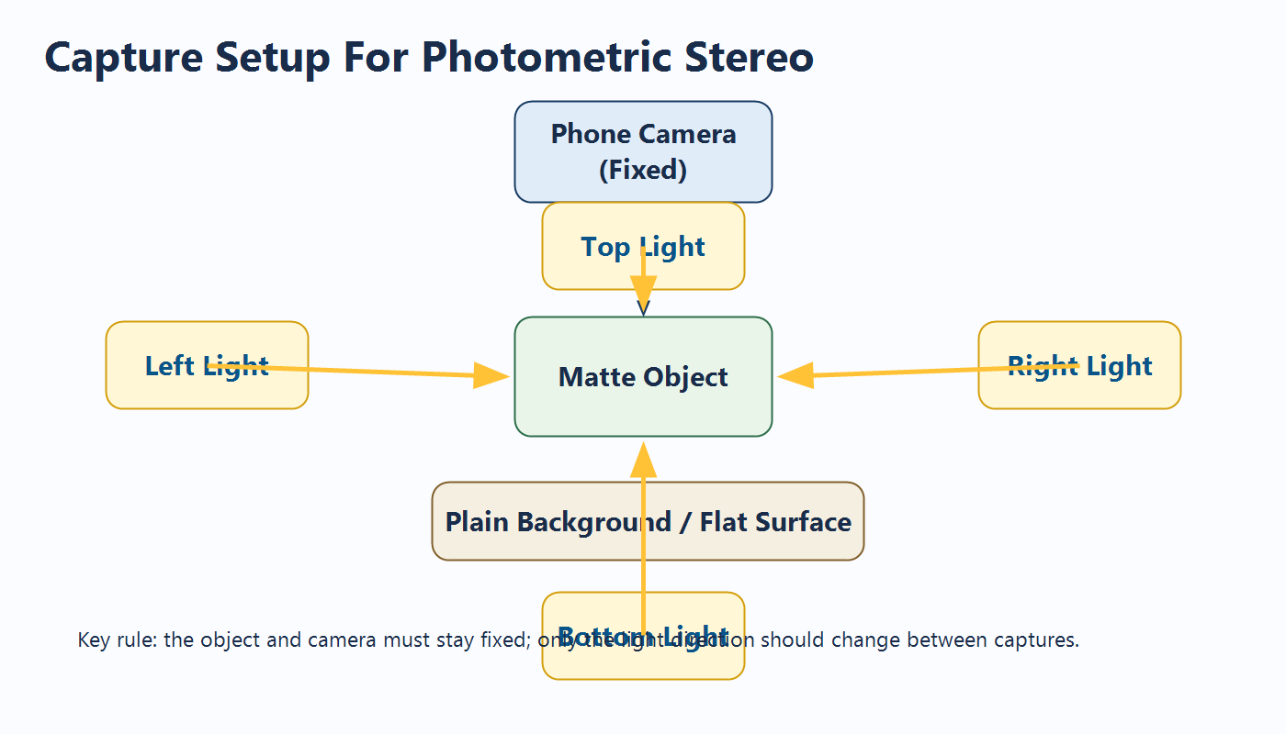
5. Syllabus Mapping
• Module 1: image formation, filtering, image enhancement, intensity normalization
• Module 3: segmentation and object extraction
• Module 5: light at surfaces, albedo estimation, photometric stereo, Shape From X
6. Methodology
The workflow consists of image acquisition, preprocessing, object masking, photometric stereo estimation, and depth recovery. Each stage is lightweight and runs on CPU using standard computer vision libraries.
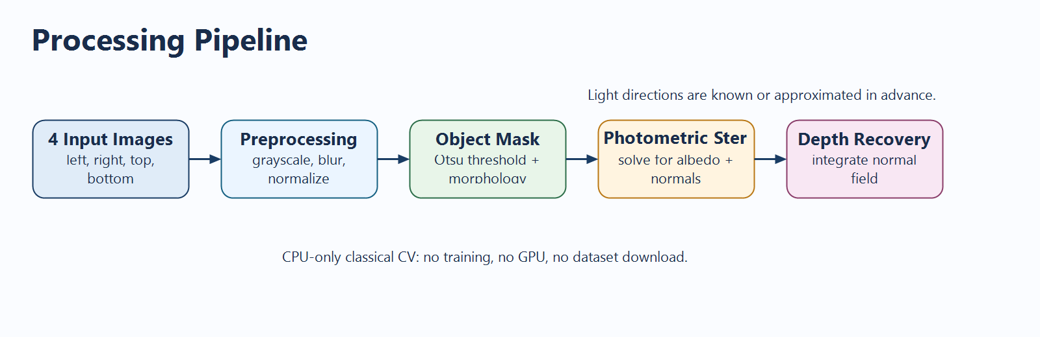
• Input acquisition: capture left, right, top, and bottom illuminated images.
• Preprocessing: convert to grayscale, denoise, and normalize intensity.
• Mask generation: use Otsu thresholding and morphological cleanup.
• Photometric stereo: solve for scaled surface normals using known light directions.
• Depth recovery: integrate the normal field using an FFT-based method.
7. Core Equation
For each pixel, the intensity vector I can be expressed as I = Lg, where L is the light direction matrix and g is the scaled normal vector. The magnitude of g provides the albedo, while the normalized direction of g gives the surface normal.
8. Main Outputs
The system produces several outputs that make the demo visually strong and easy to interpret.
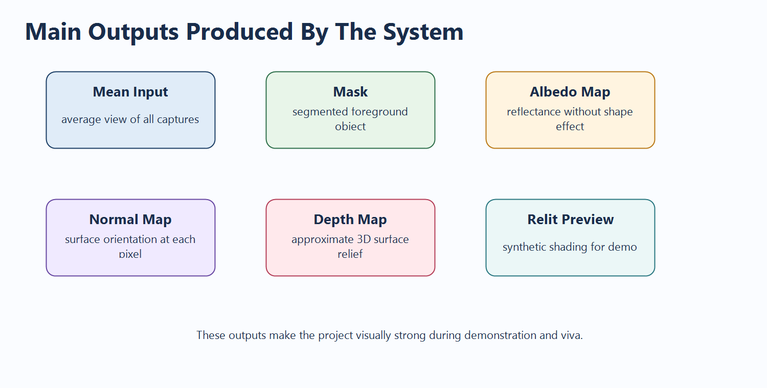
• Mean input image
• Foreground mask
• Albedo map
• Normal map
• Depth map
• Relit preview
9. Advantages
• Unique topic compared to common class projects
• Very low CPU, RAM, and storage usage
• No deep learning, GPU, or training dataset required
• Strong theoretical connection to the syllabus
• Outputs are visually appealing during project demonstration
10. Limitations
• Works best for matte objects with limited specular reflection
• Camera and object must remain fixed
• Depth recovered is approximate rather than exact metric geometry
• Strong shadows or harsh ambient lighting can reduce quality
11. Software and Hardware Requirements
• Python 3.10 or above
• OpenCV and NumPy
• Mobile phone camera
• Torch or phone flashlight
12. Applications
• Educational 3D reconstruction demos
• Small object surface inspection
• Texture and relief analysis
• Cultural artifact documentation
13. Conclusion
This project demonstrates that meaningful surface reconstruction can be achieved using classical computer vision under very limited resources. By estimating albedo, normals, and approximate depth from four images with varying light direction, the system remains unique, syllabus-driven, and practical for academic submission.
14. References
• Richard Szeliski, Computer Vision: Algorithms and Applications, Springer, 2011.
• D. A. Forsyth and J. Ponce, Computer Vision: A Modern Approach, Pearson, 2003.
• Richard Hartley and Andrew Zisserman, Multiple View Geometry in Computer Vision, Cambridge University Press, 2004.
• Rafael C. Gonzalez and Richard E. Woods, Digital Image Processing, Addison-Wesley, 1992.

