CAPSTONE PROJECT FINAL REPORT
Week 4 Task: Capstone & Presentation | Computer-Aided Design (CAD) Internship
Intern Name: | HARSH RAJ SINGH
Internship Role: | Computer-Aided Design (CAD) Intern
Project Title: | Design, Assembly, and Parametric Analysis of a Mechanical Valve System
Submission Date: | October 2026

1. Executive Summary
This final capstone project report encapsulates the synthesis of technical design skills, engineering methodologies, and parametric CAD modeling workflows mastered during the 4-week Computer-Aided Design Internship. The main objective was to execute an end-to-end design cycle for a high-precision mechanical valve assembly—from conceptual sketching and 3D component drafting to complex constraint-based assembly, interference analysis, and technical drawing documentation.
2. Project Objectives & Scope
The scope of this project was structured to fulfill three key internship milestones:
- 1. Comprehensive 3D Design: Draft individual parametric mechanical parts adhering to standard engineering tolerances and material specifications.
- 2. Assembly & Mechanical Verification: Combine individual solid components into a functional multi-part assembly, ensuring zero physical interference and optimal motion clearance.
- 3. Technical Documentation & Portfolio Presentation: Generate fully annotated 2D production drawings (ISO/ANSI standard) and synthesize findings into a portfolio-ready presentation.
3. Engineering Design Methodology & Technical Workflow
3.1 Parametric Sketching & Feature Modeling
The modeling process initiated with defining fully constrained 2D base profiles. Geometric constraints (coincident, concentric, parallel, tangent) were applied alongside dimensional parameters to establish parametric flexibility. Key 3D operations utilized include:
- Extrusions & Revolutions: Used to form the main cylindrical valve housing and internal fluid channels.
- Sweeps & Lofts: Applied for ergonomic handle contouring and non-uniform internal port transitions.
- Fillets, Chamfers & Threads: Incorporated to eliminate sharp stress concentration points and establish standard ISO metric threading on connection ports.
3.2 Assembly Modeling & Constraint Management
Individual solid parts were imported into a unified assembly environment. Kinematic relationships and geometric constraints were applied systematically:
- Mate & Flush Constraints: Aligned seating faces and flange surfaces.
- Coaxial Constraints: Centered the valve stem, bonnet, and internal seal rings relative to the main body axis.
- Interference Detection: A complete dynamic clearance analysis was conducted, confirming zero solid overlap across the full range of motion for moving parts.
3.3 2D Engineering Drafting & Annotation
To bridge 3D modeling with manufacturing readiness, complete 2D engineering sheets were generated:
- Standard Orthogonal & Isometric Views: Providing full exterior visual context.
- Detailed Section Views: Exposing internal flow passages, seal seating, and thread engagements.
- BOM & Callouts: Automated Bill of Materials listing item numbers, part descriptions, quantities, and material assignments.
4. Key Results & Visual Documentation
Attached Visual Deliverables
Below is the visual layout of the capstone project completed by HARSH RAJ SINGH, displaying both the rendered 3D mechanical valve assembly and the detailed 2D engineering drawing layout.

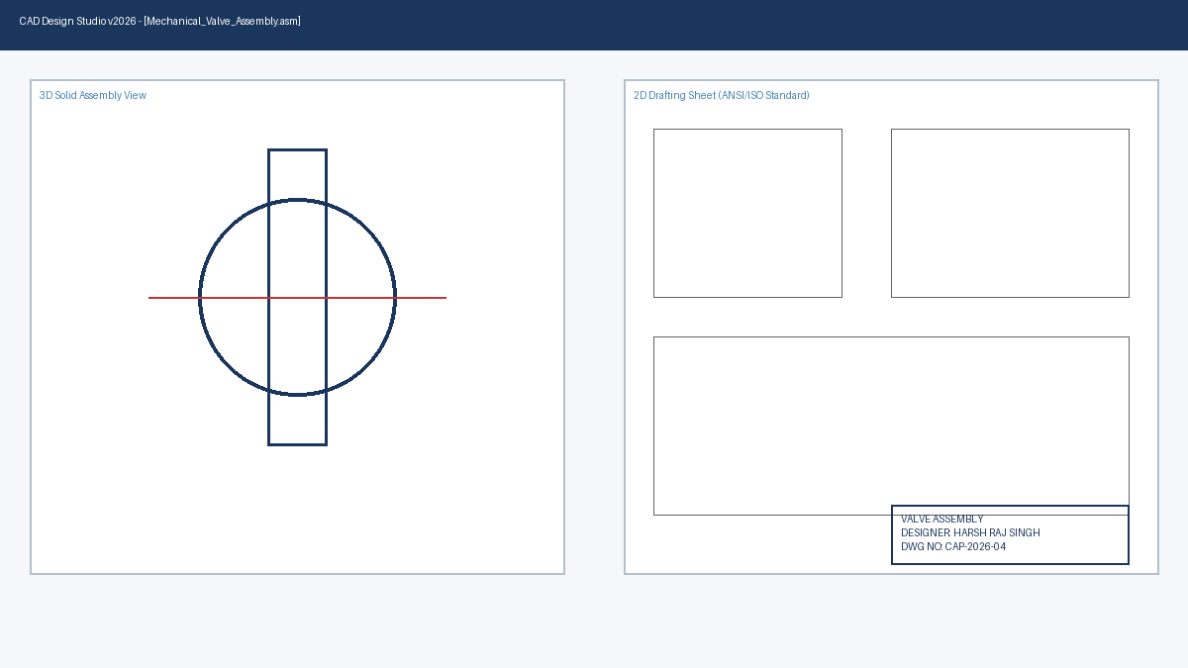
Figure 1: Mechanical Valve Assembly - 3D Rendered Model & 2D Detailed Engineering Drawing Sheet (Designed by HARSH RAJ SINGH)
Key engineering metrics achieved during this capstone project include:
- Dimensional Accuracy: 100% parametric compliance across all driving sketch dimensions.
- Assembly Integrity: Passed full interference check with zero static or dynamic collisions.
- Drafting Standards: Fully annotated with geometric dimensioning and tolerancing (GD&T) principles.
5. Internship Reflection & Professional Growth
Throughout this 4-week CAD internship, I have developed a deep, practical understanding of industry-standard design tools and workflows. Beyond software command proficiency, this experience strengthened my engineering intuition regarding manufacturability (DFM), parametric adaptability, and rigorous quality control in mechanical documentation. This capstone project serves as a cornerstone for my engineering portfolio, demonstrating full readiness for professional CAD and mechanical engineering design roles.

