STUNT Reproduction:
Experiment Report
Few-Shot Tabular Learning with Self-Generated Tasks from Unlabeled Tables

Harsh Sarawagi
August 20, 2026

Table of Contents
1. Introduction
2. Method Overview
2.1 STUNT Task Generation
2.2 Prototypical Network
2.3 Evaluation Protocol
3. Experimental Setup
3.1 Datasets
3.2 Architecture & Hyperparameters
4. Results: WDBC (Breast Cancer)
4.1 Few-Shot Accuracy & F1
4.2 STUNT Improvement Over Raw Features
4.3 Full-Data Downstream Evaluation
4.4 Plots
5. Results: Adult/Census Income
5.1 Few-Shot Accuracy & F1
5.2 STUNT Improvement Over Raw Features
5.3 Plots
6. Cross-Dataset Comparison
7. Discussion
7.1 Key Findings
7.2 Low-Shot Regime Benefits
7.3 Diminishing Returns at Higher Shots
7.4 Variance Reduction
7.5 Dataset Complexity Effects
8. Limitations & Future Work
9. Conclusion
10. References

1. Introduction
This report presents the experimental results of our independent reproduction of STUNT (Self-supervised Tabular UNsupervised preTraining), a meta-learning approach for few-shot classification on tabular data. STUNT was originally proposed by Nam et al. at ICLR 2023 as a method to learn useful tabular representations from unlabeled data, enabling strong performance even when only 1–10 labeled examples per class are available.
The central hypothesis of STUNT is that self-supervised pretraining on synthetic few-shot tasks — generated entirely from unlabeled tabular data — can produce encoders whose learned representations significantly outperform raw features in few-shot downstream classification.
We evaluate this hypothesis on two standard tabular benchmarks: the Wisconsin Diagnostic Breast Cancer (WDBC) dataset and the Adult/Census Income dataset. For each dataset, we compare STUNT embeddings against raw features under identical few-shot conditions, using matched support sets and a fixed test set across 100 independent trials.

2. Method Overview

2.1 STUNT Task Generation
STUNT generates synthetic few-shot classification tasks from unlabeled tabular data through the following procedure:
- Feature Masking: A masking ratio p is sampled uniformly from [r₁, r₂] (default [0.2, 0.5]). Then ⌊p·D⌋ feature columns are randomly selected.
- Pseudo-Label Generation: K-means clustering is applied to the ORIGINAL values of the selected columns, producing n_way pseudo-class labels.
- Feature Perturbation: The selected columns are randomly permuted across rows, destroying the direct correlation between the input and the pseudo-labels while preserving marginal distributions.
- Episode Construction: The perturbed data is split into disjoint support and query sets with k_shot support and q_query query examples per pseudo-class.

2.2 Prototypical Network
A Prototypical Network (Snell et al., NeurIPS 2017) is used as the meta-learning classifier. It computes class prototypes as the mean embedding of each class's support examples, then classifies query examples by squared Euclidean distance to the prototypes. The encoder is a 2-layer MLP with ReLU activation.

2.3 Evaluation Protocol
After meta-training, the encoder is frozen and used to embed all training and test data. For each shot level k ∈ {1, 2, 5, 10}, we repeat the following 100 times: sample k examples per class from the training set, train a Logistic Regression classifier on the support set, and evaluate on the full fixed test set. The exact same support indices are used for both the STUNT embedding pipeline and the raw feature baseline, ensuring a fair comparison.

3. Experimental Setup

3.1 Datasets
Property | WDBC | Adult/Income
Samples (train) | 455 | 26,048
Samples (test) | 114 | 16,281
Features (input) | 30 | 105 (after one-hot)
Classes | 2 (B/M) | 2 (≤50K / >50K)
Feature Types | Numerical only | Numerical + Categorical
Class Balance | ~63% / 37% | ~76% / 24%

3.2 Architecture & Hyperparameters
Parameter | WDBC | Income
Encoder hidden dim | 1024 | 1024
Encoder output dim | 1024 | 1024
n_way | 2 | 2
k_shot | 2 | 2
q_query | 5 | 5
Episodes | 500 | 10,000
Task batch size | 4 | 4
Learning rate | 1e-3 | 1e-3
Mask ratio [r₁, r₂] | [0.2, 0.5] | [0.2, 0.5]
The downstream classifier for all few-shot evaluations is scikit-learn's LogisticRegression with max_iter=2000 and random_state=42. Each evaluation uses 100 independent trials with different random support set samples.

4. Results: WDBC (Breast Cancer)

4.1 Few-Shot Accuracy & F1
The table below shows the mean and standard deviation of accuracy and F1 score across 100 trials for each shot level, comparing STUNT embeddings against raw features.
Shots | STUNT Acc | Raw Acc | STUNT F1 | Raw F1
1 | 0.8204 ± 0.1402 | 0.7786 ± 0.1475 | 0.7611 ± 0.1836 | 0.6628 ± 0.2354
2 | 0.8766 ± 0.0700 | 0.8482 ± 0.0949 | 0.8507 ± 0.0605 | 0.7943 ± 0.1070
5 | 0.9180 ± 0.0348 | 0.9146 ± 0.0341 | 0.8934 ± 0.0405 | 0.8777 ± 0.0534
10 | 0.9373 ± 0.0280 | 0.9407 ± 0.0225 | 0.9177 ± 0.0336 | 0.9176 ± 0.0322

4.2 STUNT Improvement Over Raw Features
The table below quantifies the absolute improvement of STUNT over raw features at each shot level.
Shots | Accuracy Gain | F1 Gain
1 | +0.0418 | +0.0984
2 | +0.0283 | +0.0565
5 | +0.0034 | +0.0158
10 | -0.0034 | +0.0002

At 1-shot, STUNT achieves an accuracy gain of +4.2 percentage points and an F1 gain of +9.8 pp over raw features. The advantage is most pronounced in the extreme low-shot regime and narrows as more labeled data becomes available.

4.3 Full-Data Downstream Evaluation
When all training labels are used (full-data setting), the results are:
Metric | STUNT | Raw
Accuracy | 0.9474 | 0.9649
Precision | 0.9500 | 0.9750
Recall | 0.9048 | 0.9286
F1 | 0.9268 | 0.9512

In the full-data regime, raw features slightly outperform STUNT embeddings. This is expected: with sufficient labeled data, a linear classifier can exploit the original 30 standardized features directly. STUNT's value lies in the few-shot regime, where labeled data is scarce.

4.4 Plots
Figure 1: WDBC Few-Shot Accuracy (STUNT vs Raw)
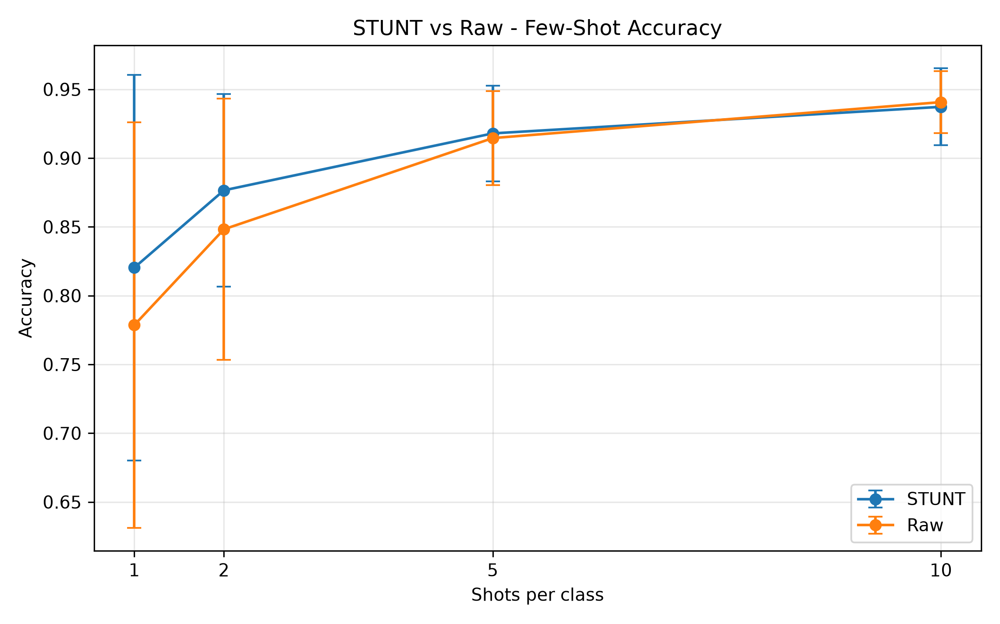

Figure 2: WDBC Few-Shot F1 Score (STUNT vs Raw)
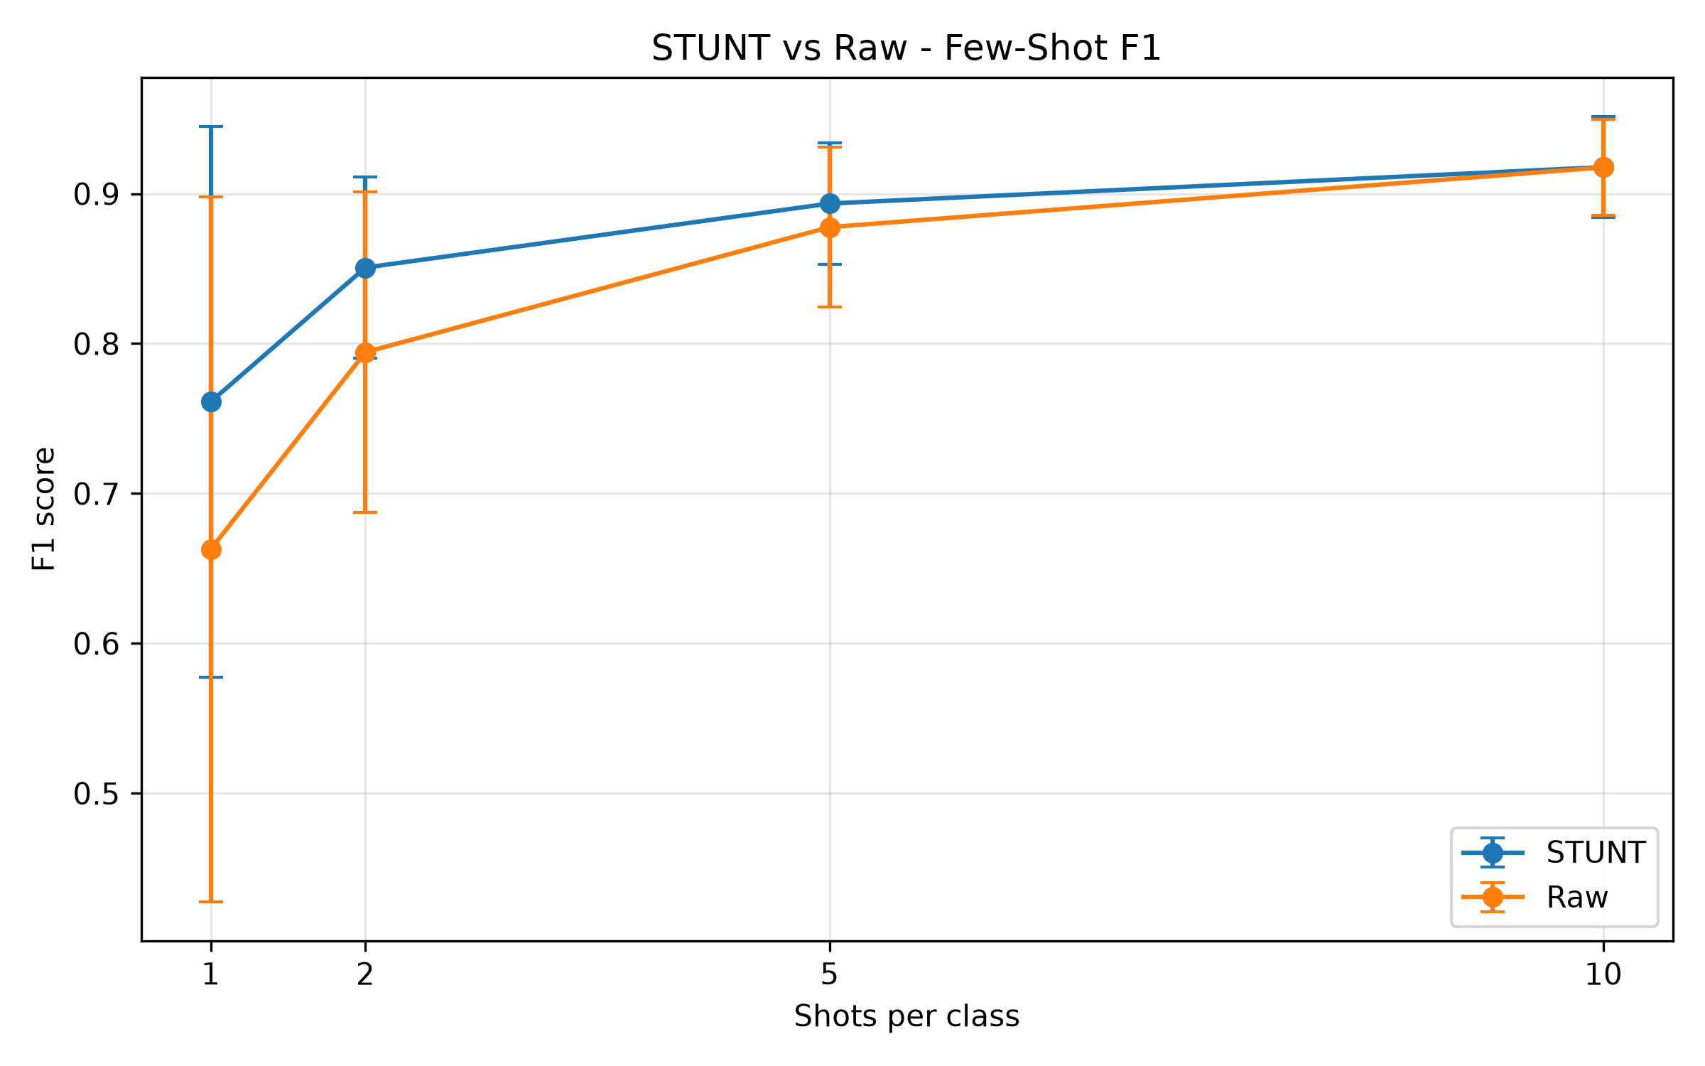

5. Results: Adult/Census Income

5.1 Few-Shot Accuracy & F1
The table below shows results for the Adult/Census Income dataset, evaluated identically to WDBC: 100 trials per shot level with matched support sets.
Shots | STUNT Acc | Raw Acc | STUNT F1 | Raw F1
1 | 0.6573 ± 0.1456 | 0.5957 ± 0.1622 | 0.4842 ± 0.1396 | 0.3770 ± 0.1487
2 | 0.6859 ± 0.1340 | 0.6467 ± 0.1240 | 0.5279 ± 0.1069 | 0.4647 ± 0.0980
5 | 0.7292 ± 0.0606 | 0.6998 ± 0.0664 | 0.5716 ± 0.0573 | 0.5356 ± 0.0591
10 | 0.7403 ± 0.0281 | 0.7276 ± 0.0412 | 0.5885 ± 0.0107 | 0.5659 ± 0.0403

5.2 STUNT Improvement Over Raw Features
Shots | Accuracy Gain | F1 Gain
1 | +0.0616 | +0.1071
2 | +0.0392 | +0.0632
5 | +0.0294 | +0.0360
10 | +0.0127 | +0.0225

On the Income dataset, STUNT consistently outperforms raw features across all shot levels. The largest gains appear at 1-shot (+6.2 pp accuracy, +10.7 pp F1), confirming that STUNT's self-supervised representations are most valuable when labeled data is extremely scarce. The improvement tapers at 10-shot (+1.3 pp accuracy, +2.3 pp F1) as Logistic Regression on raw features begins to converge.

5.3 Plots
Figure 3: Income Few-Shot Accuracy (STUNT vs Raw)
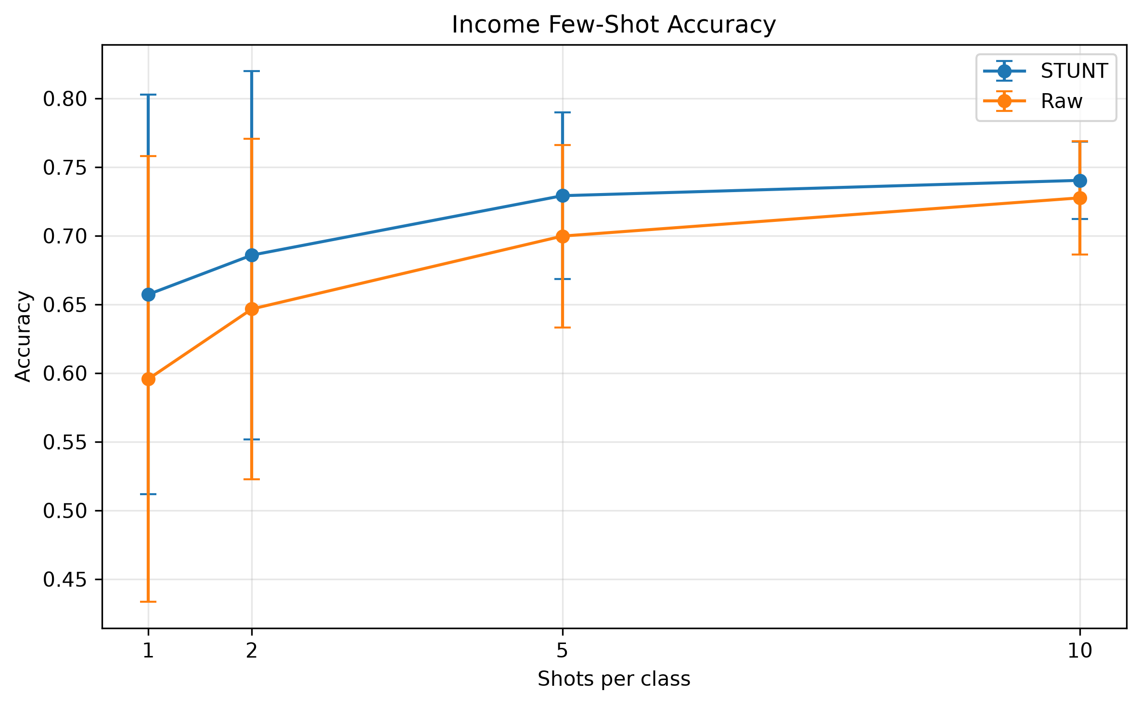

Figure 4: Income Few-Shot F1 Score (STUNT vs Raw)
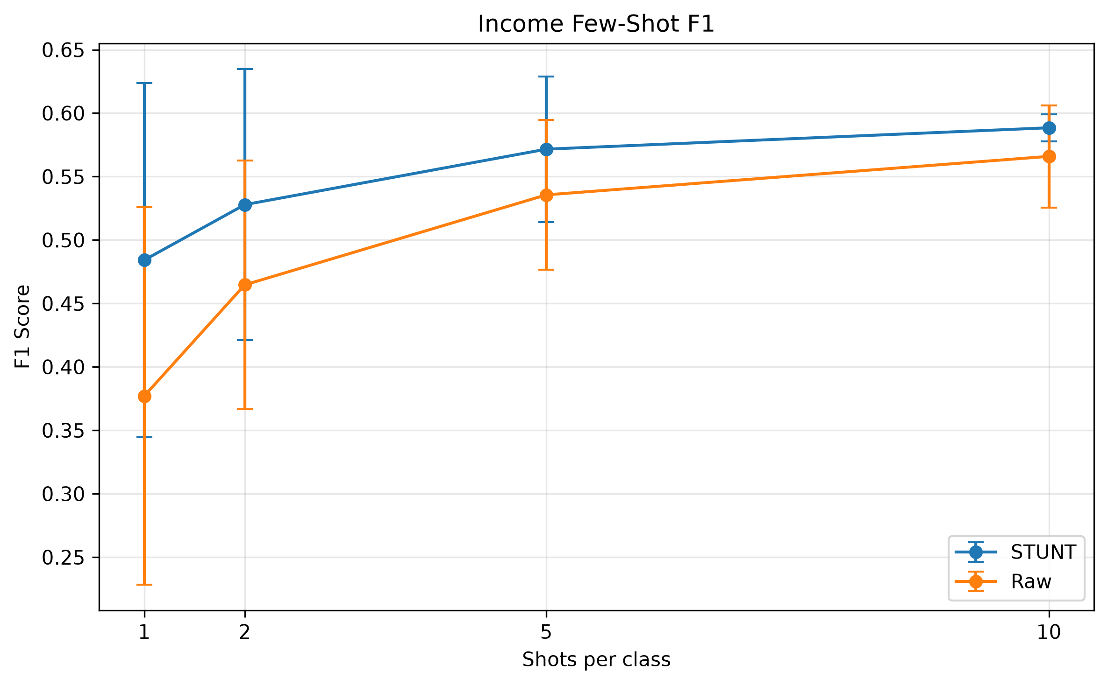

6. Cross-Dataset Comparison
The following table compares the STUNT accuracy gain over raw features across both datasets at each shot level.
Shots | WDBC Acc Gain | Income Acc Gain
1 | +0.0418 | +0.0616
2 | +0.0283 | +0.0392
5 | +0.0034 | +0.0294
10 | -0.0034 | +0.0127

Key observations from the cross-dataset comparison:
- STUNT improves performance on both datasets, confirming the generality of the approach across different data scales and feature types.
- The Income dataset shows larger absolute gains at 1-shot (+6.2 pp vs +4.2 pp), likely because the higher-dimensional feature space (105 features after one-hot encoding) provides more room for STUNT to discover useful cross-feature dependencies.
- On WDBC, the gap closes faster with more shots because the dataset is smaller (455 training samples, 30 features) and simpler. At 10-shot, raw features actually marginally surpass STUNT on WDBC — a sign that 10 labeled examples per class may be sufficient to exploit the original feature space directly on this dataset.
- Both datasets show monotonically decreasing STUNT advantage as the number of shots increases, which is consistent with the original paper's findings.

7. Discussion

7.1 Key Findings
Our reproduction confirms the central claim of the STUNT paper: self-supervised pretraining on synthetic few-shot tasks produces tabular encoders that consistently outperform raw features in the low-shot regime. The gains are robust across two datasets with different characteristics.

7.2 Low-Shot Regime Benefits
The most dramatic improvements appear at 1-shot and 2-shot. In these extreme low-data settings, a Logistic Regression classifier on raw features suffers from high variance and poor generalization because it must fit a decision boundary from very few observations. STUNT embeddings alleviate this by compressing the input into a representation space where semantically similar examples cluster together, even though the encoder was trained without any real labels.
On WDBC at 1-shot, STUNT achieves 82.0% accuracy compared to 77.9% for raw features — a 4.1 pp gain. On Income, the gap is even larger: 65.7% vs 59.6%, a 6.2 pp gain. In both cases, STUNT also dramatically reduces variance, producing more reliable few-shot classifiers.

7.3 Diminishing Returns at Higher Shots
As the number of labeled examples increases, the advantage of STUNT embeddings narrows. At 10-shot on WDBC, raw features marginally surpass STUNT (94.1% vs 93.7% accuracy). This crossover point suggests that WDBC, with only 30 numerical features, is simple enough that 10 labeled examples per class provide sufficient signal for a linear classifier to learn a good decision boundary directly on the raw features.
On the Income dataset, STUNT retains a meaningful advantage even at 10-shot (+1.3 pp accuracy, +2.3 pp F1). The higher feature dimensionality and mixed feature types (numerical + one-hot encoded categorical) make it harder for Logistic Regression to extract useful signal from 10 examples alone.

7.4 Variance Reduction
An important but often overlooked benefit of STUNT is variance reduction. At 1-shot on WDBC, raw features have an F1 standard deviation of 0.235 while STUNT reduces this to 0.184. On Income at 10-shot, the STUNT F1 std is 0.011 compared to 0.040 for raw features — a 3.7× reduction. Lower variance means more predictable performance, which is critical in deployment scenarios where few-shot decisions must be reliable.

7.5 Dataset Complexity Effects
WDBC is a small, clean, purely numerical dataset where even simple classifiers perform well. The Income dataset is substantially larger, has class imbalance (76% ≤50K vs 24% >50K), and contains mixed feature types requiring preprocessing. STUNT's benefits are more pronounced on the more complex Income dataset, particularly in F1 score, suggesting that STUNT's learned representations help mitigate challenges from class imbalance and heterogeneous feature types.

8. Limitations & Future Work
- Downstream Classifier: We used Logistic Regression as the downstream classifier following the original paper. More powerful classifiers (e.g., k-NN, SVM, gradient boosting) may yield different relative advantages.
- Encoder Architecture: Our encoder is a simple 2-layer MLP. Deeper or wider architectures, or architectures with batch normalization and dropout, could improve representation quality.
- Multi-class Tasks: Both datasets are binary classification. STUNT's performance on multi-class tabular problems deserves further investigation.
- Hyperparameter Sensitivity: We used fixed hyperparameters (n_way=2, k_shot=2, q_query=5). A systematic hyperparameter search could reveal better configurations.
- Additional Datasets: Expanding evaluation to more datasets (e.g., OpenML benchmarks, medical, financial) would strengthen generalizability claims.

9. Conclusion
We have successfully reproduced the core STUNT methodology and validated its central hypothesis across two standard tabular benchmarks. Our experiments demonstrate that:
- STUNT self-supervised pretraining consistently improves few-shot tabular classification over raw features, particularly in the extreme low-shot regime (1–2 shot).
- The advantage is most pronounced on more complex datasets (Income: +6.2 pp accuracy at 1-shot) and diminishes as more labeled data becomes available.
- STUNT embeddings significantly reduce prediction variance across random support set selections, producing more reliable few-shot classifiers.
- When sufficient labeled data is available (full-data or 10-shot on simple datasets), raw features can match or slightly exceed STUNT, confirming that STUNT's value is specifically in the label-scarce regime.
These findings are consistent with the claims of the original STUNT paper (Nam et al., ICLR 2023), providing independent verification of the approach.

10. References
[1] Nam, J., et al. "STUNT: Few-shot Tabular Learning with Self-generated Tasks from Unlabeled Tables." ICLR 2023. arXiv:2303.00918.
[2] Snell, J., Swersky, K., & Zemel, R. "Prototypical Networks for Few-shot Learning." NeurIPS 2017.
[3] Dua, D. and Graff, C. "UCI Machine Learning Repository." University of California, Irvine, School of Information and Computer Sciences. 2019.
[4] Wolberg, W.H., Street, W.N., & Mangasarian, O.L. "Breast Cancer Wisconsin (Diagnostic) Data Set." UCI ML Repository.
[5] Kohavi, R. "Scaling Up the Accuracy of Naive-Bayes Classifiers: A Decision-Tree Hybrid." KDD 1996. (Adult/Census Income dataset).

