A Validation and Adaptive-Selection Layer for Plan-Graph Planning: An LLM-Free Extension of TAPE
Authors: Divyanshu Gajbhiye, Vidhi Hadoltikar, Harshvardhan Rawat, Nirmit Hatti
Guide: Dr. Premanand P Ghadekar
Course: Machine Learning, Year 3, Semester 1 (Group 3)
Draft status. Full draft written from the project's measured results. Every number comes from a file in results/ and can be regenerated with the commands in the Appendix; the figures are drawn by paper/make_figures.py. Items marked [TODO] need a decision or more work before submission. The Word version (paper/paper.docx) is generated from this file by paper/build_paper_docx.py. Reformat to the target venue's template at the end.

Abstract
Plan-graph planners such as TAPE merge several candidate plans into one graph and let an external solver pick a path. Two weaknesses remain: a move is trusted without being checked against the environment's rules, and a single solver is used for every task. We add a layer that (i) validates each move with a per-game checker that rejects impossible moves and downweights doubtful ones, (ii) scales trust by a persistent record of past failures, (iii) scores each move from goal progress, confidence and budget, and (iv) chooses between A* and a constraint solver according to how many pieces can move. No language model is used; candidate plans come from synthetic and search-based proposers. We evaluate on Sokoban, River Crossing, Rush Hour, 3,000 levels of the public Boxoban set, and three harder games: Peg Solitaire, the 24-puzzle and the Rubik's cube. The checker turns River Crossing from 0% to 100% safe success and, used to prune search, raises Boxoban solve rates at every node budget in every difficulty set (for example 54% to 82% on the hard set at 30,000 nodes). Adaptive selection cuts planning time where one piece moves, and failure memory reduces replans when failures depend on the state. A comparison of search methods shows that depth-first search helps in one game only (Peg Solitaire, about 13 times fewer nodes than weighted A*), that breadth-first search suffices only on tiny games, and that AO* does not apply because every game is deterministic. We also report what did not work: tuning the cost weights found nothing better than the defaults, merging plans did not shorten paths, and with a competent proposer the layer's benefit is safety and fewer wasted replans, not a higher goal-reach rate.

1. Introduction
Long-horizon planning is hard for language-model agents because a single plan often fails midway. TAPE [1] responds by generating several candidate plans, merging states they share into one plan graph, selecting a feasible path with an external solver, executing it under constrained decoding, and replanning when the observed state differs from the predicted one. The TAPE authors name two open problems: the graph is only as reliable as the plans behind it, and the solver is fixed in advance.
This project builds on TAPE and targets both problems, in a setting where the proposer of candidate plans is not a language model. Our contributions are:
- Move validation. A per-game validator that rejects moves the rules forbid and lowers confidence in moves that look risky, before a move enters the graph.
- Experience-weighted trust. A persistent store of successes and failures per (state, move) that scales confidence in later episodes.
- A move score. One cost per move combining goal progress, confidence and step budget, minimized by the solver.
- Adaptive path selection. A* when one piece can move, a constraint solver (CP-SAT) when several must be coordinated.
- An evaluation on seven games, including 3,000 externally defined levels and three harder puzzles (Peg Solitaire, the 24-puzzle, the Rubik's cube), with an independent safety audit, held-out checks, a comparison of search methods, and negative results reported alongside positive ones.
The guide ruled out language models for this project. We treat that as a design constraint: the contribution is a proposer-agnostic checking and selection layer, evaluated with proposers whose quality we can control.

2. Related Work
Reasoning and acting with language models. ReAct [2] interleaves reasoning with actions and observations. Tree of Thoughts [3] searches a tree of reasoning steps with look-ahead and backtracking, and Graph of Thoughts [4] generalizes this to an arbitrary graph in which paths can merge. Reflexion [5] uses verbal feedback from past failures, Toolformer [6] teaches models to call tools, and chain-of-thought prompting [7] elicits step-by-step reasoning. Plan-and-Solve [8] and ReWOO [9] separate planning from execution. TAPE [1] combines a merged plan graph with an external solver and evaluates on Sokoban, ALFWorld [10], MuSiQue [11] and GSM8K-Hard (a harder variant of GSM8K [12]).
Gap. These systems check a plan mainly by acting on it. None validates a proposed move against known environment rules before trusting it, and feedback from failures is textual rather than a per-move confidence. TAPE's solver is fixed per task.
Search and puzzle complexity. A* [13] is the standard heuristic shortest-path method. Sokoban [14] and Rush Hour [15] are PSPACE-complete, which makes them hard, structured test beds. Pruning dead corners is a standard Sokoban solver technique; we use it as a validator and measure it, without claiming it as new. Boxoban [16] provides a public level set; we solve with OR-Tools CP-SAT [17].
Search methods. Weighted A* [18] trades plan quality for speed by inflating the heuristic. Iterative-deepening A* [19] made optimal sliding-tile solving practical, and pattern databases did the same for the Rubik's cube [20]; the cube's diameter is twenty moves [21]. Peg Solitaire has a classical tool for proving a position lost, the pagoda function [22, 23]. AO* solves AND/OR graphs, where an action has several possible outcomes, and LAO* [24] extends it to graphs with loops. Our contribution here is not a new search method but a measured comparison on games that share one interface, and the use of such proofs as pipeline validators.

3. Background: the TAPE pipeline
Given a state, TAPE (1) asks the proposer for candidate plans, (2) simulates each plan and merges equal states into one graph node, (3) assigns edge costs, (4) selects a path from the current state to a goal with an integer program, (5) executes it, and (6) replans from the real state if a move's result differs from the prediction. We reimplemented this pipeline as our baseline, with CP-SAT as the solver. Figure 1 shows the pipeline with our additions (the Check and Choose stages).
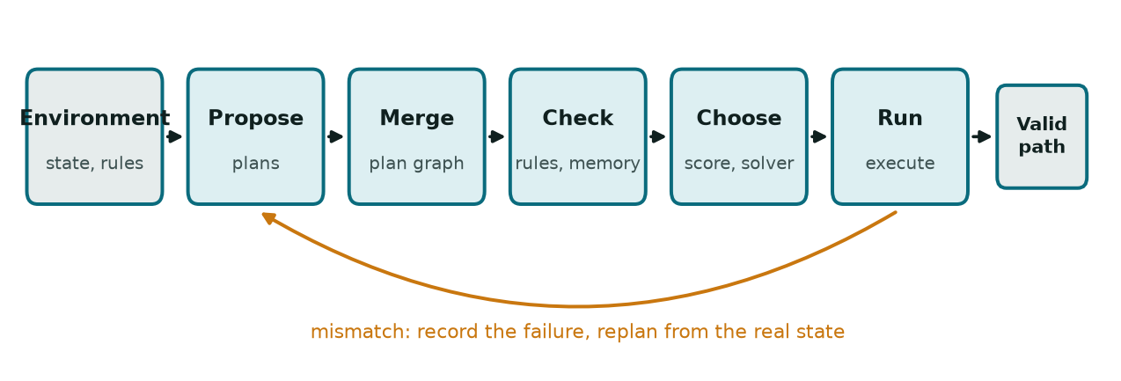
Figure 1. The pipeline. Check (validator and experience memory) and Choose (move score, A* or CP-SAT) are the additions; a mismatch during Run triggers a replan from the real state.

4. Method
All benchmarks implement one interface: ACTIONS, step, is_goal, heuristic, complexity and render. A new game therefore plugs into the pipeline without changing it.

4.1 Move validation
A validator returns, for a move from state s to s', either reject, or accept with a confidence in (0, 1]. A rejected move is never added to the graph, so any candidate plan that uses it ends there. We implemented three validators:
- Sokoban: pushing a box into a corner that is not a goal is rejected (it can never be recovered); a box resting against a wall off a goal is accepted at confidence 0.5.
- River Crossing: a state in which cannibals outnumber missionaries (with at least one missionary present) on either bank is rejected. The environment's step deliberately does not enforce this, so the rule lives only in the validator.
- Rush Hour: a row filled entirely by horizontal vehicles that block the target is rejected; a blocker that is itself stuck is accepted at confidence 0.5.
- Peg Solitaire: a pagoda is a weight w(p) >= 0 per hole with w(a) + w(b) >= w(c) for every jump of a over b into c. A jump removes pegs at a and b and adds one at c, so the total weight of the pegs never rises. A position whose total is below the weight of the goal (one peg in the centre) cannot win and is rejected. We obtain twelve pagodas from a small linear programme (OR-Tools GLOP) and re-check every inequality after solving. A lone peg with no neighbour is accepted at confidence 0.5.
- 24-puzzle: a move is rejected if the resulting arrangement is unsolvable by the inversion-parity rule. Legal moves preserve parity, so this only fires on an unsolvable start.
- Rubik's cube: a state is rejected if it breaks any of the four cubie invariants (every slot holds a real cubie once; corner twists sum to 0 mod 3; edge flips sum to 0 mod 2; corner and edge permutations have equal parity). These are exactly the conditions for a cube to be solvable. Like the parity rule, they only fire on an unsolvable start. The move tables are built from sticker geometry rather than typed in.

4.2 Experience store
A SQLite table records successes and failures per (level, state, move). Confidence is Laplace-smoothed:
confidence = (successes + 1) / (successes + failures + 2)
with no history meaning full trust. It multiplies the validator's confidence. One recorded failure lowers trust from 1.00 to 0.33.

4.3 Move score
Each accepted move receives an integer cost (scaled by 10 for the integer solver):
cost = round(10 × [ 1 + 1.5 × regression + 4.0 × (1 − confidence) + 2.0 × (steps used / budget)² ]), at least 1,
where regression = max(0, h(s') − h(s)) is how much the move increases the game's heuristic distance to the goal. The weights are defaults; Section 6.3 tests whether tuning improves them.

4.4 Adaptive path selection
Path selection is A* (using the same cost) when complexity(state) = 1 (one independently movable piece: a single Sokoban box, the River Crossing boat) and CP-SAT when it exceeds 1 (several boxes or vehicles whose routes can conflict).

4.5 Execution and replanning
The chosen path is executed move by move. On a mismatch the failure is recorded in the experience store and planning restarts from the real state, up to a replan limit.

5. Experimental Setup
Benchmarks. Sokoban (four hand-made levels, from one to three boxes, the hardest with a 29-move optimum); River Crossing (three missionary-cannibal pairs, two-seat boat, 11-move optimum); Rush Hour (a six-move board); three harder games: Peg Solitaire (English board, about 3.6 million reachable positions), the 24-puzzle (about 7.8 x 10^24 states) and the 3x3x3 Rubik's cube (about 4.3 x 10^19 states), each behind the same interface with the validators of Section 4.1; and Boxoban [16]: one file (000.txt) from each difficulty set (unfiltered/valid, medium/valid, hard), 1,000 ten-by-ten levels with four boxes each, 3,000 levels in total.
Proposers (no language model).
- Goal-biased mock: one BFS-optimal plan plus noisy goal-biased walks. Because it always plants a good plan, absolute success rates with it are optimistic (Section 8).
- Adversarial: uniform random moves with no guaranteed good plan.
- Quality proposer: mixes goal-biased and random walks ("guided"), or takes an optimal plan and randomizes each step with probability 1 − quality ("corrupt").
- Weighted A* proposer (Boxoban, Peg Solitaire, 24-puzzle): runs weighted A* under a per-search node budget and returns the plans that finish.
- Meet in the middle (Rubik's cube, 24-puzzle): breadth-first search from the start and from the solved state at once.
- BFS and DFS: plain breadth-first and depth-first search with a node budget, used in Section 6.7.
Metrics. Safe success: the goal is reached and no executed move is rejected by an independent domain auditor, whether or not the configuration used a validator. This matters because plain success hides rule-breaking in games such as River Crossing whose step does not enforce rules. We also report replans per episode, planning time, and (Boxoban) the share of levels solved within a node budget. Intervals are 95% Wilson intervals for proportions; for paired comparisons, mean difference ± standard error over seeds.

6. Results

6.1 Ablation: safety and speed
Five configurations (baseline; +validator; +validator+experience; +adaptive selection; all) were run on six benchmarks, 30 episodes per cell, 15% slip, goal-biased proposer.
River Crossing | Safe success | Goal reached
Baseline (no validator) | 0% | 100%
With validator | 100% | 100%

Planning time per episode (ms) | Always CP-SAT | Adaptive
Sokoban, one box | 51.8 | 7.6
River Crossing | 62.1 | 3.6
Sokoban, two boxes | 99.9 | 96.4
Rush Hour | 36.2 | 36.1

The validator converts unsafe successes into safe ones. Adaptive selection saves time where one piece moves and ties elsewhere, with identical success and action counts. Hard Sokoban stays near 53% in every configuration: none of the extensions changes it.

6.2 Experience store under state-dependent failure
With uniform random slips the store gave no benefit, since there is nothing state-dependent to learn. We therefore made 25% of (state, move) pairs slip with probability 0.7 and compared validator-only against validator plus store, paired over 20 hazard seeds of 30 episodes, 30 candidates per round.
Benchmark | Late-half replans, store minus no store | Success difference
Sokoban, one box | −0.56 ± 0.18 | +5.5 points
River Crossing | −0.54 ± 0.15 | +5.0 points
Rush Hour | −0.17 ± 0.11 | +1.2 points
Sokoban, two boxes | +0.06 ± 0.03 | −0.2 points

The store reduces replans by roughly 14% on two games and does nothing on the others. Our reading, not tested here, is that with more possible routes the candidates rarely contain a detour around a learned hazard, and the store can only reweight edges already in the graph.

6.3 Tuning the score weights
We searched 80 combinations of the three penalty weights (regression {0, 0.75, 1.5, 3}, confidence {0, 2, 4, 8, 16}, budget {0, 1, 2, 4}) on 8 training seeds and re-ran the top three and the defaults on 16 unseen seeds. The objective was replans + 3 × (1 − success) averaged over four benchmarks (lower is better). The best training point (0, 16, 2) had objective 3.906 against 4.219 for the defaults (rank 23 of 80) but was worse on held-out seeds (+0.122 ± 0.111). No candidate beat the defaults by more than one standard error. We keep the defaults; this is a null result, not proof that they are optimal.

6.4 Proposer quality
To see how much the layer helps as proposer quality changes, we compared baseline against the full layer under the state-dependent failure model (10 hazard seeds × 20 episodes, 30 candidates). The "guided" proposer hit a floor (at most 17% success on the easiest non-trivial level, none on the harder ones) and was uninformative. With the "corrupt" proposer, quality 0.5 to 0.95, the extra layers barely change the goal-reach rate on Sokoban and Rush Hour: almost every paired difference is within two standard errors of zero. River Crossing stays at 0% safe success in both arms because this proposer never learns the safety rule, so its optimal plan is the unsafe one and the validator, correctly, rejects it; the validator does cut replans by 2.7 to 3.4 per episode at quality 0.7 and above by rejecting unsafe plans early. A validator filters proposals; it does not create them.

6.5 Boxoban
Solve rate is the share of 1,000 levels per set for which any of the four searches finds a plan within the node budget. Without pruning the search is unaware of dead corners; with the checker it prunes them.
Nodes per search | Unfiltered | Medium | Hard
2,000 | 57% vs 65% | 14% vs 23% | 6% vs 13%
5,000 | 73% vs 82% | 29% vs 45% | 16% vs 29%
10,000 | 84% vs 92% | 46% vs 65% | 27% vs 49%
20,000 | 92% vs 96% | 61% vs 82% | 44% vs 70%
30,000 | 95% vs 98% | 71% vs 88% | 54% vs 82%

Each cell is no pruning vs with checker. The checker wins in all 15 cells, the 95% intervals do not overlap in any of them, and pruning never missed a level that no-pruning solved (0 of 1,000 in every cell). The gain grows with difficulty: at 10,000 nodes it is 8, 19 and 22 points; at 30,000 nodes 3, 17 and 28 points. The checker also expands 20%, 25% and 23% fewer nodes per level at the full budget. Merging plans did not shorten paths: the merged path was shorter than the best single plan on one level in total (by two moves) and longer on 19, 9 and 5 levels across the three sets, because the solver minimizes the Section 4.3 cost, not move count.
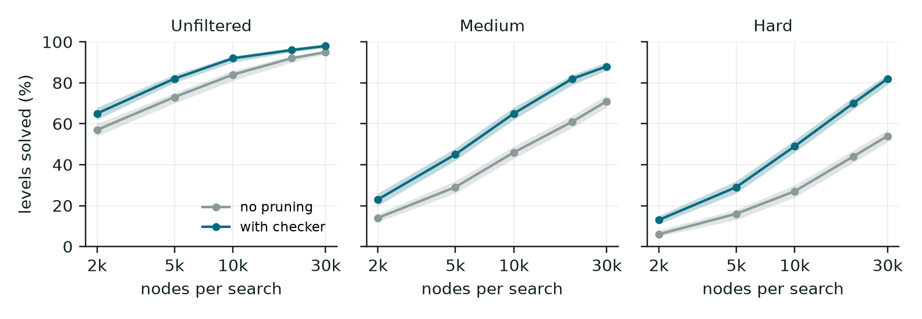
Figure 2. Boxoban: share of 1,000 levels solved against the node budget, without and with the corner checker. Bands are 95% Wilson intervals.

6.6 Harder games
Weighted A* proposes plans for Peg Solitaire and the 24-puzzle, and a meet-in-the-middle search for the cube (60 instances per row, 30 for the cube).
Peg Solitaire is the one game where the checker helps during play. A pagoda is a weight per hole with w(a) + w(b) >= w(c) for every jump, so the total weight of the pegs never rises; a position whose total is below the goal's weight cannot win. We obtain twelve pagodas from a small linear programme and re-check every inequality. A test confirms by exhaustive search that every sampled rejected position is truly unsolvable. From the real start the checker cuts the search from 139,048 to 82,009 nodes (41% fewer). On positions built by playing jumps backwards from the goal, so each is solvable, within 60,000 nodes it solves 98% vs 93% at 22 jumps and 75% vs 58% at 26 jumps, using 19 to 31% fewer nodes, and it never lost a position the plain search solved.
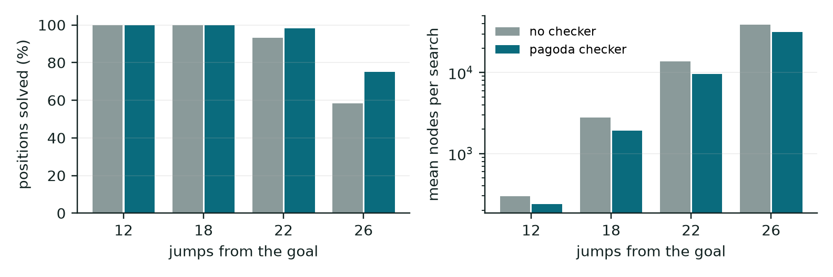
Figure 3. Peg Solitaire on positions built backwards from the goal: share solved (left) and mean nodes per search (right, log scale), without and with the pagoda checker.
24-puzzle and Rubik's cube. The parity rule and the cubie invariants are never broken by a legal move, so they change no result on a solvable start (verified: zero differences). They guard the input: on an unsolvable start (two tiles swapped; one corner twisted) the plain search spends its whole budget (60,000 and 400,000 nodes), and the check stops it after at most one node. Weighted A* solves random-walk scrambles of the 24-puzzle 100%, 95%, 73% and 57% of the time at 20, 40, 60 and 80 moves, and the meet-in-the-middle search solves every cube scramble of 4 to 8 moves.
For these two games the checker is a start gate, not a planning improvement. Scrambles are random walks, easier than uniformly random instances, and the cube is tested only to 8-move scrambles.

6.7 Do other search methods help?
We compared BFS, DFS, weighted A* and meet in the middle on every game each can run on, with no checkers so that only the algorithm differs (budget 100,000 nodes; one instance for the small games, 20 for the rest).
game | instances | BFS | DFS | weighted A* | meet in the middle
River Crossing | 1 | 100%, 28 nodes, 9.0 moves | 100%, 19 nodes, 15.0 moves | 100%, 26 nodes, 9.0 moves | n/a
Rush Hour | 1 | 100%, 20 nodes, 6.0 moves | 100%, 18 nodes, 18.0 moves | 100%, 12 nodes, 6.0 moves | n/a
Sokoban | 1 | 100%, 1,363 nodes, 11.0 moves | 0% | 100%, 107 nodes, 11.0 moves | n/a
Peg Solitaire | 1 | 0% | 100%, 10,845 nodes, 31.0 moves | 0% | n/a
Boxoban (20 levels) | 20 | 45%, 41,347 nodes, 33.8 moves | 55%, 37,835 nodes, 93.4 moves | 55%, 24,368 nodes, 36.5 moves | n/a
Peg Solitaire, 22 jumps out | 20 | 0% | 85%, 23,769 nodes, 22.0 moves | 95%, 20,853 nodes, 22.0 moves | n/a
24-puzzle, 20 move scramble | 20 | 0% | 0% | 100%, 413 nodes, 23.6 moves | 100%, 18,453 nodes, 19.5 moves
24-puzzle, 40 move scramble | 20 | 0% | 0% | 100%, 7,934 nodes, 48.1 moves | 0%
Rubik's cube, 5 move scramble | 20 | 30%, 30,755 nodes, 3.8 moves | 5%, 27,728 nodes, 12.0 moves | 100%, 66 nodes, 4.7 moves | 100%, 3,078 nodes, 4.7 moves
Rubik's cube, 6 move scramble | 20 | 15%, 11,676 nodes, 4.0 moves | 0% | 100%, 392 nodes, 5.5 moves | 100%, 5,544 nodes, 5.5 moves

Each cell is the share solved, then mean nodes and mean plan length over the solved instances.
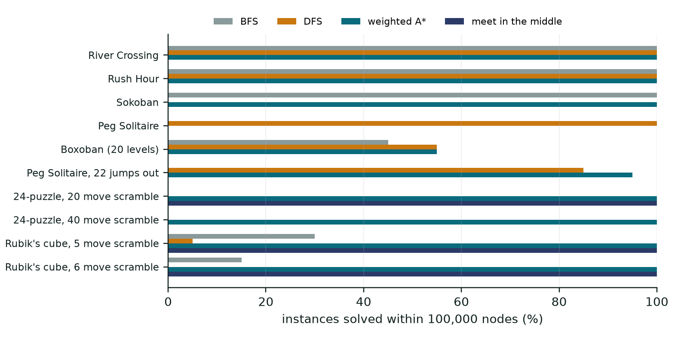
Figure 4. Share of instances solved within 100,000 nodes, by search method.
DFS helps in one game, by a wide margin. Every Peg Solitaire solution is exactly 31 jumps, so a depth-first search that never revisits a state loses nothing. From the real start it needs 10,845 nodes, against 139,048 for weighted A*, while BFS finds nothing in 400,000. With the pagoda checker pruning, DFS needs 6,455. On positions 22 jumps from the goal, weighted A* is slightly better (95% against 85%). BFS helps only where the state space is tiny (River Crossing, Rush Hour) and is the only method that always returns a shortest plan. Weighted A* is the best general choice (sliding puzzle, Boxoban, short cube scrambles); DFS finds Boxoban plans about 2.5 times longer. Meet in the middle guarantees a shortest plan but used more nodes than A* on these short cube scrambles and ran out on the 40-move 24-puzzle.
AO* does not help here. It plans over graphs where an action can have several outcomes. Every game in this work is deterministic, so its graph has no AND nodes and AO* reduces to A*. It could matter for the slip model, where a move sometimes does nothing, but that creates a loop (the slip returns to the same state), for which the relevant algorithm is LAO* [24]. We did not implement it. Node counts are expansions for BFS, DFS and A* and generated states for meet in the middle, so they should be compared loosely.

7. Discussion
The layer's value depends on the proposer. Where the environment allows moves that are physically legal but forbidden by a rule, checking is decisive: River Crossing goes from 0% to 100% safe. Used as a pruner inside a search, the same idea solves substantially more real Boxoban levels within a fixed budget, and more so on harder sets. Adaptive selection is a plain efficiency gain. Failure memory helps only when failures are state-dependent and the candidates contain an alternative. On the harder games the checker is a different tool: for Peg Solitaire it is a proof that prunes during play, and for the 24-puzzle and the cube it is a gate that stops an unsolvable start from consuming the whole search budget. Among search methods no single one dominates: DFS suits fixed-length problems, A* the general case. When the proposer is already competent, the layer does not raise the goal-reach rate; its contribution is safety and fewer wasted replans.

8. Limitations and Threats to Validity
- Synthetic proposers. No language model was used, so results say nothing about real model failures. The goal-biased mock plants a BFS-optimal plan, which inflates absolute success rates in Sections 6.1 and 6.2; the paired comparisons are less affected but should be read in that light.
- Corner pruning is not new. It is standard in Sokoban solvers; Section 6.5 shows our validator works as that pruner on external levels, not that pruning is a contribution.
- Coverage. One file per Boxoban set, one checker rule, and hand-made levels elsewhere. The harder games use random-walk scrambles, and the cube only to 8 moves. Other files and other rules (for example frozen boxes) were not run.
- Not comparable to TAPE. ALFWorld, MuSiQue and GSM8K-Hard require a language model and are out of scope, so our numbers cannot be compared to the original paper's.
- Tuning. The weight search used 8 training seeds, so its ranking is noisy.
- Search comparison. Small instance counts (one for the small games), random-walk scrambles that are easier than uniformly random instances, a cube tested only to 6-move scrambles in that comparison, and non-optimal plans from weighted A*, so fewer nodes can come with longer plans.
- Merging. Merged paths were not shorter than the best single plan, so we make no claim that graph merging improves plan quality in these settings.

9. Conclusion and Future Work
We built a validation and adaptive-selection layer on the TAPE pipeline and evaluated it on seven games without any language model. Rule checking made plans safe and made search solve more real levels; choosing the solver per task saved planning time; failure memory reduced replans when failures depend on the state. Several hoped-for effects did not appear, and we report them. A comparison of search methods found that depth-first search suits Peg Solitaire and weighted A* suits the rest, and that AO* does not apply to deterministic games. Next steps: a learned, non-LLM proposer with realistic errors ([TODO] confirm with the guide whether learned models are allowed), further Boxoban files and a second checker rule, and reformatting for the target venue.

References
[1] J. Jeong, J. Kim, K. Lee, "TAPE: Tool-Guided Adaptive Planning and Constrained Execution in Language Model Agents," arXiv:2602.19633, 2026.
[2] S. Yao, J. Zhao, D. Yu, N. Du, I. Shafran, K. Narasimhan, Y. Cao, "ReAct: Synergizing Reasoning and Acting in Language Models," arXiv:2210.03629, 2022.
[3] S. Yao, D. Yu, J. Zhao, I. Shafran, T. L. Griffiths, Y. Cao, K. Narasimhan, "Tree of Thoughts: Deliberate Problem Solving with Large Language Models," arXiv:2305.10601, 2023.
[4] M. Besta et al., "Graph of Thoughts: Solving Elaborate Problems with Large Language Models," arXiv:2308.09687, 2023.
[5] N. Shinn, F. Cassano, E. Berman, A. Gopinath, K. Narasimhan, S. Yao, "Reflexion: Language Agents with Verbal Reinforcement Learning," arXiv:2303.11366, 2023.
[6] T. Schick et al., "Toolformer: Language Models Can Teach Themselves to Use Tools," arXiv:2302.04761, 2023.
[7] J. Wei et al., "Chain-of-Thought Prompting Elicits Reasoning in Large Language Models," arXiv:2201.11903, 2022.
[8] L. Wang et al., "Plan-and-Solve Prompting: Improving Zero-Shot Chain-of-Thought Reasoning by Large Language Models," arXiv:2305.04091, 2023.
[9] B. Xu et al., "ReWOO: Decoupling Reasoning from Observations for Efficient Augmented Language Models," arXiv:2305.18323, 2023.
[10] M. Shridhar et al., "ALFWorld: Aligning Text and Embodied Environments for Interactive Learning," arXiv:2010.03768, 2020.
[11] H. Trivedi, N. Balasubramanian, T. Khot, A. Sabharwal, "MuSiQue: Multihop Questions via Single-hop Question Composition," arXiv:2108.00573, 2021.
[12] K. Cobbe et al., "Training Verifiers to Solve Math Word Problems," arXiv:2110.14168, 2021.
[13] P. E. Hart, N. J. Nilsson, B. Raphael, "A Formal Basis for the Heuristic Determination of Minimum Cost Paths," IEEE Trans. Systems Science and Cybernetics, 1968.
[14] J. Culberson, "Sokoban is PSPACE-complete," Technical Report TR97-02, University of Alberta, 1997.
[15] G. W. Flake, E. B. Baum, "Rush Hour is PSPACE-complete, or 'Why you should generously tip parking lot attendants'," Theoretical Computer Science 270(1-2):895-911, 2002.
[16] DeepMind, "Boxoban levels," https://github.com/google-deepmind/boxoban-levels.
[17] L. Perron, V. Furnon, "OR-Tools," Google, https://developers.google.com/optimization.
[18] I. Pohl, "Heuristic search viewed as path finding in a graph," Artificial Intelligence 1(3-4):193-204, 1970.
[19] R. E. Korf, "Depth-first iterative-deepening: an optimal admissible tree search," Artificial Intelligence 27(1):97-109, 1985.
[20] R. E. Korf, "Finding optimal solutions to Rubik's Cube using pattern databases," Proc. AAAI-97, pp. 700-705, 1997.
[21] T. Rokicki, H. Kociemba, M. Davidson, J. Dethridge, "The diameter of the Rubik's Cube group is twenty," SIAM Journal on Discrete Mathematics 27(2):1082-1105, 2013.
[22] J. D. Beasley, "The Ins and Outs of Peg Solitaire," Oxford University Press, 1985.
[23] E. R. Berlekamp, J. H. Conway, R. K. Guy, "Winning Ways for your Mathematical Plays," Academic Press, 1982.
[24] E. A. Hansen, S. Zilberstein, "LAO*: A heuristic search algorithm that finds solutions with loops," Artificial Intelligence 129(1-2):35-62, 2001.
[TODO] References [18], [19], [21] and [24] were checked against Crossref. [20], [22] and [23] were not independently checked: confirm their details. Confirm publication details for [13] (volume and pages) and add the software version for [17] before submission. Verify against [1] how GSM8K-Hard relates to GSM8K [12], and cite the GSM8K-Hard source directly if [1] does.

Appendix: reproducing the results
python -m pytest tests/ -q # 90 tests
python experiments/run_ablation.py --episodes 30 # Section 6.1 -> results/ablation.md
python experiments/run_experience_test.py --runs 20 --episodes 30 # 6.2 -> results/experience_test.md
python experiments/tune_weights.py # 6.3 -> results/weight_tuning.md
python experiments/run_proposer_sweep.py corrupt # 6.4 -> results/proposer_sweep_corrupt.md
python experiments/run_boxoban.py --levels 1000 --workers 12 --file data/boxoban/hard_000.txt --out boxoban_hard.md # 6.5
python experiments/run_hard_games.py --n 60 # 6.6 -> results/hard_games.md
python experiments/compare_search.py --budget 100000 # 6.7 -> results/search_methods.md
python paper/make_figures.py # figures -> paper/figures/
python paper/build_paper_docx.py # Word version -> paper/paper.docx
Code and data: https://github.com/Harsh-v69/MachineLearningCP

