COMPARATIVE ANALYSIS OF WIRELESS SIGNAL PROPAGATION MODELS
(FREE SPACE, OKUMURA AND HATA) USING MATLAB
A Case Study Mini-Project Submitted for the Course
21CSE458T — WIRELESS AND MOBILE COMMUNICATION
B.Tech Computer Science and Engineering (7th Semester)

SUBMITTED BY:
Harsh Yadav (Registration No: RA2311003011546)
Utkarsh Dabas (Registration No: RA2311003011550)
Tamanna Singh (Registration No: RA2311003011570)
Department of Computer Science and Engineering
Academic Year 2025–2026

ABSTRACT
Accurate modeling and prediction of radio signal propagation are fundamental to designing, dimensioning, and optimizing cellular wireless networks. In real-world environments, transmitted electromagnetic waves undergo distance-dependent attenuation, reflection, diffraction, and clutter absorption, collectively known as path loss. This mini-project conducts a rigorous computational and comparative case study evaluating three seminal wireless signal propagation models: the Free Space Path Loss (FSPL) model, the Okumura Model, and the Okumura-Hata Urban Model. Numerical simulations were executed over a distance range of 1 km to 20 km at a standard carrier frequency of 900 MHz (typical GSM/LTE cellular band), with a base station antenna height of 30 m and a mobile station height of 1.5 m. The simulation findings demonstrate that while the Free Space model predicts an overly optimistic path loss varying from 91.52 dB to 117.55 dB, the Hata Urban model accounts for severe structural clutter, predicting a realistic path loss ranging from 126.40 dB to 172.23 dB. The Okumura open-area model yields an intermediate path loss of 97.90 dB to 143.73 dB. This report details the mathematical formulations, numerical implementation in Python and MATLAB, comparative analysis, and practical engineering guidelines for cellular network planning.

1. INTRODUCTION
In wireless communications, signal propagation occurs through the Earth's atmosphere and built environments. As an electromagnetic wave radiates from a base station tower toward a user's mobile device, its power density decays significantly as a function of separation distance. This reduction in signal power density between transmitter and receiver is defined as Path Loss (PL).
Why Propagation Models Matter:
1. Network Dimensioning: Wireless telecommunication operators cannot perform costly, exhaustive physical drive-test measurements for every potential tower location. Reliable mathematical propagation models allow engineers to predict coverage footprints computationally.
2. Link Budget Design: Radio link budgets depend critically on path loss calculations to allocate appropriate transmit power, determine antenna gains, and establish receiver sensitivity thresholds.
3. Interference Management: Accurate loss prediction ensures adjacent cellular base stations provide continuous handovers without producing intolerable co-channel interference.

2. THEORETICAL BACKGROUND & MATHEMATICAL MODELS

2.1 Free Space Path Loss (Friis) Model
The Free Space Path Loss model represents an idealized theoretical propagation channel where the transmitter and receiver maintain an unobstructed Line-of-Sight (LOS) in an infinite, lossless dielectric medium. It assumes zero ground reflection, no atmospheric absorption, and no terrain obstacles. The received power is governed by the Friis transmission formula.
Mathematical Equation (in dB):
L_FSPL (dB) = 20 * log10(d) + 20 * log10(f) + 32.44
Where:
• d: Distance between transmitter and receiver in kilometers (km)
• f: Carrier frequency in Megahertz (MHz)
• 32.44: Wavelength constant derived from 20 * log10(4 * pi / c) with units in km and MHz.

2.2 Okumura Model
The Okumura model is one of the most widely cited classical empirical models for cellular radio propagation. Developed by Yoshihisa Okumura in 1968, it is based on extensive field measurements conducted in Tokyo, Japan, across frequencies from 150 MHz to 1920 MHz and distances from 1 km to 100 km. It incorporates empirical correction factors for base station antenna height, mobile antenna height, and terrain clutter.
Mathematical Formulation:
L (dB) = L_FSL + A_mu(f, d) - G(h_te) - G(h_re) - G_area
For an open/rural area, standard empirical formulations apply a terrain correction factor relative to urban baseline:
Correction (dB) = -4.78 * (log10(f))^2 + 18.33 * log10(f) - 40.94
L_Okumura = L_Hata_Urban + Correction

2.3 Okumura-Hata Urban Model
Although the Okumura model provided high real-world accuracy, its reliance on graphical charts made automated simulation cumbersome. In 1980, Masaharu Hata formulated closed-form parametric equations that fitted Okumura's graphical curves. The Hata model is valid for carrier frequencies from 150 MHz to 1500 MHz, tower heights from 30 m to 200 m, mobile heights from 1 m to 10 m, and distances from 1 km to 20 km.
Mathematical Formulation (Urban Medium/Small City):
a(h_re) = (1.1 * log10(f) - 0.7) * h_re - (1.56 * log10(f) - 0.8)
L_Hata (dB) = 69.55 + 26.16 * log10(f) - 13.82 * log10(h_te) - a(h_re) + [44.9 - 6.55 * log10(h_te)] * log10(d)
Where:
• f: Frequency in MHz (900 MHz)
• h_te: Base station antenna height in meters (30 m)
• h_re: Mobile station antenna height in meters (1.5 m)
• a(h_re): Mobile antenna height correction factor (dB)
• d: Link distance in kilometers (1 to 20 km)

3. SIMULATION METHODOLOGY & PARAMETERS
The comparative simulation study was performed programmatically using Python (NumPy and Matplotlib) and MATLAB. The simulation workflow followed four structured steps:
1. Parameter Initialization: Defined carrier frequency f = 900 MHz, tower antenna height h_te = 30 m, mobile antenna height h_re = 1.5 m, and link distance vector d ranging discretely from 1 km to 20 km in steps of 1 km.
2. Path Loss Computation: Concurrently computed path loss vectors for Free Space, Okumura (open area), and Hata Urban models.
3. Tabular Evaluation: Printed discrete readings at benchmark points (1 km, 5 km, 10 km, 15 km, 20 km).
4. Graphical Rendering: Generated comparative plots on a unified coordinate frame with clear legends, gridlines, and markers.
Parameter Name | Symbol & Units | Assigned Value
Carrier Frequency | f (MHz) | 900 MHz
Base Station Tower Height | h_te (m) | 30 meters
Mobile Station Antenna Height | h_re (m) | 1.5 meters
Distance Range | d (km) | 1 km to 20 km (step 1 km)

4. SIMULATION RESULTS
The numerical outputs computed across the 1 km to 20 km distance vector are tabulated below. The graph illustrating the three comparative attenuation curves is embedded in Figure 1.

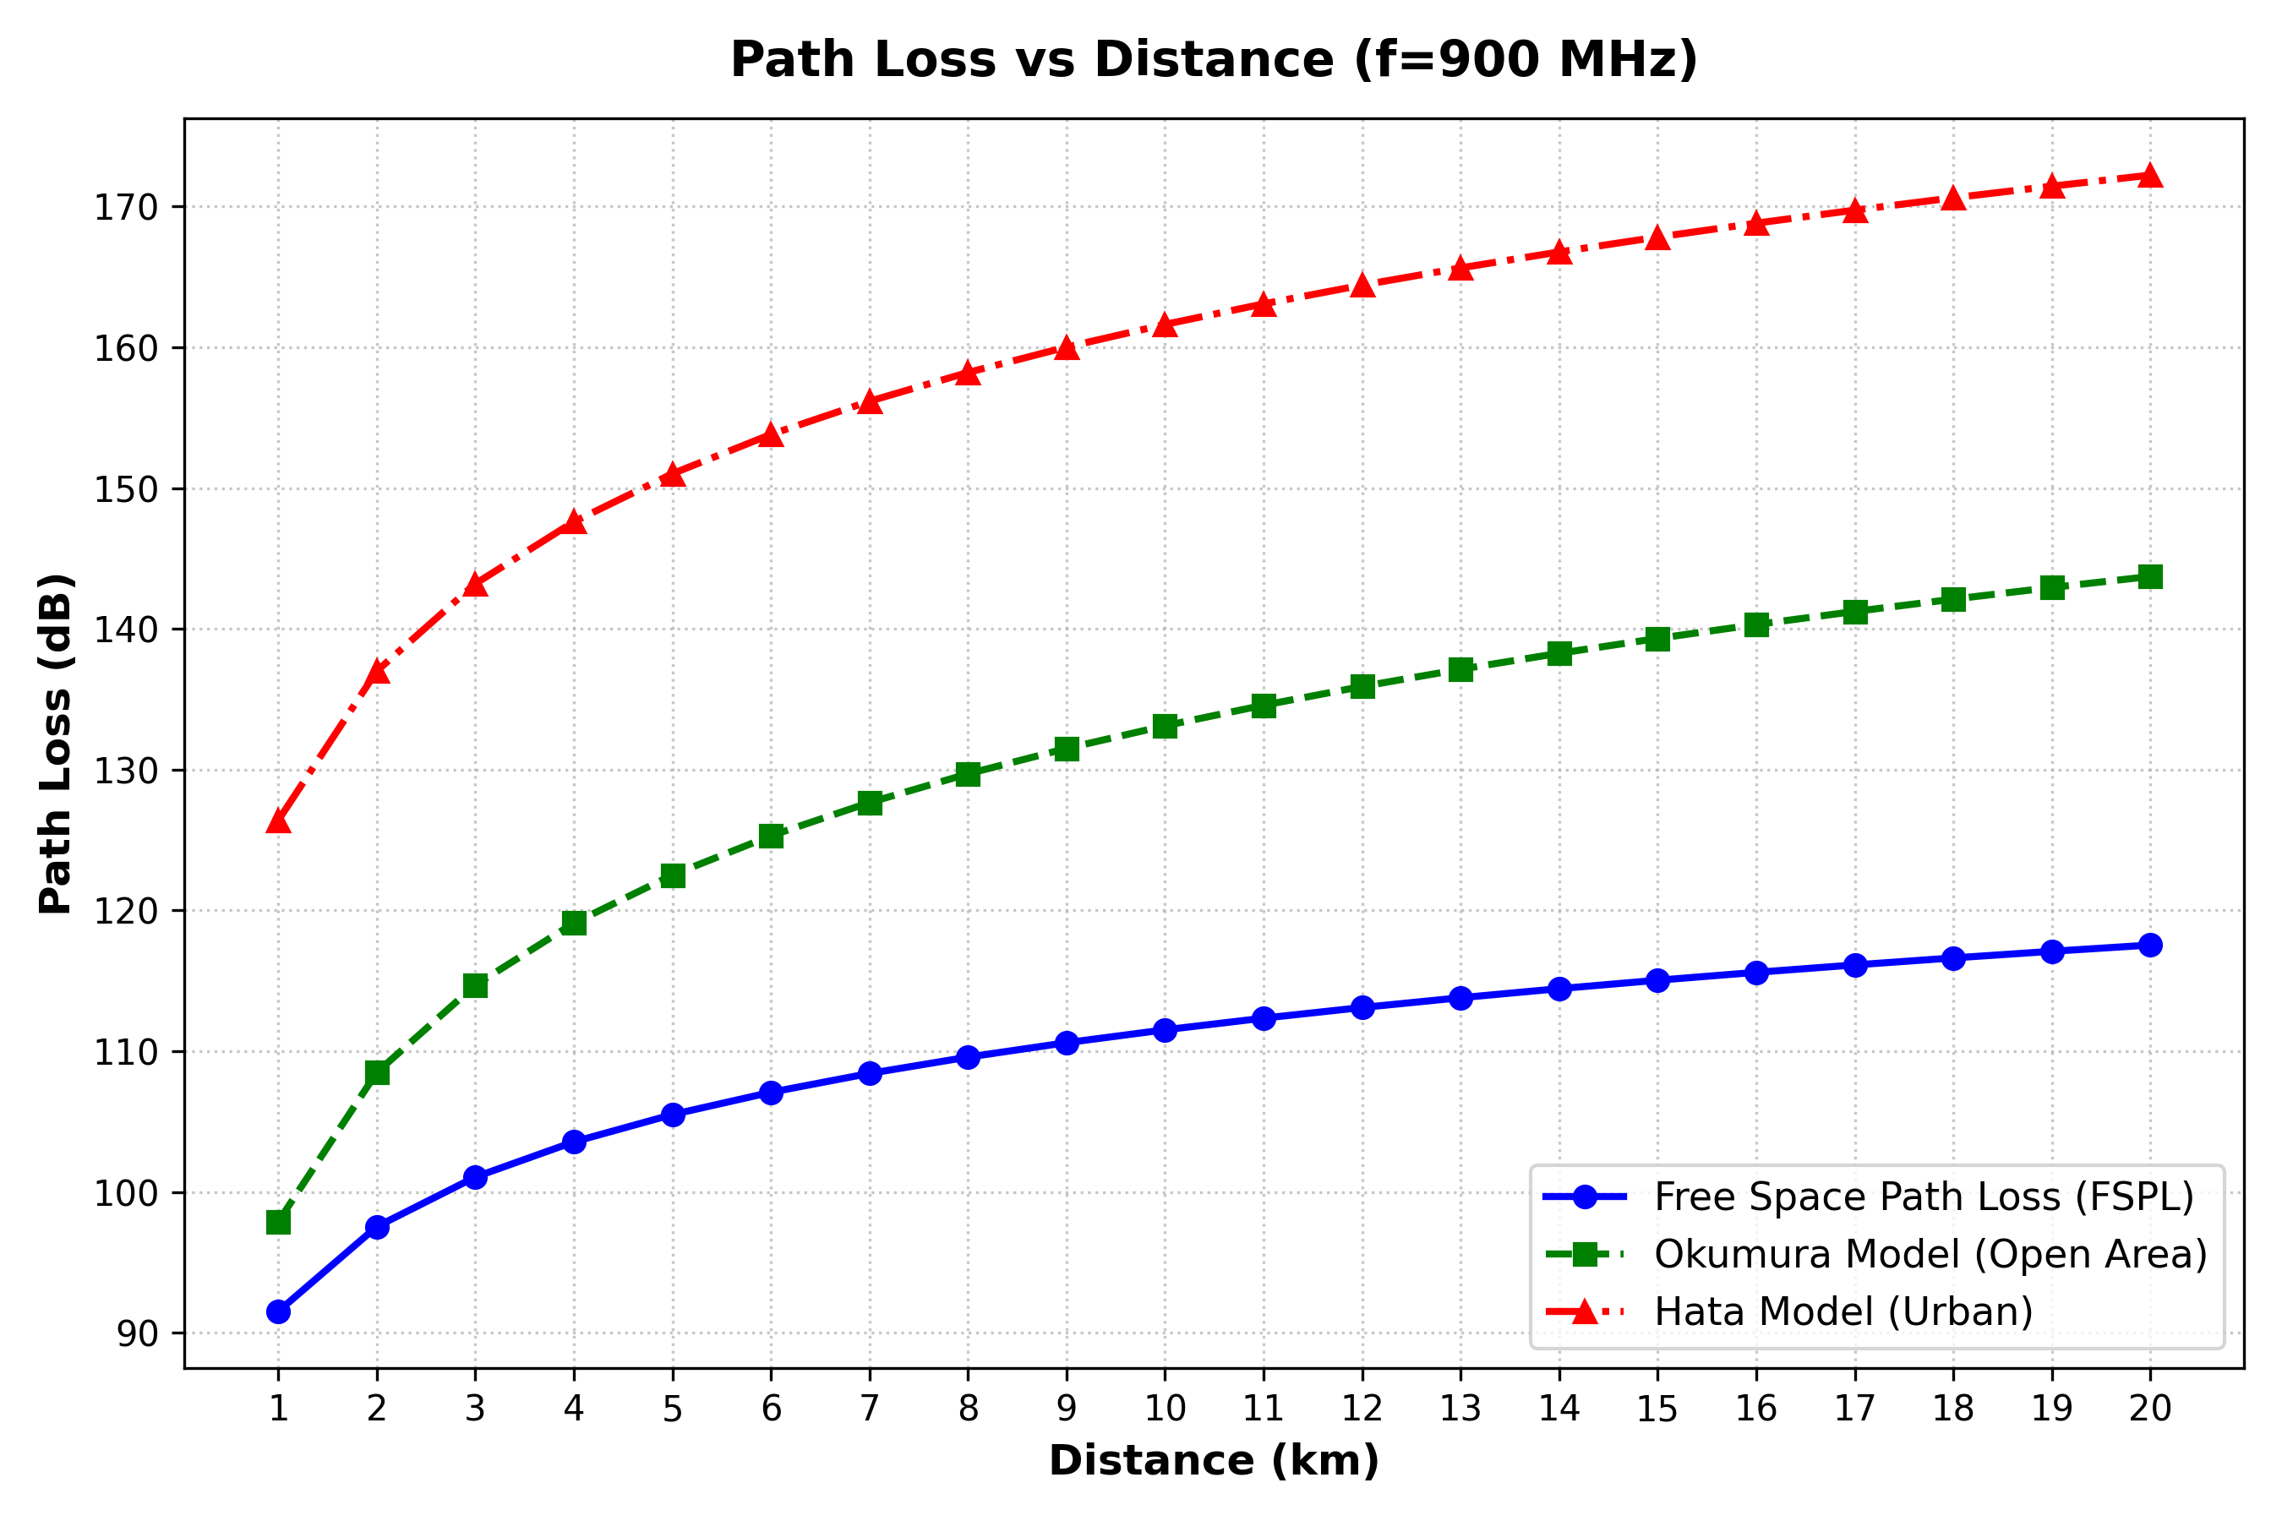
Figure 1: Comparative Plot of Path Loss vs Distance for Free Space, Okumura, and Hata Models (f = 900 MHz).

Numerical Readings Table (1 km to 20 km)
Distance (km) | Free Space (dB) | Okumura (dB) | Hata Urban (dB)
1 km (Cell Center) | 91.52 dB | 97.90 dB | 126.40 dB
3 km | 101.07 dB | 114.70 dB | 143.21 dB
5 km | 105.50 dB | 122.52 dB | 151.02 dB
10 km | 111.52 dB | 133.12 dB | 161.63 dB
15 km | 115.05 dB | 139.32 dB | 167.83 dB
18 km | 116.63 dB | 142.11 dB | 170.62 dB
20 km (Cell Edge) | 117.55 dB | 143.73 dB | 172.23 dB

5. COMPARATIVE ANALYSIS & CONCLUSION
Analysis of Simulation Findings:
1. Free Space Path Loss (Optimistic Baseline): Free Space yields the absolute lowest path loss across all distances (91.52 dB at 1 km and 117.55 dB at 20 km). It assumes an impossible vacuum without ground multipath or building absorption. Consequently, relying on Free Space for cellular planning would drastically underestimate required transmit power.
2. Okumura Model (Open Area Benchmark): The Okumura open-area curve predicts 97.90 dB at 1 km and 143.73 dB at 20 km. It provides approximately 6 to 26 dB higher loss than Free Space due to atmospheric and terrain ground reflection.
3. Hata Urban Model (Realistic Planning Standard): The Hata urban model predicts the highest loss (126.40 dB at 1 km and 172.23 dB at 20 km). At 20 km, Hata predicts 54.68 dB more attenuation than Free Space. This significant excess loss accurately captures the real-world impact of urban clutter, multi-building diffraction, and street canyon absorption.
Conclusion: For practical cellular radio network engineering, the Okumura-Hata Urban model is the most dependable and realistic design standard, whereas Free Space serves strictly as an unattainable theoretical baseline.

6. FUTURE SCOPE
Possible future extensions to this case study include:
• High-Frequency Sub-6 GHz and mmWave Models: Evaluating 3GPP TR 38.901 channel models for 5G NR (3.5 GHz and 28 GHz).
• 3D Ray-Tracing Simulation: Incorporating GIS building polygons and Digital Elevation Models (DEM) using tools like Wireless InSite.
• Machine Learning Integration: Training neural network regressors on actual drive-test measurements to dynamically adjust empirical path loss exponents.

7. REFERENCES
[1] T. S. Rappaport, Wireless Communications: Principles and Practice, 2nd ed. Upper Saddle River, NJ: Prentice Hall, 2002.
[2] Y. Okumura, E. Ohmori, T. Kawano, and K. Fukuda, "Field strength and its variability in VHF and UHF land-mobile radio service," Review of the Electrical Communication Laboratory, vol. 16, no. 9-10, pp. 825–873, Sep.–Oct. 1968.
[3] M. Hata, "Empirical formula for propagation loss in land mobile radio services," IEEE Transactions on Vehicular Technology, vol. VT-29, no. 3, pp. 317–325, Aug. 1980.
[4] A. Goldsmith, Wireless Communications. Cambridge, UK: Cambridge University Press, 2005.

