TECHNICAL CASE STUDY DOCUMENT
Comparative Analysis of Wireless Signal Propagation Models
for Urban Macrocellular Network Planning
A Simulation-Based Engineering Case Study Using MATLAB, Python (FastAPI), and React
Course: Wireless and Mobile Communication | B.Tech Computer Science & Engineering
Team Member | Registration Number | Primary Case Study Role
Harsh Yadav | RA2311003011546 | Mathematical Modeling, Python Engine & Backend API
Utkarsh Dabas | RA2311003011550 | MATLAB Simulation, Sensitivity Sweeps & Validation
Tamanna Singh | RA2311003011570 | UI/UX Architecture, Link Budget & Comparative Analysis

1. Executive Summary & Case Study Scenario
Modern cellular operators designing 4G LTE and 5G networks face a critical RF planning challenge: predicting how fast radio frequency signals attenuate between a macrocell base station tower and mobile subscribers across heterogeneous terrain. Selecting an overly optimistic theoretical model causes severe urban dead zones and dropped calls, while overestimating loss leads to excessive base station deployments and inflated capital expenditure (CAPEX).
Case Scenario Evaluated: A telecommunications provider is deploying a 900 MHz macrocellular tower (antenna height h_te = 30 m, transmit power Pt = 43 dBm = 20 W, directional sector gain Gt = 15 dBi) serving handheld mobile devices (h_re = 1.5 m, receiver sensitivity threshold -100 dBm) across a 1 km to 20 km service radius. This case study quantitatively evaluates how theoretical, empirical, and stochastic propagation models diverge under identical RF conditions.

2. Propagation Models Evaluated
Seven core propagation models were implemented in modular Python and MATLAB engines and exposed through the interactive WavePulse RF web application:
- Free Space Path Loss (FSPL): Friis inverse-square law baseline assuming unobstructed Line-of-Sight (PL = 20 log10(d) + 20 log10(f) + 32.44). Path loss exponent n = 2.0 (20 dB/decade).
- Okumura Model (Tokyo Empirical, 1968): Derived from drive-test measurements in Tokyo; evaluated for open-area terrain via the empirical frequency correction (-4.78*(log10(f))^2 + 18.33*log10(f) - 40.94).
- Okumura-Hata Urban Model (1980): Closed-form analytical macrocell equation incorporating urban rooftop diffraction, street clutter, base station height (30-200 m), and mobile height correction a(h_re).
- COST-231 Hata Extension: Extends Hata urban/suburban modeling to 1500-2000 MHz PCS and LTE frequency bands.
- Two-Ray Ground Reflection Model: Captures interference between the direct LOS ray and ground-reflected wave, transitioning to 40 dB/decade decay beyond the Fresnel crossover distance.
- Log-Distance & Log-Normal Shadowing: Introduces environment-tunable exponent n and zero-mean Gaussian shadowing X_sigma (dB) to predict cell-edge outage probability.

3. System Architecture & Simulation Pipeline
To guarantee cross-platform reproducibility, all computations were validated across three synchronized layers:
1. Core Scientific Package (src/propagation/): Independent Python modules validated by 32 automated pytest assertions.
2. MATLAB Benchmark Scripts (path_loss_simulation.m & path_loss_animation.m): Native matrix implementation printing formatted tables and animated curve trajectories.
3. Full-Stack Web Studio (backend/ FastAPI + frontend/ React & Tailwind): Live REST endpoints powering real-time Recharts path loss plots, HTML5 electromagnetic wavefront motion graphics, and interactive link budget calculators.

4. Case Study Quantitative Findings (f = 900 MHz)
Table 1 summarizes exact numerical path loss predictions across 1 km to 20 km for the three primary macrocell benchmark models (Free Space, Okumura Open Area, and Hata Urban).
Distance (km) | Free Space (dB) | Okumura Open (dB) | Hata Urban (dB) | Reality Gap (Hata - FSPL)
1 km | 91.52 dB | 97.90 dB | 126.40 dB | +34.88 dB
2 km | 97.55 dB | 108.50 dB | 137.01 dB | +39.46 dB
5 km | 105.50 dB | 122.52 dB | 151.02 dB | +45.52 dB
10 km | 111.52 dB | 133.12 dB | 161.63 dB | +50.11 dB
15 km | 115.05 dB | 139.32 dB | 167.83 dB | +52.78 dB
18 km | 116.63 dB | 142.11 dB | 170.62 dB | +53.99 dB
20 km | 117.55 dB | 143.73 dB | 172.23 dB | +54.68 dB

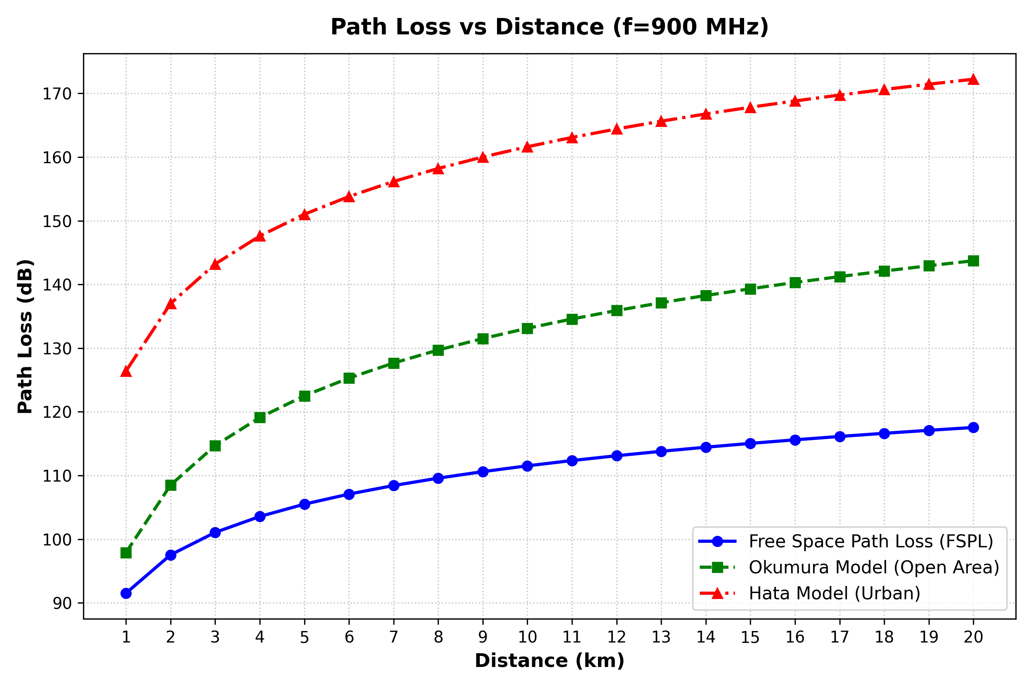
Figure 1: Path Loss vs Distance (f = 900 MHz, h_te = 30 m, h_re = 1.5 m) comparing Free Space, Okumura, and Hata Urban.

5. Case Study Analysis & RF Design Conclusions
1. Free Space Represents a Strict Lower Bound: With 91.52 dB at 1 km and 117.55 dB at 20 km, Free Space assumes a vacuum with zero obstacles. Using it for urban cell sizing leads to catastrophic coverage holes.
2. Dramatic 54.68 dB Urban Clutter Penalty: At the 20 km boundary, Hata Urban predicts 172.23 dB — 54.68 dB higher attenuation than Free Space (nearly 294,000x weaker linear received power).
3. Link Budget Coverage Impact: For our scenario (EIRP = 58 dBm, Rx sensitivity = -100 dBm, Lsys = 3 dB), Maximum Allowable Path Loss is 155 dB. Free Space falsely predicts > 20 km coverage, whereas Hata Urban reveals actual reliable urban coverage drops below threshold around ~6.5 km.
4. Recommendation: Urban and suburban macrocell RF planning must rely on Hata / COST-231 Hata models paired with a Log-Normal Shadowing fade margin (typically >= 11.8 dB for 95% reliability at sigma = 6 dB).

6. Academic References
[1] T. S. Rappaport, Wireless Communications: Principles and Practice, 2nd ed. Prentice Hall, 2002.
[2] Y. Okumura et al., 'Field strength and its variability in VHF and UHF land-mobile radio service,' Rev. Elec. Commun. Lab., vol. 16, pp. 825-873, 1968.
[3] M. Hata, 'Empirical formula for propagation loss in land mobile radio services,' IEEE Trans. Veh. Technol., vol. VT-29, no. 3, pp. 317-325, Aug. 1980.

