

Game Programming

Game Design Document

Game: Creature Chronicles

Submitted To:

Mr. Pankaj Badoni

Submitted By:

Manas Vig Harsh Singh

500102153 500101783

B.Tech. CSE B.Tech. CSE

2nd year, Batch 1 2nd year, Batch 1



**Game Design Document:**

**"Creature Chronicles"**

1. **Overview**
   1. **Concept:**

"Creature Chronicles" is a 3D turn based strategy game that draws inspiration from the universe of Pokemon. Players control a fierce beast running through challenging landscapes filled with enemies and obstacles.

* 1. **Genre:** 3D Turn Based Strategy Game
  2. **Platform:** PC
  3. **Game Elements:** Turn Based Fighting, Free roam, AI Coded Enemies
  4. **No of Players:** Single Player

1. **Gameplay:**

Creature Chronicles offers a third-person perspective, focusing on the protagonist Griffin. The player guides Griffin around the city confronting enemies. W, A, S, D for player movement and mouse click to select attacks during turn based combat. The objective is to defeat as many creatures as possible.

If Griffin encounters a beast in the wild or if Griffin approaches a beast voluntarily, scene changes and Griffin goes into combat mode. Upon losing all health, player loses the game and all the progress he/she makes.

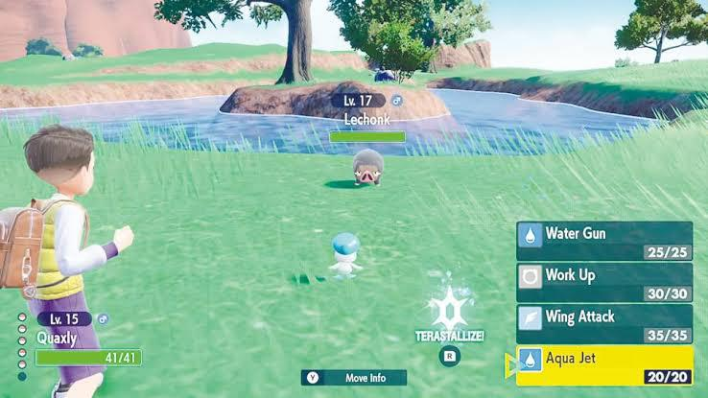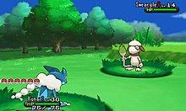

* 1. **Core Gameplay Mechanics:**
     1. **Character Control:**
        + W, A, S, D for player movement
        + Mouse Click to select attacks during turn based combat
     2. **Combat:**
        + Click on the attack button to attack enemies during your turn.
        + Enemy’s health will decrease, after the player attacks, and will eventually reach zero.
     3. **World:**
* A city with different beasts spread all over it.

**2.2 Objectives:**

* Engage in combats to level up.
* Defeat enemies for more health and strength to fight bigger enemies.

**2.3 Progression System:**

* Defeat enemies to level up

1. **Characters:**
   1. **Protagonist:**
      * Name: Griffin
      * Description: A vicious beast capable of defeating other beasts.
      * Abilities: 3 types of moves; Heal, Standard Attack and Super Attack.
   2. **Enemies:**
      * Different types inspired by the Pokemon universe.
      * Varied attack patterns and moves.
2. **Environments:**
   1. **Settings:**
      * City landscapes inspired by Pokemon.
      * Locations: City, Park.

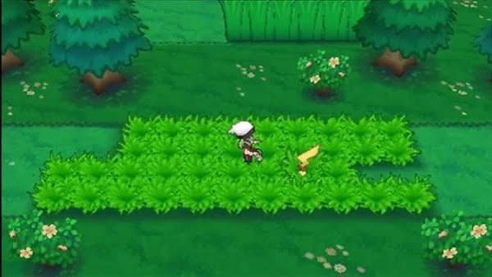

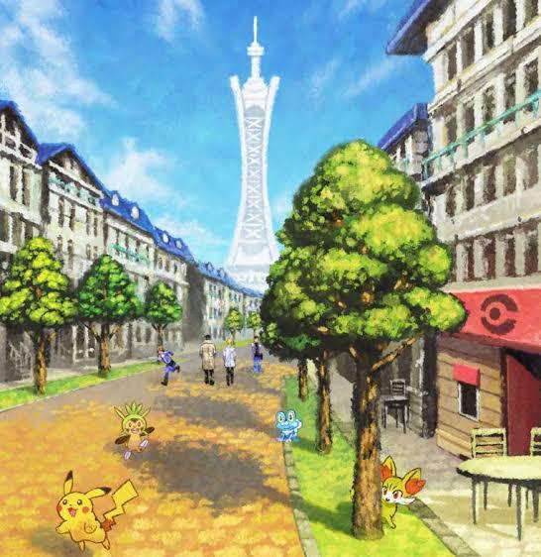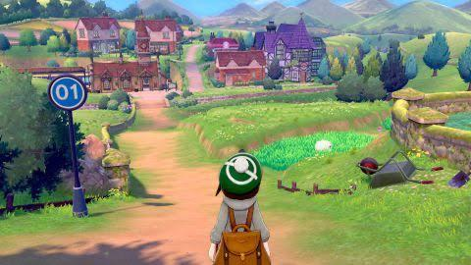

* 1. **Obstacles:**
     + Random Enemies inside the park and around the city.

1. **Art and Sound:**

Creature Chronicle’s appearance appeals to a very broad audience (children to adults). The graphic style draws inspiration from the popular anime Pokemon universe.

* 1. **Sound:**
     + Intense battle music during combat.
     + Atmospheric and city sounds to enhance the urban setting.
     + All assets are royalty-free or appropriately credited. Segments include:
       - Background music

o Enemy Attack Sounds

o UI sound effects

o Levelling Up (unique sounds)

A disclaimer accompanies the game documents, crediting music and sounds in the game's credits if applicable.

1. **Technical Considerations:**

The game will be made with the help of UNITY Engine and we will be importing characters and their animation from Miaxmo, and assets will be used from Unity Asset Store.

* 1. **Platforms:**
     + PC
  2. **Languages Used:**
     + C#
  3. **Technical From:**
     + 3D graphics • 3rd person view

1. **Marketing:**
   1. **Target Audience:**
      * Fans of the Pokemon series
      * Children and Adults
2. **Main Menu:**

* The main menu will have a 3D landscape of the game with a “Play” and “Quit” button.
* The combat scene change will have an option to either run away or fight the beast.
* The end menu will have an option to either play again or quit the game.

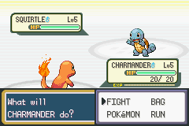

**9.Team Contributions:**

* **Manas Vig: Level Design, Movement and Behaviour Coding, Animations**
* **Harsh Singh: UI Design, Combat System Coding**