**EXPERIMENT N0-6**

**COMPLEX QUERIES BASED ON HR SCHEMA**

**1: Find mean of employees working in IT department**

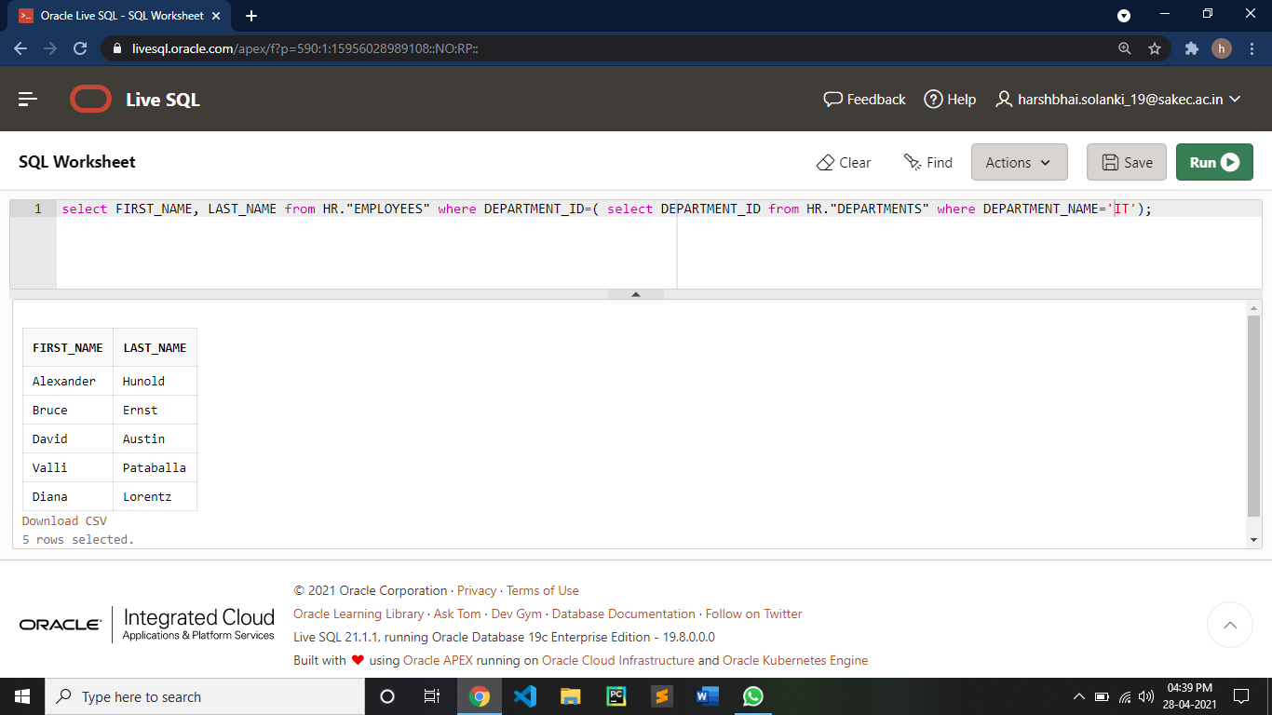

**2: Find the department located in tokyo**

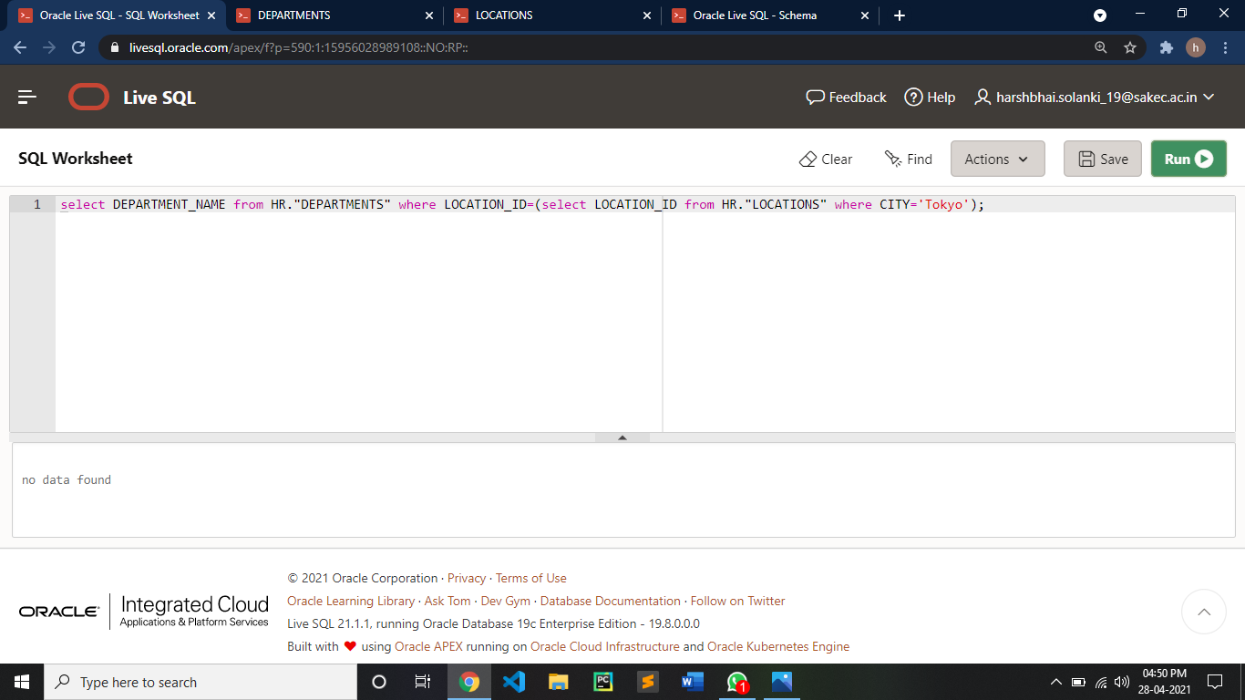

**3: Find the avg salary of employees of each department**

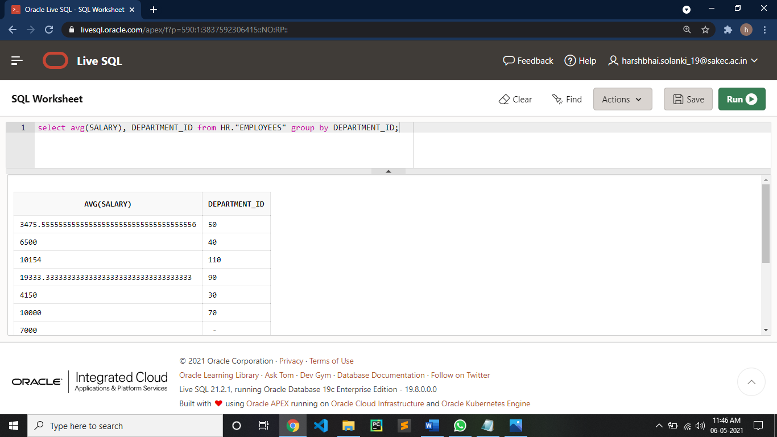

**4: Find the first name of employees whose name start with ‘s’**

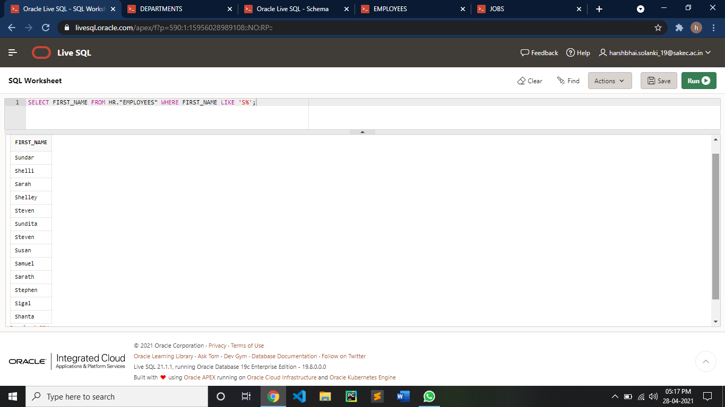

**5: find the manager of IT department**

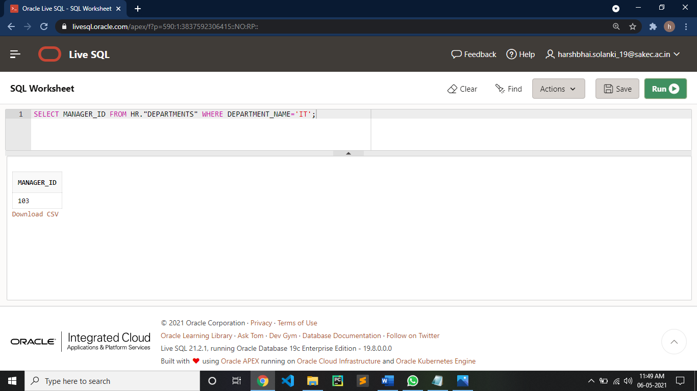

**6: Find the number of employees working in ADMINISTARION department and have salary garter than 20000**

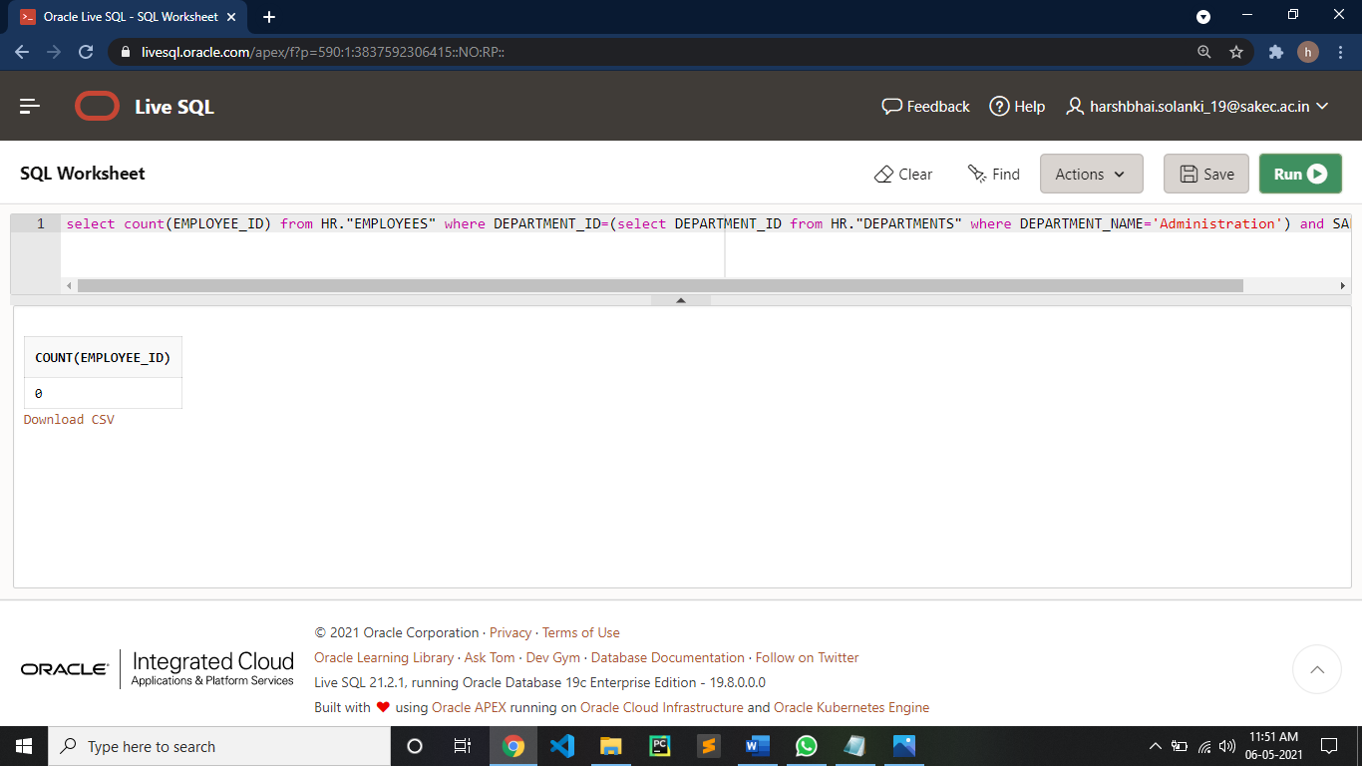

**7: Find the maximum salary given for job title programmer**

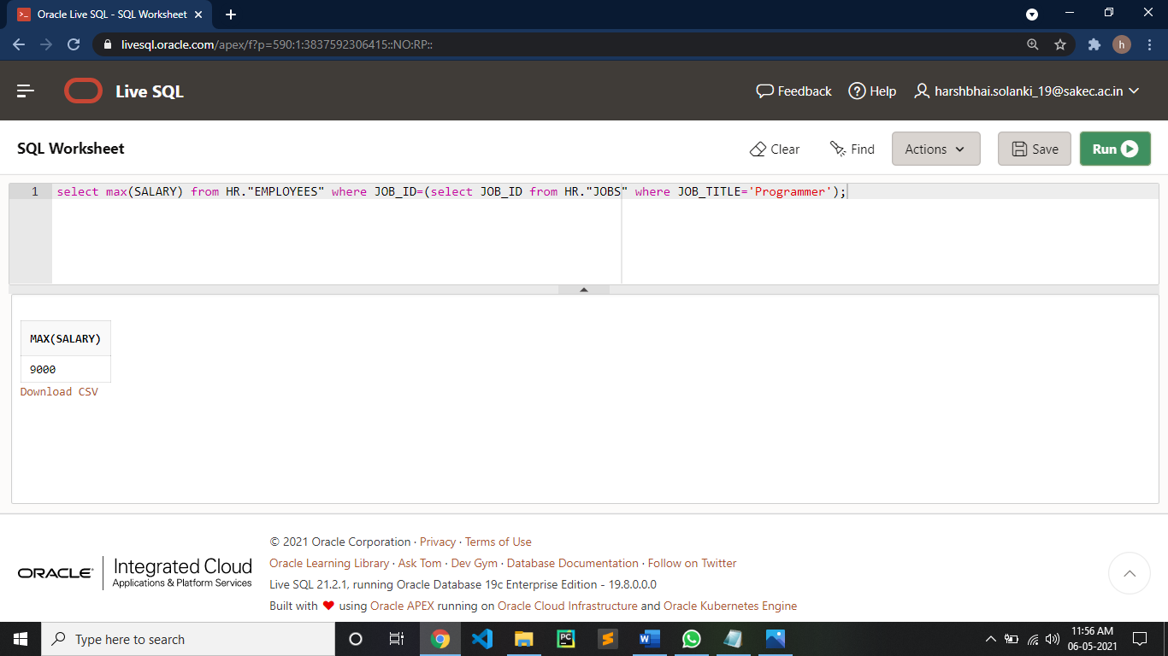

**8: List all the jobs in ascending order of job id**

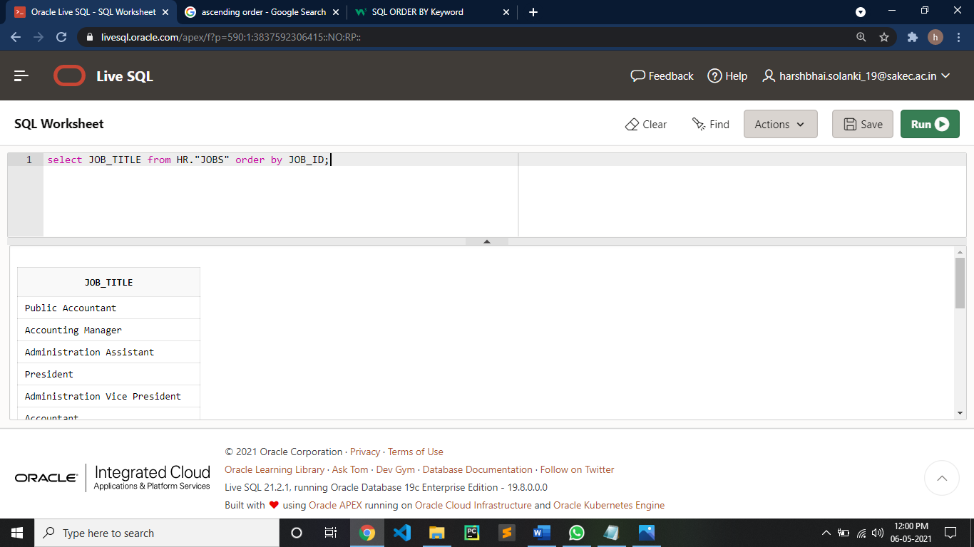

**9: Find the maximum salary of each department** 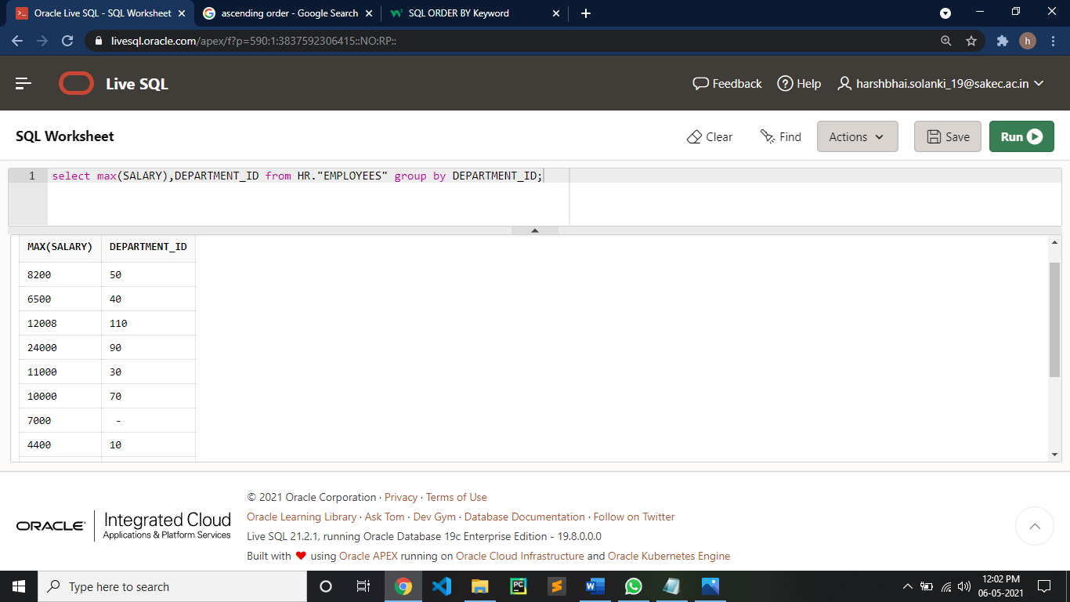

**10: Display all countries in EURPOE region**

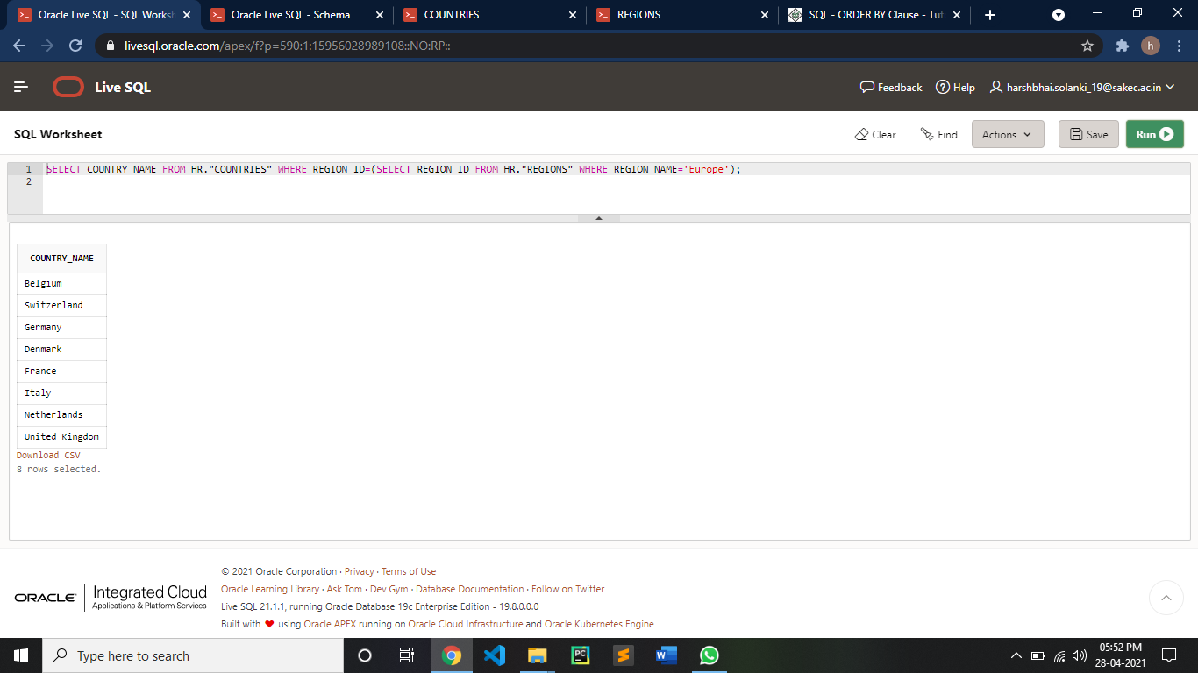

**11: Find member address, member email, receipt id reserved gym on 10th April 2021**

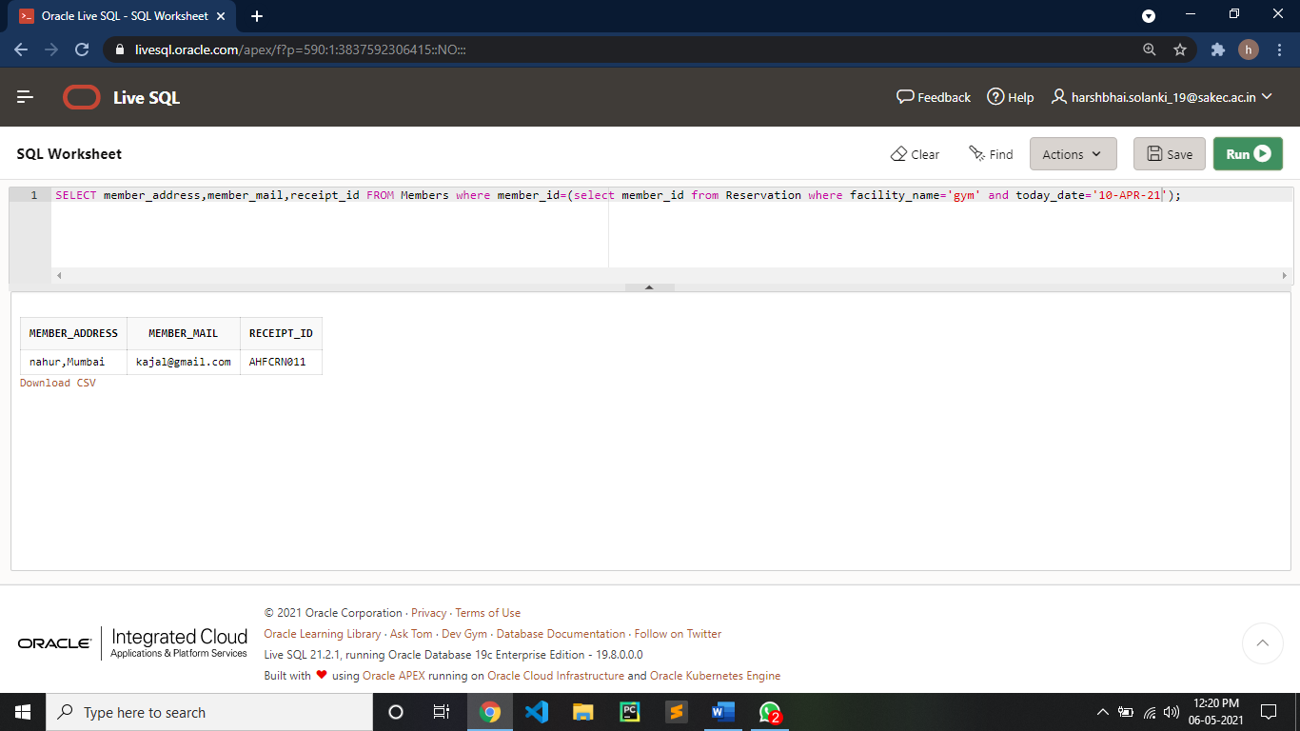

**12: Find the status of common poll on**

