**EXPERIMENT N0-8**

AIM: Write View and Triggers for the given statement of problem.

1.Create Trigger for inserting new members in member table.

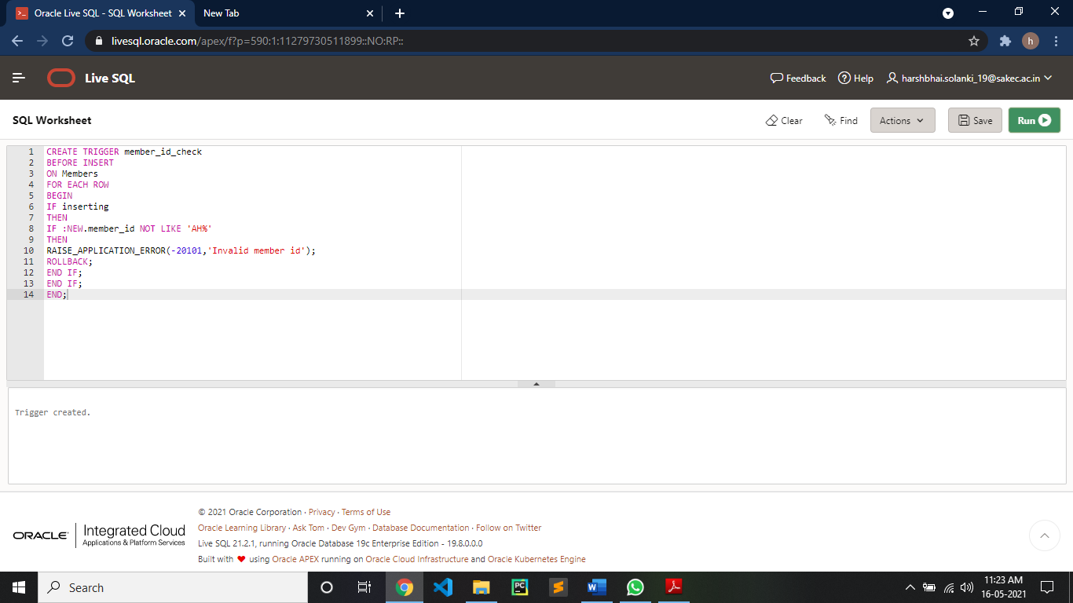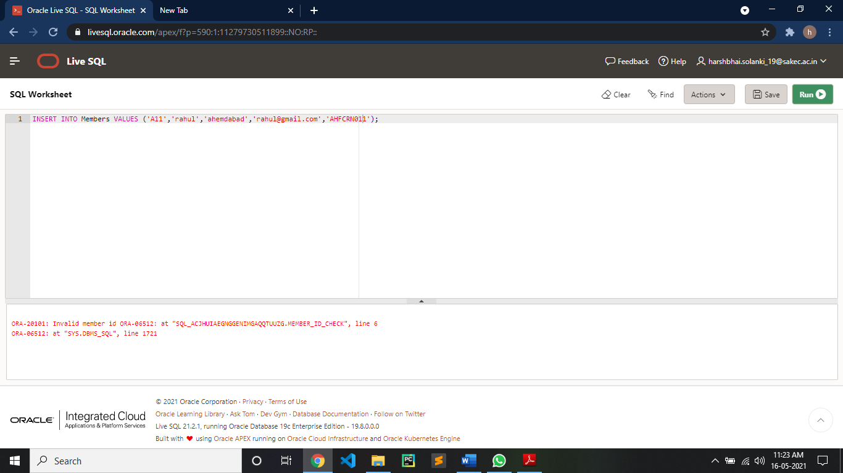

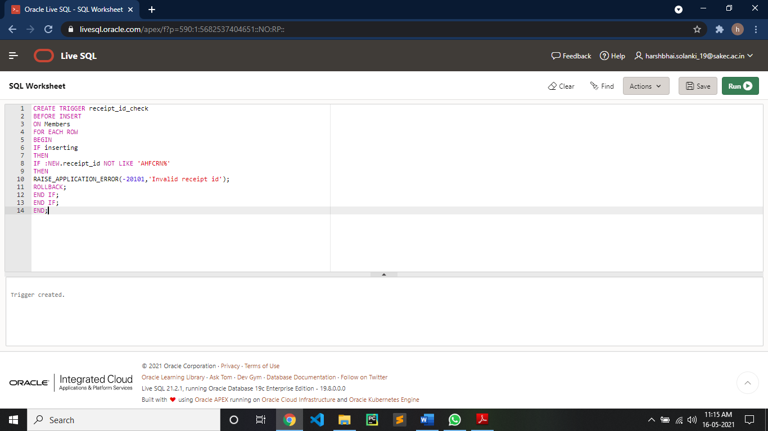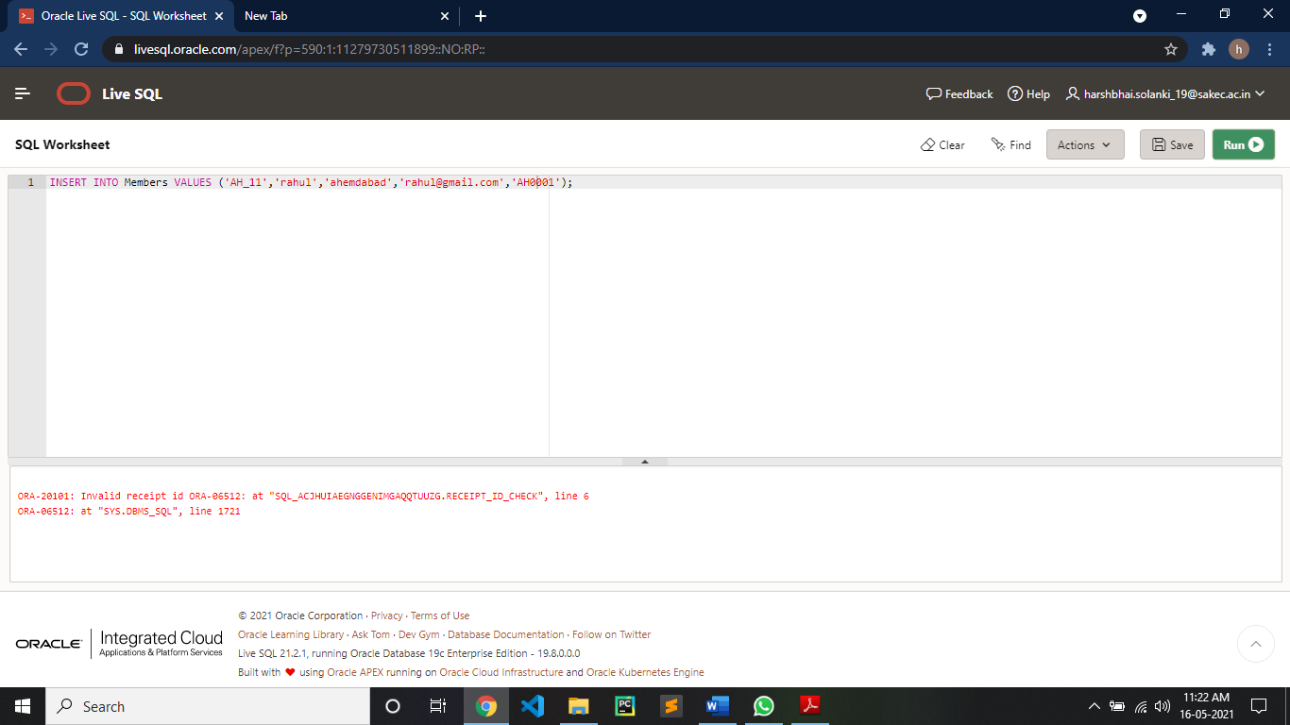

2. Create view for showing all member details as name address with their receipt details.

