**EXPERIMENT N0-9**

AIM: Write Functions and procedure for the given statement of

problem.

1: Write function to calculate total amount of the membership of the member.

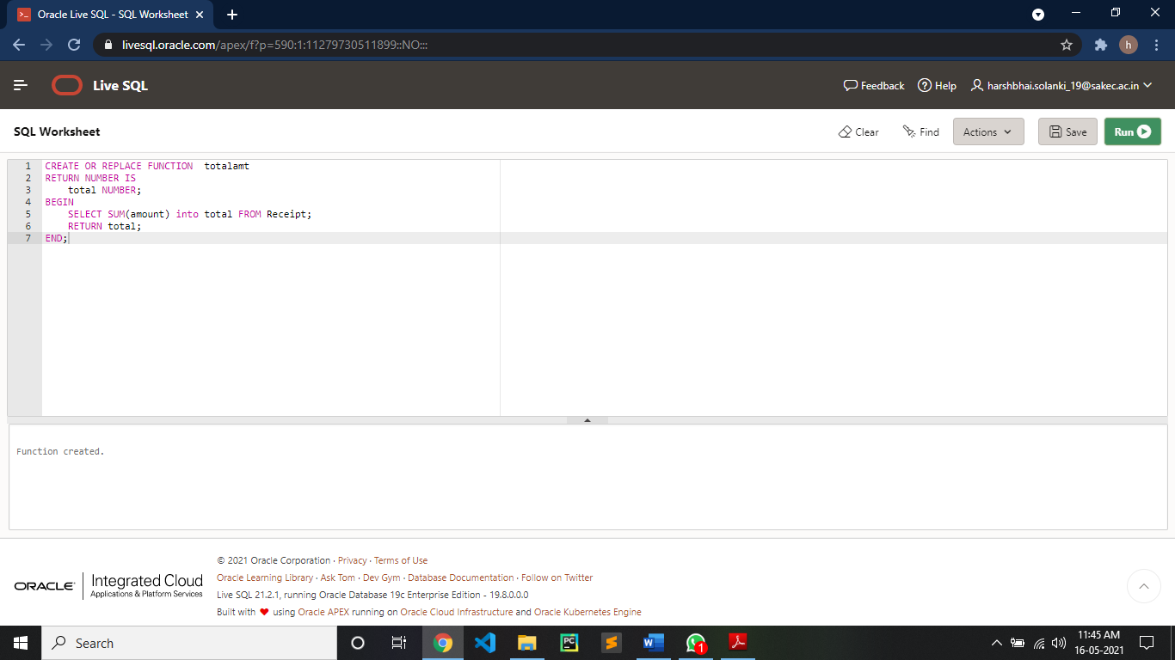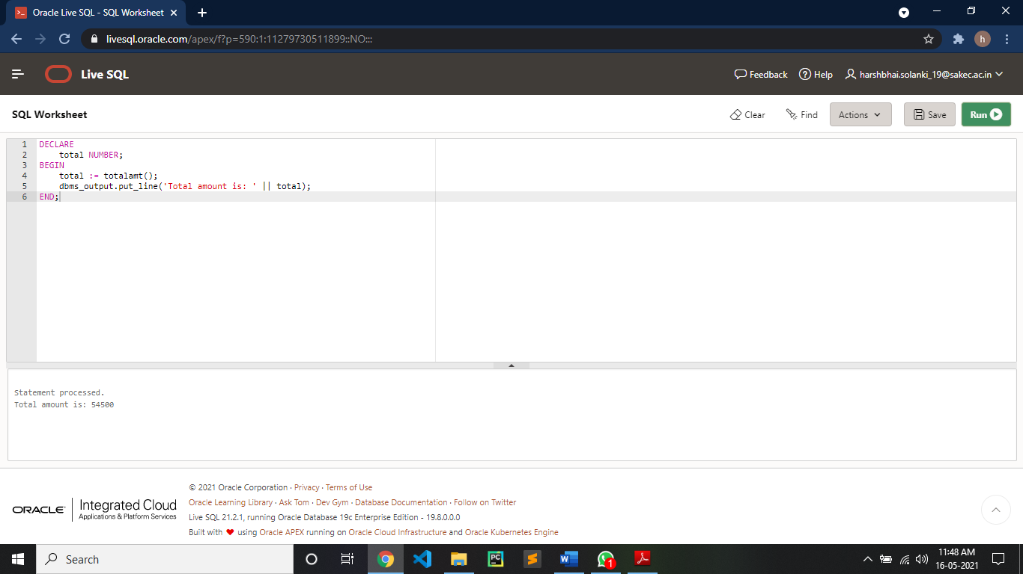

2: write procedure to insert new members details in member table

