**EXPERIMENT N0-11**

**Write a Program to perform database connectivity (JDBCODBC)**

**TASK:**

**Reservation and cancellation page which should be accessed by admin for accepting and cancelling also user should be able to fill that form for same reserving and cancelling**

**ADMIN:**

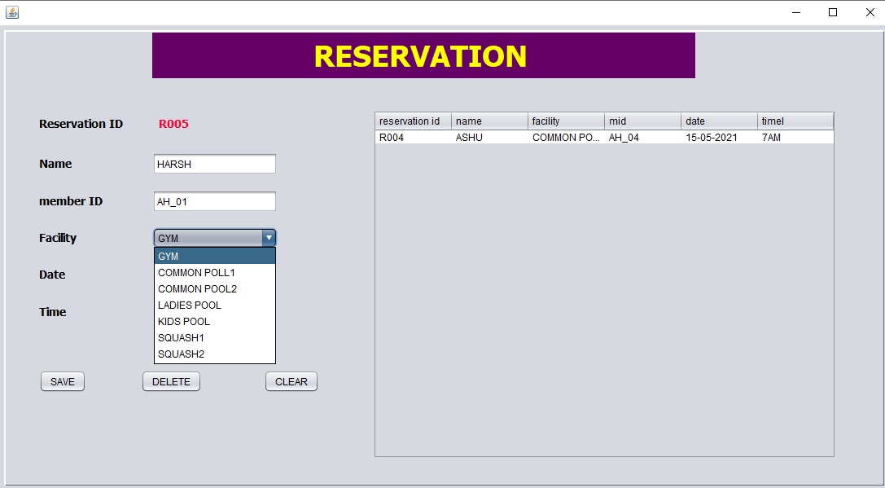

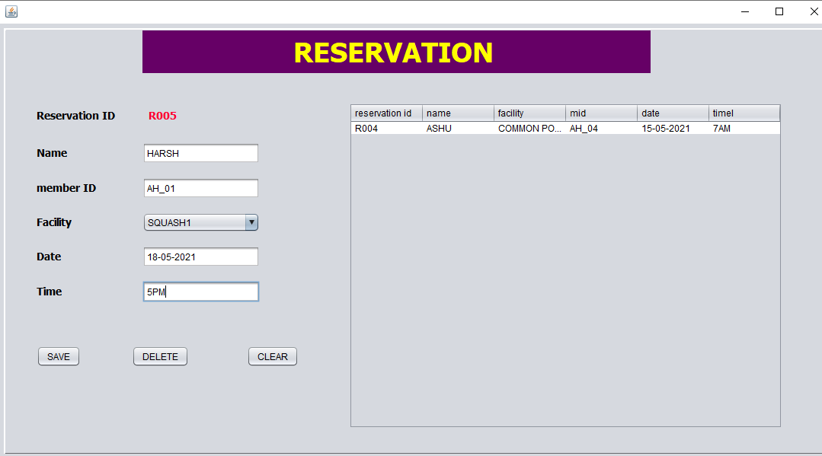

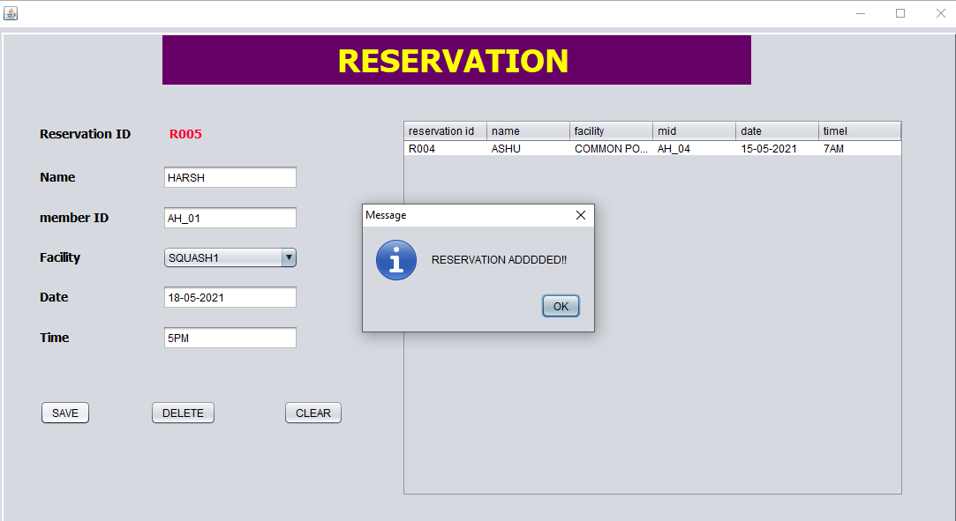

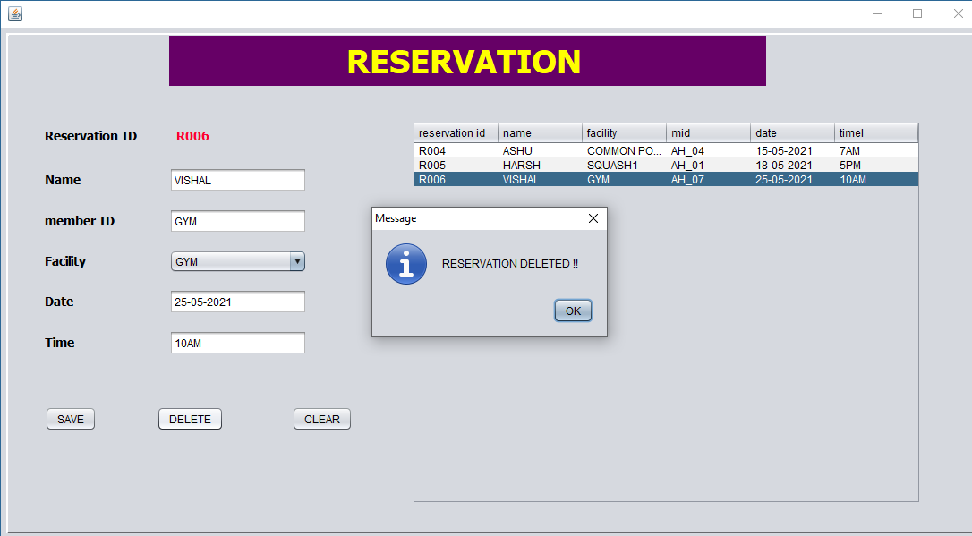

**USER:**

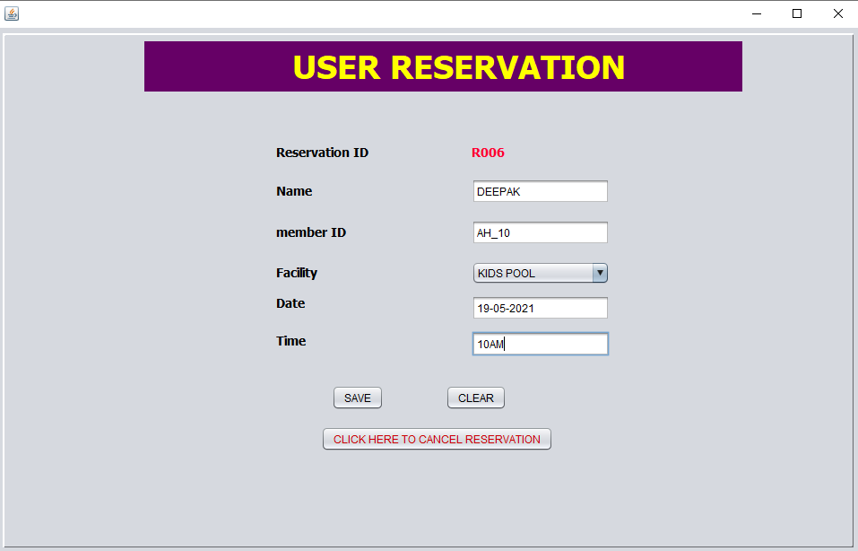

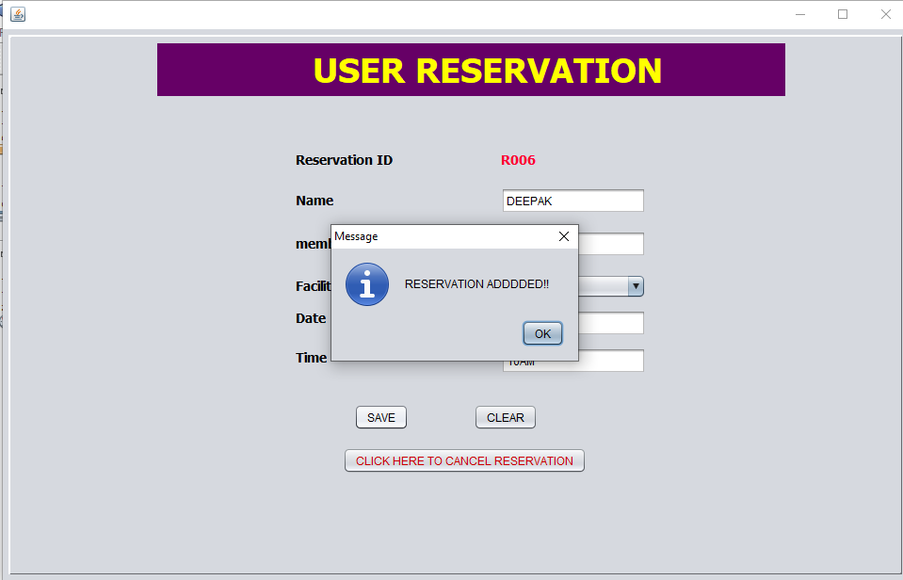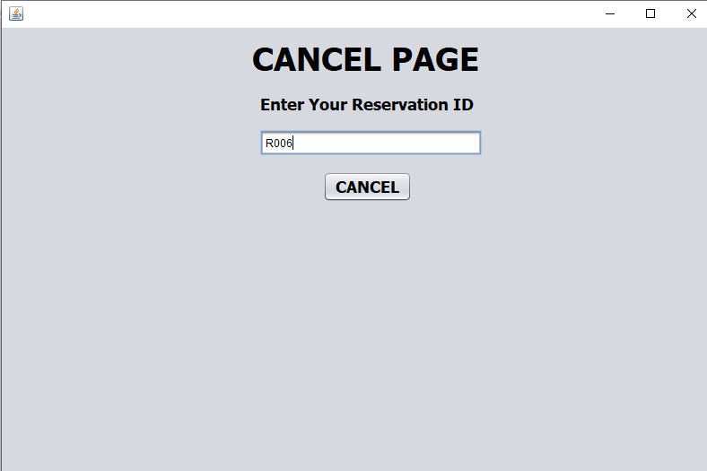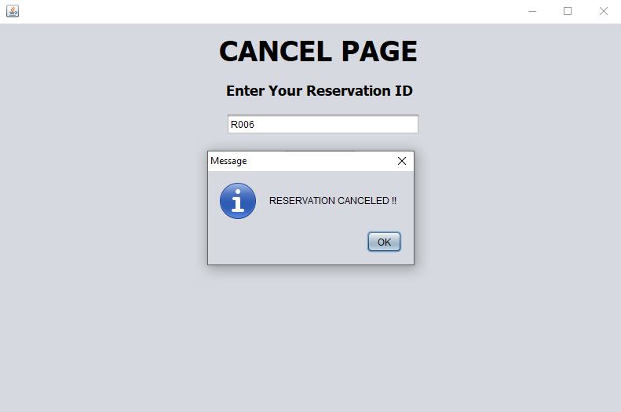

**DATABASE:**

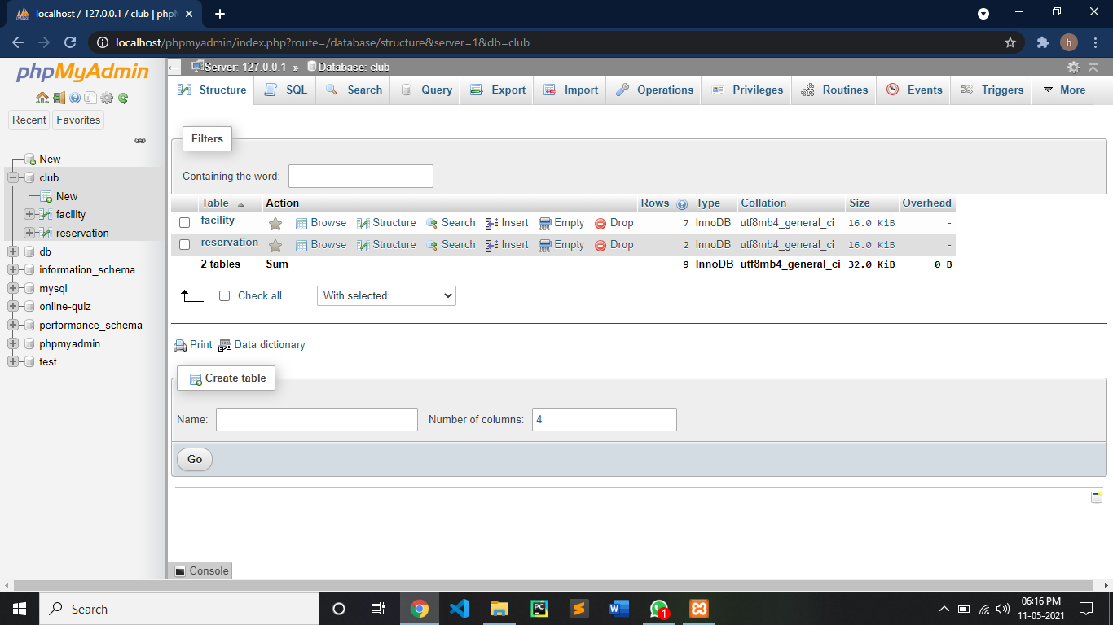

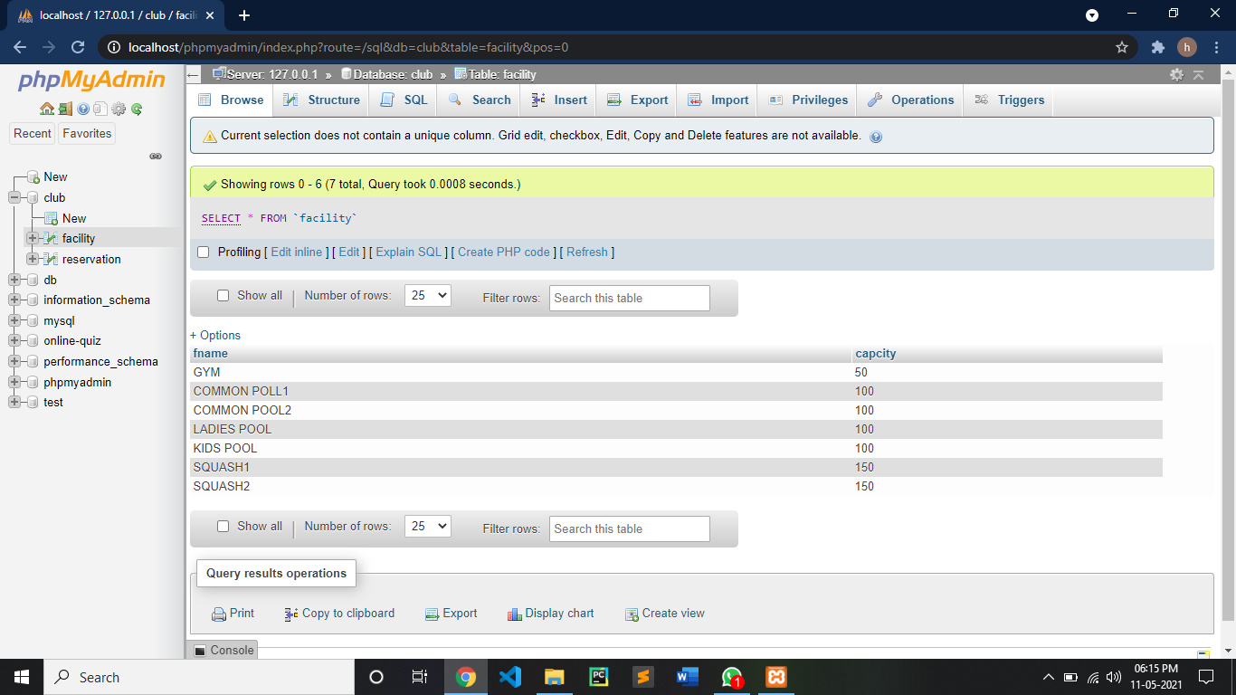

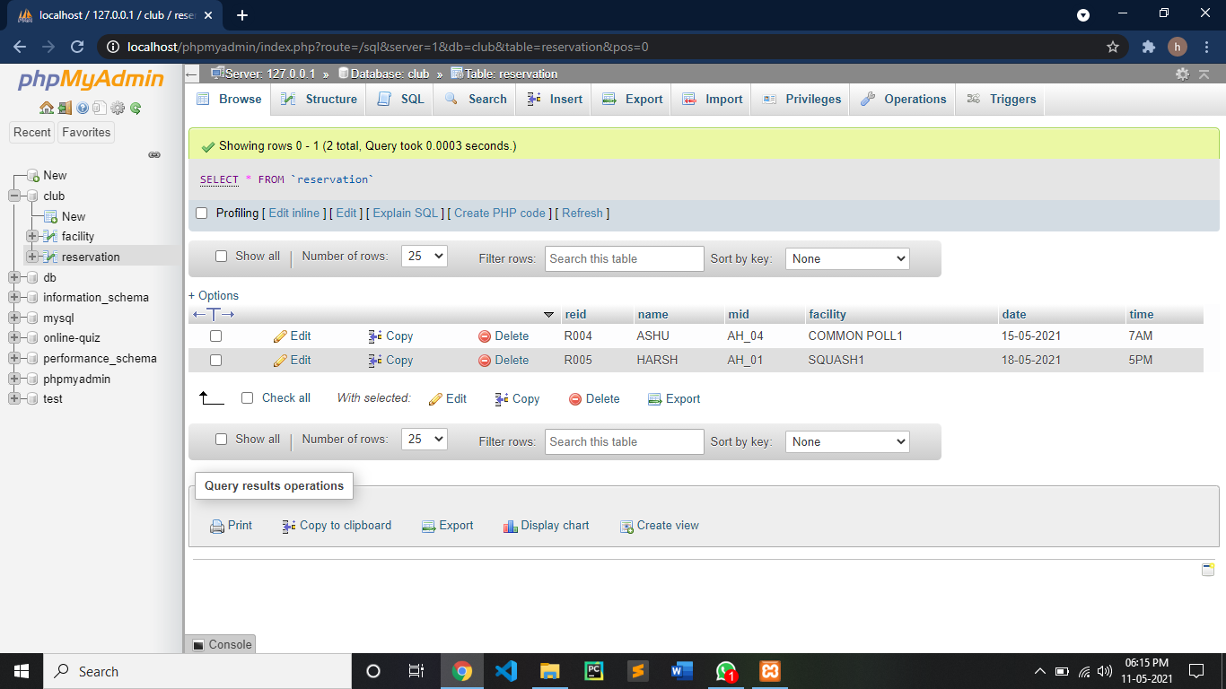

**CODE:**

**ADMIN RESERVATION PAGE:**

/*

* To change this license header, choose License Headers in Project Properties.

* To change this template file, choose Tools | Templates

* and open the template in the editor.

*/

package Reservationcancel;

import com.mysql.jdbc.Statement;

import java.sql.Connection;

import java.sql.DriverManager;

import java.sql.PreparedStatement;

import java.sql.ResultSet;

import java.sql.ResultSetMetaData;

import java.sql.SQLException;

import java.util.Vector;

import java.util.logging.Level;

import java.util.logging.Logger;

import javax.swing.JOptionPane;

import javax.swing.table.DefaultTableModel;

/**

*

* @author Harsh

*/

public class reservation extends javax.swing.JFrame {

/**

* Creates new form reservation

*/

public reservation() {

initComponents();

Connect();

autoID();

factype();

Load_reservation();

}

Connection con;

PreparedStatement pst;

public void Connect(){

try {

Class.forName("com.mysql.jdbc.Driver");

con = DriverManager.getConnection("jdbc:mysql://localhost/club","root","");

} catch (ClassNotFoundException ex) {

Logger.getLogger(reservation.class.getName()).log(Level.SEVERE, null, ex);

} catch (SQLException ex) {

Logger.getLogger(reservation.class.getName()).log(Level.SEVERE, null, ex);

}

}

public void autoID(){

try {

java.sql.Statement s = con.createStatement(); //hi

ResultSet rs = s.executeQuery("select MAX(reid) from reservation");

rs.next();

rs.getString("MAX(reid)");

if(rs.getString("MAX(reid)")== null){

jLabel8.setText("R0001");

}

else{

long id = Long.parseLong(rs.getString("MAX(reid)").substring(2,rs.getString("MAX(reid)").length()));

id++;

jLabel8.setText("R"+String.format("%03d",id));

}

} catch (SQLException ex) {

Logger.getLogger(reservation.class.getName()).log(Level.SEVERE, null, ex);

}

}

public void factype(){

try {

pst = con.prepareStatement("select * from facility");

ResultSet rs = pst.executeQuery();

txtfac.removeAllItems();

while(rs.next()){

txtfac.addItem(rs.getString(1));

}

} catch (SQLException ex) {

Logger.getLogger(reservation.class.getName()).log(Level.SEVERE, null, ex);

}

}

public void Load_reservation(){

int c;

try {

pst = con.prepareStatement("select * from reservation");

ResultSet rs = pst.executeQuery();

ResultSetMetaData rsd = rs.getMetaData();

c = rsd.getColumnCount();

DefaultTableModel d = (DefaultTableModel)jTable1.getModel();

d.setRowCount(0);

while(rs.next()){

Vector v2 = new Vector();

int i;

for(i=1;i<=c;i++){

v2.add(rs.getString("reid"));

v2.add(rs.getString("name"));

v2.add(rs.getString("facility"));

v2.add(rs.getString("mid"));

v2.add(rs.getString("date"));

v2.add(rs.getString("time"));

}

d.addRow(v2);

}

} catch (SQLException ex) {

Logger.getLogger(reservation.class.getName()).log(Level.SEVERE, null, ex);

}

}

/**

* This method is called from within the constructor to initialize the form.

* WARNING: Do NOT modify this code. The content of this method is always

* regenerated by the Form Editor.

*/

@SuppressWarnings("unchecked")

// <editor-fold defaultstate="collapsed" desc="Generated Code">

private void initComponents() {

jPanel1 = new javax.swing.JPanel();

jLabel2 = new javax.swing.JLabel();

jLabel3 = new javax.swing.JLabel();

jLabel4 = new javax.swing.JLabel();

jLabel5 = new javax.swing.JLabel();

jLabel6 = new javax.swing.JLabel();

jLabel7 = new javax.swing.JLabel();

txtname = new javax.swing.JTextField();

txtmid = new javax.swing.JTextField();

txtfac = new javax.swing.JComboBox<>();

txtdate = new javax.swing.JTextField();

txttime = new javax.swing.JTextField();

jButton1 = new javax.swing.JButton();

jButton2 = new javax.swing.JButton();

jButton3 = new javax.swing.JButton();

jScrollPane1 = new javax.swing.JScrollPane();

jTable1 = new javax.swing.JTable();

jLabel8 = new javax.swing.JLabel();

jPanel2 = new javax.swing.JPanel();

jLabel1 = new javax.swing.JLabel();

setDefaultCloseOperation(javax.swing.WindowConstants.EXIT_ON_CLOSE);

jPanel1.setBorder(new javax.swing.border.SoftBevelBorder(javax.swing.border.BevelBorder.RAISED));

jLabel2.setFont(new java.awt.Font("Tahoma", 1, 14)); // NOI18N

jLabel2.setText("Reservation ID");

jLabel3.setFont(new java.awt.Font("Tahoma", 1, 14)); // NOI18N

jLabel3.setText("Name");

jLabel4.setFont(new java.awt.Font("Tahoma", 1, 14)); // NOI18N

jLabel4.setText("member ID");

jLabel5.setFont(new java.awt.Font("Tahoma", 1, 14)); // NOI18N

jLabel5.setText("Facility");

jLabel6.setFont(new java.awt.Font("Tahoma", 1, 14)); // NOI18N

jLabel6.setText("Date");

jLabel7.setFont(new java.awt.Font("Tahoma", 1, 14)); // NOI18N

jLabel7.setText("Time");

txtname.addActionListener(new java.awt.event.ActionListener() {

public void actionPerformed(java.awt.event.ActionEvent evt) {

txtnameActionPerformed(evt);

}

});

jButton1.setText("SAVE");

jButton1.addActionListener(new java.awt.event.ActionListener() {

public void actionPerformed(java.awt.event.ActionEvent evt) {

jButton1ActionPerformed(evt);

}

});

jButton2.setText("DELETE");

jButton2.addActionListener(new java.awt.event.ActionListener() {

public void actionPerformed(java.awt.event.ActionEvent evt) {

jButton2ActionPerformed(evt);

}

});

jButton3.setText("CLEAR");

jButton3.addActionListener(new java.awt.event.ActionListener() {

public void actionPerformed(java.awt.event.ActionEvent evt) {

jButton3ActionPerformed(evt);

}

});

jTable1.setModel(new javax.swing.table.DefaultTableModel(

new Object [][] {

},

new String [] {

"reservation id", "name", "facility", "mid", "date", "timel"

}

));

jTable1.addMouseListener(new java.awt.event.MouseAdapter() {

public void mouseClicked(java.awt.event.MouseEvent evt) {

jTable1MouseClicked(evt);

}

});

jScrollPane1.setViewportView(jTable1);

jLabel8.setFont(new java.awt.Font("Tahoma", 1, 14)); // NOI18N

jLabel8.setForeground(new java.awt.Color(255, 0, 51));

jLabel8.setText("jLabel8");

jPanel2.setBackground(new java.awt.Color(102, 0, 102));

jLabel1.setFont(new java.awt.Font("Tahoma", 1, 36)); // NOI18N

jLabel1.setForeground(new java.awt.Color(255, 255, 0));

jLabel1.setText("RESERVATION");

javax.swing.GroupLayout jPanel2Layout = new javax.swing.GroupLayout(jPanel2);

jPanel2.setLayout(jPanel2Layout);

jPanel2Layout.setHorizontalGroup(

jPanel2Layout.createParallelGroup(javax.swing.GroupLayout.Alignment.LEADING)

.addGroup(jPanel2Layout.createSequentialGroup()

.addGap(198, 198, 198)

.addComponent(jLabel1)

.addContainerGap(206, Short.MAX_VALUE))

);

jPanel2Layout.setVerticalGroup(

jPanel2Layout.createParallelGroup(javax.swing.GroupLayout.Alignment.LEADING)

.addGroup(jPanel2Layout.createSequentialGroup()

.addContainerGap()

.addComponent(jLabel1)

.addContainerGap(javax.swing.GroupLayout.DEFAULT_SIZE, Short.MAX_VALUE))

);

javax.swing.GroupLayout jPanel1Layout = new javax.swing.GroupLayout(jPanel1);

jPanel1.setLayout(jPanel1Layout);

jPanel1Layout.setHorizontalGroup(

jPanel1Layout.createParallelGroup(javax.swing.GroupLayout.Alignment.LEADING)

.addGroup(jPanel1Layout.createSequentialGroup()

.addGap(40, 40, 40)

.addGroup(jPanel1Layout.createParallelGroup(javax.swing.GroupLayout.Alignment.LEADING)

.addGroup(jPanel1Layout.createSequentialGroup()

.addGroup(jPanel1Layout.createParallelGroup(javax.swing.GroupLayout.Alignment.LEADING)

.addGroup(jPanel1Layout.createSequentialGroup()

.addGap(139, 139, 139)

.addGroup(jPanel1Layout.createParallelGroup(javax.swing.GroupLayout.Alignment.LEADING)

.addComponent(txtname, javax.swing.GroupLayout.PREFERRED_SIZE, 154, javax.swing.GroupLayout.PREFERRED_SIZE)

.addComponent(jPanel2, javax.swing.GroupLayout.PREFERRED_SIZE, javax.swing.GroupLayout.DEFAULT_SIZE, javax.swing.GroupLayout.PREFERRED_SIZE)

.addComponent(txtmid, javax.swing.GroupLayout.PREFERRED_SIZE, 154, javax.swing.GroupLayout.PREFERRED_SIZE)

.addComponent(txtfac, javax.swing.GroupLayout.PREFERRED_SIZE, 154, javax.swing.GroupLayout.PREFERRED_SIZE)

.addComponent(txtdate, javax.swing.GroupLayout.PREFERRED_SIZE, 154, javax.swing.GroupLayout.PREFERRED_SIZE)

.addComponent(txttime, javax.swing.GroupLayout.PREFERRED_SIZE, 154, javax.swing.GroupLayout.PREFERRED_SIZE)))

.addGroup(jPanel1Layout.createSequentialGroup()

.addComponent(jButton1)

.addGap(67, 67, 67)

.addComponent(jButton2)

.addGap(76, 76, 76)

.addComponent(jButton3)))

.addContainerGap(javax.swing.GroupLayout.DEFAULT_SIZE, Short.MAX_VALUE))

.addGroup(jPanel1Layout.createSequentialGroup()

.addGroup(jPanel1Layout.createParallelGroup(javax.swing.GroupLayout.Alignment.LEADING)

.addComponent(jLabel3)

.addComponent(jLabel2)

.addComponent(jLabel4)

.addComponent(jLabel5)

.addComponent(jLabel6)

.addComponent(jLabel7))

.addGap(44, 44, 44)

.addComponent(jLabel8)

.addPreferredGap(javax.swing.LayoutStyle.ComponentPlacement.RELATED, 213, Short.MAX_VALUE)

.addComponent(jScrollPane1, javax.swing.GroupLayout.PREFERRED_SIZE, 569, javax.swing.GroupLayout.PREFERRED_SIZE)

.addGap(56, 56, 56))))

);

jPanel1Layout.setVerticalGroup(

jPanel1Layout.createParallelGroup(javax.swing.GroupLayout.Alignment.LEADING)

.addGroup(jPanel1Layout.createSequentialGroup()

.addComponent(jPanel2, javax.swing.GroupLayout.PREFERRED_SIZE, javax.swing.GroupLayout.DEFAULT_SIZE, javax.swing.GroupLayout.PREFERRED_SIZE)

.addGroup(jPanel1Layout.createParallelGroup(javax.swing.GroupLayout.Alignment.LEADING)

.addGroup(jPanel1Layout.createSequentialGroup()

.addGap(47, 47, 47)

.addGroup(jPanel1Layout.createParallelGroup(javax.swing.GroupLayout.Alignment.BASELINE)

.addComponent(jLabel2)

.addComponent(jLabel8))

.addGap(27, 27, 27)

.addGroup(jPanel1Layout.createParallelGroup(javax.swing.GroupLayout.Alignment.BASELINE)

.addComponent(jLabel3)

.addComponent(txtname, javax.swing.GroupLayout.PREFERRED_SIZE, javax.swing.GroupLayout.DEFAULT_SIZE, javax.swing.GroupLayout.PREFERRED_SIZE))

.addGap(18, 18, 18)

.addGroup(jPanel1Layout.createParallelGroup(javax.swing.GroupLayout.Alignment.BASELINE)

.addComponent(jLabel4)

.addComponent(txtmid, javax.swing.GroupLayout.PREFERRED_SIZE, javax.swing.GroupLayout.DEFAULT_SIZE, javax.swing.GroupLayout.PREFERRED_SIZE))

.addGap(18, 18, 18)

.addGroup(jPanel1Layout.createParallelGroup(javax.swing.GroupLayout.Alignment.BASELINE)

.addComponent(jLabel5)

.addComponent(txtfac, javax.swing.GroupLayout.PREFERRED_SIZE, javax.swing.GroupLayout.DEFAULT_SIZE, javax.swing.GroupLayout.PREFERRED_SIZE))

.addGap(18, 18, 18)

.addGroup(jPanel1Layout.createParallelGroup(javax.swing.GroupLayout.Alignment.BASELINE)

.addComponent(jLabel6)

.addComponent(txtdate, javax.swing.GroupLayout.PREFERRED_SIZE, javax.swing.GroupLayout.DEFAULT_SIZE, javax.swing.GroupLayout.PREFERRED_SIZE))

.addGap(18, 18, 18)

.addGroup(jPanel1Layout.createParallelGroup(javax.swing.GroupLayout.Alignment.BASELINE)

.addComponent(jLabel7)

.addComponent(txttime, javax.swing.GroupLayout.PREFERRED_SIZE, javax.swing.GroupLayout.DEFAULT_SIZE, javax.swing.GroupLayout.PREFERRED_SIZE))

.addGap(57, 57, 57)

.addGroup(jPanel1Layout.createParallelGroup(javax.swing.GroupLayout.Alignment.BASELINE)

.addComponent(jButton1)

.addComponent(jButton2)

.addComponent(jButton3))

.addContainerGap(javax.swing.GroupLayout.DEFAULT_SIZE, Short.MAX_VALUE))

.addGroup(javax.swing.GroupLayout.Alignment.TRAILING, jPanel1Layout.createSequentialGroup()

.addPreferredGap(javax.swing.LayoutStyle.ComponentPlacement.RELATED, 39, Short.MAX_VALUE)

.addComponent(jScrollPane1, javax.swing.GroupLayout.PREFERRED_SIZE, javax.swing.GroupLayout.DEFAULT_SIZE, javax.swing.GroupLayout.PREFERRED_SIZE)

.addGap(30, 30, 30))))

);

javax.swing.GroupLayout layout = new javax.swing.GroupLayout(getContentPane());

getContentPane().setLayout(layout);

layout.setHorizontalGroup(

layout.createParallelGroup(javax.swing.GroupLayout.Alignment.LEADING)

.addGroup(layout.createSequentialGroup()

.addContainerGap()

.addComponent(jPanel1, javax.swing.GroupLayout.DEFAULT_SIZE, javax.swing.GroupLayout.DEFAULT_SIZE, Short.MAX_VALUE)

.addContainerGap())

);

layout.setVerticalGroup(

layout.createParallelGroup(javax.swing.GroupLayout.Alignment.LEADING)

.addGroup(layout.createSequentialGroup()

.addContainerGap()

.addComponent(jPanel1, javax.swing.GroupLayout.DEFAULT_SIZE, javax.swing.GroupLayout.DEFAULT_SIZE, Short.MAX_VALUE)

.addContainerGap())

);

pack();

}// </editor-fold>

private void jButton1ActionPerformed(java.awt.event.ActionEvent evt) {

String rno = jLabel8.getText();

String name = txtname.getText();

String mid = txtmid.getText();

String fac = txtfac.getSelectedItem().toString();

String date = txtdate.getText();

String time = txttime.getText();

try{

pst = con.prepareStatement("insert into reservation(reid,name,mid,facility,date,time) values(?,?,?,?,?,?)");

pst.setString(1,rno);

pst.setString(2,name);

pst.setString(3,mid);

pst.setString(4,fac);

pst.setString(5,date);

pst.setString(6,time);

pst.executeUpdate();

JOptionPane.showMessageDialog(this,"RESERVATION ADDDDED!!");

txtname.setText("");

txtmid.setText("");

txtfac.setSelectedItem(-1);

txtdate.setText("");

txttime.setText("");

autoID();

}catch(SQLException ex){

Logger.getLogger(reservation.class.getName()).log(Level.SEVERE,null,ex);

}

}

private void jButton2ActionPerformed(java.awt.event.ActionEvent evt) {

// TODO add your handling code here:

String rno = jLabel8.getText();

try{

pst = con.prepareStatement("delete from reservation where reid=?");

pst.setString(1,rno);

pst.executeUpdate();

JOptionPane.showMessageDialog(this,"RESERVATION DELETED !!");

txtname.setText("");

txtmid.setText("");

txtfac.setSelectedItem(-1);

txtdate.setText("");

txttime.setText("");

autoID();

}catch(SQLException ex){

Logger.getLogger(reservation.class.getName()).log(Level.SEVERE,null,ex);

}

}

private void txtnameActionPerformed(java.awt.event.ActionEvent evt) {

// TODO add your handling code here:

}

private void jTable1MouseClicked(java.awt.event.MouseEvent evt) {

// TODO add your handling code here:

DefaultTableModel d = (DefaultTableModel)jTable1.getModel();

int selectIndex = jTable1.getSelectedRow();

jLabel8.setText(d.getValueAt(selectIndex,0).toString());

txtname.setText(d.getValueAt(selectIndex,1).toString());

txtmid.setText(d.getValueAt(selectIndex,2).toString());

txtfac.setSelectedItem(d.getValueAt(selectIndex,3).toString());

txtdate.setText(d.getValueAt(selectIndex,4).toString());

txttime.setText(d.getValueAt(selectIndex,5).toString());

}

private void jButton3ActionPerformed(java.awt.event.ActionEvent evt) {

// TODO add your handling code here:

txtname.setText("");

txtmid.setText("");

txtfac.setSelectedItem(-1);

txtdate.setText("");

txttime.setText("");

autoID();

Load_reservation();

}

/**

* @param args the command line arguments

*/

public static void main(String args[]) {

/* Set the Nimbus look and feel */

//<editor-fold defaultstate="collapsed" desc=" Look and feel setting code (optional) ">

/* If Nimbus (introduced in Java SE 6) is not available, stay with the default look and feel.

* For details see http://download.oracle.com/javase/tutorial/uiswing/lookandfeel/plaf.html

*/

try {

for (javax.swing.UIManager.LookAndFeelInfo info : javax.swing.UIManager.getInstalledLookAndFeels()) {

if ("Nimbus".equals(info.getName())) {

javax.swing.UIManager.setLookAndFeel(info.getClassName());

break;

}

}

} catch (ClassNotFoundException ex) {

java.util.logging.Logger.getLogger(reservation.class.getName()).log(java.util.logging.Level.SEVERE, null, ex);

} catch (InstantiationException ex) {

java.util.logging.Logger.getLogger(reservation.class.getName()).log(java.util.logging.Level.SEVERE, null, ex);

} catch (IllegalAccessException ex) {

java.util.logging.Logger.getLogger(reservation.class.getName()).log(java.util.logging.Level.SEVERE, null, ex);

} catch (javax.swing.UnsupportedLookAndFeelException ex) {

java.util.logging.Logger.getLogger(reservation.class.getName()).log(java.util.logging.Level.SEVERE, null, ex);

}

//</editor-fold>

/* Create and display the form */

java.awt.EventQueue.invokeLater(new Runnable() {

public void run() {

new reservation().setVisible(true);

}

});

}

// Variables declaration - do not modify

private javax.swing.JButton jButton1;

private javax.swing.JButton jButton2;

private javax.swing.JButton jButton3;

private javax.swing.JLabel jLabel1;

private javax.swing.JLabel jLabel2;

private javax.swing.JLabel jLabel3;

private javax.swing.JLabel jLabel4;

private javax.swing.JLabel jLabel5;

private javax.swing.JLabel jLabel6;

private javax.swing.JLabel jLabel7;

private javax.swing.JLabel jLabel8;

private javax.swing.JPanel jPanel1;

private javax.swing.JPanel jPanel2;

private javax.swing.JScrollPane jScrollPane1;

private javax.swing.JTable jTable1;

private javax.swing.JTextField txtdate;

private javax.swing.JComboBox<String> txtfac;

private javax.swing.JTextField txtmid;

private javax.swing.JTextField txtname;

private javax.swing.JTextField txttime;

// End of variables declaration

}

**USER RESERVATION:**

/*

* To change this license header, choose License Headers in Project Properties.

* To change this template file, choose Tools | Templates

* and open the template in the editor.

*/

package uregister;

import com.mysql.jdbc.Statement;

import java.sql.Connection;

import java.sql.DriverManager;

import java.sql.PreparedStatement;

import java.sql.ResultSet;

import java.sql.ResultSetMetaData;

import java.sql.SQLException;

import java.util.Vector;

import java.util.logging.Level;

import java.util.logging.Logger;

import javax.swing.JOptionPane;

import javax.swing.table.DefaultTableModel;

/**

*

* @author Harsh

*/

public class ureservation extends javax.swing.JFrame {

/**

* Creates new form reservation

*/

public ureservation() {

initComponents();

Connect();

autoID();

factype();

//Load_reservation();

}

Connection con;

PreparedStatement pst;

public void Connect(){

try {

Class.forName("com.mysql.jdbc.Driver");

con = DriverManager.getConnection("jdbc:mysql://localhost/club","root","");

} catch (ClassNotFoundException ex) {

Logger.getLogger(ureservation.class.getName()).log(Level.SEVERE, null, ex);

} catch (SQLException ex) {

Logger.getLogger(ureservation.class.getName()).log(Level.SEVERE, null, ex);

}

}

public void autoID(){

try {

java.sql.Statement s = con.createStatement(); //hi

ResultSet rs = s.executeQuery("select MAX(reid) from reservation");

rs.next();

rs.getString("MAX(reid)");

if(rs.getString("MAX(reid)")== null){

jLabel8.setText("R0001");

}

else{

long id = Long.parseLong(rs.getString("MAX(reid)").substring(2,rs.getString("MAX(reid)").length()));

id++;

jLabel8.setText("R"+String.format("%03d",id));

}

} catch (SQLException ex) {

Logger.getLogger(ureservation.class.getName()).log(Level.SEVERE, null, ex);

}

}

public void factype(){

try {

pst = con.prepareStatement("select * from facility");

ResultSet rs = pst.executeQuery();

txtfac.removeAllItems();

while(rs.next()){

txtfac.addItem(rs.getString(1));

}

} catch (SQLException ex) {

Logger.getLogger(ureservation.class.getName()).log(Level.SEVERE, null, ex);

}

}

// public void Load_reservation(){

// int c;

// try {

// pst = con.prepareStatement("select * from reservation");

// ResultSet rs = pst.executeQuery();

// ResultSetMetaData rsd = rs.getMetaData();

// c = rsd.getColumnCount();

// DefaultTableModel d = (DefaultTableModel)jTable1.getModel();

// d.setRowCount(0);

// while(rs.next()){

// Vector v2 = new Vector();

// int i;

// for(i=1;i<=c;i++){

// v2.add(rs.getString("reid"));

// v2.add(rs.getString("name"));

// v2.add(rs.getString("facility"));

// v2.add(rs.getString("mid"));

// v2.add(rs.getString("date"));

// v2.add(rs.getString("time"));

// }

// d.addRow(v2);

// }

//

// } catch (SQLException ex) {

// Logger.getLogger(ureservation.class.getName()).log(Level.SEVERE, null, ex);

// }

// }

/**

* This method is called from within the constructor to initialize the form.

* WARNING: Do NOT modify this code. The content of this method is always

* regenerated by the Form Editor.

*/

@SuppressWarnings("unchecked")

// <editor-fold defaultstate="collapsed" desc="Generated Code">

private void initComponents() {

jPanel1 = new javax.swing.JPanel();

jLabel2 = new javax.swing.JLabel();

jLabel3 = new javax.swing.JLabel();

jLabel4 = new javax.swing.JLabel();

jLabel5 = new javax.swing.JLabel();

jLabel6 = new javax.swing.JLabel();

jLabel7 = new javax.swing.JLabel();

txtname = new javax.swing.JTextField();

txtmid = new javax.swing.JTextField();

txtfac = new javax.swing.JComboBox<>();

txtdate = new javax.swing.JTextField();

txttime = new javax.swing.JTextField();

jButton1 = new javax.swing.JButton();

jButton2 = new javax.swing.JButton();

jButton3 = new javax.swing.JButton();

jLabel8 = new javax.swing.JLabel();

jPanel2 = new javax.swing.JPanel();

jLabel1 = new javax.swing.JLabel();

setDefaultCloseOperation(javax.swing.WindowConstants.EXIT_ON_CLOSE);

jPanel1.setBorder(new javax.swing.border.SoftBevelBorder(javax.swing.border.BevelBorder.RAISED));

jLabel2.setFont(new java.awt.Font("Tahoma", 1, 14)); // NOI18N

jLabel2.setText("Reservation ID");

jLabel3.setFont(new java.awt.Font("Tahoma", 1, 14)); // NOI18N

jLabel3.setText("Name");

jLabel4.setFont(new java.awt.Font("Tahoma", 1, 14)); // NOI18N

jLabel4.setText("member ID");

jLabel5.setFont(new java.awt.Font("Tahoma", 1, 14)); // NOI18N

jLabel5.setText("Facility");

jLabel6.setFont(new java.awt.Font("Tahoma", 1, 14)); // NOI18N

jLabel6.setText("Date");

jLabel7.setFont(new java.awt.Font("Tahoma", 1, 14)); // NOI18N

jLabel7.setText("Time");

txtname.addActionListener(new java.awt.event.ActionListener() {

public void actionPerformed(java.awt.event.ActionEvent evt) {

txtnameActionPerformed(evt);

}

});

jButton1.setText("SAVE");

jButton1.addActionListener(new java.awt.event.ActionListener() {

public void actionPerformed(java.awt.event.ActionEvent evt) {

jButton1ActionPerformed(evt);

}

});

jButton2.setForeground(new java.awt.Color(204, 0, 0));

jButton2.setText("CLICK HERE TO CANCEL RESERVATION");

jButton2.addActionListener(new java.awt.event.ActionListener() {

public void actionPerformed(java.awt.event.ActionEvent evt) {

jButton2ActionPerformed(evt);

}

});

jButton3.setText("CLEAR");

jButton3.addActionListener(new java.awt.event.ActionListener() {

public void actionPerformed(java.awt.event.ActionEvent evt) {

jButton3ActionPerformed(evt);

}

});

jLabel8.setFont(new java.awt.Font("Tahoma", 1, 14)); // NOI18N

jLabel8.setForeground(new java.awt.Color(255, 0, 51));

jLabel8.setText("jLabel8");

jPanel2.setBackground(new java.awt.Color(102, 0, 102));

jLabel1.setFont(new java.awt.Font("Tahoma", 1, 36)); // NOI18N

jLabel1.setForeground(new java.awt.Color(255, 255, 0));

jLabel1.setText("USER RESERVATION");

javax.swing.GroupLayout jPanel2Layout = new javax.swing.GroupLayout(jPanel2);

jPanel2.setLayout(jPanel2Layout);

jPanel2Layout.setHorizontalGroup(

jPanel2Layout.createParallelGroup(javax.swing.GroupLayout.Alignment.LEADING)

.addGroup(javax.swing.GroupLayout.Alignment.TRAILING, jPanel2Layout.createSequentialGroup()

.addContainerGap(165, Short.MAX_VALUE)

.addComponent(jLabel1)

.addGap(130, 130, 130))

);

jPanel2Layout.setVerticalGroup(

jPanel2Layout.createParallelGroup(javax.swing.GroupLayout.Alignment.LEADING)

.addGroup(jPanel2Layout.createSequentialGroup()

.addContainerGap()

.addComponent(jLabel1)

.addContainerGap(javax.swing.GroupLayout.DEFAULT_SIZE, Short.MAX_VALUE))

);

javax.swing.GroupLayout jPanel1Layout = new javax.swing.GroupLayout(jPanel1);

jPanel1.setLayout(jPanel1Layout);

jPanel1Layout.setHorizontalGroup(

jPanel1Layout.createParallelGroup(javax.swing.GroupLayout.Alignment.LEADING)

.addGroup(jPanel1Layout.createSequentialGroup()

.addContainerGap(155, Short.MAX_VALUE)

.addGroup(jPanel1Layout.createParallelGroup(javax.swing.GroupLayout.Alignment.LEADING)

.addGroup(javax.swing.GroupLayout.Alignment.TRAILING, jPanel1Layout.createSequentialGroup()

.addComponent(jPanel2, javax.swing.GroupLayout.PREFERRED_SIZE, javax.swing.GroupLayout.DEFAULT_SIZE, javax.swing.GroupLayout.PREFERRED_SIZE)

.addGap(121, 121, 121))

.addGroup(javax.swing.GroupLayout.Alignment.TRAILING, jPanel1Layout.createSequentialGroup()

.addComponent(jButton1)

.addGap(69, 69, 69)

.addComponent(jButton3)

.addGap(384, 384, 384))

.addGroup(javax.swing.GroupLayout.Alignment.TRAILING, jPanel1Layout.createSequentialGroup()

.addGroup(jPanel1Layout.createParallelGroup(javax.swing.GroupLayout.Alignment.LEADING)

.addComponent(jLabel2)

.addComponent(jLabel4)

.addComponent(jLabel5)

.addComponent(jLabel6)

.addComponent(jLabel7)

.addComponent(jLabel3))

.addGap(115, 115, 115)

.addGroup(jPanel1Layout.createParallelGroup(javax.swing.GroupLayout.Alignment.LEADING)

.addComponent(txtname, javax.swing.GroupLayout.PREFERRED_SIZE, 154, javax.swing.GroupLayout.PREFERRED_SIZE)

.addComponent(txtmid, javax.swing.GroupLayout.PREFERRED_SIZE, 154, javax.swing.GroupLayout.PREFERRED_SIZE)

.addComponent(jLabel8)

.addComponent(txtfac, javax.swing.GroupLayout.PREFERRED_SIZE, 154, javax.swing.GroupLayout.PREFERRED_SIZE)

.addComponent(txtdate, javax.swing.GroupLayout.PREFERRED_SIZE, 154, javax.swing.GroupLayout.PREFERRED_SIZE)

.addComponent(txttime, javax.swing.GroupLayout.PREFERRED_SIZE, 154, javax.swing.GroupLayout.PREFERRED_SIZE))

.addGap(269, 269, 269))))

.addGroup(jPanel1Layout.createSequentialGroup()

.addGap(352, 352, 352)

.addComponent(jButton2)

.addGap(0, 0, Short.MAX_VALUE))

);

jPanel1Layout.setVerticalGroup(

jPanel1Layout.createParallelGroup(javax.swing.GroupLayout.Alignment.LEADING)

.addGroup(jPanel1Layout.createSequentialGroup()

.addContainerGap()

.addComponent(jPanel2, javax.swing.GroupLayout.PREFERRED_SIZE, javax.swing.GroupLayout.DEFAULT_SIZE, javax.swing.GroupLayout.PREFERRED_SIZE)

.addGap(59, 59, 59)

.addGroup(jPanel1Layout.createParallelGroup(javax.swing.GroupLayout.Alignment.BASELINE)

.addComponent(jLabel2)

.addComponent(jLabel8))

.addGap(21, 21, 21)

.addGroup(jPanel1Layout.createParallelGroup(javax.swing.GroupLayout.Alignment.BASELINE)

.addComponent(jLabel3)

.addComponent(txtname, javax.swing.GroupLayout.PREFERRED_SIZE, javax.swing.GroupLayout.DEFAULT_SIZE, javax.swing.GroupLayout.PREFERRED_SIZE))

.addGap(18, 18, 18)

.addGroup(jPanel1Layout.createParallelGroup(javax.swing.GroupLayout.Alignment.BASELINE)

.addComponent(txtmid, javax.swing.GroupLayout.PREFERRED_SIZE, javax.swing.GroupLayout.DEFAULT_SIZE, javax.swing.GroupLayout.PREFERRED_SIZE)

.addComponent(jLabel4))

.addGap(18, 18, 18)

.addGroup(jPanel1Layout.createParallelGroup(javax.swing.GroupLayout.Alignment.BASELINE)

.addComponent(jLabel5)

.addComponent(txtfac, javax.swing.GroupLayout.PREFERRED_SIZE, javax.swing.GroupLayout.DEFAULT_SIZE, javax.swing.GroupLayout.PREFERRED_SIZE))

.addPreferredGap(javax.swing.LayoutStyle.ComponentPlacement.UNRELATED)

.addGroup(jPanel1Layout.createParallelGroup(javax.swing.GroupLayout.Alignment.LEADING)

.addComponent(jLabel6)

.addComponent(txtdate, javax.swing.GroupLayout.PREFERRED_SIZE, javax.swing.GroupLayout.DEFAULT_SIZE, javax.swing.GroupLayout.PREFERRED_SIZE))

.addGroup(jPanel1Layout.createParallelGroup(javax.swing.GroupLayout.Alignment.LEADING)

.addGroup(jPanel1Layout.createSequentialGroup()

.addGap(14, 14, 14)

.addComponent(jLabel7))

.addGroup(jPanel1Layout.createSequentialGroup()

.addPreferredGap(javax.swing.LayoutStyle.ComponentPlacement.UNRELATED)

.addComponent(txttime, javax.swing.GroupLayout.PREFERRED_SIZE, javax.swing.GroupLayout.DEFAULT_SIZE, javax.swing.GroupLayout.PREFERRED_SIZE)))

.addGap(32, 32, 32)

.addGroup(jPanel1Layout.createParallelGroup(javax.swing.GroupLayout.Alignment.BASELINE)

.addComponent(jButton3)

.addComponent(jButton1))

.addGap(18, 18, 18)

.addComponent(jButton2)

.addContainerGap(104, Short.MAX_VALUE))

);

javax.swing.GroupLayout layout = new javax.swing.GroupLayout(getContentPane());

getContentPane().setLayout(layout);

layout.setHorizontalGroup(

layout.createParallelGroup(javax.swing.GroupLayout.Alignment.LEADING)

.addGroup(layout.createSequentialGroup()

.addContainerGap()

.addComponent(jPanel1, javax.swing.GroupLayout.DEFAULT_SIZE, javax.swing.GroupLayout.DEFAULT_SIZE, Short.MAX_VALUE)

.addContainerGap())

);

layout.setVerticalGroup(

layout.createParallelGroup(javax.swing.GroupLayout.Alignment.LEADING)

.addGroup(layout.createSequentialGroup()

.addContainerGap()

.addComponent(jPanel1, javax.swing.GroupLayout.DEFAULT_SIZE, javax.swing.GroupLayout.DEFAULT_SIZE, Short.MAX_VALUE)

.addContainerGap())

);

pack();

}// </editor-fold>

private void jButton1ActionPerformed(java.awt.event.ActionEvent evt) {

String rno = jLabel8.getText();

String name = txtname.getText();

String mid = txtmid.getText();

String fac = txtfac.getSelectedItem().toString();

String date = txtdate.getText();

String time = txttime.getText();

try{

pst = con.prepareStatement("insert into reservation(reid,name,mid,facility,date,time) values(?,?,?,?,?,?)");

pst.setString(1,rno);

pst.setString(2,name);

pst.setString(3,mid);

pst.setString(4,fac);

pst.setString(5,date);

pst.setString(6,time);

pst.executeUpdate();

JOptionPane.showMessageDialog(this,"RESERVATION ADDDDED!!");

txtname.setText("");

txtmid.setText("");

txtfac.setSelectedItem(-1);

txtdate.setText("");

txttime.setText("");

autoID();

}catch(SQLException ex){

Logger.getLogger(ureservation.class.getName()).log(Level.SEVERE,null,ex);

}

}

private void jButton2ActionPerformed(java.awt.event.ActionEvent evt) {

// TODO add your handling code here:

cancel c = new cancel();

c.setVisible(true);

}

private void txtnameActionPerformed(java.awt.event.ActionEvent evt) {

// TODO add your handling code here:

}

private void jButton3ActionPerformed(java.awt.event.ActionEvent evt) {

// TODO add your handling code here:

txtname.setText("");

txtmid.setText("");

txtfac.setSelectedItem(-1);

txtdate.setText("");

txttime.setText("");

autoID();

//Load_reservation();

}

/**

* @param args the command line arguments

*/

public static void main(String args[]) {

/* Set the Nimbus look and feel */

//<editor-fold defaultstate="collapsed" desc=" Look and feel setting code (optional) ">

/* If Nimbus (introduced in Java SE 6) is not available, stay with the default look and feel.

* For details see http://download.oracle.com/javase/tutorial/uiswing/lookandfeel/plaf.html

*/

try {

for (javax.swing.UIManager.LookAndFeelInfo info : javax.swing.UIManager.getInstalledLookAndFeels()) {

if ("Nimbus".equals(info.getName())) {

javax.swing.UIManager.setLookAndFeel(info.getClassName());

break;

}

}

} catch (ClassNotFoundException ex) {

java.util.logging.Logger.getLogger(ureservation.class.getName()).log(java.util.logging.Level.SEVERE, null, ex);

} catch (InstantiationException ex) {

java.util.logging.Logger.getLogger(ureservation.class.getName()).log(java.util.logging.Level.SEVERE, null, ex);

} catch (IllegalAccessException ex) {

java.util.logging.Logger.getLogger(ureservation.class.getName()).log(java.util.logging.Level.SEVERE, null, ex);

} catch (javax.swing.UnsupportedLookAndFeelException ex) {

java.util.logging.Logger.getLogger(ureservation.class.getName()).log(java.util.logging.Level.SEVERE, null, ex);

}

//</editor-fold>

/* Create and display the form */

java.awt.EventQueue.invokeLater(new Runnable() {

public void run() {

new ureservation().setVisible(true);

}

});

}

// Variables declaration - do not modify

private javax.swing.JButton jButton1;

private javax.swing.JButton jButton2;

private javax.swing.JButton jButton3;

private javax.swing.JLabel jLabel1;

private javax.swing.JLabel jLabel2;

private javax.swing.JLabel jLabel3;

private javax.swing.JLabel jLabel4;

private javax.swing.JLabel jLabel5;

private javax.swing.JLabel jLabel6;

private javax.swing.JLabel jLabel7;

private javax.swing.JLabel jLabel8;

private javax.swing.JPanel jPanel1;

private javax.swing.JPanel jPanel2;

private javax.swing.JTextField txtdate;

private javax.swing.JComboBox<String> txtfac;

private javax.swing.JTextField txtmid;

private javax.swing.JTextField txtname;

private javax.swing.JTextField txttime;

// End of variables declaration

}

**USER CANCEL PAGE:**

/*

* To change this license header, choose License Headers in Project Properties.

* To change this template file, choose Tools | Templates

* and open the template in the editor.

*/

package uregister;

import java.sql.Connection;

import java.sql.DriverManager;

import java.sql.PreparedStatement;

import java.sql.SQLException;

import java.util.logging.Level;

import java.util.logging.Logger;

import javax.swing.JOptionPane;

/**

*

* @author Harsh

*/

public class cancel extends javax.swing.JFrame {

/**

* Creates new form cancel

*/

public cancel() {

initComponents();

Connect();

}

Connection con;

PreparedStatement pst;

public void Connect(){

try {

Class.forName("com.mysql.jdbc.Driver");

con = DriverManager.getConnection("jdbc:mysql://localhost/club","root","");

} catch (ClassNotFoundException ex) {

Logger.getLogger(ureservation.class.getName()).log(Level.SEVERE, null, ex);

} catch (SQLException ex) {

Logger.getLogger(ureservation.class.getName()).log(Level.SEVERE, null, ex);

}

}

/**

* This method is called from within the constructor to initialize the form.

* WARNING: Do NOT modify this code. The content of this method is always

* regenerated by the Form Editor.

*/

@SuppressWarnings("unchecked")

// <editor-fold defaultstate="collapsed" desc="Generated Code">

private void initComponents() {

jPanel1 = new javax.swing.JPanel();

jLabel1 = new javax.swing.JLabel();

jLabel2 = new javax.swing.JLabel();

txtrid = new javax.swing.JTextField();

jButton1 = new javax.swing.JButton();

setDefaultCloseOperation(javax.swing.WindowConstants.EXIT_ON_CLOSE);

jLabel1.setBackground(new java.awt.Color(204, 0, 204));

jLabel1.setFont(new java.awt.Font("Tahoma", 1, 36)); // NOI18N

jLabel1.setText("CANCEL PAGE");

jLabel2.setFont(new java.awt.Font("Tahoma", 1, 18)); // NOI18N

jLabel2.setText("Enter Your Reservation ID");

jButton1.setFont(new java.awt.Font("Tahoma", 1, 18)); // NOI18N

jButton1.setText("CANCEL");

jButton1.addActionListener(new java.awt.event.ActionListener() {

public void actionPerformed(java.awt.event.ActionEvent evt) {

jButton1ActionPerformed(evt);

}

});

javax.swing.GroupLayout jPanel1Layout = new javax.swing.GroupLayout(jPanel1);

jPanel1.setLayout(jPanel1Layout);

jPanel1Layout.setHorizontalGroup(

jPanel1Layout.createParallelGroup(javax.swing.GroupLayout.Alignment.LEADING)

.addGroup(jPanel1Layout.createSequentialGroup()

.addContainerGap(273, Short.MAX_VALUE)

.addGroup(jPanel1Layout.createParallelGroup(javax.swing.GroupLayout.Alignment.LEADING)

.addGroup(javax.swing.GroupLayout.Alignment.TRAILING, jPanel1Layout.createSequentialGroup()

.addComponent(jLabel1, javax.swing.GroupLayout.PREFERRED_SIZE, 273, javax.swing.GroupLayout.PREFERRED_SIZE)

.addGap(234, 234, 234))

.addGroup(javax.swing.GroupLayout.Alignment.TRAILING, jPanel1Layout.createSequentialGroup()

.addGroup(jPanel1Layout.createParallelGroup(javax.swing.GroupLayout.Alignment.LEADING)

.addComponent(txtrid, javax.swing.GroupLayout.PREFERRED_SIZE, 247, javax.swing.GroupLayout.PREFERRED_SIZE)

.addComponent(jLabel2))

.addGap(251, 251, 251))

.addGroup(javax.swing.GroupLayout.Alignment.TRAILING, jPanel1Layout.createSequentialGroup()

.addComponent(jButton1)

.addGap(329, 329, 329))))

);

jPanel1Layout.setVerticalGroup(

jPanel1Layout.createParallelGroup(javax.swing.GroupLayout.Alignment.LEADING)

.addGroup(jPanel1Layout.createSequentialGroup()

.addContainerGap()

.addComponent(jLabel1)

.addGap(18, 18, 18)

.addComponent(jLabel2)

.addGap(18, 18, 18)

.addComponent(txtrid, javax.swing.GroupLayout.PREFERRED_SIZE, javax.swing.GroupLayout.DEFAULT_SIZE, javax.swing.GroupLayout.PREFERRED_SIZE)

.addGap(18, 18, 18)

.addComponent(jButton1)

.addContainerGap(296, Short.MAX_VALUE))

);

javax.swing.GroupLayout layout = new javax.swing.GroupLayout(getContentPane());

getContentPane().setLayout(layout);

layout.setHorizontalGroup(

layout.createParallelGroup(javax.swing.GroupLayout.Alignment.LEADING)

.addGroup(layout.createSequentialGroup()

.addContainerGap()

.addComponent(jPanel1, javax.swing.GroupLayout.DEFAULT_SIZE, javax.swing.GroupLayout.DEFAULT_SIZE, Short.MAX_VALUE)

.addContainerGap())

);

layout.setVerticalGroup(

layout.createParallelGroup(javax.swing.GroupLayout.Alignment.LEADING)

.addGroup(layout.createSequentialGroup()

.addContainerGap()

.addComponent(jPanel1, javax.swing.GroupLayout.DEFAULT_SIZE, javax.swing.GroupLayout.DEFAULT_SIZE, Short.MAX_VALUE)

.addContainerGap())

);

pack();

}// </editor-fold>

private void jButton1ActionPerformed(java.awt.event.ActionEvent evt) {

//TODO add your handling code here:

String rno = txtrid.getText();

try{

pst = con.prepareStatement("delete from reservation where reid=?");

pst.setString(1,rno);

pst.executeUpdate();

JOptionPane.showMessageDialog(this,"RESERVATION CANCELED !!");

txtrid.setText("");

}catch(SQLException ex){

Logger.getLogger(ureservation.class.getName()).log(Level.SEVERE,null,ex);

}

}

/**

* @param args the command line arguments

*/

public static void main(String args[]) {

/* Set the Nimbus look and feel */

//<editor-fold defaultstate="collapsed" desc=" Look and feel setting code (optional) ">

/* If Nimbus (introduced in Java SE 6) is not available, stay with the default look and feel.

* For details see http://download.oracle.com/javase/tutorial/uiswing/lookandfeel/plaf.html

*/

try {

for (javax.swing.UIManager.LookAndFeelInfo info : javax.swing.UIManager.getInstalledLookAndFeels()) {

if ("Nimbus".equals(info.getName())) {

javax.swing.UIManager.setLookAndFeel(info.getClassName());

break;

}

}

} catch (ClassNotFoundException ex) {

java.util.logging.Logger.getLogger(cancel.class.getName()).log(java.util.logging.Level.SEVERE, null, ex);

} catch (InstantiationException ex) {

java.util.logging.Logger.getLogger(cancel.class.getName()).log(java.util.logging.Level.SEVERE, null, ex);

} catch (IllegalAccessException ex) {

java.util.logging.Logger.getLogger(cancel.class.getName()).log(java.util.logging.Level.SEVERE, null, ex);

} catch (javax.swing.UnsupportedLookAndFeelException ex) {

java.util.logging.Logger.getLogger(cancel.class.getName()).log(java.util.logging.Level.SEVERE, null, ex);

}

//</editor-fold>

/* Create and display the form */

java.awt.EventQueue.invokeLater(new Runnable() {

public void run() {

new cancel().setVisible(true);

}

});

}

// Variables declaration - do not modify

private javax.swing.JButton jButton1;

private javax.swing.JLabel jLabel1;

private javax.swing.JLabel jLabel2;

private javax.swing.JPanel jPanel1;

private javax.swing.JTextField txtrid;

// End of variables declaration

}