**EXPERIMENT N0-2**

**AIM:** Perform mapping and ER/ERR to relational schema model

**ER-DIAGRAM:**

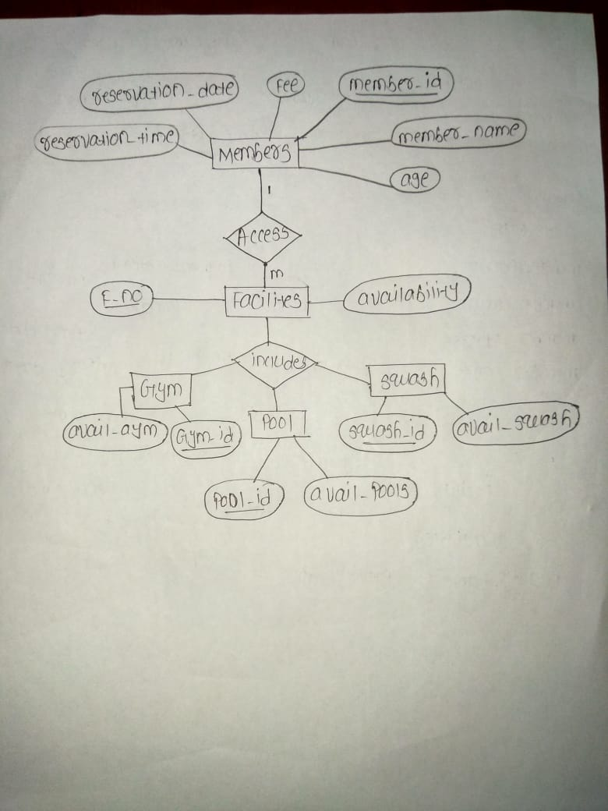

SCHEMA:

