**EXPERIMENT N0-4**

**Write Integrity Constraints for the specified system.**

**1. Domain constraints**

This constraint is used to define the datatype of the attribute so that a valid data is stored and used

The domain constraint we have used in our system are:

• Number

• Character (Integer)

• DATE

**2. Entity integrity constraints**

The entity integrity constraint states that primary key value can't be null.

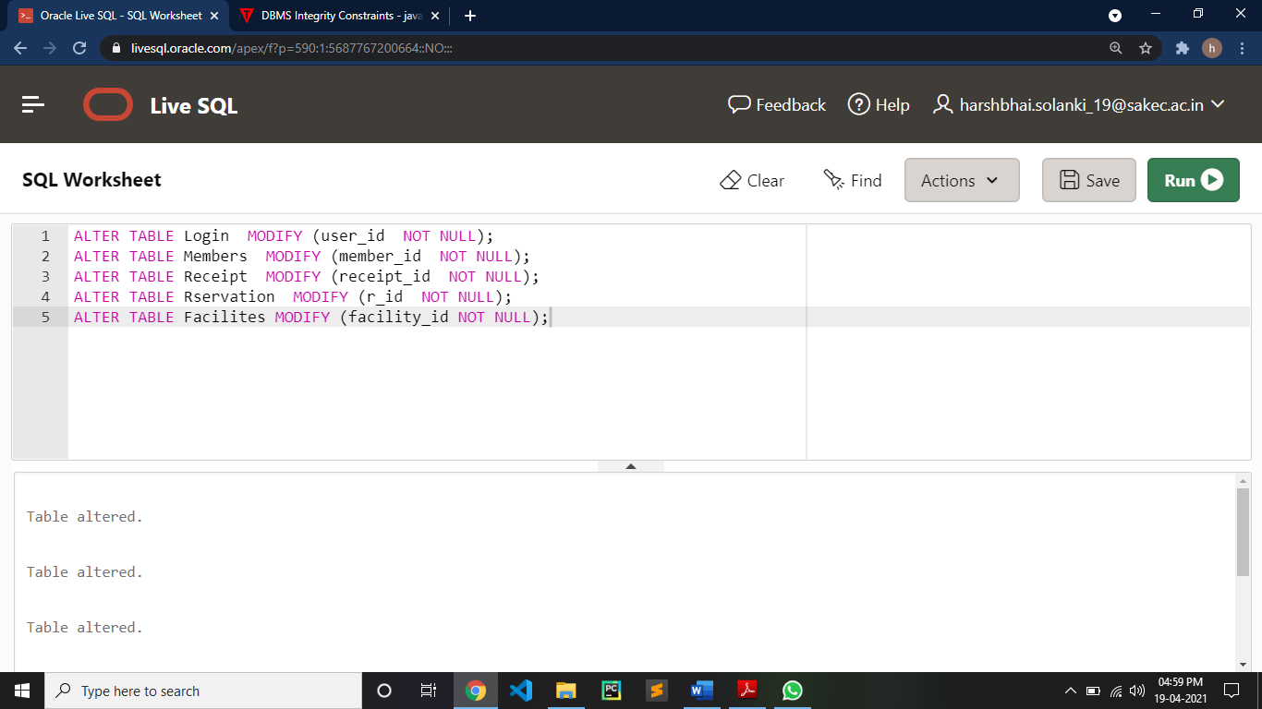

**3. Referential Integrity Constraints**

A referential integrity constraint is specified between two tables.

It is the foreign key of the table

1: ALTER TABLE Login ADD CONSTRAINT fk_login FOREIGN KEY(member_id) REFERENCES Members(member_id)

2: ALTER TABLE Members ADD CONSTRAINT fk_member FOREIGN KEY(receipt_id) REFERENCES Receipt(receipt_id)

3: ALTER TABLE Reservation ADD CONSTRAINT fk_reservation1 FOREIGN KEY(member_id) REFERENCES Members(member_id)

4: ALTER TABLE Reservation ADD CONSTRAINT fk_reservation2 FOREIGN KEY(facility_name) REFERENCES Facilities(facility_id);

5: ALTER TABLE Reservation ADD CONSTRAINT fk_reservation2 FOREIGN KEY(facility_name) REFERENCES Facilities(facility_name);

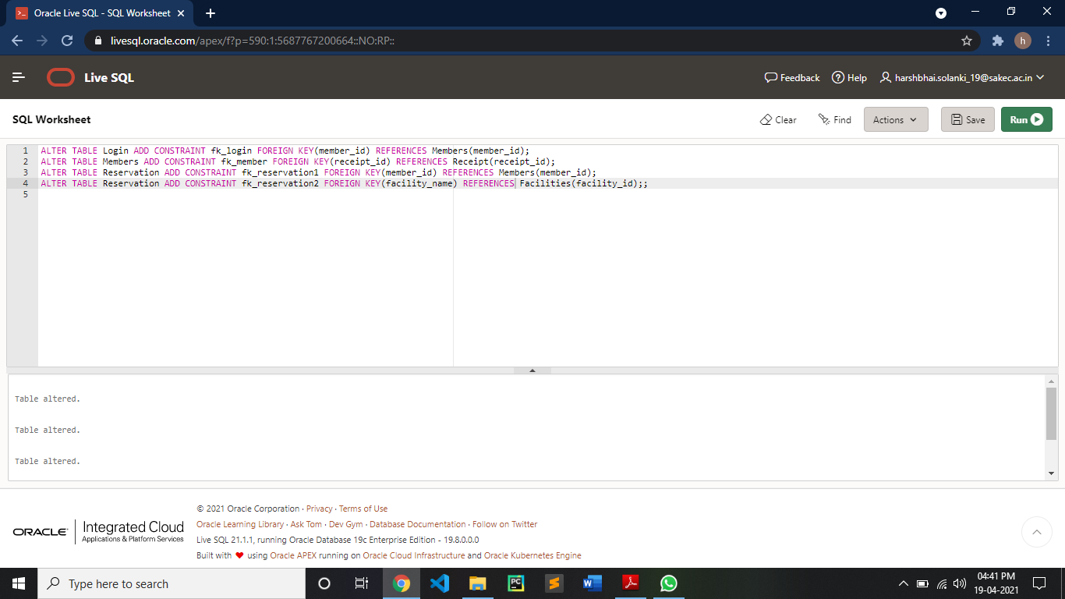

**4. Key constraints**

Keys are the entity set that is used to identify an entity within its entity set uniquely. Following is primary key constraint

ALTER TABLE Login MODIFY (user_id NOT NULL);

ALTER TABLE Members MODIFY (member_id NOT NULL);

ALTER TABLE Receipt MODIFY (receipt_id NOT NULL);

ALTER TABLE Rservation MODIFY (r_id NOT NULL);

ALTER TABLE Facilites MODIFY (facility_id NOT NULL);

