**EXPERIMENT N0-5**

**Write Simple queries, string manipulation operations for the**

**given statement of problem**.

**1: Find out the facility given to member having member_id ‘AH_04’**

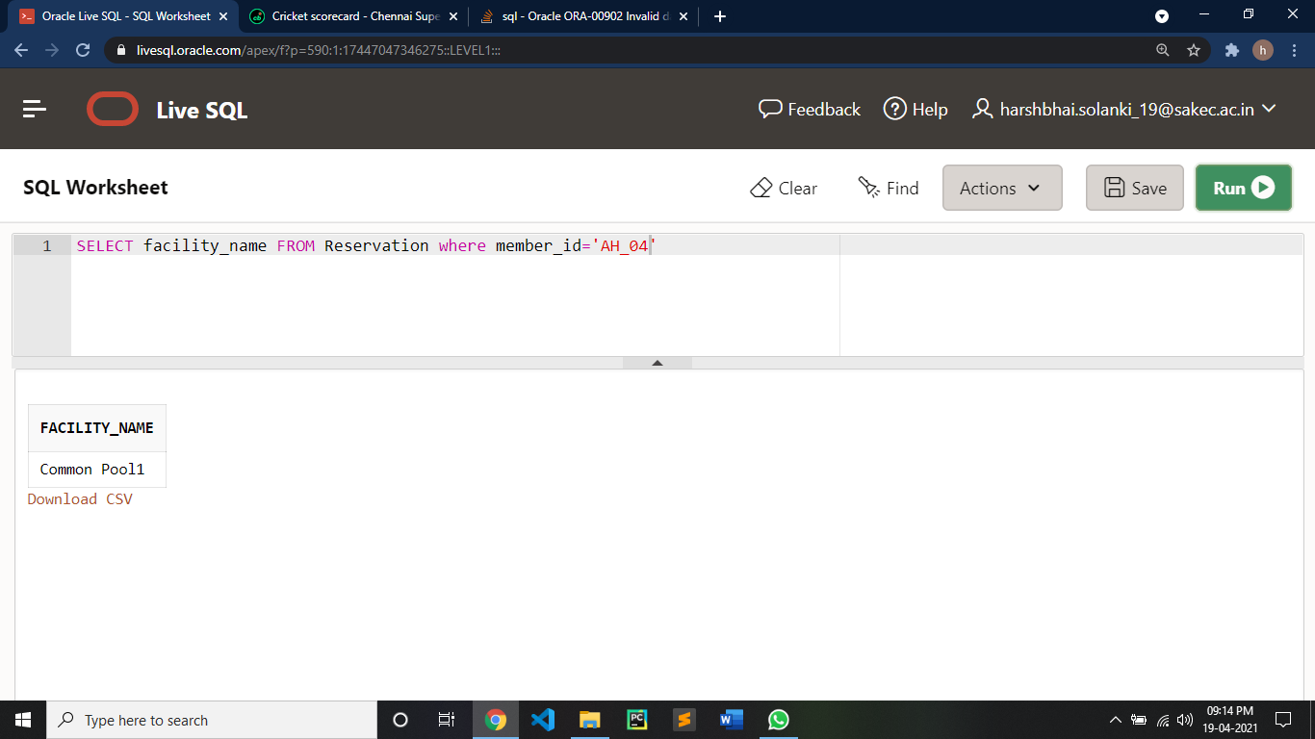

**2: What is capacity of facility gym**

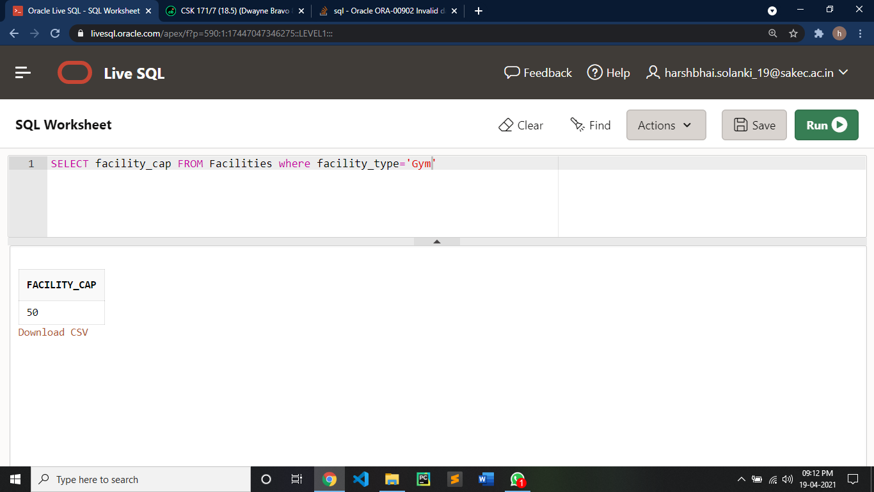

**3: Give on which date member AH_04 done reservation for the gym and what is the status of it**

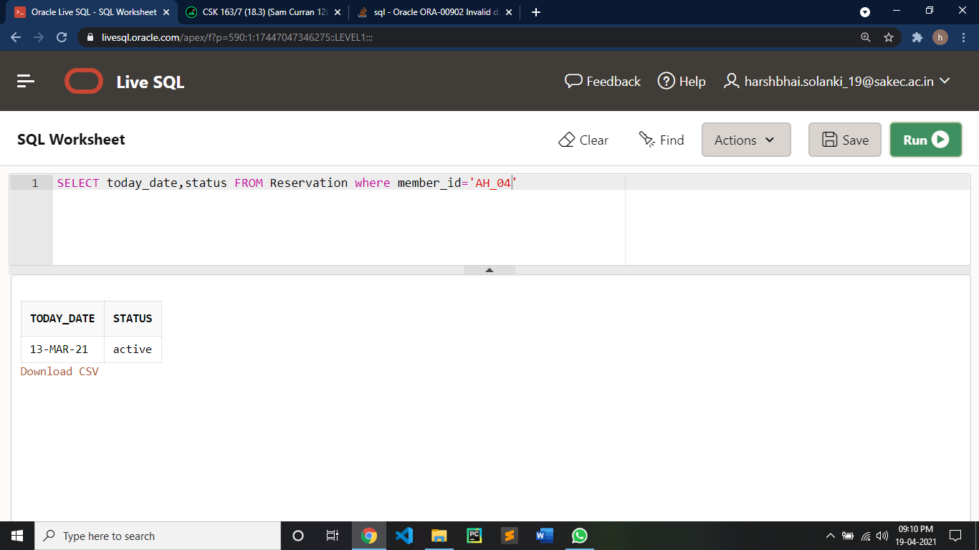

**4: Give the all details of facility taken by member AH_08**

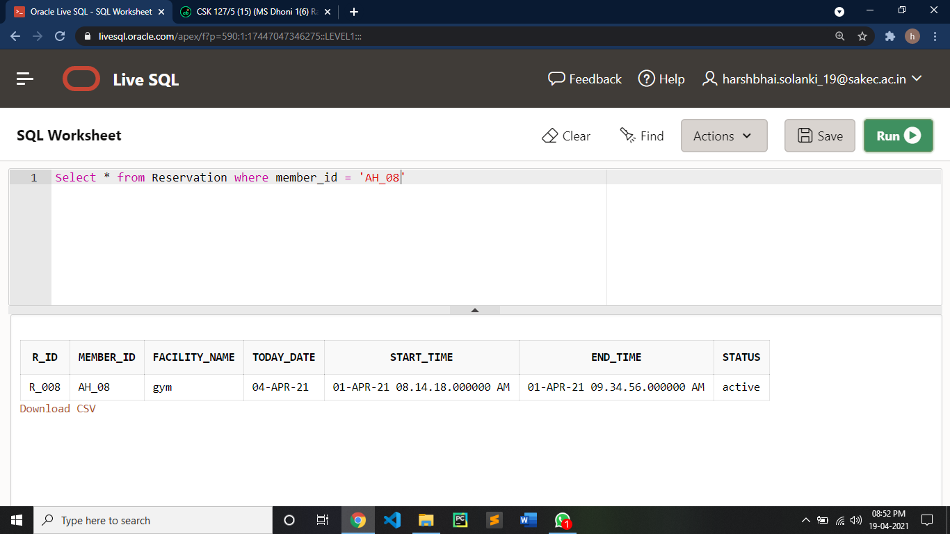

**5: Give receipt details for receipt id AHFCRN006**

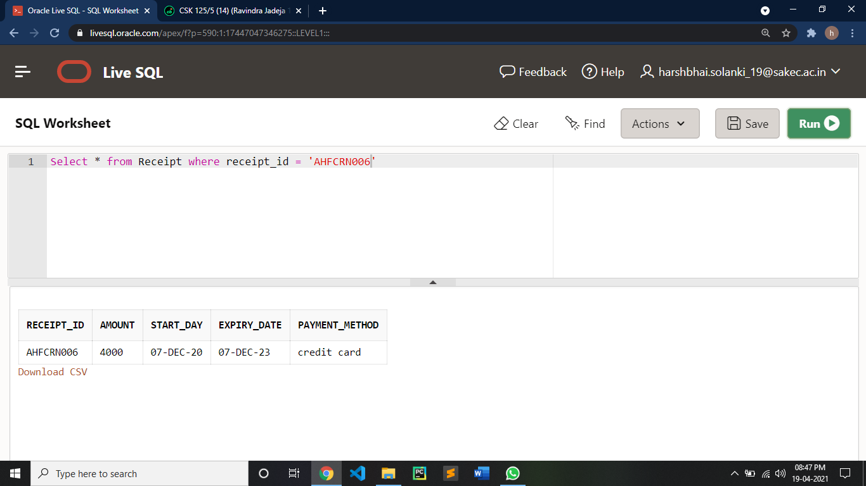

**6: Give the details of reservation done by R_003**

