**EXPERIMENT N0-2**

**Aim: Write shell scripts to do the following:**

1: Display top 10 processes in descending order

**CODE:**

echo The top 10 processes in descending order are :

ps -e | sort -r | head -10

**OUTPUT:**

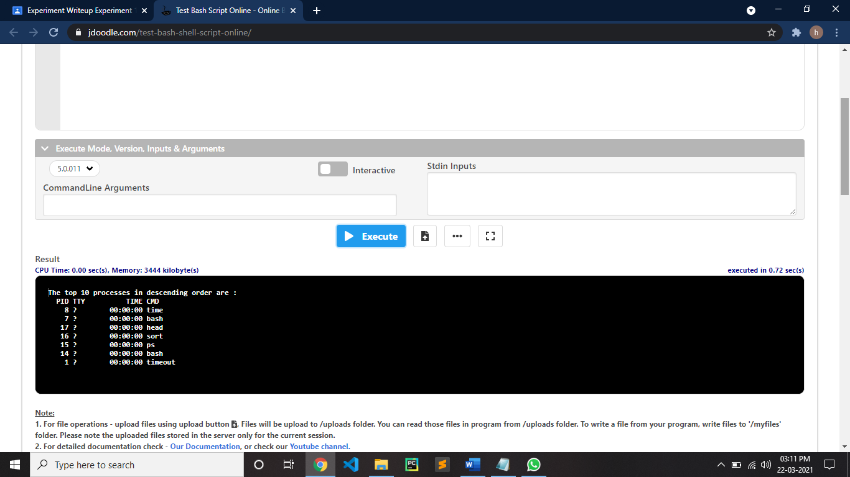

2: Display processes with highest memory usage.

**CODE:**

echo Processes with highest memory usage

ps aux | sort -k 4nr | head

**OUTPUT:**

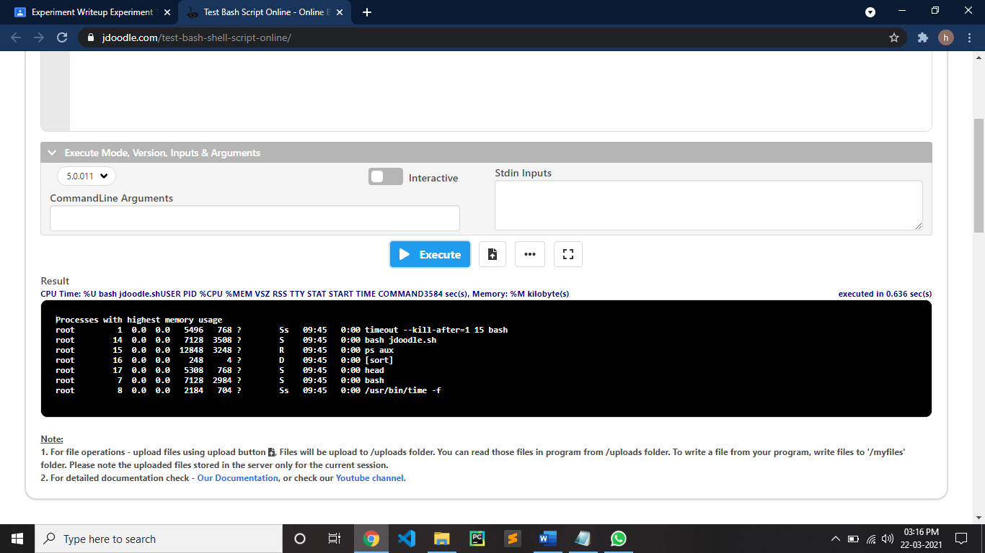

3: Display current logged in user and log name

**CODE:**

echo Current logged in user and log name

logname

**OUTPUT:**

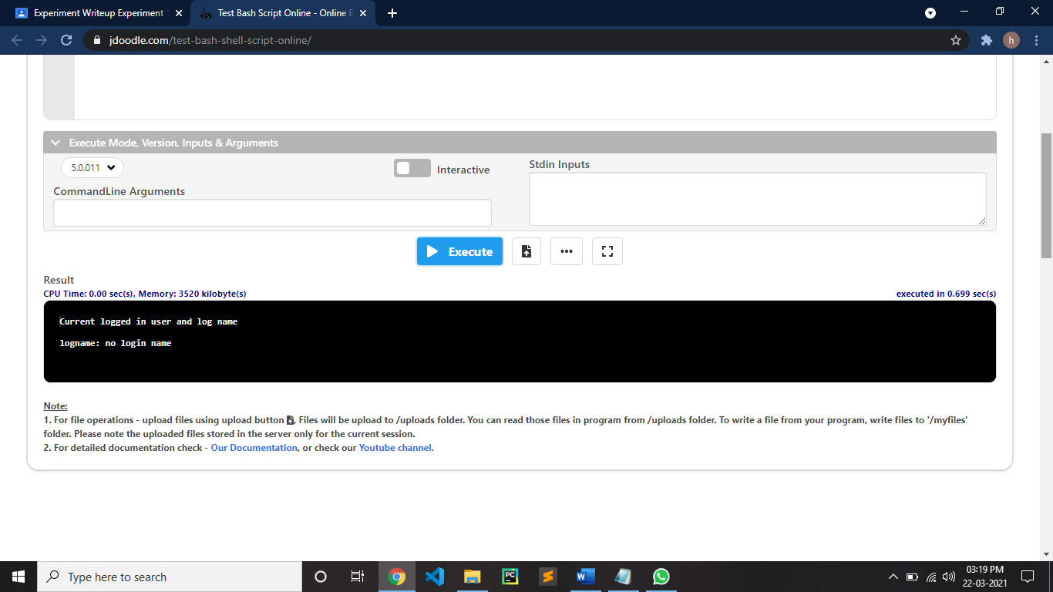

4: Display current shell, home directory, operating system type, current path setting, current working directory.

**CODE:**

echo Current shell

echo $SHELL

echo Home directory

echo $HOME

echo Operating System Type

echo $OSTYPE

echo Current path setting

echo $PATH

echo Current working directory

echo $PWD

**OUTPUT:**

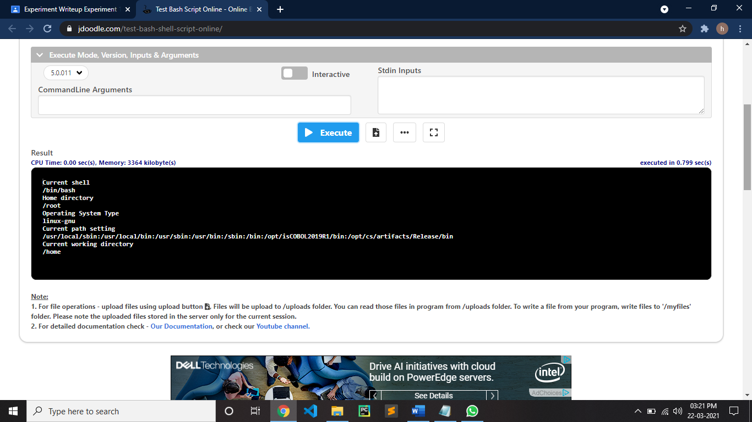

5: Display OS version, release number, kernel version

**CODE:**

echo OS version

uname -o

echo Release number

uname -r

echo kernel version

uname -v

**OUTPUT:**

