**EXPERIMENT N0-4**

**Aim : Implement basic command of linux : ls**

**CODE:**

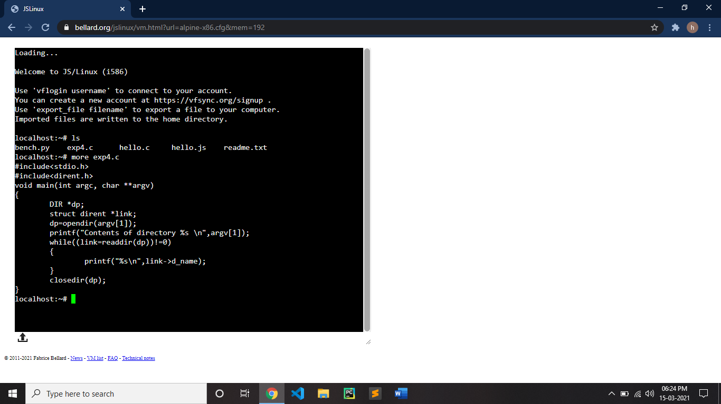

**OUTPUT:**

