**EXPERIMENT N0-11**

Write a program to perform following operations using numpy

1. Create a 6x6 matrix and fill it with a checkerboard pattern

[[0 1 0 1 0 1]

..........

[0 1 0 1 0 1]

[1 0 1 0 1 0]]

1. Create the following pattern without hardcoding. Use only numpy functions and the below input array

Input: a = np.array([1,2,3])

Desired Output:

array([1, 1, 1, 1, 2, 2, 2, 2, 3, 3, 3, 3, 1, 2, 3, 1, 2, 3, 1, 2, 3])

1. Add, subtract, multiply and divide two matrices.

**A- SOURCE CODE :-**

import numpy as np

x = np.ones((3,3))

print("Checkerboard pattern:")

x = np.zeros((6,6),dtype=int)

x[1::2,::2] = 1

x[::2,1::2] = 1

print(x)

**OUTPUT:**

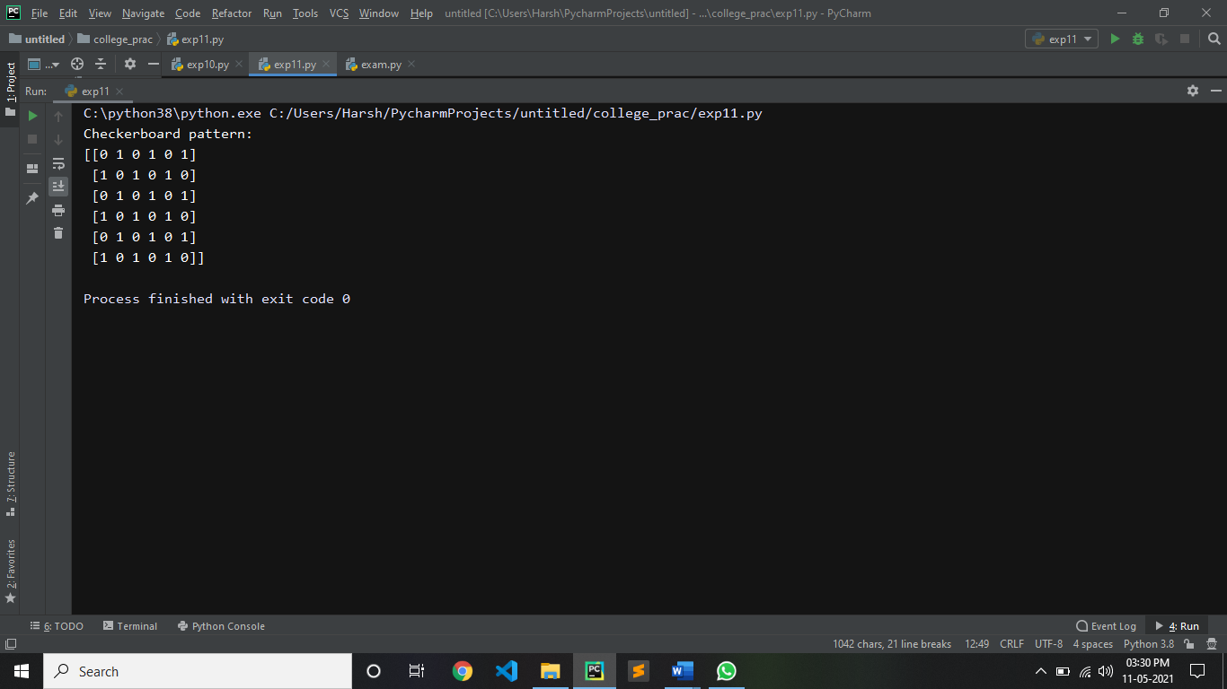

**B- SOURCE CODE :-**

from numpy import *

n1=int(input("enter the array size:"))

x1=zeros(n1,dtype=int)

u=len(x1)

i=0

while i<u:

x=int(input("enter the element:"))

x1[i]=x

i+=1

hstack((repeat(x1, 4),tile(x1, 3)))

print(r_[(repeat(x1, 4), tile(x1, 3))])

**OUTPUT:**

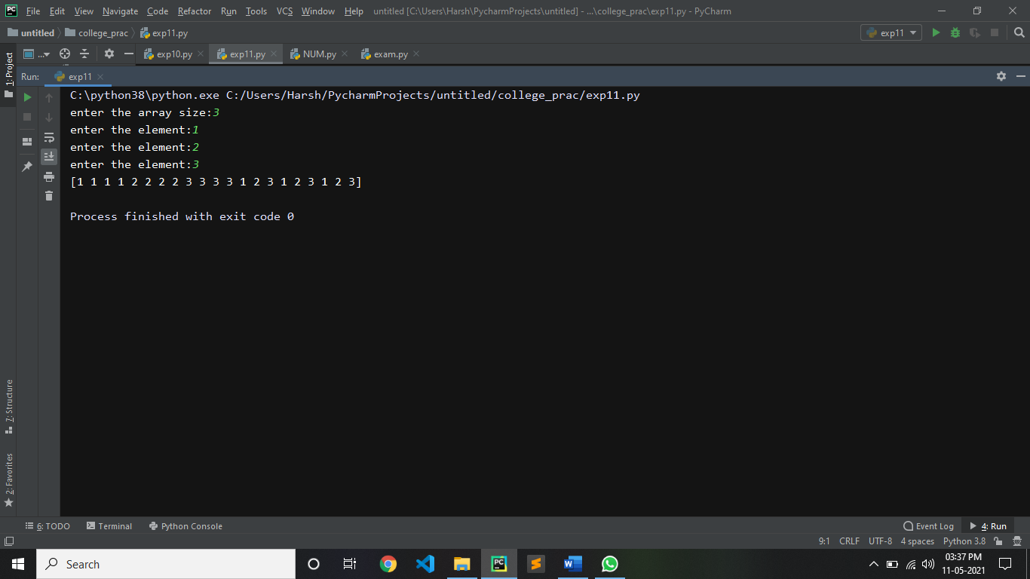

**C- SOURCE CODE :-**

Import numpy as np

R = int(input("Enter the number of rows for matrix1:"))

C = int(input("Enter the number of columns for matrix1:"))

print("Enter the entries in a single line (separated by space): ")

entries = list(map(int, input().split()))

matrix1 = np.array(entries).reshape(R, C)

print('Matrix 1 is\n',matrix1)

D = int(input("Enter the number of rows for matrix2:"))

F = int(input("Enter the number of columns for matrix2:"))

print("Enter the entries in a single line (separated by space): ")

entries = list(map(int, input().split()))

matrix2 = np.array(entries).reshape(D, F)

print('Matrix 2 is\n',matrix2,'\n')

print ('Addition of Matrix1 & Matrix2\n',np.add(matrix1,matrix2))

print ('Subtraction of Matrix1 & Matrix2\n',np.subtract(matrix1,matrix2))

print ('Multiplication of Matrix1 & Matrix2\n',np.multiply(matrix1,matrix2))

print ('Division of Matrix1 & Matrix2\n',np.divide(matrix1,matrix2))

**OUTPUT:**

