**EXPERIMENT N0-1**

1-A) Implement functions of n that calculate the following series. The sine function is part of the math module, so you need to say import math in the first line of your script. π is also in the math module and accessible as math.pi.

**Code:**

import math

def series(n):

s=0

p=1

for i in range(1,n+1):

s=s+(math.sin(i/math.pi))

p = p * (1-(1/(4*i*i)))

print(f"sum is: {s}")

print(f"product is: {p}")

if __name__ == '__main__':

n = int(input("Enter the number:"))

series(n)

**Output:**

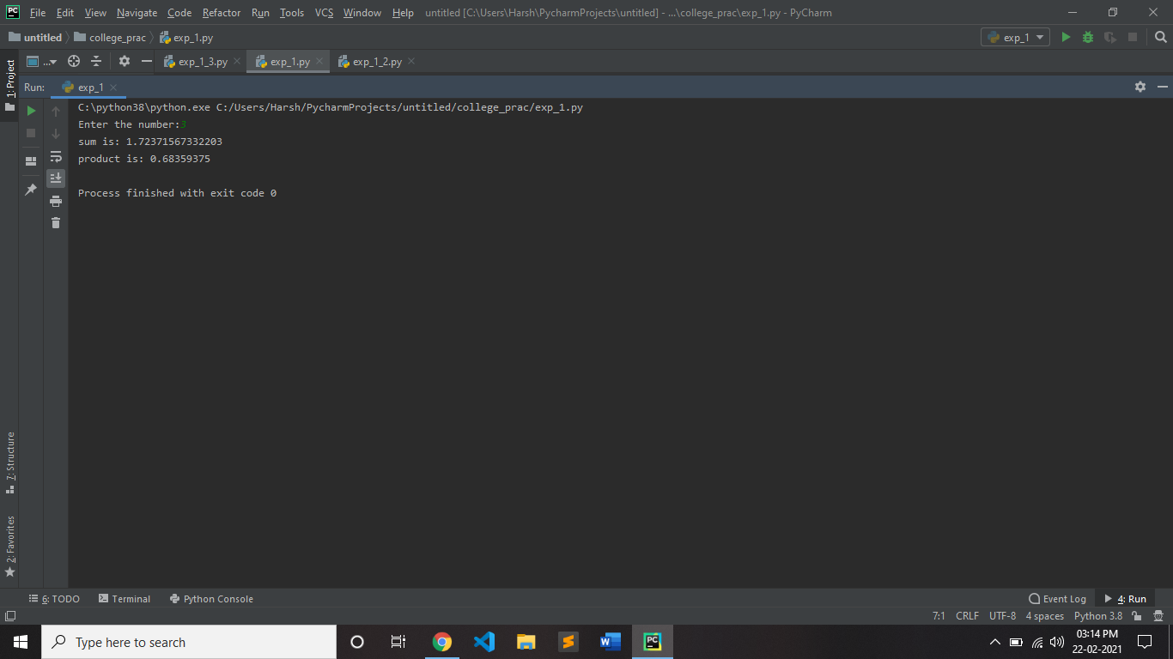

**1-B)** given the list of numbers, calculate arithmetic mean, geometric mean and harmonic mean

**Code:**

import statistics

l=[]

n=int(input("enter the number: "))

for i in range(0,n):

a=int(input(f"enter the value: "))

l.append(a)

print("values are:")

for e in l:

print(e," ",end = ' ')

are=statistics.mean(l)

geo=statistics.geometric_mean(l)

har=statistics.harmonic_mean(l)

print()

print(f"arithmetic mean is: {are}")

print(f"geometric mean is: {geo}")

print(f"harmonic mean is: {har}")

**output:**

