**EXPERIMENT N0-2**

**1. Write a function that takes a word and changes all vowels to the next vowel (cyclically): a to e; e to I; I to o; o to u; u to a.**

**CODE:**

def vowels(word1):

x = ""

l = list(word1)

for i in range(len(l)):

if l[i] == 'a':

l[i] = 'e'

elif l[i] == 'e':

l[i] = 'i'

elif l[i] == 'i':

l[i] = 'o'

elif l[i] == 'o':

l[i] = 'u'

elif l[i] == 'u':

l[i] = 'a'

elif l[i] == 'A':

l[i] = 'E'

elif l[i] == 'E':

l[i] = 'I'

elif l[i] == 'I':

l[i] = 'O'

elif l[i] == 'O':

l[i] = 'U'

elif l[i] == 'U':

l[i] = 'A'

for ele in l:

x += ele

return print(f"after changing {x}")

if __name__ == '__main__':

str = input("Enter the word : ")

vowels(str)

**OUTPUT:**

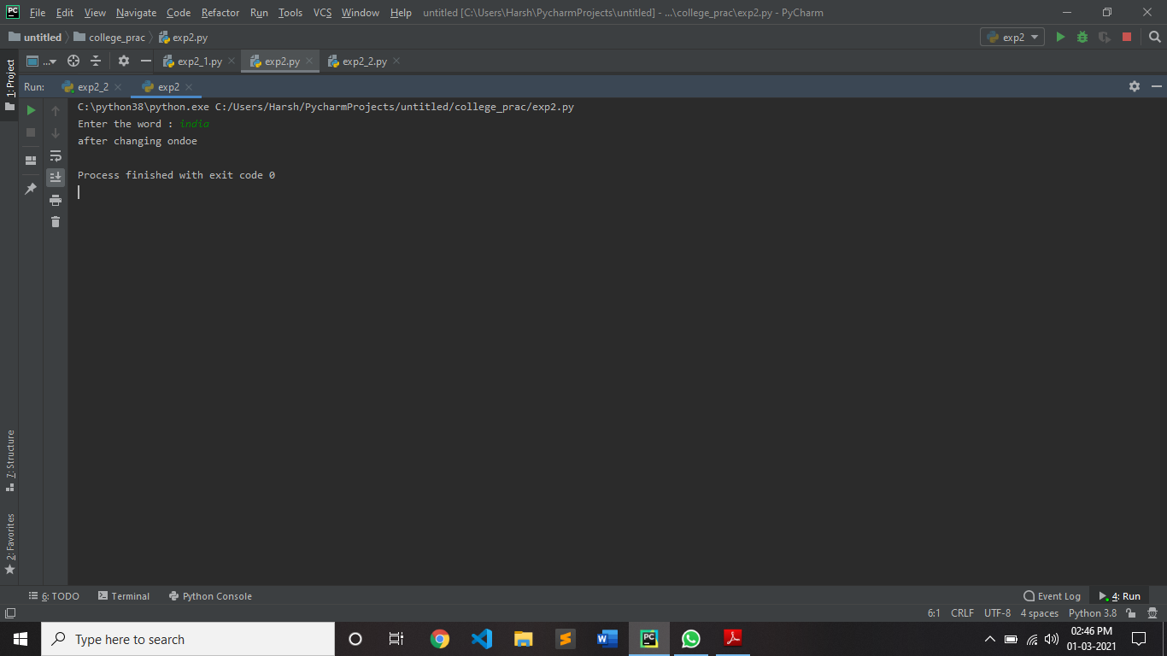

**2. Write a function which takes a C program statement as input and display all the tokens.**

**CODE:**

def token(statement1):

int_data_type = ['int', 'signed int', 'unsigned int', 'short int',

'signed short int', 'unsigned short int',

'long int', 'signed long int', 'unsigned long int']

float_data_type = ['float', 'double', 'long double']

character_data_type = ['char', 'signed char', 'unsigned char']

void_data_type = ['void']

keywords = ['auto', 'double', 'int', 'struct', 'break', 'else',

'long', 'switch', 'case', 'enum', 'register', 'typedef',

'char', 'extern', 'return', 'union', 'continue', 'for',

'signed', 'void', 'do', 'if', 'static', 'while', 'default',

'goto', 'sizeof', 'volatile', 'const', 'float', 'short',

'unsigned']

delimiter = [',', ';', '"', "'", '{', '}', '|', '/', '\\']

special_characters = ['~', '!', '#', '$', '%', '^', '&', '*', '(', ')',

'_', '+', '|', '\\', '`', '-', '=', '{', '}', '[',

']', ':', '"', ';', '<', '>', '?', ',', '.', '/']

operators = ['+', '-', '*', '/', '%', '++', '--', '==', '!=', '>', '<',

'>=', '<=', '&&', '||', '!', '&', '|', '^', '~', '<<', '>>',

'=', '+=', '-=', '*=', '/=', '%=', '<<=', '>>=', '&=', '^=',

'|=', '*', '?:', '->']

lst1 = list(statement1.split())

for i in range(len(lst1)):

flag = 0

if lst1[i] in keywords:

print(lst1[i], ": Keyword")

flag = 1

if lst1[i] in special_characters:

print(lst1[i], ": Special Character")

flag = 1

if lst1[i] in int_data_type:

print(lst1[i], ": INT data type")

elif lst1[i] in float_data_type:

print(lst1[i], ": FLOAT data type")

elif lst1[i] in character_data_type:

print(lst1[i], ": CHAR data type")

elif lst1[i] in void_data_type:

print(lst1[i], ":VOID data type")

elif lst1[i] in operators:

print(lst1[i], ": Operator")

elif lst1[i] in delimiter:

print(lst1[i], ": Delimiter")

elif lst1[i].isnumeric():

print(lst1[i], ": Number")

else:

if flag == 0:

b = list(lst1[i])

n = len(b)

if n == 3 and b[0] == b[n - 1] and (b[0] == '"' or b[0] == "'"):

print(lst1[i], ": Character Constant")

elif b[0] == b[n - 1] and (b[0] == '"' or b[0] == "'"):

print(lst1[i], ": String")

else:

print(lst1[i], ": Variable")

statement = input("Enter the Statement : ")

token(statement)

**OUTPUT:**

