**EXPERIMENT N0-3**

**AIM:** Write a menu driven python program to implement the following. Find the longest word in a list of words Check if each element in the input list is at least as big as the one before it. Reverse a list using recursion. Find transpose of a given matrix using list comprehension.

**CODE:**

def listsort():

l=[]

n=int(input("enter the number of elements in list: "))

for i in range(0,n):

a=int(input(f"enter the value: "))

l.append(a)

x=l[:]

x.sort()

if(l==x):

print("list is sorted")

else:

print("list is not sorted")

def longestLength(a):

max1 = len(a[0])

temp = a[0]

for i in a:

if (len(i) > max1):

max1 = len(i)

temp = i

print("The word with the longest length is:", temp, " and length is ", max1)

def reverse_list(NumList, num):

j = n - 1

i = 0

while (i < j):

temp = NumList[i]

NumList[i] = NumList[j]

NumList[j] = temp

i = i + 1

j = j - 1

def transpose():

r=int(input("ENTER THE NUMBER OF ROWS: "))

c= r=int(input("ENTER THE NUMBER OF COLUMNS: "))

m=[[int(input("Enter the no:"+str(i)+" "+str(j)+":")) for j in range (c)] for i in range (r)]

print("original matrix is:")

for k in m:

print(k)

rez = [[m[j][i] for j in range(c)] for i in range(r)]

print("transpose of matrix is:")

for row in rez:

print(row)

if __name__ == '__main__':

while(True):

print("******************* MENU *******************")

print("1: LONGEST WORD IN LIST")

print("2: CHECK LIST IS SORTED OR NOT")

print("3: REVERSE OF THE LIST")

print("4: TRANSPOSE OF MATRIX")

op=int(input("ENTER YOUR CHOICE:"))

if op==1:

lst = []

n = int(input("Enter number of elements IN LIST : "))

for i in range(0, n):

ele = input("Enter the elements : ")

lst.append(ele)

longestLength(lst)

elif op==2:

listsort()

elif op==3:

a = []

n = int(input("Enter total number of list: "))

for i in range(1, n + 1):

inp = int(input("Please enter the Value of %d Element : " % i))

a.append(inp)

print("Original list is", a)

reverse_list(a, n)

print("The Result of a Reverse List = ", a)

elif op==4:

transpose()

else:

print("wrong input")

print("Press q to quit and c to continue:",end=" ")

ch = ""

while (ch!= "c" and ch!= "q"):

ch = input()

if ch == "q":

exit()

elif ch == "c":

continue

**OUTPUT:**

1: LONGEST WORD IN LIST

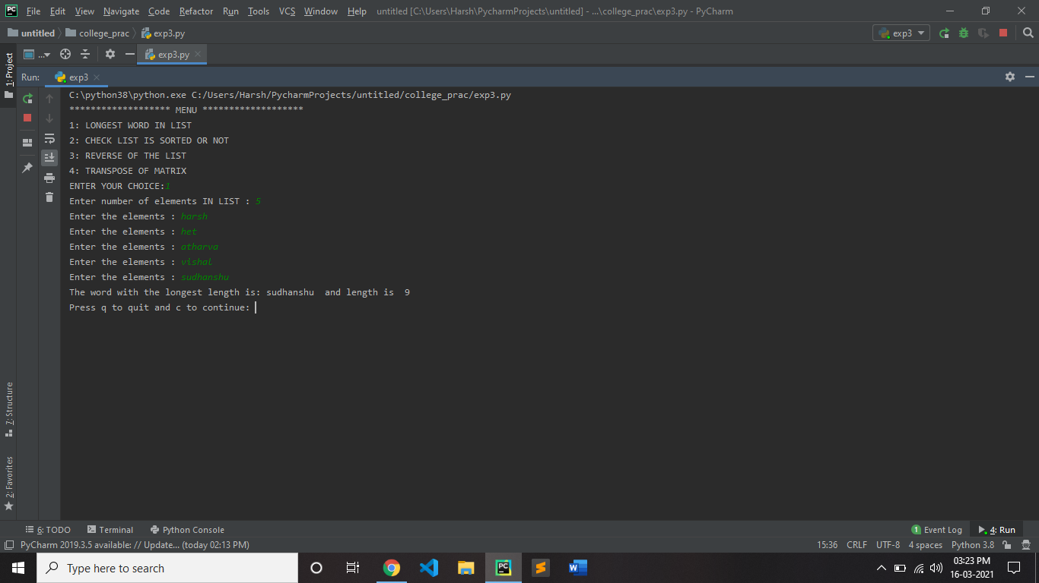

2: CHECK LIST IS SORTED OR NOT

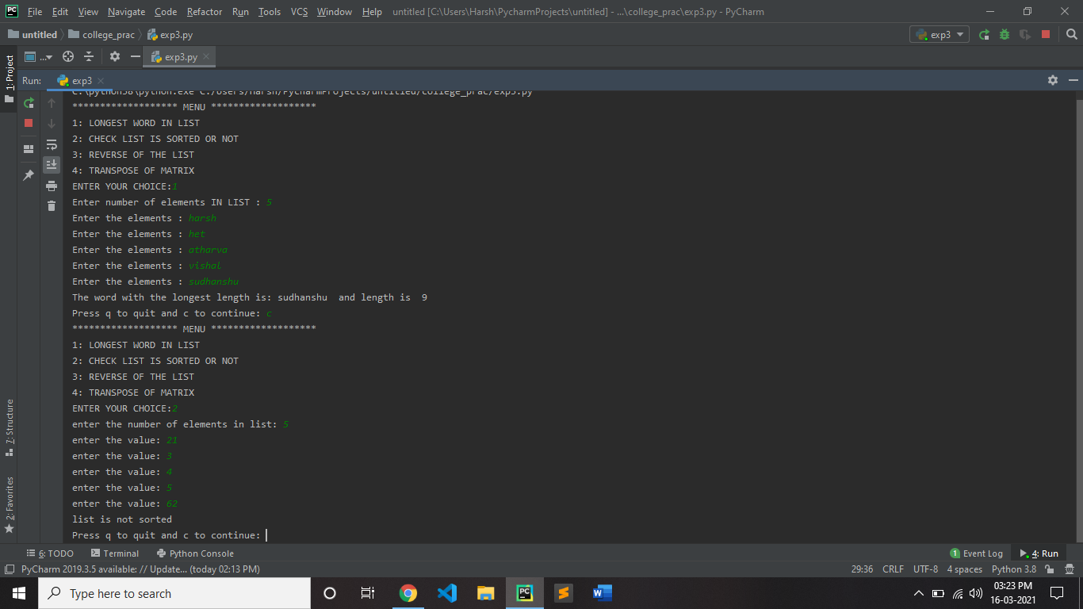

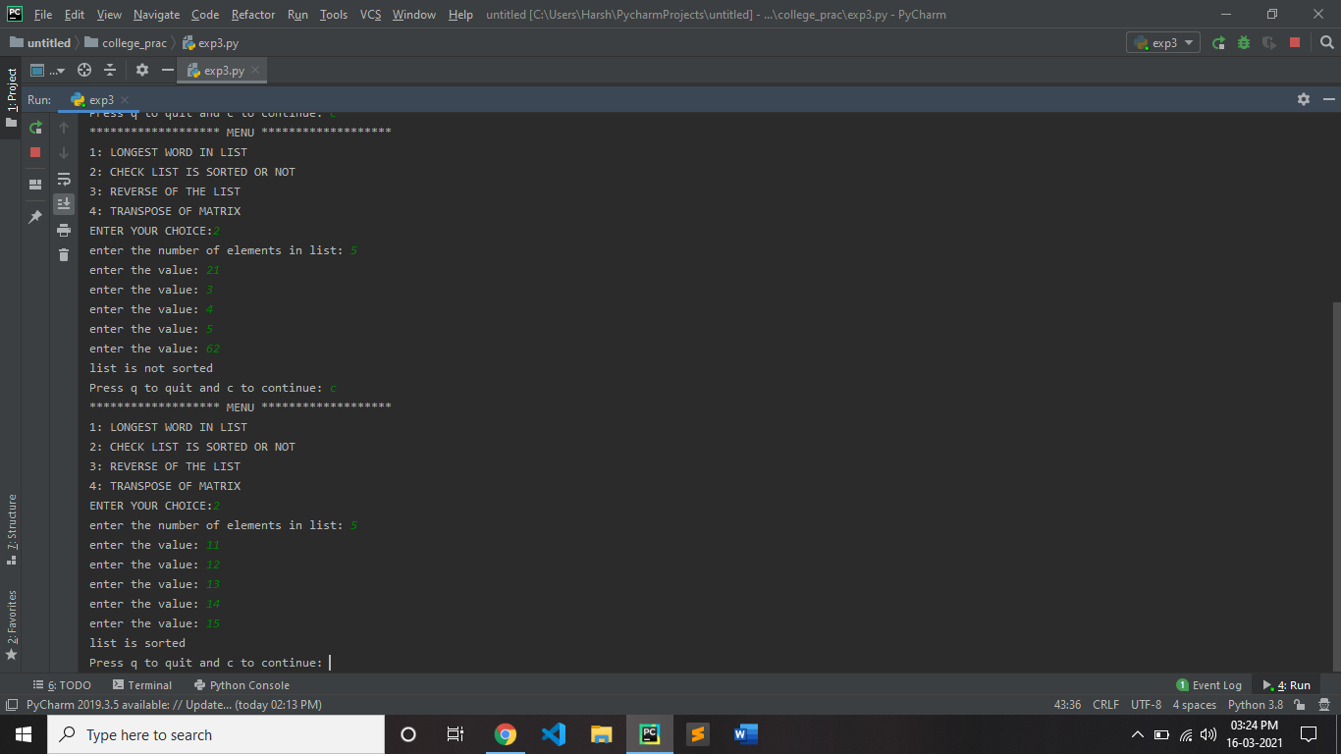

3: REVERSE OF THE LIST

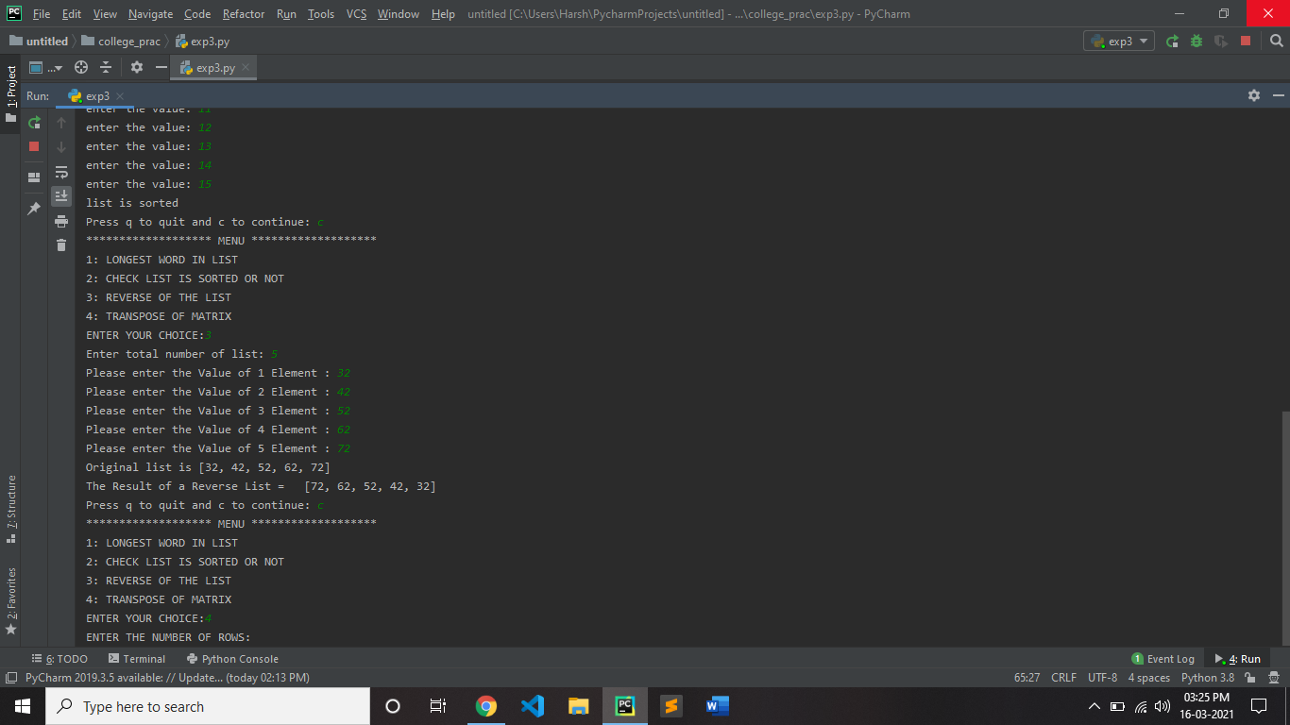

4: TRANSPOSE OF MATRIX

