**EXPERIMENT N0-4**

**AIM:** Write a menu driven python program to implement the following. a) Find if two input lists are disjoint or not. b) Count the frequency of each character in the given input string.c) Accept a comma separated sequence of words as input and prints the unique words in sorted form (alphanumerically).

**CODE:**

def areDisjoint():

l1 = []

l2 = []

x = int(input("enter the number of element of l1:"))

for i in range(x):

a = int(input("enter the value:"))

l1.append(a)

y = int(input("enter the number of element of l2:"))

for i in range(y):

b = int(input("enter the value:"))

l2.append(b)

s1=set(l1)

s2=set(l2)

if (s1.isdisjoint(s2)):

print("lists are disjoint")

else:

print("lists are not disjoint")

def count():

line = input("Enter a string: ")

count = {i: line.count(i) for i in set(line)}

print("Frequency of characters are as follows: "+str(count))

def sort():

line = input("Enter a comma separated words string: ")

line = set(line.split(','))

x=list(line)

for i in x:

print(i)

print("The sorted unique words are ")

x.sort()

for i in x:

print(i)

if __name__ == "__main__":

while (True):

print("******************* MENU *******************")

print("1: CHECK LISTS ARE DISJOINT OR NOT")

print("2: COUNT FREQUENCY OF CHARACTER IN STRING")

print("3: SORT THE WORDS")

op = int(input("ENTER YOUR CHOICE:"))

if op == 1:

areDisjoint()

elif op == 2:

count()

elif op == 3:

sort()

else:

print("wrong input")

print("Press q to quit and c to continue:", end=" ")

ch = ""

while (ch != "c" and ch != "q"):

ch = input()

if ch == "q":

exit()

elif ch == "c":

continue

**OUTPUT:**

1: CHECK LISTS ARE DISJOINT OR NOT

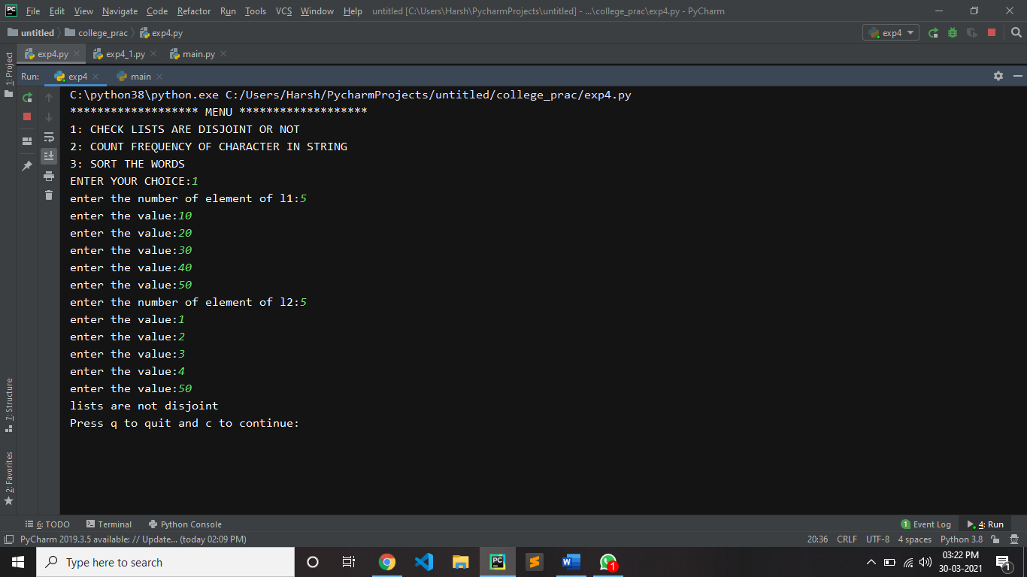

2: COUNT FREQUENCY OF CHARACTER IN STRING

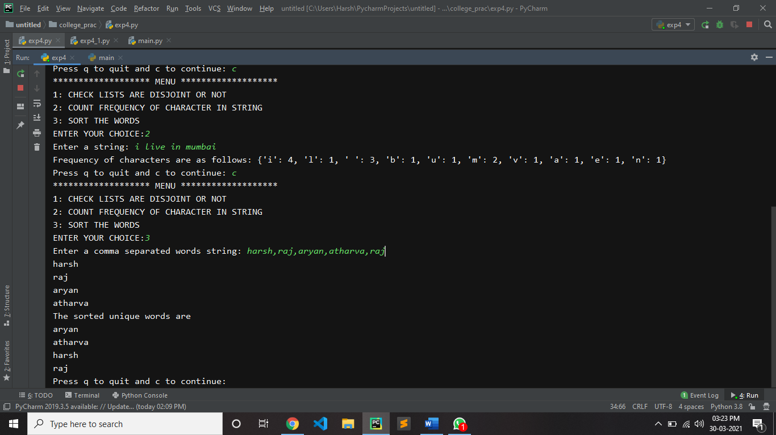

3: SORT THE WORDS

