**EXPERIMENT N0-6**

Write a python program to implement the following:

1:To read content of one file and write to another file.

**SOURCE CODE:-**

with open('input.txt','r') as f:

text=f.read()

with open('output.txt','w') as o:

o.write(text)

print("file one is written to file two")

**OUTPUT:**

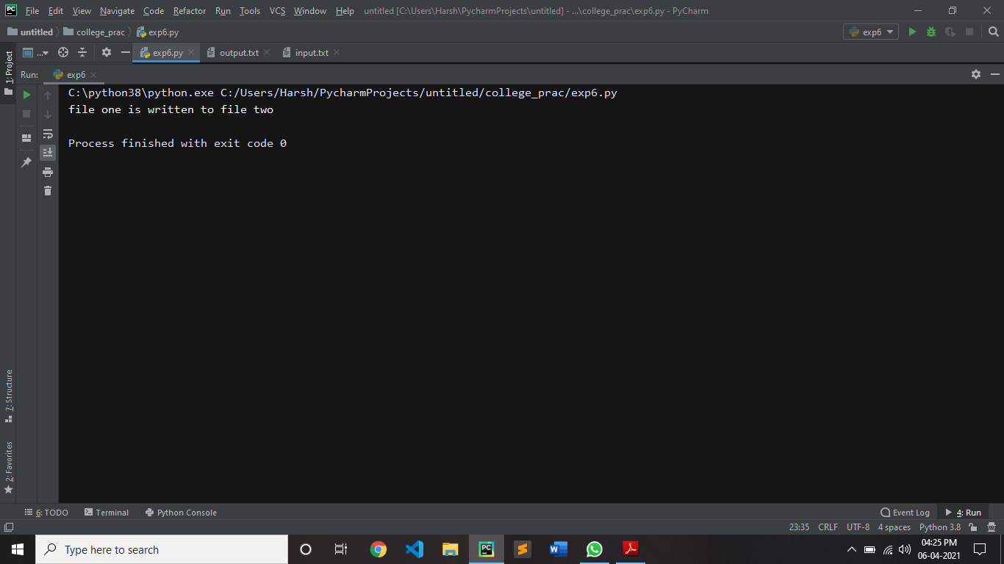

INPUT.TXT

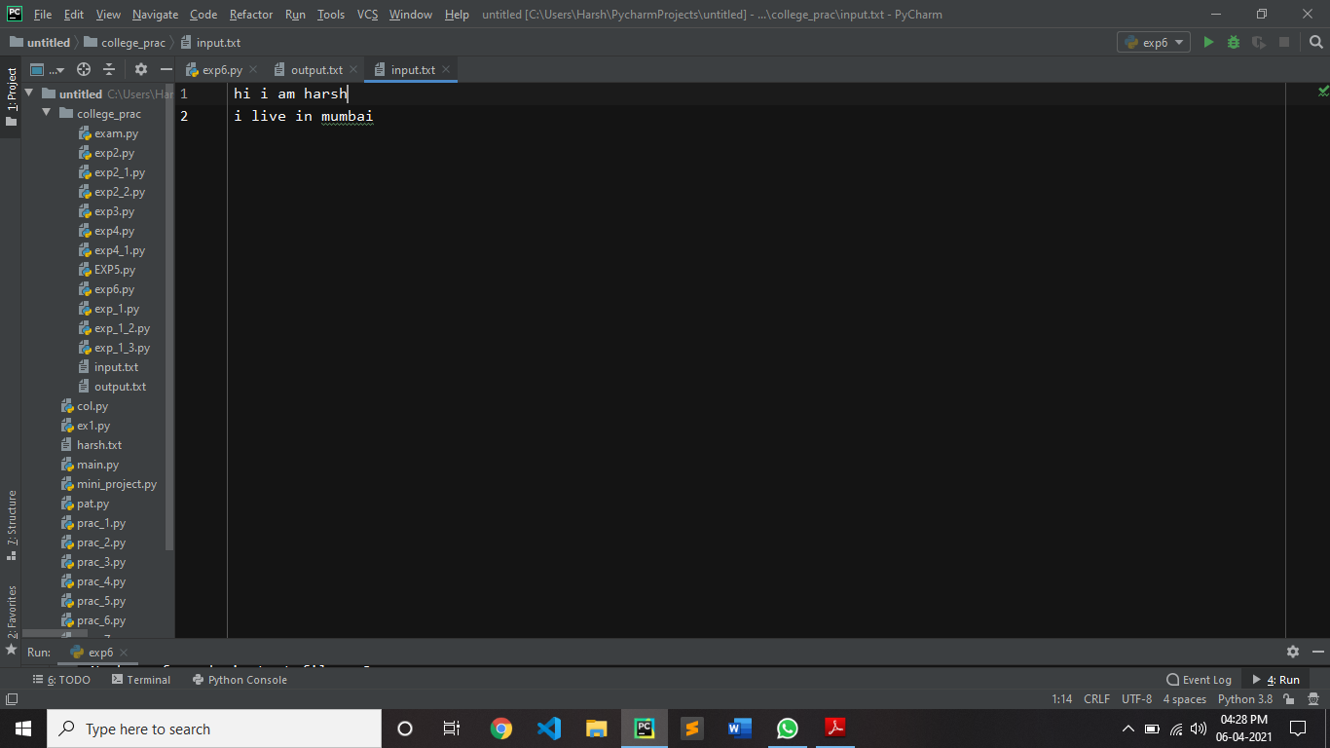

OUTPUT.TXT

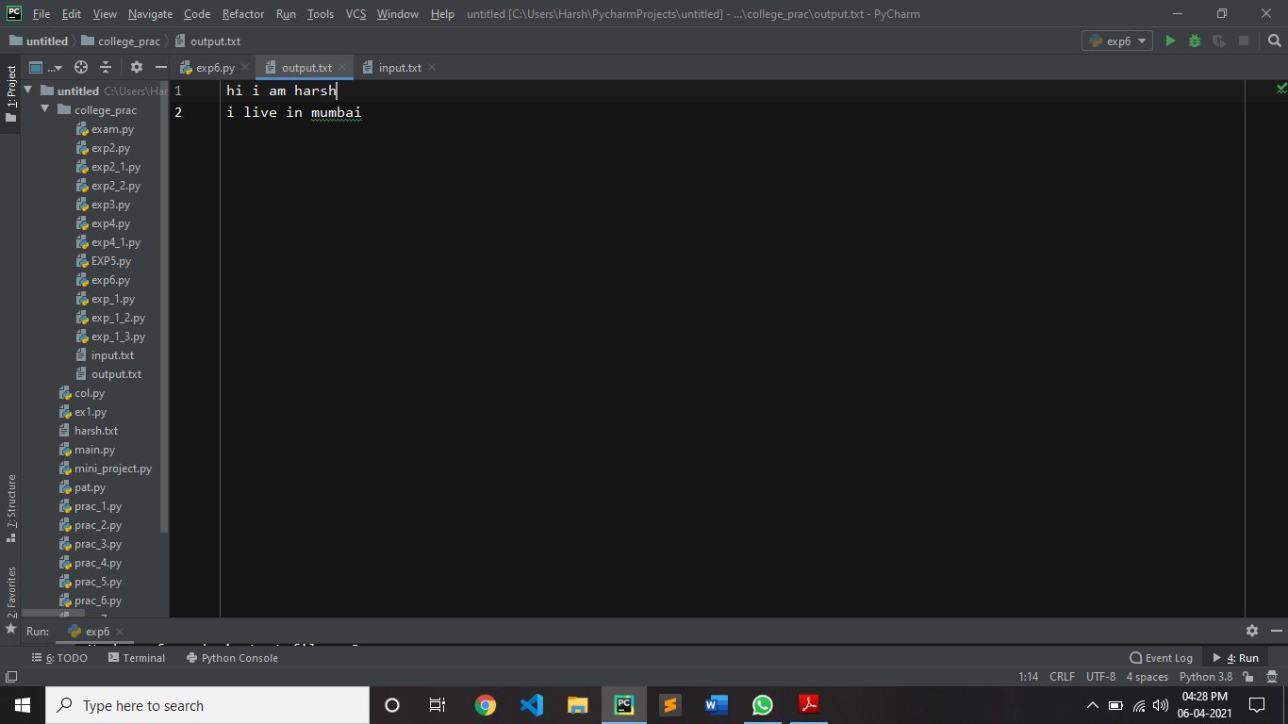

b) Count number of lines, words and characters in a file.

**SOURCE CODE:**

file = open("input.txt", "r")

Counter = 0

Content = file.read()

CoList = Content.split("\n")

for i in CoList:

if i:

Counter += 1

print("This is the number of lines in the file")

print(Counter)

b = open("input.txt", "rt")

c = b.read()

words= c.split()

print('Number of words in text file :', len(words))

x = open("input.txt", "r")

data = x.read()

number_of_characters = len(data)

print('Number of characters in text file :', number_of_characters)

**OUTPUT:**

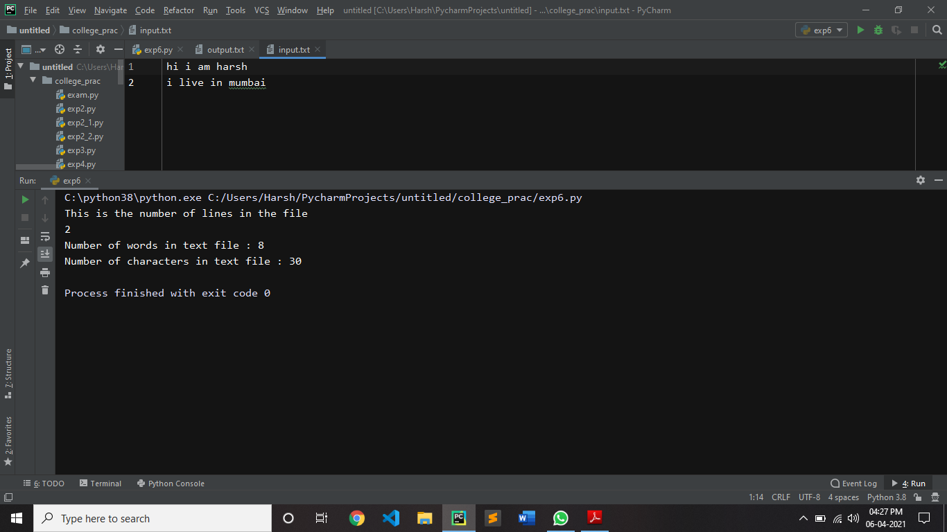

c) To display files available in current directory.

**SOURCE CODE:**

import os

k = os.listdir('.')

print(k)

**OUTPUT:**