**EXPERIMENT N0-7**

WRITE A PYTHON PROGRAM TO BUILD PAKAGE AND MODULE FOR STACK AND QUEUE

**SOURCE CODE:-**

**Main.py:**

import college_prac.stack

import college_prac.queue

q=college_prac.queue.Queue()

s=college_prac.stack.Stack()

if __name__ == "__main__":

while (True):

print("******************* MENU *******************")

print("1: STACK")

print("2: QUEUE")

x=int(input("ENTER YOUR CHOICE"))

if(x==1):

while (True):

print("******************* STACK *******************")

print("1: PUSH")

print("2: POP")

print("3: PEEK")

print("4: DISPLAY")

op = int(input("ENTER YOUR CHOICE:"))

if op == 1:

s.push()

elif op == 2:

s.pop()

elif op == 3:

s.peek()

elif op == 4:

s.print()

else:

print("wrong input")

print("Press q to quit and c to continue:", end=" ")

ch = ""

while (ch != "c" and ch != "q"):

ch = input()

if ch == "q":

exit()

elif ch == "c":

continue

elif(x==2):

while (True):

print("******************* QUEUE *******************")

print("1: ENQUEUE")

print("2: DEQUEUE")

print("3: PEEK")

print("4: DISPLAY")

op = int(input("ENTER YOUR CHOICE:"))

if op == 1:

q.enqueue()

elif op == 2:

q.dequeue()

elif op == 3:

q.peek()

elif op == 4:

q.print()

else:

print("wrong input")

print("Press q to quit and c to continue:", end=" ")

ch = ""

while (ch != "c" and ch != "q"):

ch = input()

if ch == "q":

exit()

**stack.py:**

class Stack:

stack=[]

def push(self):

s1=int(input("entre the number to push:"))

self.stack.append(s1)

def pop(self):

if(self.isempty()):

print("stack is empty")

else:

s2=self.stack.pop()

print(f"{s2} is poped")

def peek(self):

if (self.isempty()):

print("stack is empty")

else:

s3=self.stack[-1]

print(f"{s3} is peek element")

def isempty(self):

if self.stack == []:

return True

else:

return False

def print(self):

if (self.isempty()):

print("stack is empty")

else:

print("element of stack are:")

for i in self.stack:

print(i)

**queue.py:**

class Queue:

q=[]

def enqueue(self):

s1=int(input("entre the number to push:"))

self.q.append(s1)

def dequeue(self):

if(self.isempty()):

print("queue is empty")

else:

s2=self.q.pop(0)

print(f"{s2} is dequeued")

def peek(self):

if (self.isempty()):

print("queue is empty")

else:

s3=self.q[0]

print(f"{s3} is peek element")

def isempty(self):

if self.q == []:

return True

else:

return False

def print(self):

if (self.isempty()):

print("queue is empty")

else:

print("element of queue are:")

for i in self.q:

print(i)

**OUTPUT:**

STACK:

PUSH:

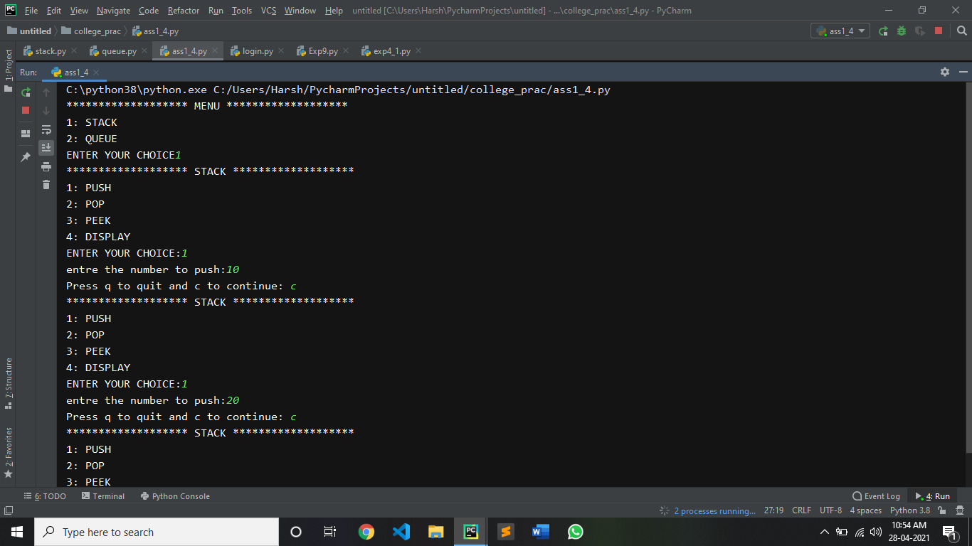

POP:

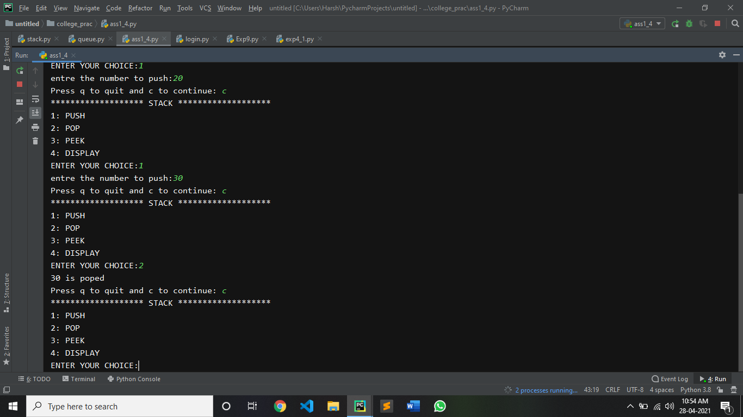

PEEK AND DISPLAY:

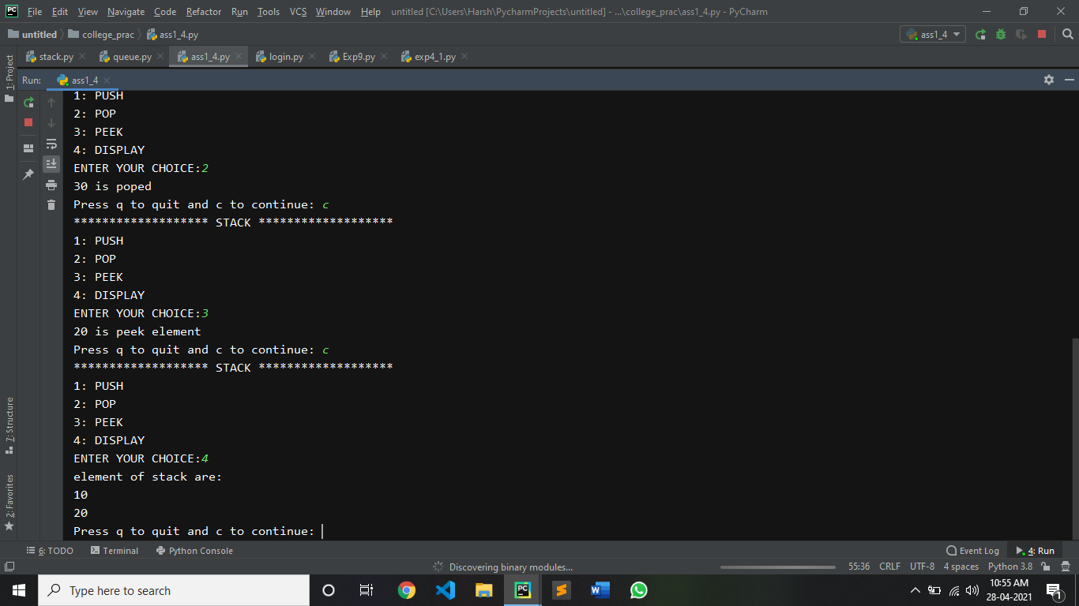

QUEUE:

ENQUEUE:

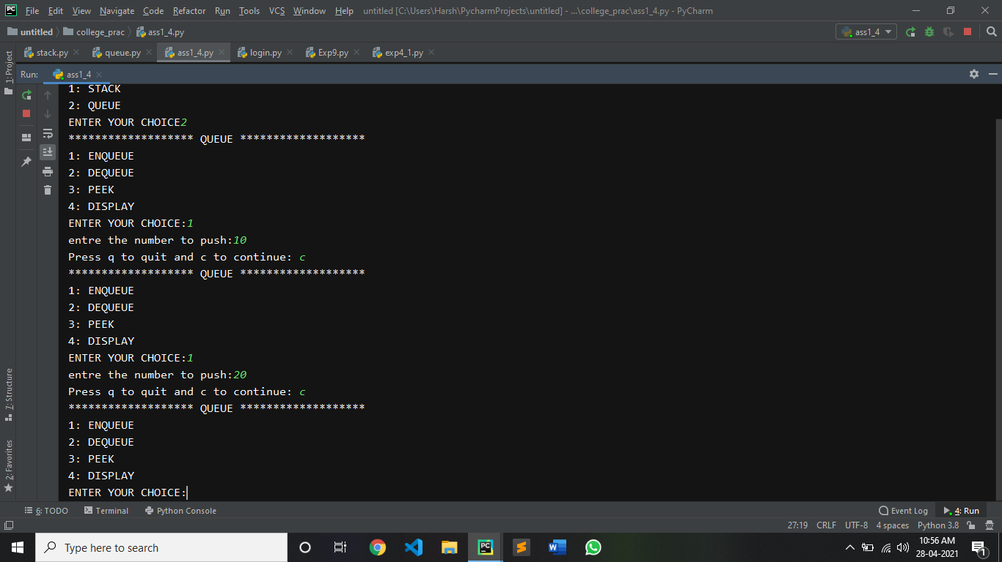

DEQUEUE:

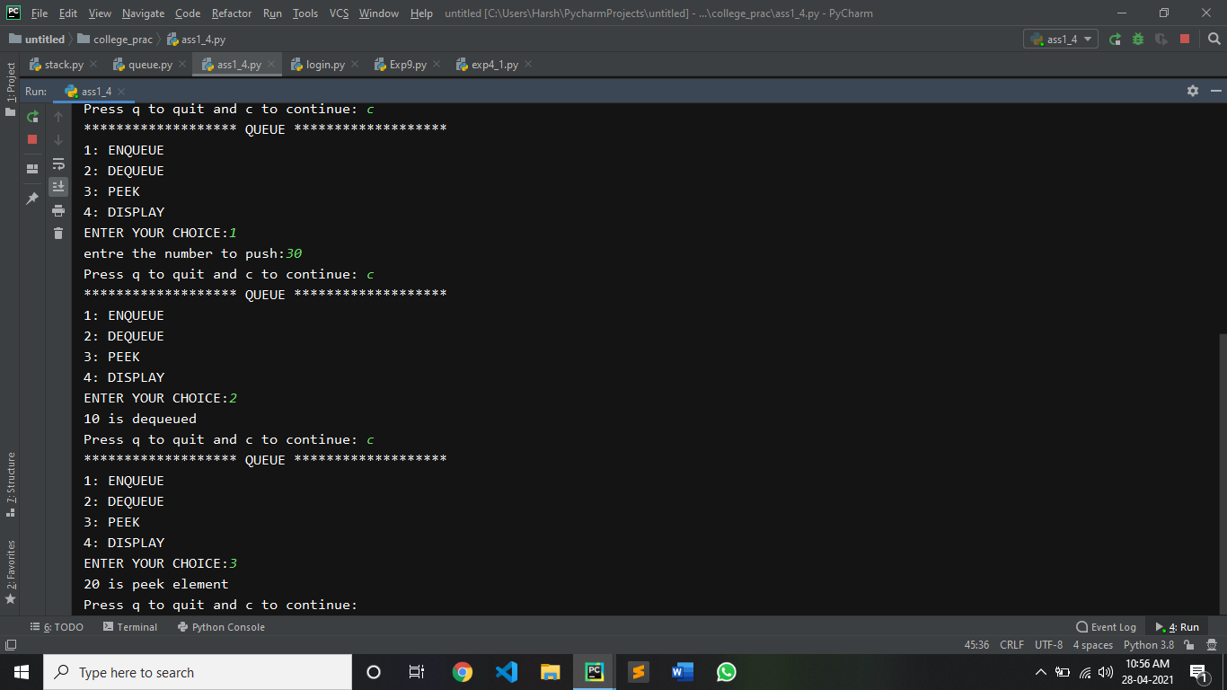

PEEK AND DISPLAY:

