**EXPERIMENT N0-8**

WRITE A PYTHON PROGRAM TO CREATE SOCKETS FOR INFORMATION EXCHANGE BETWEEN CLIENT AND SERVER

**SOURCE CODE:-**

**SERVER :**

import socket

s=socket.socket()

host = 'localhost'

port = 12345

s.bind((host,port))

s.listen(5)

c, addr = s.accept()

print('Got connection from',addr)

c.send(b'Hello, How are you? \nsuccessfully received')

msg='Bye!'

c.send(msg.encode())

c.close()

**CLIENT:**

import socket

s=socket.socket(socket.AF_INET, socket.SOCK_STREAM)

host="localhost"

port=12345

s.connect((host,port))

msg=s.recv(1024)

while msg:

print("Received : " + msg.decode())

msg=s.recv(1024)

s.close()

**OUTPUT:**

**CLIENT:**

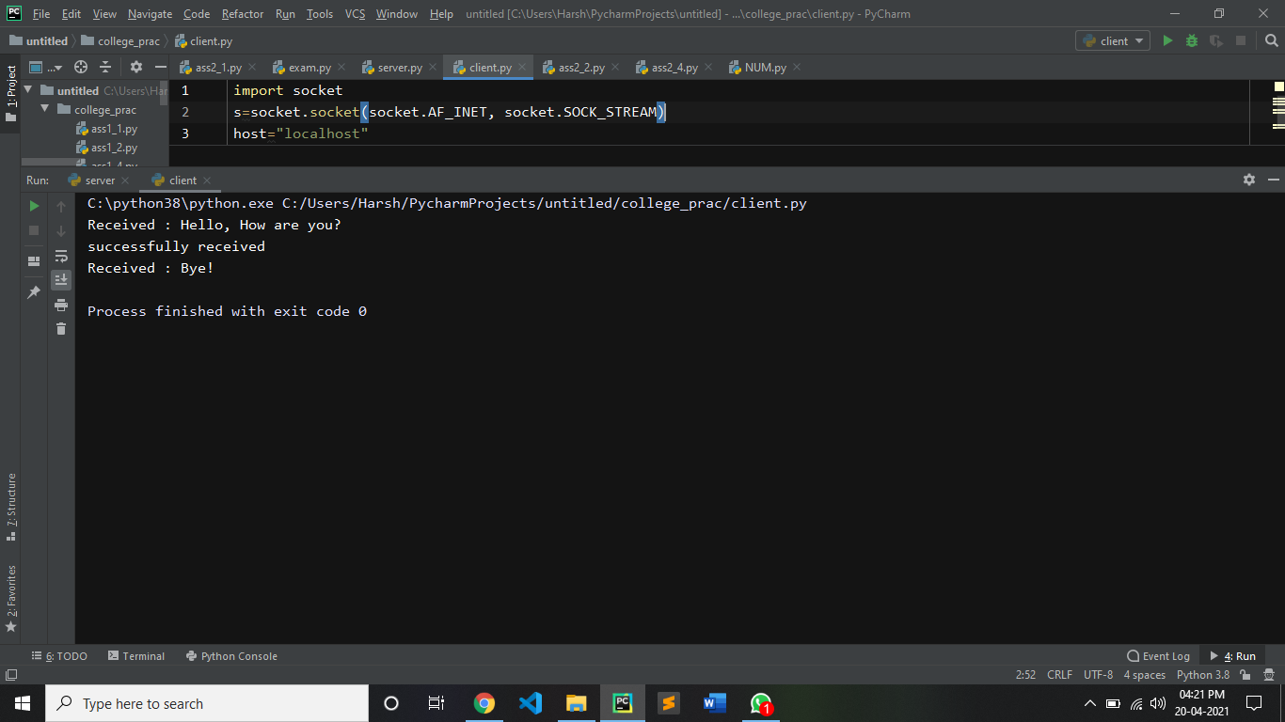

**SERVER:**

