**EXPERIMENT N0-9**

Write a Python program to create a login form with entry widgets for entering username and password. Compare the entered input with the data stored in the User table in the database. If a user exists in the database then display a login successful message else display invalid username or password (use tkinter and MySQL module).

**SOURCE CODE :-**

import MySQLdb

import tkinter as tk

top = tk.Tk()

stat = tk.StringVar()

stat.set("")

def clear():

stat.set("")

usre.delete(0, 'end')

pwde.delete(0, 'end')

def login():

user = usre.get()

pswd = pwde.get()

if (user != ''):

conn = MySQLdb.connect(host='localhost', database='db', user='root', password='')

cursor = conn.cursor()

a = "SELECT * FROM login WHERE username = ('%s')"

args = (user)

cursor.execute(a % args)

res = cursor.fetchone()

if res:

_, password = res

if (password == pswd):

stat.set("Login Successfull!!")

else:

stat.set("Invalid Password")

else:

stat.set("Invalid Username")

top.geometry("450x300")

greet = tk.Label(text="Welcome!", font=('Verdana', 20)).place(x=180, y=0)

usr = tk.Label(text="Username").place(x=40, y=60)

pwd = tk.Label(text="Password").place(x=40, y=100)

usre = tk.Entry(width=30)

usre.place(x=110, y=60)

print(usre.get())

pwde = tk.Entry(width=30, show='*')

pwde.place(x=110, y=100)

sub = tk.Button(text="Login", command=login)

sub.place(x=150, y=150)

clear = tk.Button(text="Clear", command=clear).place(x=210, y=150)

tk.Label(textvariable=stat, font=('Verdana', 12)).place(x=130, y=200)

top.mainloop()

**OUTPUT:**

**SUCCESSFUL LOGIN:**

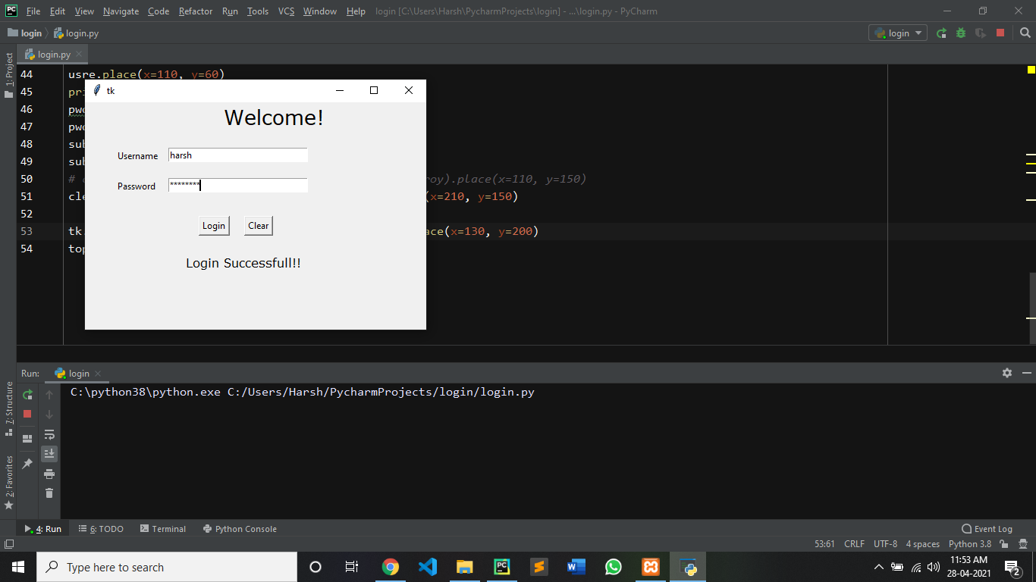

**INVALID LOGIN:**

