**EXPERIMENT N0-12**

**WRITE PYTHON PROGRAM TO READ CSV FILE AND PERFORM FOLLOWING OPERATION**

**1:READ CSV FILE:**

**CODE:**

import pandas as pd

df = pd.read_csv('Mall_Customers.csv')

print(df)

**OUTPUT:**

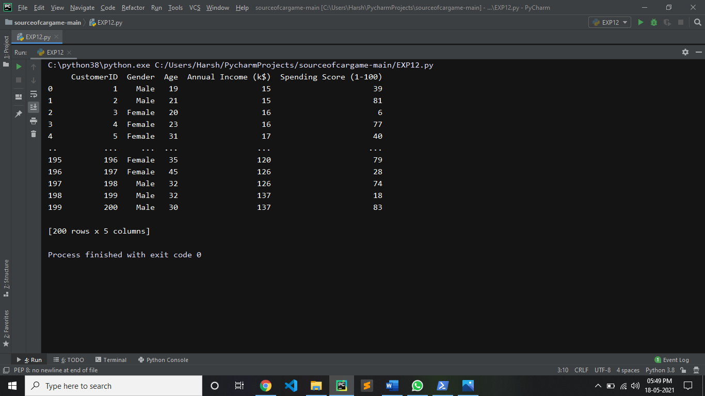

**2:READ FIRST 10,20,50 RECORDS:**

**CODE:**

import pandas as pd

df = pd.read_csv('Mall_Customers.csv')

print("first 10 records:")

print(df.head(10))

**OUTPUT:**

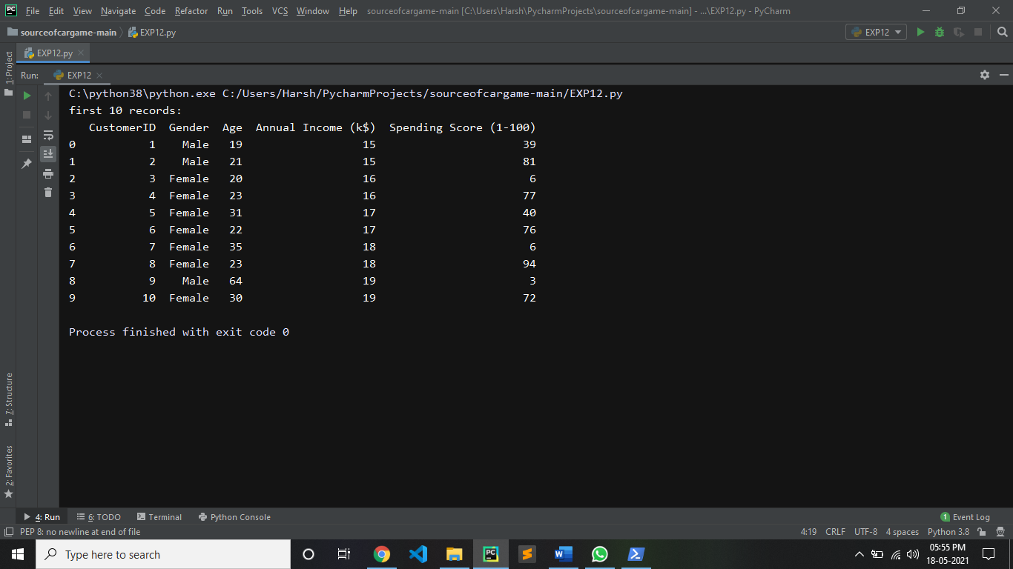

**CODE:**

import pandas as pd

df = pd.read_csv('Mall_Customers.csv')

print("first 20 records:")

print(df.head(20))

**OUTPUT:**

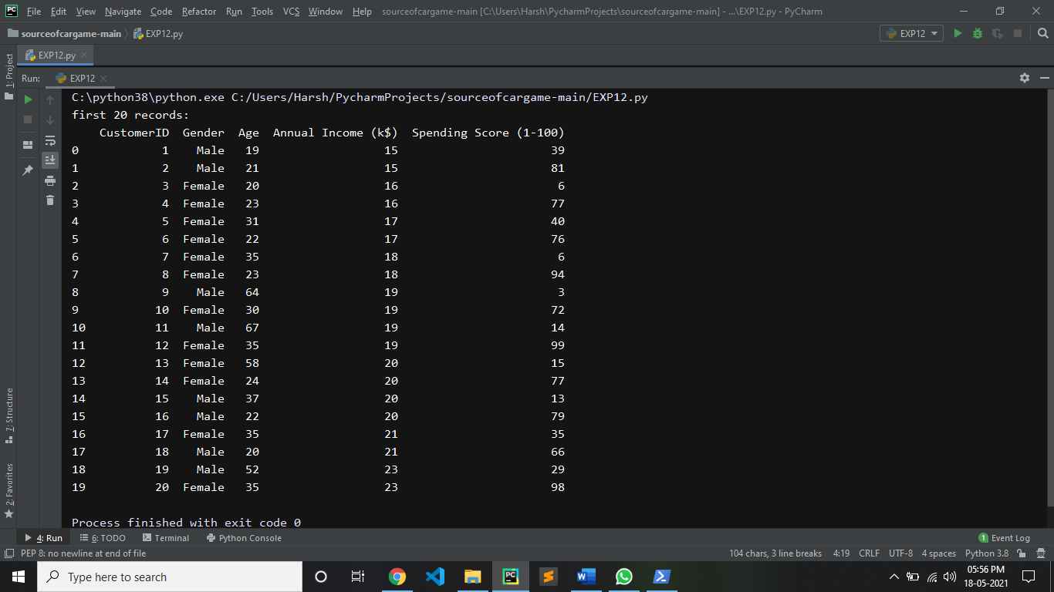

**CODE:**

import pandas as pd

df = pd.read_csv('Mall_Customers.csv')

print("first 50 records:")

print(df.head(50))

**OUTPUT:**

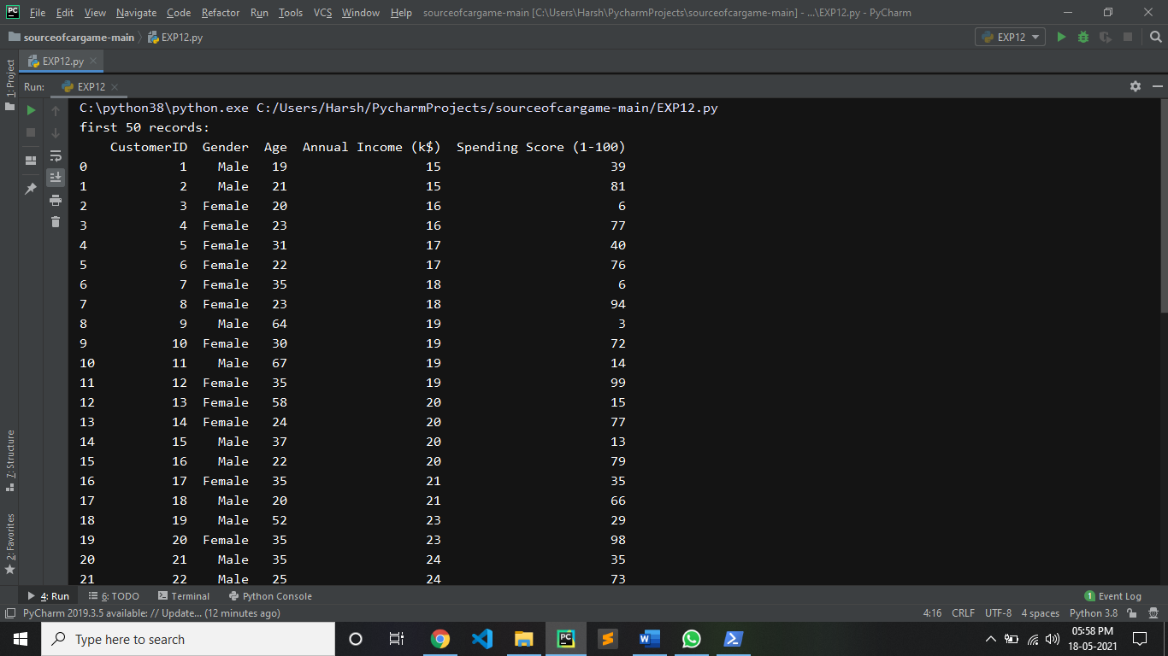

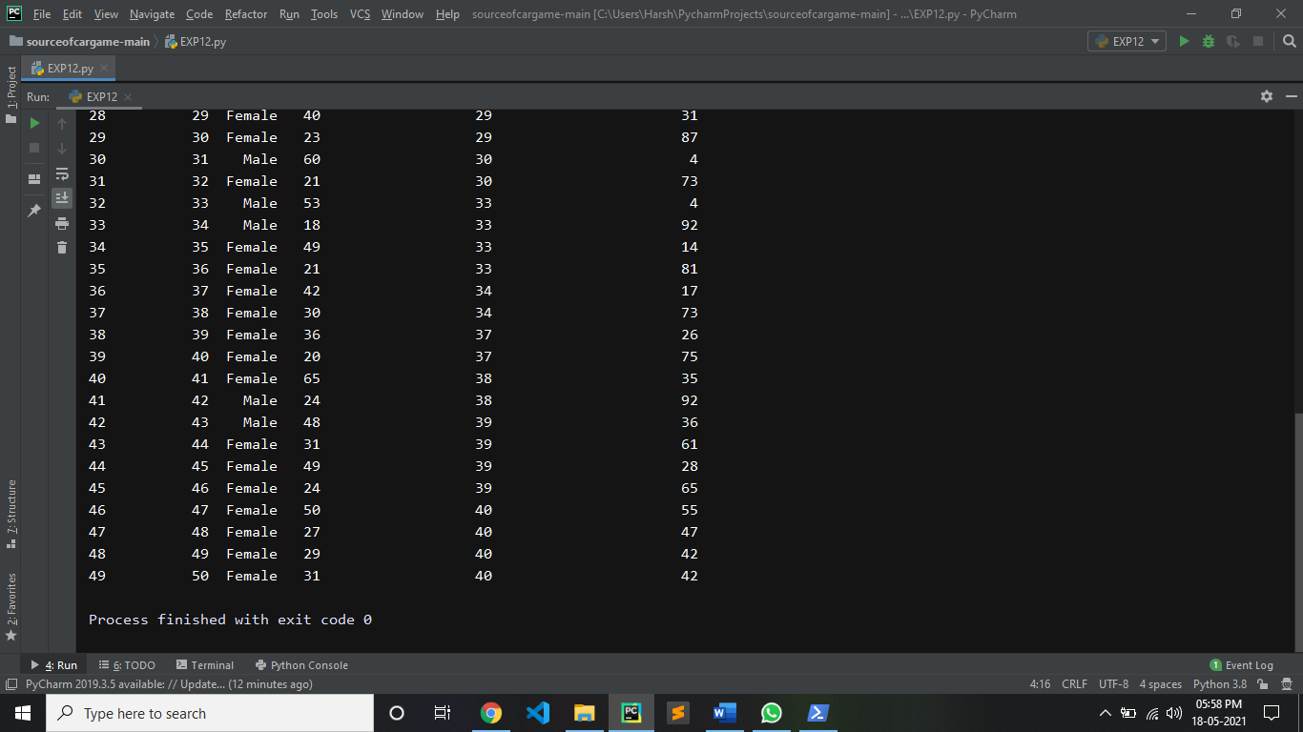

**3: CHECK DATATYPE OF ALL THE COLUMNS:**

**CODE:**

import pandas as pd

df = pd.read_csv('Mall_Customers.csv')

res = df.dtypes

print(res)

**OUTPUT:**

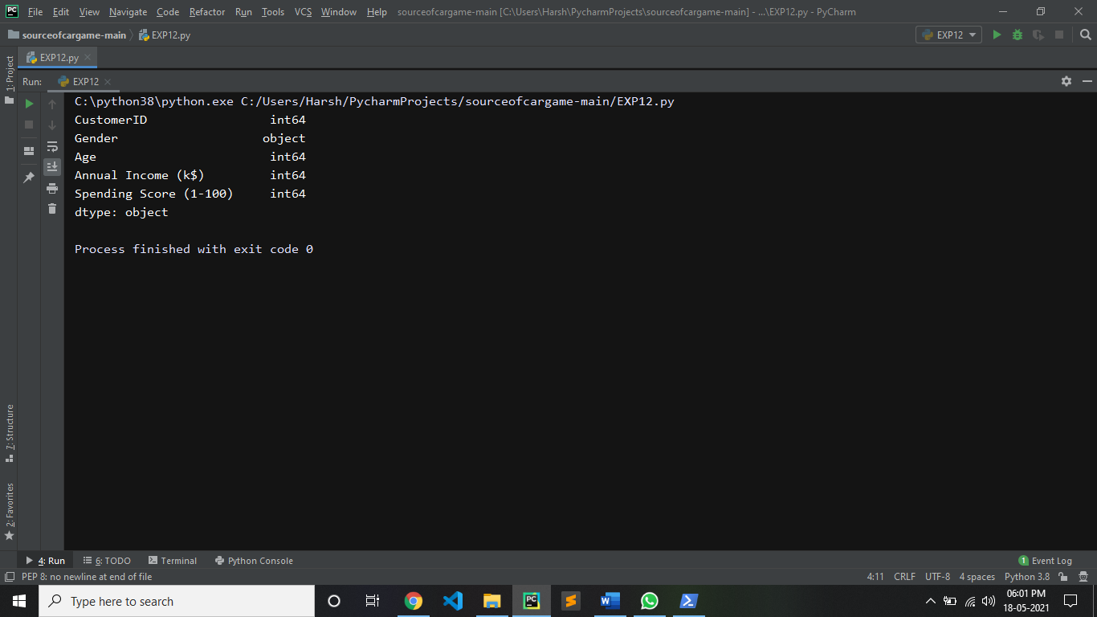

**4:**

**DISPLAY MIN,MAX,SUM,COUNT,PROD,MEAN,MEDIAN,MODE,STD OF GIVEN DATASET:**

**CODE:**

import pandas as pd

df = pd.read_csv('Mall_Customers.csv')

print("mean is:")

print(df.mean())

print("-----------------")

print("min is:")

print(df.min())

print("-----------------")

print("max is:")

print(df.max())

print("-----------------")

print("count is:")

print(df.count())

print("-----------------")

print("sum is:")

print(df.sum())

print("-----------------")

print("prod is:")

print(df.prod())

print("-----------------")

print("median is:")

print(df.median())

print("-----------------")

print("mode is:")

print(df.mode())

print("-----------------")

print("standard deviation is:")

print(df.std())

**OUTPUT:**

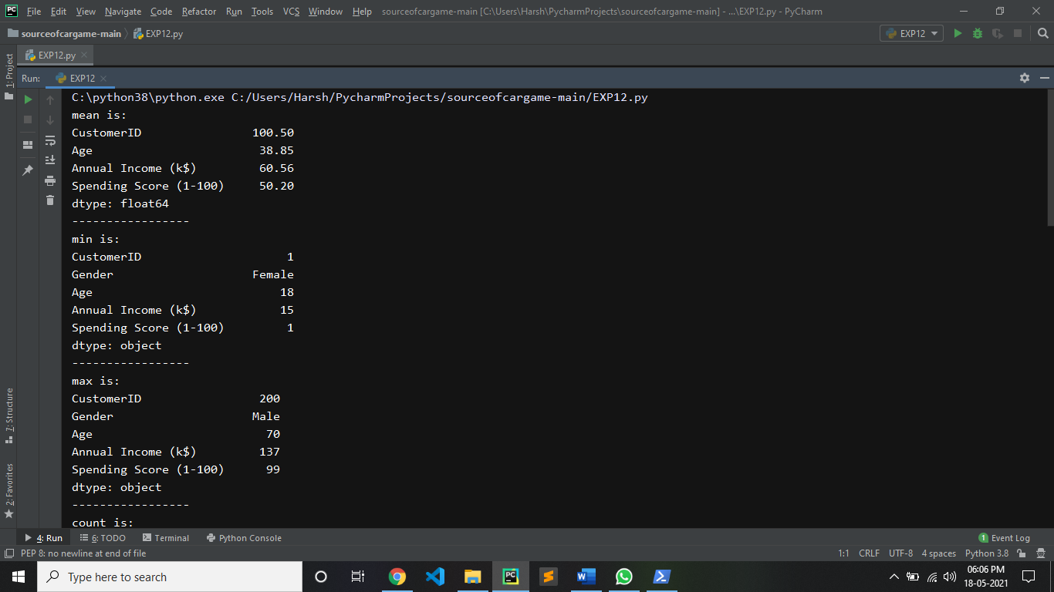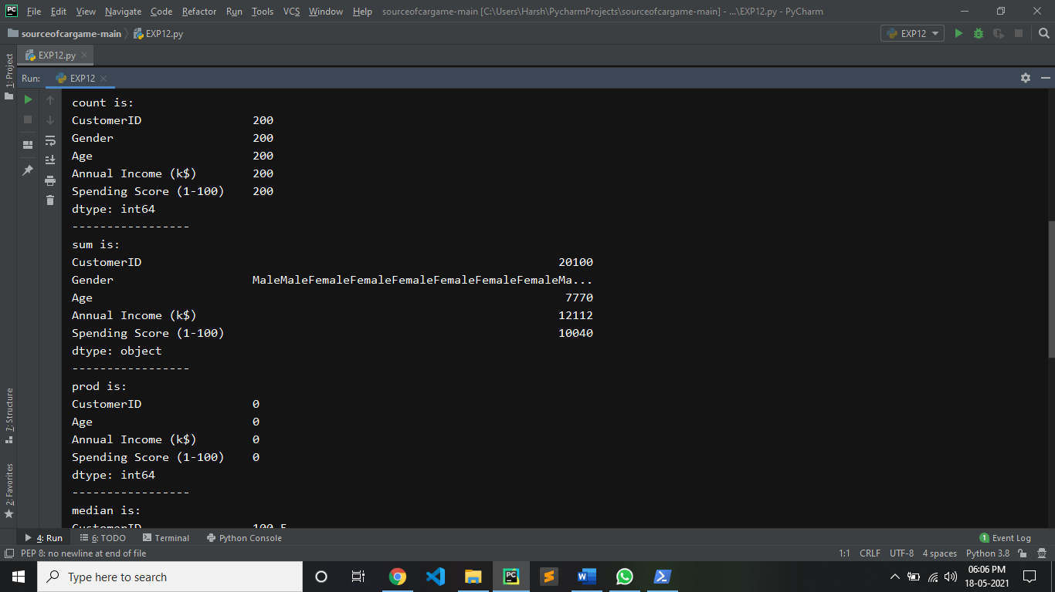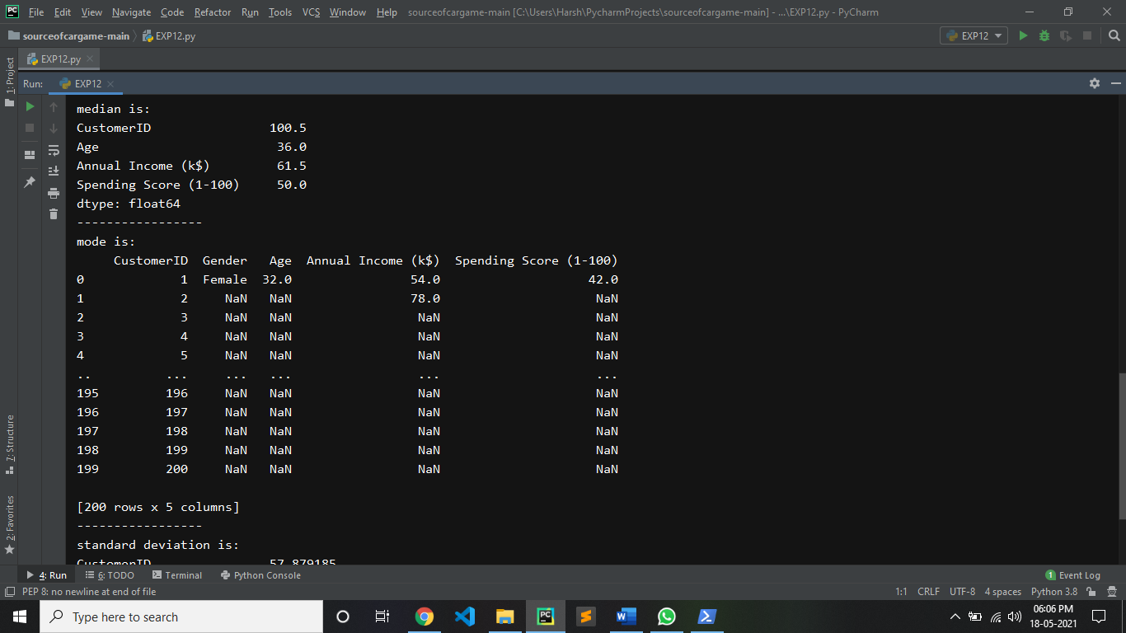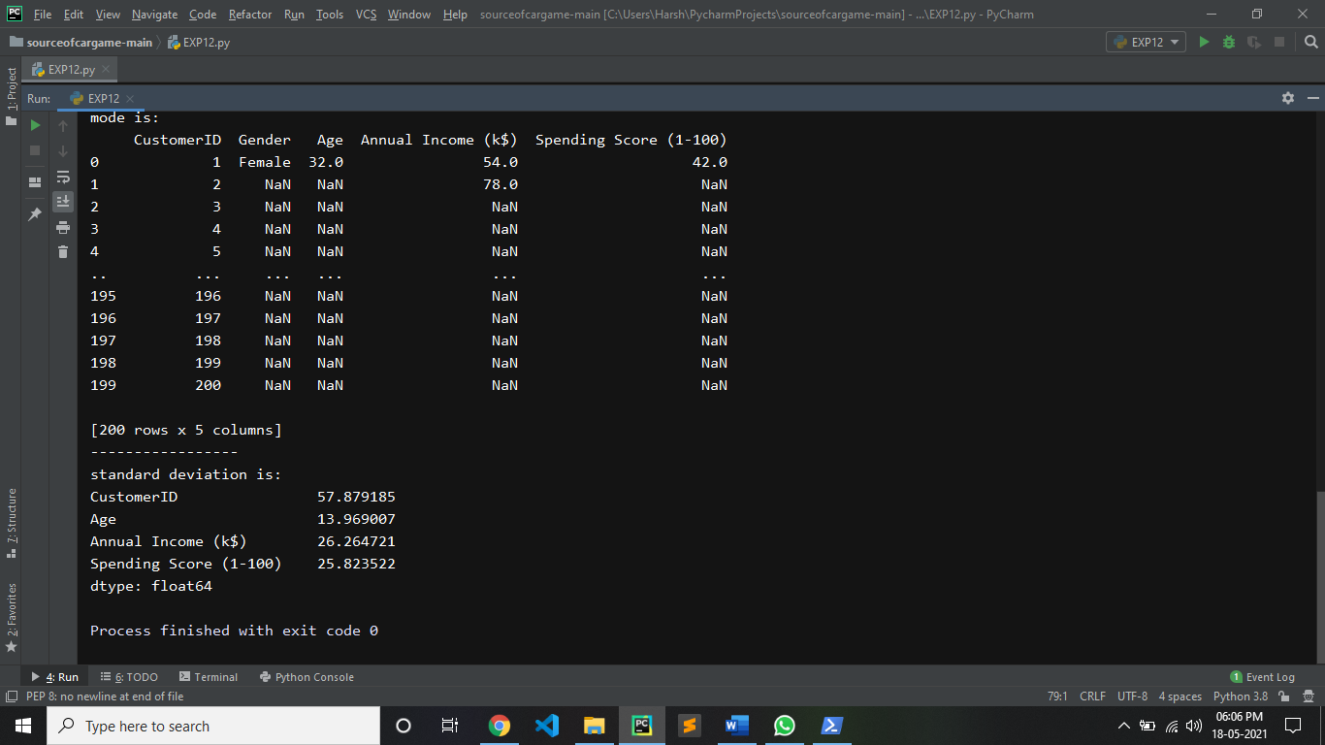

**5: FIND HOW MANY VALUES IN ANNUAL INCOME COLUMN:**

**CODE:**

import pandas as pd

df = pd.read_csv('Mall_Customers.csv')

print("count in Annual Income is:")

print(df['Annual Income (k$)'].count())

**OUTPUT:**

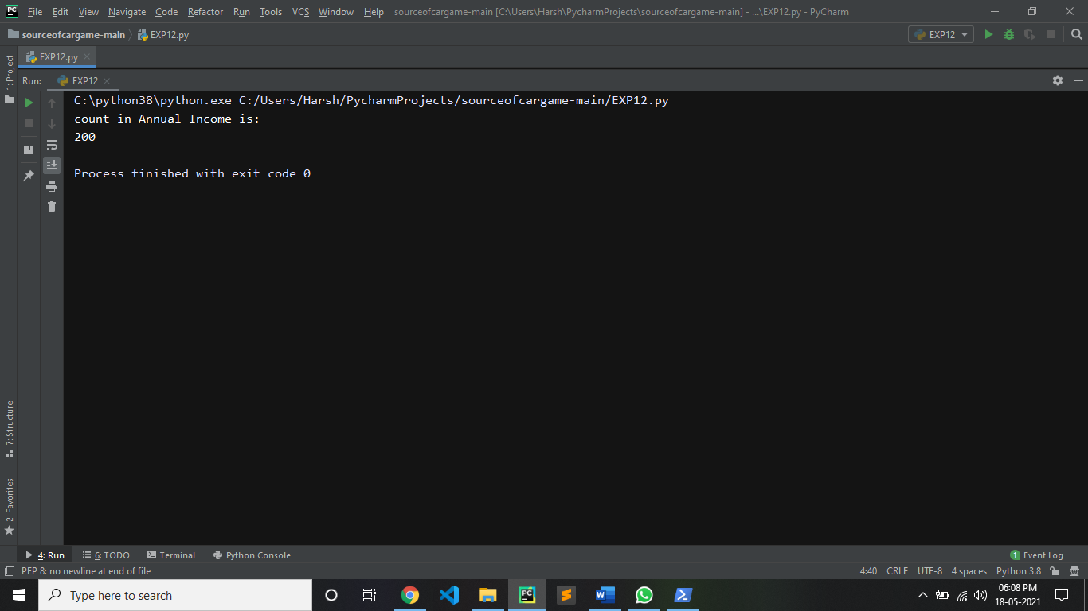

**6: CALCULATE AVRAGE ANNUAL INCOME:**

**CODE:**

import pandas as pd

df = pd.read_csv('Mall_Customers.csv')

print("avrage Annual Income is:")

print(df['Annual Income (k$)'].mean())

**OUTPUT:**

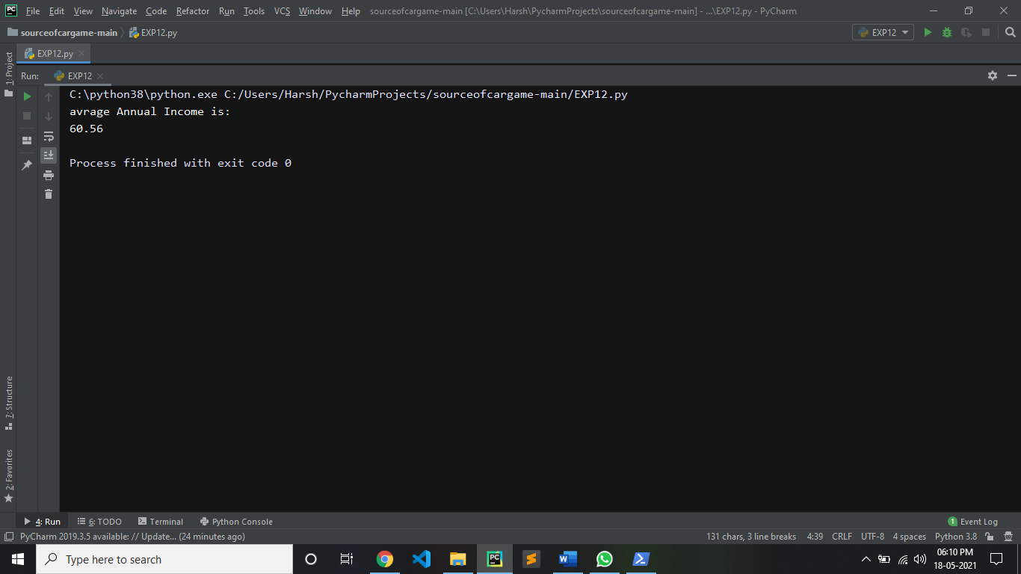

**7: CALCULATE MEAN ANNUAL INCOME OF EACH MALE CUSTOMER:**

**CODE:**

import pandas as pd

df = pd.read_csv('Mall_Customers.csv')

male=df[df['Gender'] == 'Male']

print('mean is:')

print(male['Annual Income (k$)'].mean())

**OUTPUT:**

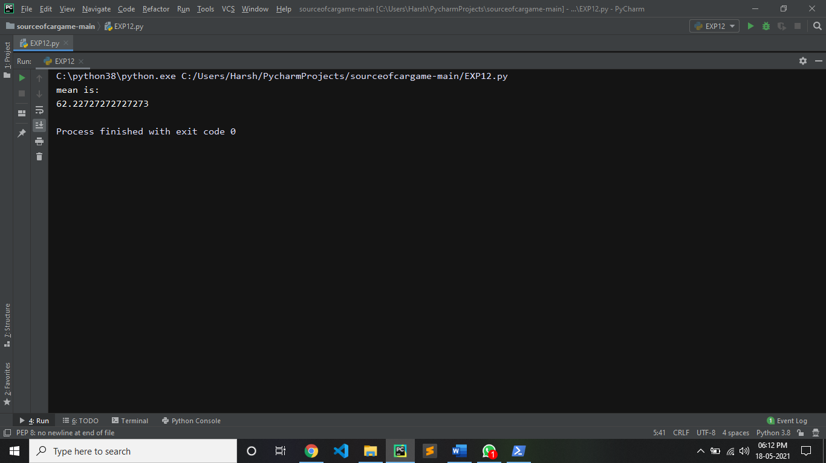

**8: SELECT ONLY THOSE ROW WHICH CONTTAIN FEAMLE :**

**CODE:**

import pandas as pd

df = pd.read_csv('Mall_Customers.csv')

female=df[df['Gender'] == 'Female']

print(female)

**OUTPUT:**

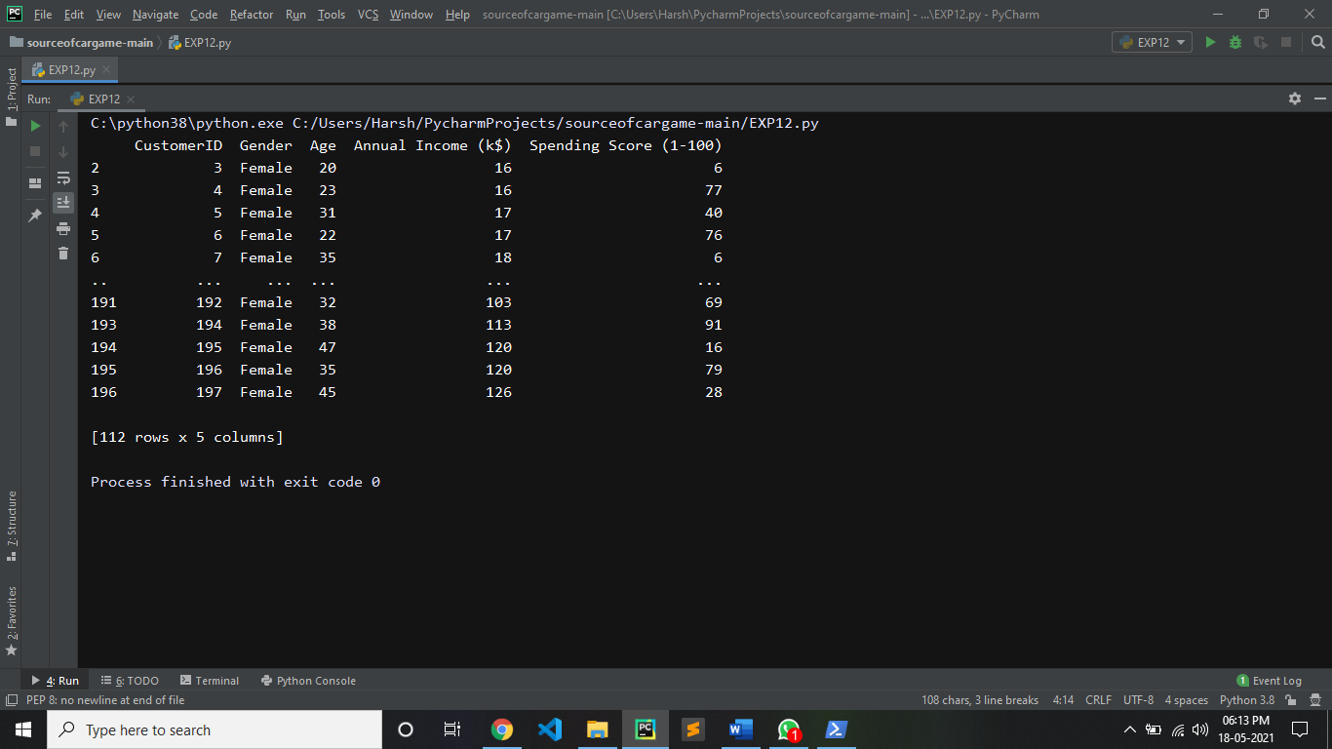

**9: CREATE NEW DATAFRAME FROM ORIGINAL SORTED BY SPENDING SCORE:**

**CODE:**

import pandas as pd

df = pd.read_csv('Mall_Customers.csv')

sorted_data = df.sort_values("Spending Score (1-100)", ascending = True)

print(sorted_data)

**OUTPUT:**

