SmartPark IU – Final Project Report
Course: Applied Database Technology
Semester: Fall 2025
Authors: Harsh Gupta, Pranay Bandaru

1. Purpose and Audience
Parking on large university campuses is often inefficient and confusing due to the large number of parking lots, varying permit rules, and lack of centralized visibility into availability. SmartPark IU was designed to address this problem by providing a structured, database-driven application that helps users identify suitable parking options based on proximity, permit eligibility, and parking capacity.
The primary purpose of this project is to demonstrate how a well-designed relational database can support a real-world application with both end-user query functionality and administrative data management.
The intended audience includes:
- Students searching for parking near academic or residential buildings.
- Faculty and staff seeking permit-compliant parking options close to their destination.
- Campus administrators or planners, who could use the system to manage parking data and analyze utilization patterns.
The application is structured to serve both read-only users and administrative users, highlighting different database access patterns.

2. Application Functionalities
SmartPark IU consists of two major components:
- A User-facing parking recommendation interface
- An Administrator Panel for authenticated data management.
2.1 User-Facing Functionalities
The core MVP supports the following features:
- Building-based parking search
Users select a campus building as their destination. The system retrieves nearby parking lots using precomputed walking distances stored in the database.
- Permit filtering
Users can filter parking lots by permit type (e.g., Student, Employee, Accessible). An “Any Permit” option allows users to view all nearby lots without restriction.
- Capacity visibility using latest snapshots
Parking availability is derived from the most recent snapshot per lot stored in the lot_inventory table, ensuring users see current capacity information.
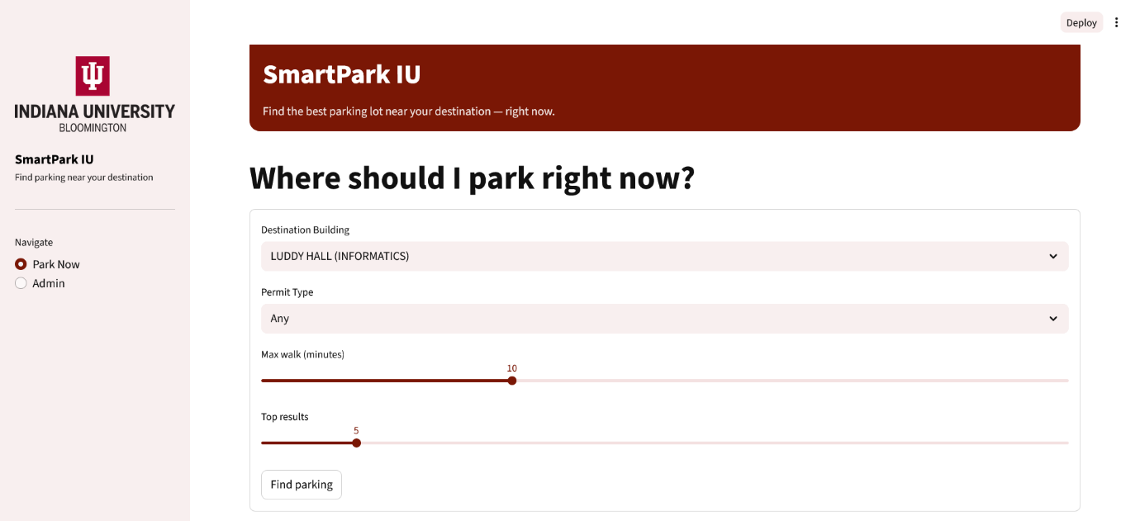
- Ranked recommendations
Parking lots are ranked primarily by walking distance and secondarily by availability, providing practical recommendations.
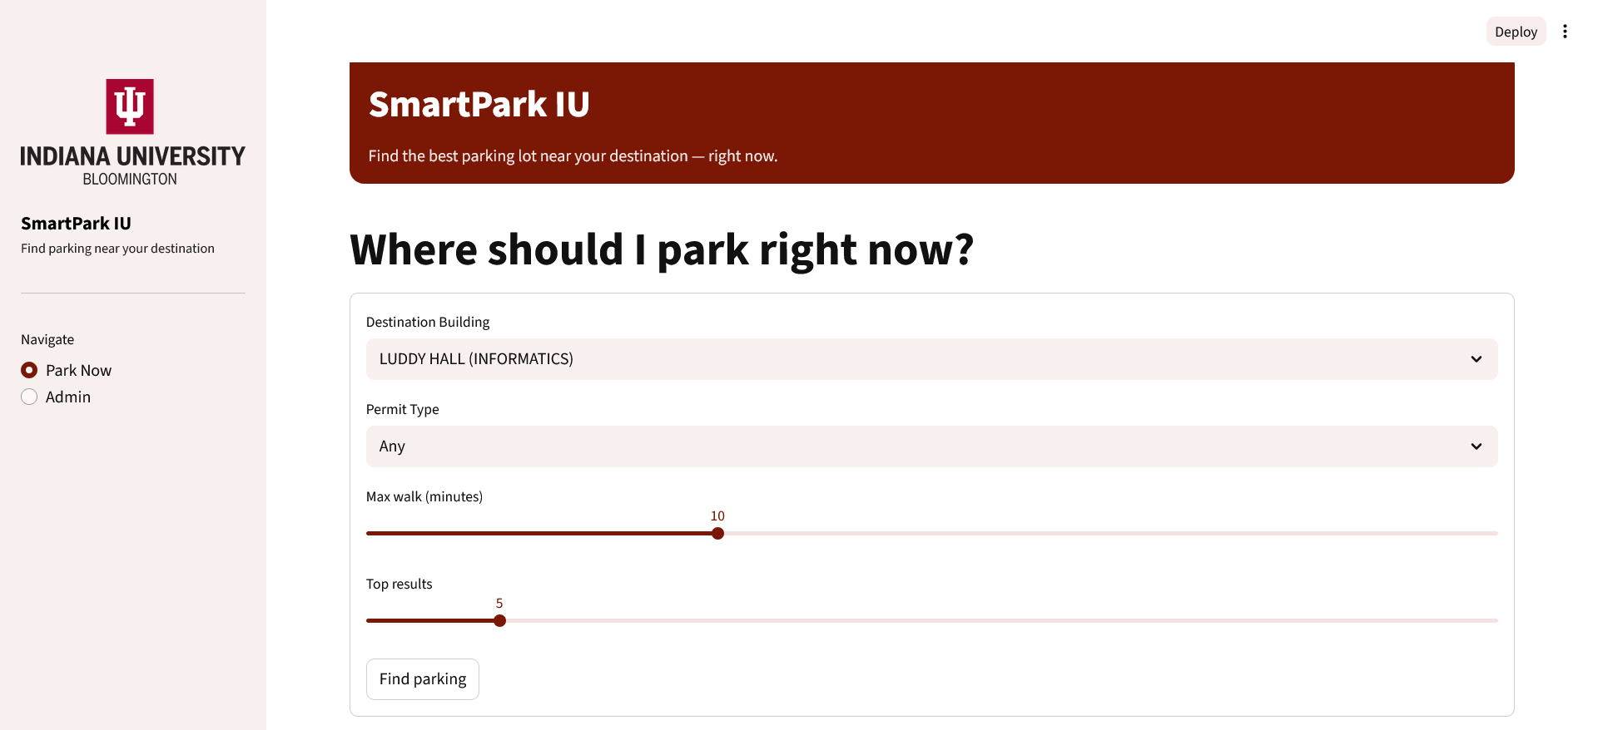
- Map-based visualization
Parking lots are displayed on an interactive map with metadata such as distance, permit type, and capacity.
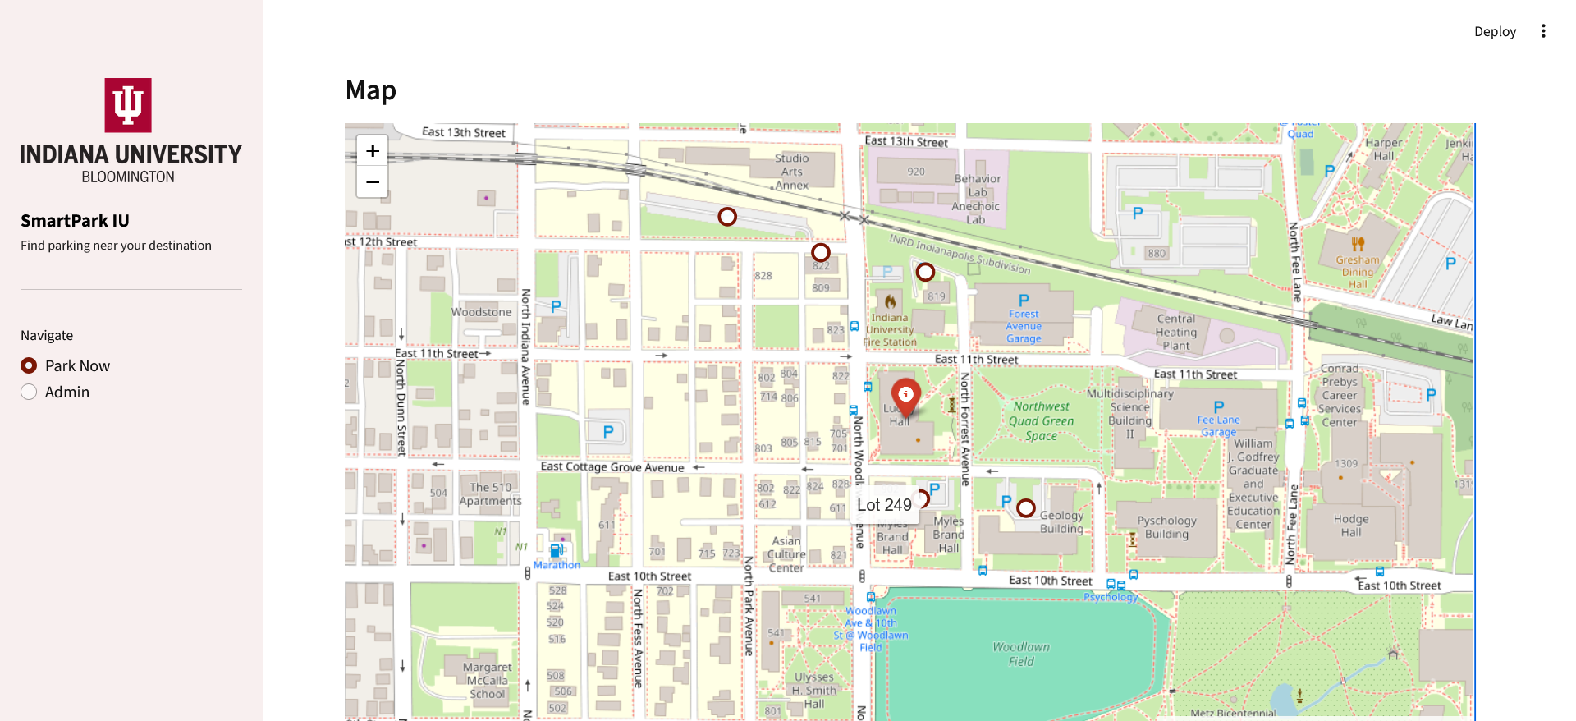

2.2 Admin Panel Functionalities
The Admin Panel extends the application beyond read-only access and enables controlled database modification.
Key features include:
- Admin authentication
  - Admin access requires login.
  - Session-based authentication prevents unauthorized access.
  - Logout clears session state safely.
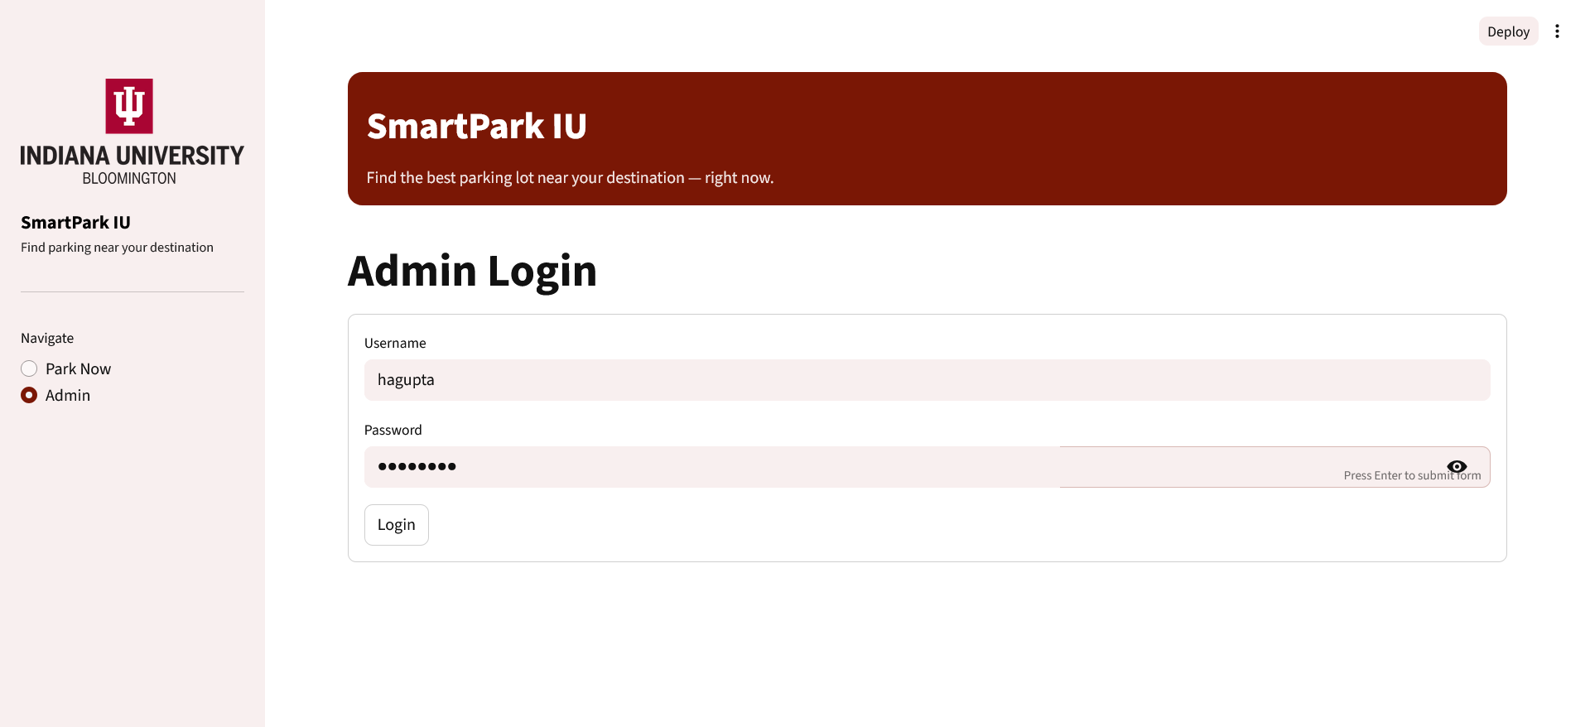
- Schema-aware CRUD operations
  - Admins can insert, update, and delete records from selected database tables.
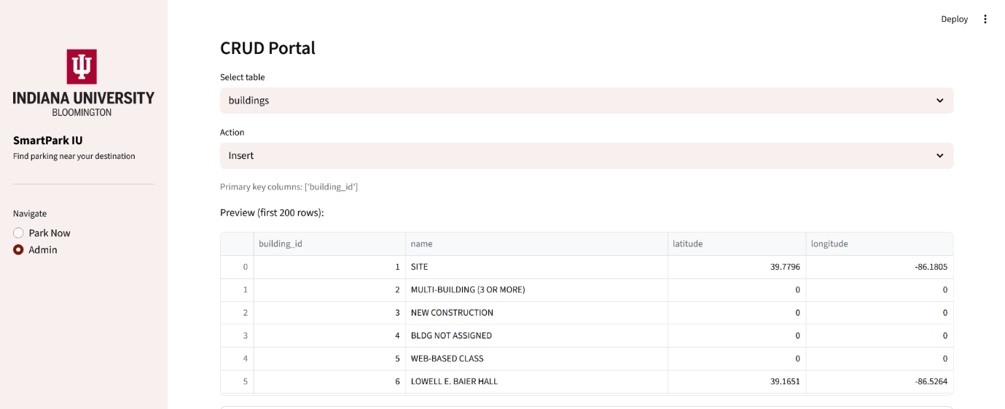
  - Primary keys are automatically detected and enforced for updates and deletes.
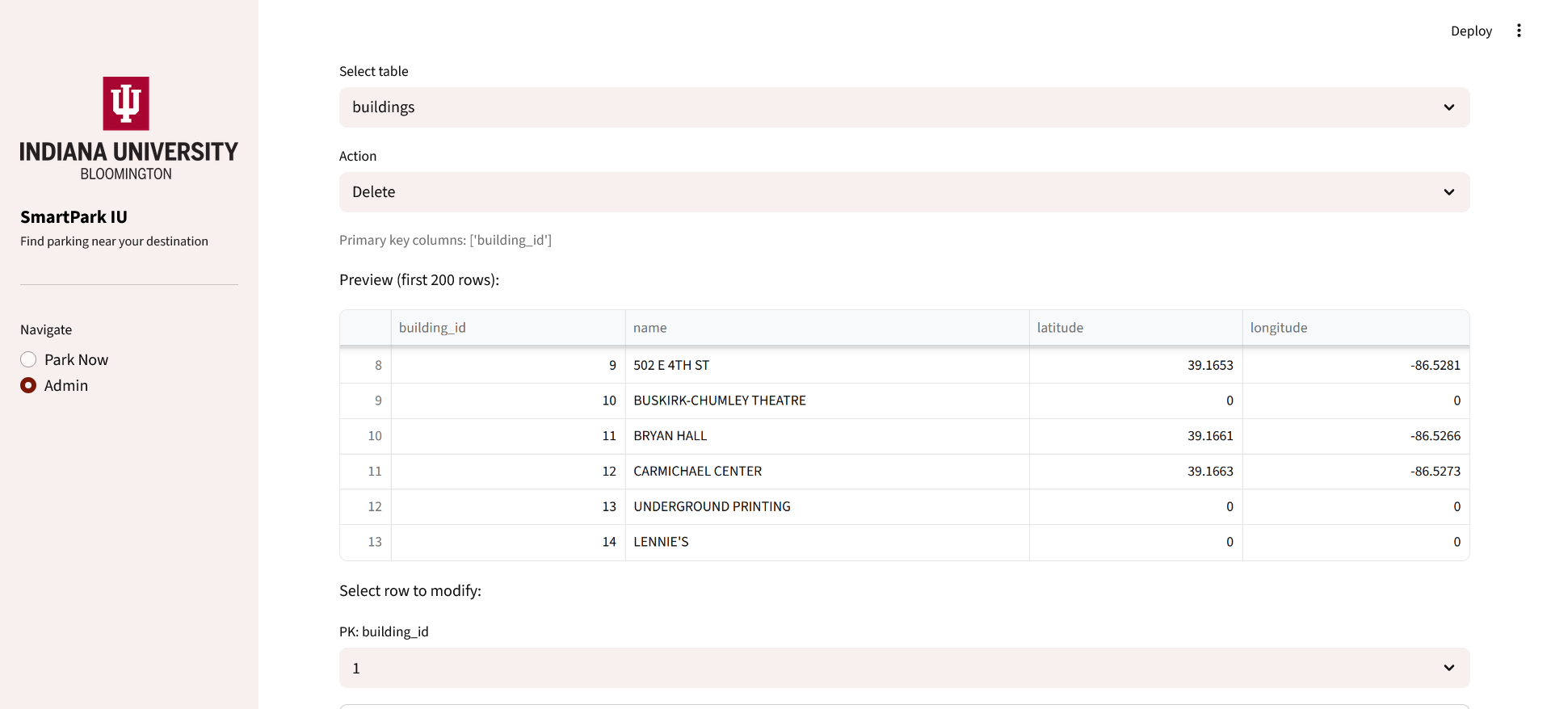
  - Auto-increment columns are protected from manual modification.
  - Partial updates are supported (blank fields are ignored).
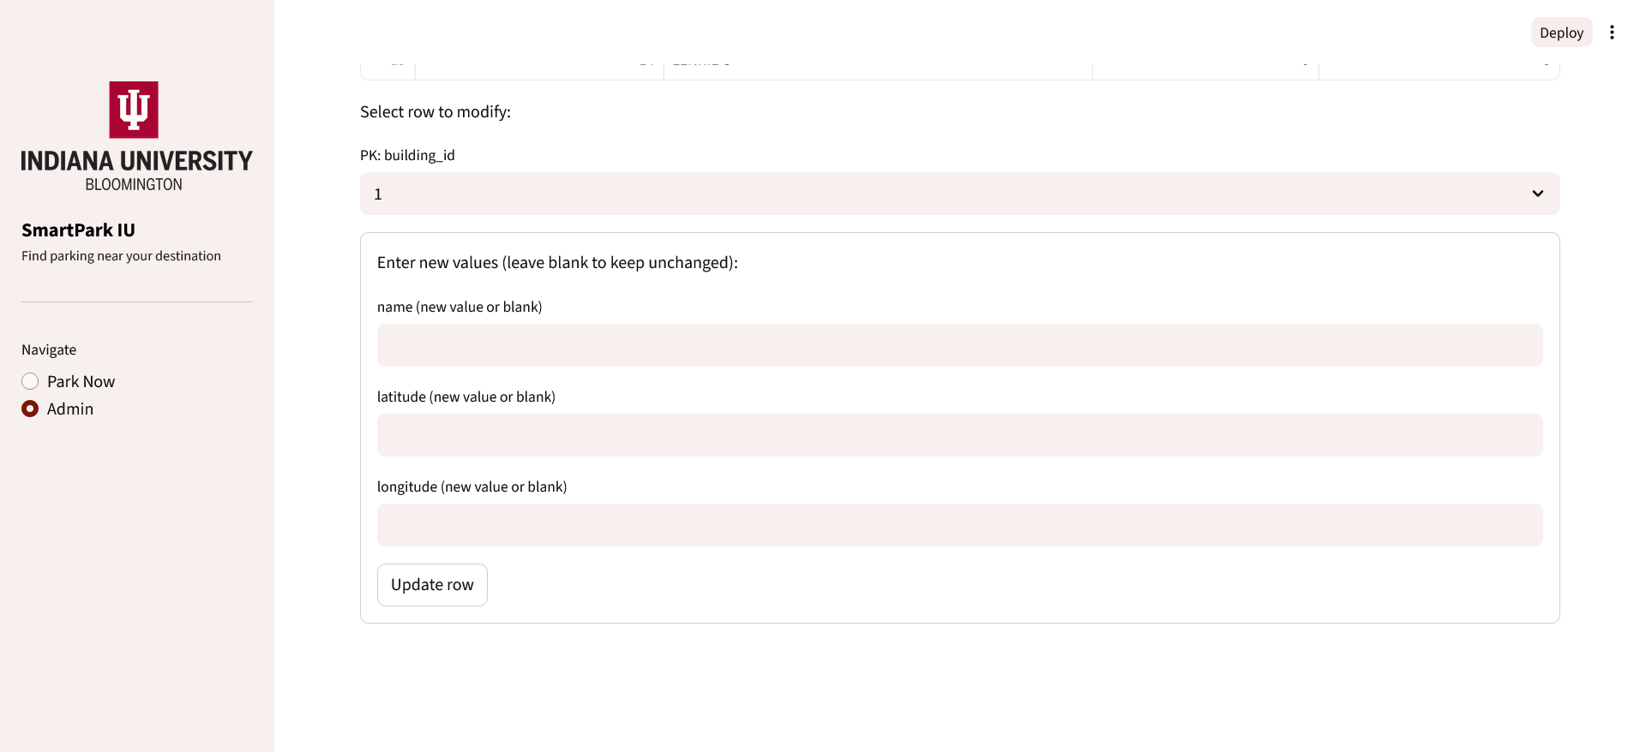
- Live data preview
  - Admins can preview existing table rows before performing update or delete actions.
  - This reduces accidental modification of incorrect records.
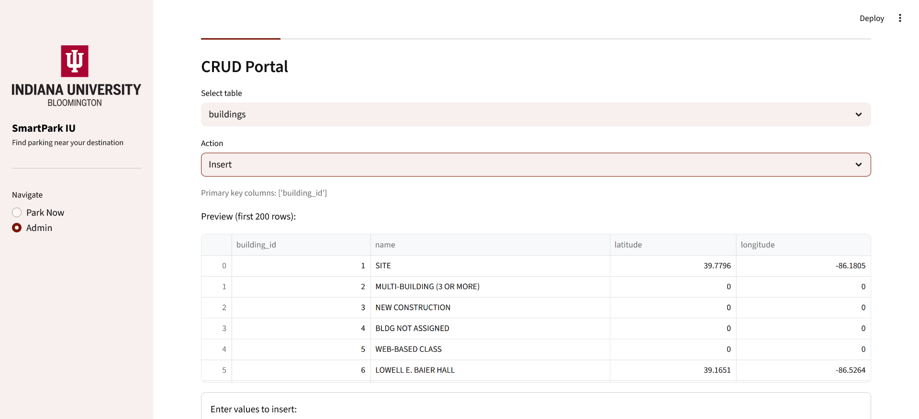
- Bulk distance data upload
  - Admins can upload CSV files into a staging table (staging_lot_building_distance).
  - Uploaded data is previewed before insertion.
  - Large files are inserted in chunks for stability.
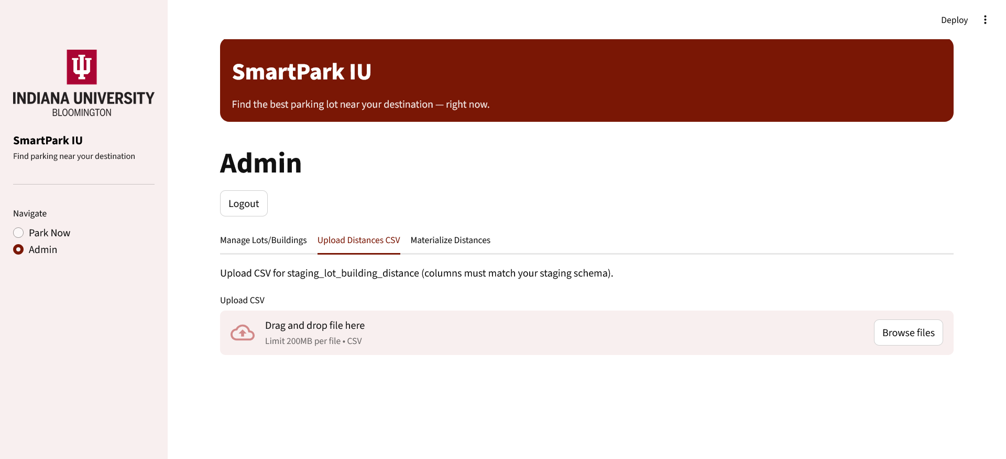
- Materialized upsert from staging
  - A controlled process converts staging data into canonical distance records.
  - ON DUPLICATE KEY UPDATE ensures idempotent updates and prevents duplication.
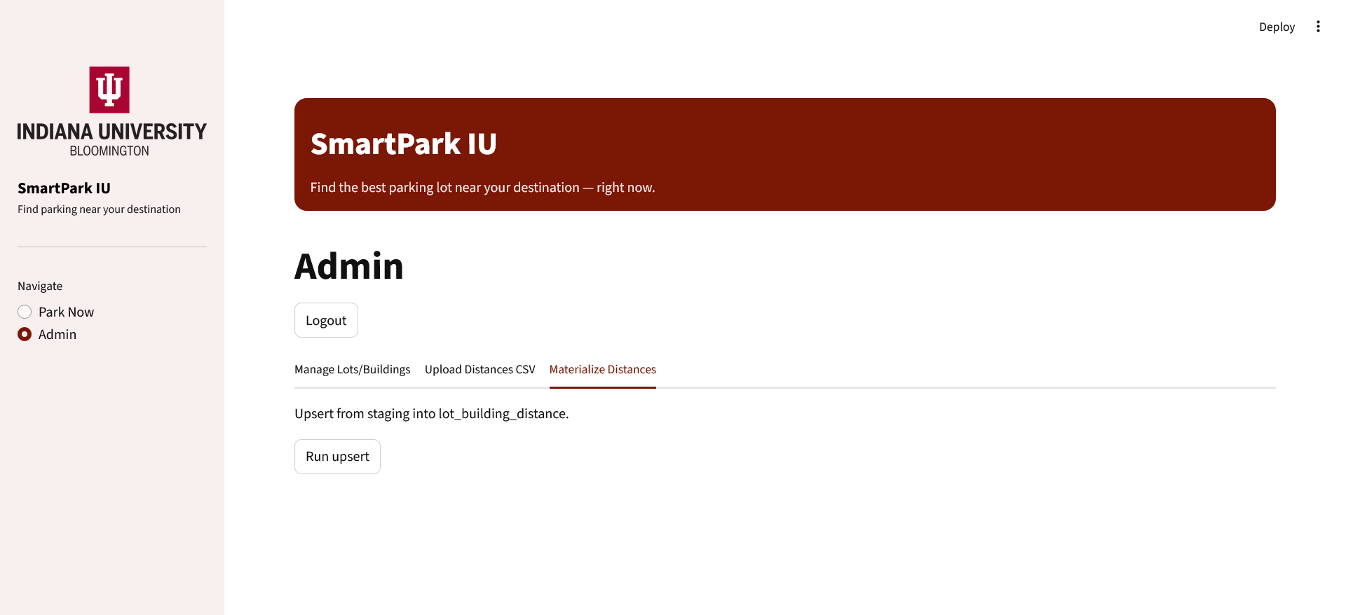
This design demonstrates both transactional CRUD workflows and ETL-style batch processing within a single application.

3. Application Hosting and Execution Details
Technology Stack
- Database: MySQL
- Database Hosting: Railway.app
- UI Hosting: https://share.streamlit.io/
- Frontend & Backend: Streamlit (Python)
Hosting Setup
- The MySQL database is hosted on Railway, providing persistent, remotely accessible storage for application data.
- The Streamlit application is deployed on Streamlit Community Cloud, enabling easy access through a public URL:
https://adt-iu-hagupta-pbandaru.streamlit.app/
- This setup allows the application frontend and backend to interact seamlessly with the hosted database over the network.
- The codebase is hosted on IU’s github at https://github.iu.edu/hagupta/ADT_Final_Project/

4. Technical Development and Contributions
The technical foundation of SmartPark IU builds directly on the normalized relational schema, constraints, and queries designed during the midterm milestone
4.1 Database Design
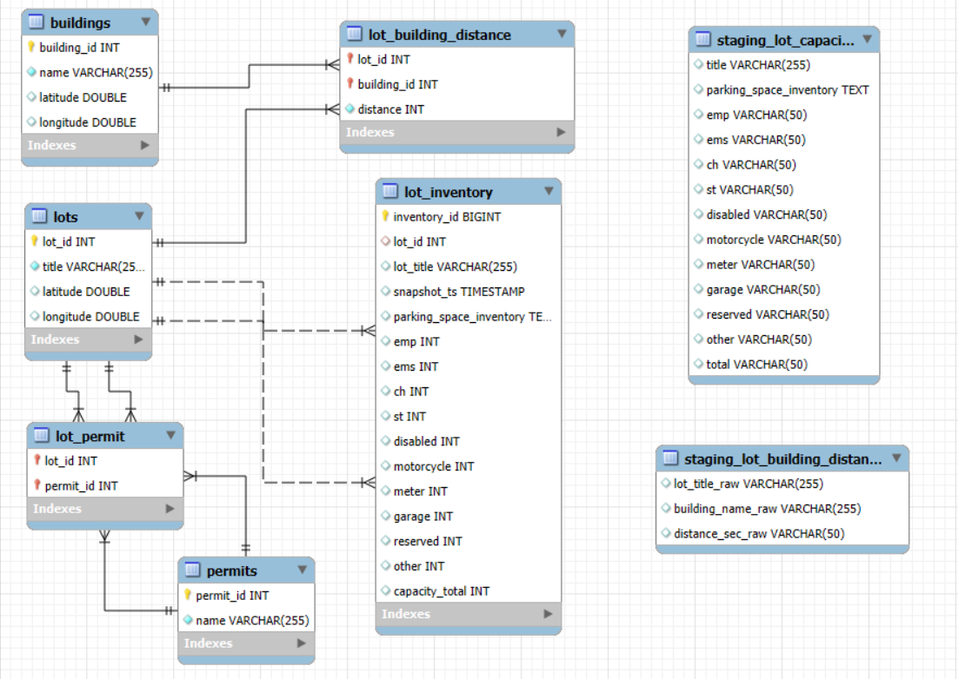
- Normalized schema including:
  - lots, buildings, permits
  - lot_inventory (time-series snapshots)
  - lot_building_distance (precomputed distances)
- Strong integrity enforcement:
  - Primary keys, foreign keys
  - UNIQUE, NOT NULL, and CHECK constraints
- Junction tables for many-to-many relationships.
- Indexes to support frequent query paths.
4.2 Application Integration
- Parameterized SQL queries prevent injection.
- Schema metadata is used to dynamically generate admin forms.
- Primary key detection ensures safe updates and deletes.
- ETL logic uses staging tables and set-based SQL operations.
4.3 Contributions
Harsh Gupta
- Application architecture and backend integration.
- Admin authentication and session handling.
- CRUD engine and schema-aware form generation.
- Query design and database hosting.
Pranay Bandaru
- Requirements definition and scope refinement.
- Validation of constraints and CRUD safety.
- ETL materialization logic and optimization.
- Database testing and data normalization checks.
- Indexing strategy and documentation review.
This collaboration ensured both database correctness and application usability.

5. References and Tools Used
The following resources and tools were used:
- MySQL Documentation – schema design, constraints, indexing.
- Streamlit Documentation – UI and application structure.
- Railway.app Documentation – MySQL hosting and configuration.
No database schema, application logic, or SQL code was generated automatically by coding assistants.
6. Reflections
What We Learned
This project reinforced the importance of database-first design. Designing a strong schema with proper constraints significantly simplified application logic and reduced error handling complexity. We also learned how metadata-driven systems can be used to build flexible admin tools.
Most Challenging Aspects
The most challenging part was implementing safe update and delete workflows in the admin panel. Handling primary keys, nullable fields, and partial updates required careful coordination between database constraints and application logic.
Another challenge was integrating batch uploads while maintaining data integrity, which was addressed using staging tables and controlled upserts.
What We Would Change With More Time
With additional time, we would:
- Implement role-based access control.
- Add audit logs for admin actions.
- Deploy the Streamlit app online.
- Add predictive analytics for parking availability.

Conclusion
SmartPark IU demonstrates how a well-designed relational database can power both user-facing applications and administrative tools. By combining normalized schema design, integrity constraints, and efficient querying with a functional application layer, the project meets the core learning objectives of Applied Database Technology while addressing a realistic campus problem.

