**ELECTRONIC MOBILE DETECTOR CIRCUIT (RF SIGNAL DETECTOR)**

**INTRODUCTION**

Cell phone detector is a circuit that can sense the presence of any activated cell-phone nearby and gives an indication. Basically, Cell-phone detector is a Frequency Detector or a Current to Voltage Converter Circuit which catches frequencies about 0.8 – 3.0GHz (Mobile band frequencies).

It can detect both the outgoing and incoming calls, messages, and video transmission even if the cell is kept in silent mode.

The moment the Loop Antenna Capacitor detects RF transmission signal from an activated cellphone, the LED starts blinking until signal transmission ceases.

When an inductor is placed near the RF signal source, it receives the signal through mutual induction. This signal is then rectified and amplified and then can be used to power any indicator like an LED.

**CIRCUIT DIAGRAM**

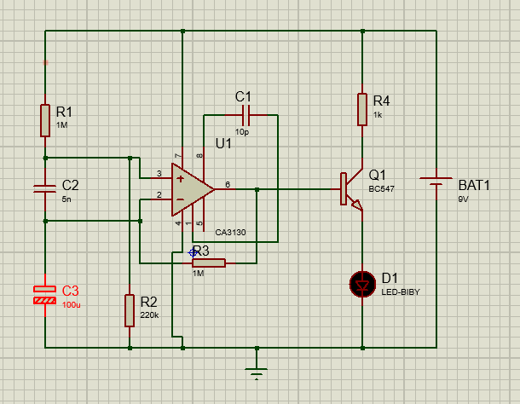

**DESIGN AND WORKING**

COMPONENTS:

* IC CA3130
* Transistor BC547
* Capacitors -5 nF
  + - 10 pF
    - 100 pF
* Resistors
  + - 1k
    - 100k
    - 1M
* 9V Battery
* LED
* Jumper/Connecting Wires

**CA3130 IC**

It is a CMOS Version gate protected p channel MOSFET. It acts as a differential amplifier and it is used in the circuit as a current to voltage convertor. It provides very high input impedance, very low input current and very high speed of performance.

**1k Resistor (BC 547 Collector Resistance)**

Keeps the non-inverting input stable for easy swing of the output to high state.

**220k Resistor (Between Non-Inverting terminal and ground)**

Provides the discharge path for C2 capacitor.

**5nF capacitor (Ceramic, RF Signal Receiver)**

Acts as a small Giga Hertz loop antenna to collect the RF signal from the mobile phone.

**BC547 Transistor**

n-p-n type silicon transistor. Mainly used for switching and it has a higher breakdown voltage as compared to its sister counterpart BC548.

**1M Ohm Resistors (Feedback Resistor)**

Makes the inverting input high, when output becomes high.

**10pF (Between pin 1 and 8 of the OPAMP IC)**

Ceramic Capacitor which acts like a di-electric. It is connected between pin 1 and 8 for phase composition and gain control to optimize the frequency response.

**Working Principle**

Ordinary LC Circuits are used to detect low frequency radiation in the AM and FM bands. It can detect MHz frequency at max. But for mobile phones we require frequency to be detected in the GHz range.

The transmission of frequency of mobile phone ranges 0.9 to 3 GHz with wavelength of 3.3-10cm.

Here 5nF capacitor is used to capture the RF signal from the mobile phone, this along with the lead act as a small Gigahertz loop antenna to collect the RF Signal. One lead of the capacitor gets DC from the positive rail and the other goes to the inverting input of the OPAMP IC.

The capacitor gets energy for storage, this energy is applied to the input of the IC, so the inputs of the IC are almost balanced and output is almost zero. But at any time IC can give a high output if a small current is induced to its inputs.

There is a natural electromagnetic field around the capacitor caused by the 50Hz from electrical wiring. When the mobile phone radiates high frequency radiation, capacitor oscillates and release energy in the inputs of IC. This oscillation is indicated by the flashing of LED with approximately the same frequency.

In short capacitor carries energy and is in an electromagnetic field, so a slight change in field caused by the RF signal from the phone will disturb the field and force the capacitor to release energy. The LED blink until the transmission of RF signal ceases.

**RESULT**

A simple mobile detector/RF signal detector has been successfully constructed using IC CA3130 and BC548.

The circuit is capable of detecting RF signals within a range of 1.5m which can be increased by using a better antenna and the LED used indicates the presence of signals by blinking at the same frequency as that of the signal.

This device is sensitive to even channelize other RF signals belonging to other devices other than cellphones like Radio.

**REFERENCES**

* <https://electronicsforu.com/electronics-projects/rf-signal-detector>
* <http://www.theorycircuit.com/rf-signal-detector-circuit/>
* <https://www.electronicshub.org/cell-phone-detector-circuit>
* <https://electronicsforu.com/electronics-projects/rf-signal-detector>