Practical No:05(B)
Practical Title:Sorting of an array using selection and bubble sort.
Aim: Write a Python program to store first year percentage of students in array. Write function for sorting array of floating point numbers in ascending order using
a)Selection Sort
b) Bubble sort and display top five scores.
Program:
a)Selection Sort
marks=[]
x=int(input("Enter no. of students :"))
print("Enter marks for ",x,"students: ")
for i in range(0,x):
y=int(input())
marks.append(y)
print("The marks of ",x,"students are: ")
print(marks)
def selection_sort(marks):
for i in range(len(marks)):
min=i
for j in range(i+1,len(marks)):
if marks[min]>marks[j]:
min=j
(marks[i], marks[min]) =( marks[min], marks[i])
print("Marks after selection sort are: ")
for i in range(len(marks)):
print(marks[i])
selection_sort(marks)
Output:
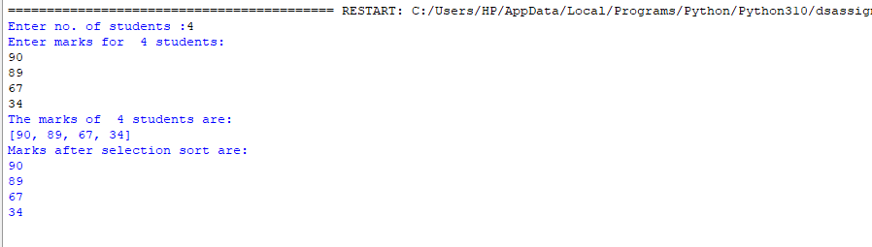
b) Bubble Sort
marks=[]
x=int(input("Enter no of students: "))
print("Enter marks for ",x,"students: ")
for i in range(0,x):
y=int(input())
marks.append(y)

print("The marks of ",x,"students are: ")
print(marks)
def bubble_sort(marks):
n=len(marks)
for i in range(n-1):
for j in range(0,n-i-1):

#Traverse array from 0 to n-i-1
if marks[j]>marks[j+1]:
(marks[j],marks[j+1])=(marks[j+1], marks[j])
for i in range(len(marks)):
print(marks[i])

bubble_sort(marks)

Output:
