Practical No:6 (B)
Practical Title : Sorting of an array using insertion and shell sort Aim: Write a Python program to store second year percentage of students in array. Write function for sorting array of floating point numbers in ascending order using
a) Insertion sort
b) Shell Sort and display top five scores
Program:
a)Insertion Sort:
#include<iostream>
using namespace std;
/*function to implement insertionSort*/
int insert(int a[],int n)
{
int i,j,temp;
for(int i=1;i<n;i++)
{
temp=a[i];
j=i-1;
while(j>=0 && temp && temp <= a[j])
{
a[j+1]=a[j];
j=j-1;
}
a[j+1]=temp;
}
}
void printarr(int a[],int n)
{
int i;
for(i=0;i<n;i++)
cout<<a[i]<<" ";
}
int main()
{
int a[]={64,84,30,72,51,97,34};
int n=sizeof(a)/sizeof(a[0]);
cout<<"Before sorting array elements are-\n";
printarr(a,n);
insert(a,n);
cout<<"\nAfter Applying Insertion Sort,the array elements are-\n";
printarr(a,n);
return 0;
}
Output:
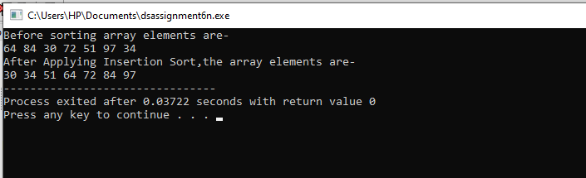

b)Shell Sort:
#include<iostream>
using namespace std;
/*function to implement shellSort*/
int shell(int a[],int n)
{
for(int interval=n/2;interval>0;interval/=2)
{
for(int i=interval;i<n;i+=1)
{
int temp=a[i];
int j;
for(j=i;j>=interval && a[j-interval]>temp;j-=interval)
a[j]=a[j-interval];
a[j]=temp;
}
}
return 0;
}
void printarr(int a[],int n)
{
int i;
for(i=0;i<n;i++)
cout<<a[i]<<" ";
}
int main()
{
int a[]={56,89,23,76,45,21,90,65};
int n=sizeof(a)/sizeof(a[0]);
cout<<"Before sorting array elements are-\n";
printarr(a,n);
shell(a,n);
cout<<"\nAfter Applying Shell Sort,the array elements are-\n";
printarr(a,n);
return 0;
}
Output:
