Report
Of
Spam Email Classifier
Submitted
To
School of Computer Science and Engineering
IILM University, Greater Noida, U.P.
In partial fulfilment of the requirement of degree of
B.Tech CSE

By
Roll Number of Student: 25SCS1003003722
Name of Student: HARSH LOKWANI
Batch: 2026-27

CONTENTS

Chapter No. | Chapter Name | Page Nos.
 | Cover Page | ----
1. | Candidate's Declaration | i
2. | Acknowledgement | ii
3. | Internship Completion Certificate | iii
4. | Project Description  4.1 Introduction  4.2 Organization Profile  4.3 Problem Statement  4.4 Project Objectives  4.5 Scope of the Project  4.6 Technologies and Tools Used  4.7 System Architecture  4.8 Methodology  4.9 Expected Outcomes  4.10 Certificates of completion and other communication mail proof | 1 - 5
5. | Bibliography/References | 6

CANDIDATE'S DECLARATION
I, Harsh Lokwani, do hereby declare that the internship report titled "Spam Email Classifier" has been completed by me to fulfil the requirement for the award of the degree of Bachelor of Technology in CSE. All the references have been quoted and I have not taken as such any material from any other source. I affirm to you that this report is my own and has not been submitted to any other institute for any degree/diploma requirement and further I shall be solely responsible for any kind of copyright violation in this regard.
Signature:

Student Name: Harsh Lokwani
Roll No.: 25SCS1003003722

ACKNOWLEDGEMENT
I am using this opportunity to express my gratitude to everyone who supported me throughout the Internship Program at Codec Technologies Pvt. Ltd. I am thankful for their aspiring guidance, invaluably constructive criticism and friendly advice during this work. I would especially like to thank Dr. Anurag Shrivastava, Program Manager, and the entire team at Codec Technologies for giving me the opportunity to work on the "Spam Email Classifier" project as part of the Artificial Intelligence Internship Program. I am sincerely grateful to them for sharing their truthful and illuminating views on a number of issues related to this work.
I would also like to extend my heartfelt thanks to the School of Computer Science and Engineering, IILM University, Greater Noida, for their continuous support, guidance and encouragement throughout the duration of this internship.
I express my gratitude to my parents for their blessings.
Signature:
Student Name: Harsh Lokwani
Roll No.: 25SCS1003003722

INTERNSHIP COMPLETION CERTIFICATE
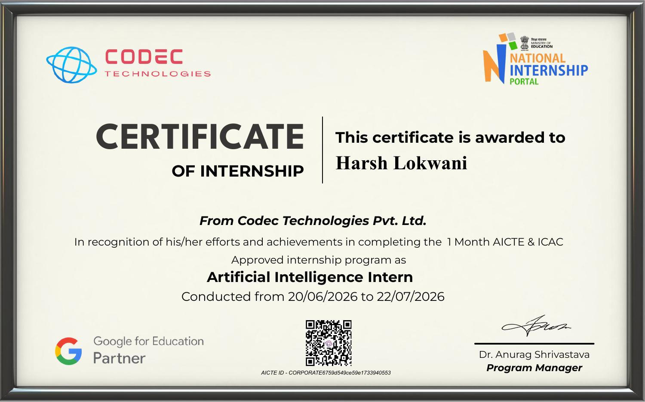

4. PROJECT DESCRIPTION
4.1 Introduction
Artificial Intelligence (AI) has become one of the most transformative technologies of the present era, enabling systems to learn from data, identify patterns, and make intelligent decisions with minimal human intervention. As part of the B.Tech CSE curriculum, I undertook a one-month Artificial Intelligence Internship at Codec Technologies Pvt. Ltd., an AICTE and ICAC approved industry training program offered through the National Internship Portal, from 20th June 2026 to 22nd July 2026.
During this internship, I worked on the design and development of a Spam Email Classifier, a machine learning based system that automatically distinguishes between legitimate ('ham') and unwanted ('spam') emails based on their textual content. This report presents an overview of the organization, the problem addressed, the objectives and scope of the project, the tools and methodology used, and the outcomes achieved during the course of the internship.
4.2 Organization Profile
Codec Technologies Pvt. Ltd. is a global platform dedicated to empowering learners and connecting diverse talent to meaningful career opportunities worldwide. The organization delivers dedicated IT and business consultancy services across more than 27 countries, supporting global innovation and strategic growth. Codec Technologies is a recognized Google for Education Partner and is ISO 9001:2015 certified for its quality management processes.
The company runs AICTE and ICAC approved internship programs listed on the National Internship Portal, offering students an immersive, industry-oriented learning experience across domains such as Artificial Intelligence, Web Development, Data Science, and Cybersecurity. Codec Technologies is headquartered at the Chandivali IT Hub, Mumbai, and operates its internship programs in a Pan-India, hybrid mode, with interns reporting to assigned project heads and undergoing periodic performance evaluation.
4.3 Problem Statement
With the exponential growth of email communication, spam emails have become a persistent and evolving problem, ranging from harmless advertisements to malicious phishing attempts designed to steal sensitive user information. Manually filtering such emails is impractical given the sheer volume received daily by users and organizations. There is, therefore, a need for an automated, intelligent system that can accurately classify incoming emails as spam or legitimate (ham) based on their content, thereby reducing security risks and improving user productivity. The objective of this project was to design and implement such a classifier using supervised machine learning techniques.
4.4 Project Objectives
- To collect and pre-process a labelled email/SMS dataset consisting of spam and ham messages.
- To convert unstructured text data into numerical feature vectors using text-representation techniques such as Bag-of-Words and TF-IDF.
- To train and compare classification models, primarily Multinomial Naive Bayes and Support Vector Machines (SVM), for spam detection.
- To evaluate model performance using metrics such as accuracy, precision, recall, F1-score, and confusion matrix.
- To build a simple, functional prediction pipeline capable of classifying a new, unseen email as spam or ham.
4.5 Scope of the Project
The scope of this project is limited to text-based classification of English-language emails/SMS messages using traditional supervised machine learning algorithms. The system analyses the textual content of a message to predict its class (spam or ham) and does not extend to scanning email attachments, images, or embedded links for malware analysis. The project is intended as a proof-of-concept model suitable for academic and learning purposes, with scope for future enhancement into a deployable, real-time email filtering system integrated with an email client or server.
4.6 Technologies and Tools Used
- Programming Language: Python 3
- Libraries: scikit-learn, pandas, NumPy, NLTK, Matplotlib, Seaborn
- Development Environment: Jupyter Notebook / Google Colab
- Machine Learning Algorithms: Multinomial Naive Bayes, Support Vector Machine (SVM)
- Feature Extraction Technique: TF-IDF (Term Frequency-Inverse Document Frequency) Vectorizer / Bag-of-Words
- Version Control: Git and GitHub
4.7 System Architecture
The system follows a standard machine learning pipeline architecture consisting of the following stages, arranged sequentially:
- Data Collection — Gathering a labelled dataset of spam and ham messages.
- Data Pre-processing — Cleaning text (lowercasing, removing punctuation, stop-word removal, tokenization, stemming/lemmatization).
- Feature Extraction — Transforming cleaned text into numerical vectors using TF-IDF/Bag-of-Words.
- Model Training — Training Naive Bayes and SVM classifiers on the vectorized training data.
- Model Evaluation — Testing the trained models on unseen data and comparing performance metrics.
- Prediction Module — Using the best performing model to classify new, incoming email text as spam or ham.
4.8 Methodology
The project was carried out using a structured machine learning workflow, described below:
- Dataset Acquisition: A publicly available labelled spam/ham dataset (similar to the SMS Spam Collection dataset) containing thousands of messages tagged as 'spam' or 'ham' was used for training and testing.
- Data Cleaning: The raw text was pre-processed by converting to lowercase, removing punctuation, numbers, and stop words, and applying tokenization and stemming using the NLTK library.
- Train-Test Split: The cleaned dataset was split into training (80%) and testing (20%) subsets to ensure unbiased evaluation of the model.
- Feature Engineering: The TF-IDF Vectorizer was used to convert the pre-processed text messages into numerical feature vectors suitable for machine learning algorithms.
- Model Building: Two classification algorithms — Multinomial Naive Bayes and Support Vector Machine (SVM) — were implemented using scikit-learn and trained on the feature vectors.
- Model Evaluation: The trained models were evaluated on the test dataset using accuracy, precision, recall, F1-score, and a confusion matrix to identify the better-performing algorithm.
- Testing and Validation: The final selected model was tested with new, unseen sample emails to validate real-world classification performance.
4.9 Expected Outcomes
- A working Spam Email Classifier capable of accurately distinguishing between spam and legitimate emails.
- Comparative performance analysis between Naive Bayes and SVM classifiers for text classification tasks.
- A trained model achieving high classification accuracy, suitable for further extension into a real-time filtering application.
- Practical, hands-on exposure to the complete AI/ML development lifecycle — from data pre-processing to model deployment.
- Strengthened understanding of Natural Language Processing (NLP) concepts and their application in real-world problems.
4.10 Certificates of completion and other communication mail proof
The Internship Completion Certificate issued by Codec Technologies Pvt. Ltd. has been attached in Chapter 3 of this report. The Internship Offer Letter, issued at the commencement of the program, is attached below as proof of communication and enrolment in the internship program.
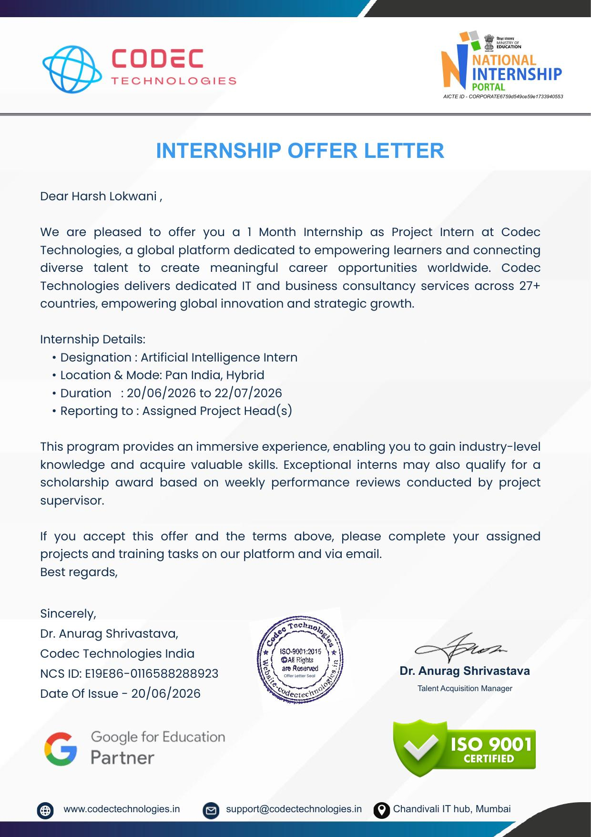
Figure 4.1: Internship Offer Letter — Codec Technologies Pvt. Ltd.

5. BIBLIOGRAPHY / REFERENCES
[1] Pedregosa, F. et al., "Scikit-learn: Machine Learning in Python," Journal of Machine Learning Research, vol. 12, pp. 2825-2830, 2011.
[2] scikit-learn documentation, "Naive Bayes," scikit-learn.org. [Online]. Available: https://scikit-learn.org/stable/modules/naive_bayes.html
[3] scikit-learn documentation, "Support Vector Machines," scikit-learn.org. [Online]. Available: https://scikit-learn.org/stable/modules/svm.html
[4] NLTK Project, "Natural Language Toolkit documentation," nltk.org. [Online]. Available: https://www.nltk.org/
[5] Almeida, T. A., Hidalgo, J. M., "SMS Spam Collection Dataset," UCI Machine Learning Repository, 2012.
[6] GeeksforGeeks, "Spam Classification using SVM and Naive Bayes," geeksforgeeks.org.
[7] Codec Technologies Pvt. Ltd., Internship Offer Letter and Certificate of Internship, 2026.

