Aspect-Based Sentiment Analysis of Code-Mixed Hinglish E-commerce Reviews:
A Dataset, Benchmark Models and an Explainable, Retrieval-Aware Pipeline
B.Tech Project — Mid-Term Evaluation Report
Submitted by
Name
Arpita [Roll No.]
Harsh [Roll No.]
Punit [Roll No.]
Under the supervision of
[Supervisor Name]
Department of Computer Science and Engineering
[University Name]
September 2026
____________  Arpita | ____________  Harsh | ____________  Punit | ____________  [Supervisor Name]  (Supervisor)

1. Introduction
Online shopping and quick-commerce applications such as Meesho, Nykaa, Blinkit and Zepto have become part of daily life for a large number of Indian consumers, and after a purchase, customers frequently leave a short review on the application's Google Play Store page describing what worked and what did not. Taken together, these reviews are a rich source of feedback — delivery delays, pricing complaints, product defects and service failures, all in the customer's own words — but popular applications receive thousands of them every week, and reading them one by one is neither fast nor consistent.
A large part of this feedback is not written in clean English or clean Hindi. Indian users tend to switch between the two languages within a single sentence, a habit usually called code-mixing, and the result, commonly known as Hinglish, is almost always typed in the Roman script rather than Devanagari. A review from our own data illustrates this well: "good groceries app but kabhi kabhi kuch chiz Boht purane aati Hai" (good groceries app, but sometimes items arrive very old). Sentiment analysis of Hinglish text has been studied before, for instance by the SemEval-2020 SentiMix shared task [3], but almost always at the level of the whole message.
That distinction matters a great deal in practice. Figure 1, taken directly from our pilot data, shows a customer who is happy with how quickly an order arrived but unhappy about the price. A single sentiment label cannot represent both opinions at once, and more importantly it does not tell a business which of the two things it should fix. Aspect-Based Sentiment Analysis (ABSA) avoids this by identifying each aspect a review discusses and assigning it a sentiment individually [1], [2].
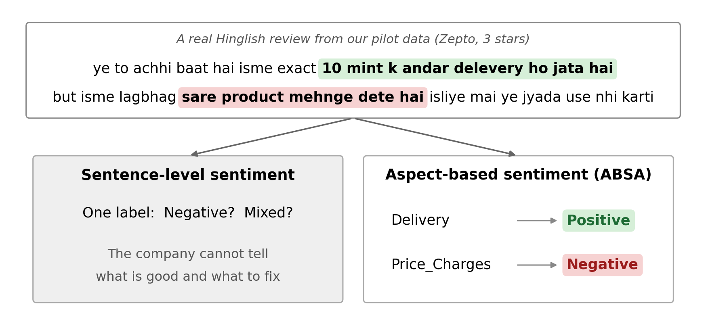
Figure 1: A real Hinglish review from our data; a single label cannot capture that delivery and pricing are viewed differently.
Working with this text is harder than it looks. Spelling is not standardised — bahut (“very”) appears as bahut, bhot and bohot in our own data — reviews carry slang, sarcasm and emoji, and no existing dataset is built for this specific setting: published code-mixed ABSA resources are drawn from restaurant and laptop reviews [4], [5], and even the Hindi-English portion of the most recent benchmark turns out to be a translated English dataset rendered in Devanagari rather than the way people actually type.
This project is our attempt to close that gap. We are (i) building a labelled dataset of real Hinglish e-commerce reviews, (ii) training and comparing models that predict sentiment separately per aspect, (iii) adding an explanation layer and a retrieval step so predictions are not a black box, and (iv) turning the output into a summary a non-technical reader could act on. At the time of writing, (i) and (ii) are largely complete; (iii) exists as a working prototype, evaluated honestly including where it currently falls short. Section 2 surveys related work, Section 3 describes our methodology, Section 4 reports results and discussion, and Section 5 outlines what remains.

2. Literature Survey
The idea that a review discusses several distinct features rather than one overall opinion goes back to Hu and Liu [1], who extracted product features from reviews along with the sentiment expressed about each. This matured into the SemEval-2014 Task 4 shared task [2], which released English restaurant and laptop datasets and formalised subtasks such as aspect extraction and aspect category polarity; these remain the reference benchmarks for ABSA, though monolingual and limited to two domains. Neural models built on pre-trained transformers improved on this considerably; a formulation we rely on directly is due to Sun et al. [6], who reframed ABSA as sentence-pair classification — the review paired with a phrase naming the aspect — so that a single review can receive different sentiments for different aspects. We adopt this for our own transformer baselines.
Code-mixed text brings its own difficulties: inconsistent spelling, transliteration and limited labelled data. SentiMix [3] is the most visible Hinglish-specific effort, releasing around 20,000 annotated tweets, but it assigns one sentiment per tweet and is drawn from social media rather than product reviews. Work combining code-mixing with aspect-level analysis is rarer still: ABSA-MIX [4] adapted SemEval-style annotation to Hindi-English restaurant and laptop reviews, and CMF_HIT [5] — the model we treat as our main point of comparison — combines XLM-R, a hierarchical transformer for code-mixed text and a CNN-ELMo-TF-IDF module through gated fusion, and predicts aspect category and polarity jointly across four Indic-English language pairs. Its released Hindi-English data, on inspection, consists of restaurant reviews whose identifiers match the English SemEval-2014 set and are written mostly in Devanagari, which we return to in Section 4.
Pre-trained multilingual encoders underlie most current work in this space: XLM-R [7] is trained on a large multilingual web corpus, while MuRIL [8] is trained specifically on Indian languages together with their transliterated forms. We use both as baselines. For retrieval we draw on the idea behind Retrieval-Augmented Generation [9], grounding a prediction in similar already-labelled examples retrieved through dense embeddings [14] and FAISS [15]; for explainability we use SHAP [10], which estimates each word's contribution using Shapley values from cooperative game theory, since raw attention weights alone do not always reliably indicate what drove a decision.
Table 1 places the closest resources side by side. No existing Hinglish ABSA resource is built from e-commerce reviews, the nearest Hindi-English data is a translated set written in a script most users do not type in, and none of the models we found produce an explanation or an output a business could act on directly — the two gaps this project is addressing.
Table 1: Related resources compared with this project.
Work | Language | Domain | Sentiment level | Script as typed | Explains / actionable
SemEval-2014 [2] | English | Restaurant, laptop | Aspect | n/a | No
SentiMix [3] | Hinglish | Twitter | Sentence | Yes | No
ABSA-MIX [4] | Hindi-English | Restaurant, laptop | Aspect | Not confirmed | No
CMF_HIT [5] | 4 Indic-English pairs | Restaurant (Hi-En release) | Sentence-level | No (Devanagari) | No
This project | Hinglish | E-commerce apps | Aspect | Yes | Yes

3. Problem Statement and Methodology
Given a Hinglish review r from an e-commerce application and a fixed set of aspect categories C, our goal is to identify every category the review discusses and, for each one, predict whether it is expressed positively, negatively or neutrally — a review can produce more than one such (category, sentiment) pair. Each review is also assigned a single review-level sentiment, letting us compare aspect-level and whole-review analysis directly. Figure 2 shows how this fits into the pipeline we are building: data collection, cleaning, annotation, modelling, evaluation, explanation and a business-facing summary.
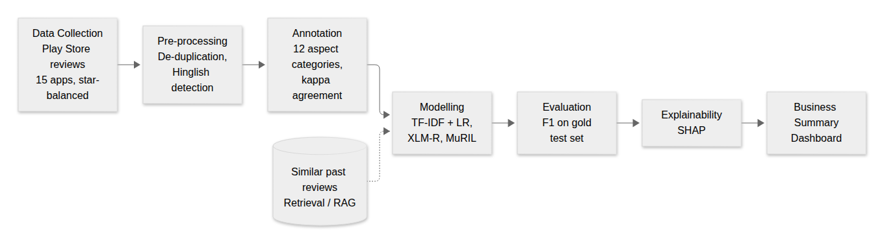
Figure 2: The project pipeline, from data collection through to a business-facing dashboard.
Reviews are collected from Play Store pages using google-play-scraper [11], which needs no login. Because reviews for these applications skew heavily positive, we query each star rating separately rather than at random, and under both the English and Hindi store-language settings, since Hinglish reviews surface under either. Only review text, star rating and timestamp are kept. A first pass across four applications (Meesho, Nykaa, Blinkit, Zepto) yielded 2,459 usable reviews, of which about 20% were code-mixed; a second, larger pass extended this to 15 applications, including three D2C brands (Lenskart, Purplle, Bewakoof) added specifically to bring in more product-focused language, and roughly 21,000 further reviews, from which 600 more were selected for annotation.
[INSERT SCREENSHOT S1 HERE]
Insert a couple of Hinglish reviews as they appear on a Play Store app page (e.g. Meesho or Zepto), with usernames and photos blurred.
(Delete this box after inserting the screenshot.)
Figure 3: Hinglish reviews as they appear on the Play Store.
Cleaning removes duplicate reviews and any under four words, since these rarely mention anything specific. Separating Hinglish from English-only or Devanagari text uses a keyword detector: a review is treated as Hinglish once it contains two or more common Hindi words written in Roman letters (hai, nahi, bahut, and their many spelling variants), and emoji are deliberately kept rather than stripped, since a thumbs-down or heart often carries real sentiment.
We defined twelve aspect categories after examining the pilot data — Delivery, Price_Charges, Offers_Discounts, Product_Quality, Availability, Wrong_Missing_Item, Refund_Return, Payment_Wallet, Customer_Support, App_Experience, Packaging and Overall — and for every review, annotators mark each category discussed with a sentiment, plus one review-level sentiment overall, with star ratings hidden while labelling. Before labelling everything, we piloted the scheme: all three of us independently labelled the same 100 reviews, without discussing them. Agreement (Fleiss' kappa [13]) came out moderate overall (0.55 on category and sentiment together) but almost perfect on sentiment alone once an aspect was agreed on (0.80); pairwise Cohen's kappa [12] between individual annotators told the same story, ranging from 0.51 to 0.63. Roughly half of the disagreement traced back to one category, Overall, which each of us had understood differently — used as a running summary by one annotator, and reserved for explicit statements by another — with agreement on it alone essentially at chance (kappa −0.02).
We revised the guidelines in response: Overall is now used only for an explicit general statement (“accha app hai”, “fraud”) rather than as a summary, the whole-review sentiment moved into its own field, App_Experience was narrowed to technical issues only, and two categories the team asked for, Offers_Discounts and Availability, were added. Repeating the exercise on a fresh set of 147 reviews under the new guidelines raised agreement across the board (Figure 4): 0.68 on category and sentiment together, 0.84 on sentiment, and — most tellingly — agreement on Overall itself from −0.02 to 0.52. The seven cases where all three labels still differed were settled by a designated adjudicator following the written guidelines, and the remaining reviews were then split up and labelled once each.
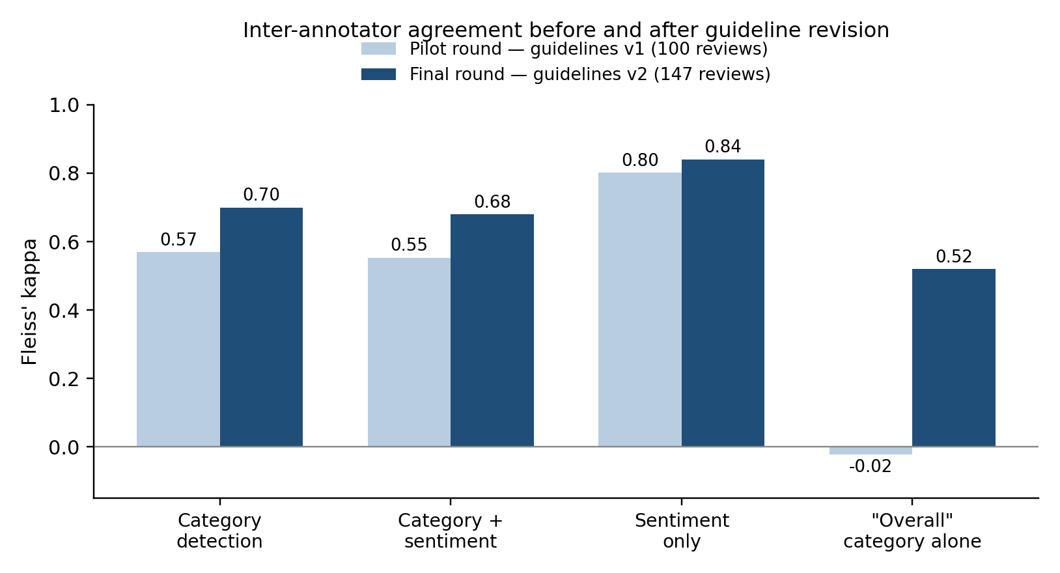
Figure 4: Inter-annotator agreement before and after the guidelines were revised.
[INSERT SCREENSHOT S2 HERE]
Insert the printed output of Box 3 in Step5_Final_Agreement.ipynb (the pairwise and Fleiss kappa tables for the 147-review round).
(Delete this box after inserting the screenshot.)
Figure 5: Raw output of the final agreement calculation.
For modelling, every (review, category) pair becomes one training example, predicting none, positive, negative or neutral, with none-examples capped at three times the number of real ones so the model is not overwhelmed by the majority class. We compare a classical baseline — TF-IDF word bigrams and character 2–5-grams (chosen partly to absorb spelling variation) feeding into one class-balanced logistic regression per category — against XLM-R and MuRIL, both fine-tuned with a class-weighted loss and trained across three random seeds, reporting mean ± standard deviation rather than a single run. A retrieval step embeds every review with a multilingual sentence encoder [14] and indexes it with FAISS [15] to surface similar labelled reviews, and a SHAP-based module explains individual predictions; both are evaluated in Section 4 as early prototypes rather than finished components. All models are trained on the singly-annotated reviews and evaluated on a 232-review gold set built from the two independently double/triple-labelled rounds, using aspect detection F1, the stricter aspect-and-sentiment F1, and macro F1 across categories — reported both including and excluding Overall, since it was labelled inconsistently in parts of the data even after revision. The project uses Python, PyTorch and HuggingFace Transformers for model training, scikit-learn for the baseline and evaluation metrics, SHAP [10] for explanations, sentence-transformers/FAISS [14], [15] for retrieval, and Google Colab (T4 GPU), with code and guidelines version-controlled on GitHub.

4. Work Done Till Date, Results and Discussion
In summary, the following pieces are in place at the time of writing:
- 2,459 pilot reviews cleaned from four applications, plus a further roughly 21,000 reviews from a larger second pass across 15 applications;
- annotation guidelines written and revised through a measured pilot study (Section 3);
- 1,018 reviews labelled in total, 232 of them forming a doubly/triply-checked gold test set;
- a classical baseline and two fine-tuned transformers trained and evaluated, each transformer across three random seeds;
- a first version of retrieval implemented and evaluated, and SHAP explanations generated for the full test set;
- a working dashboard tying the dataset, models, explanations and retrieved reviews together;
- a detailed reading of the base paper's public implementation, having originally hoped to reproduce it as a further baseline.
Table 2: Aspect mentions in the final labelled dataset (1,018 reviews: 668 train, 118 validation, 232 test).
Category | Train | Val | Test | Positive | Negative | Neutral | Total
Delivery | 152 | 26 | 53 | 53 | 167 | 11 | 231
Price_Charges | 75 | 20 | 39 | 31 | 98 | 5 | 134
Offers_Discounts | 37 | 5 | 24 | 14 | 50 | 2 | 66
Product_Quality | 114 | 16 | 34 | 67 | 84 | 13 | 164
Availability | 30 | 7 | 13 | 9 | 38 | 3 | 50
Wrong_Missing_Item | 33 | 4 | 11 | 0 | 46 | 2 | 48
Refund_Return | 78 | 7 | 22 | 7 | 98 | 2 | 107
Payment_Wallet | 47 | 14 | 13 | 5 | 56 | 13 | 74
Customer_Support | 48 | 8 | 15 | 1 | 68 | 2 | 71
App_Experience | 108 | 20 | 58 | 31 | 146 | 9 | 186
Packaging | 6 | 3 | 7 | 4 | 11 | 1 | 16
Overall | 342 | 55 | 89 | 270 | 186 | 30 | 486
Total | 1070 | 185 | 378 | 492 | 1048 | 93 | 1633

[INSERT SCREENSHOT S3 HERE]
Insert the printed output of Box 5 in Step6_Final_Experiments.ipynb (train/validation/test counts and the label-statistics table).
(Delete this box after inserting the screenshot.)
Figure 6: Dataset statistics as printed by the experiments notebook.
We had planned to reproduce CMF_HIT [5] on our own data as a direct baseline, so before writing any code of our own we went through the authors' public repository. This turned out not to be straightforward. The released Hindi-English data consists of restaurant reviews whose identifiers match the English SemEval-2014 benchmark almost exactly, suggesting they were translated rather than collected from Hindi-English speakers directly, and are written mostly in Devanagari rather than the Roman script our own data uses. The released training script, meanwhile, does not implement the architecture the paper describes: the hierarchical-transformer input is randomly generated rather than computed, the language-aware tokenizer's output is discarded after being used only in a regularisation term, the three feature streams are concatenated rather than combined through gated fusion, and category and polarity are predicted per sentence rather than per aspect. We note this only as an observation — a more complete implementation may exist privately — but in practice it meant direct reproduction was not possible with what has been released.
Table 3 reports results on the 232-review gold test set, with the transformer rows averaged over three seeds, both including and excluding the inconsistently-labelled Overall category.
Table 3: Test set results on the 232-review gold set (Det. = detection F1, A+S = aspect + sentiment F1, Macro = macro F1).
Model | Det. | A+S | Macro | Det.* | A+S* | Macro*
TF-IDF + LR | 0.559 | 0.494 | 0.384 | 0.518 | 0.451 | 0.364
XLM-R | 0.562±.004 | 0.481±.005 | 0.434±.008 | 0.552±.006 | 0.481±.011 | 0.430±.009
MuRIL | 0.405±.097 | 0.323±.092 | 0.198±.132 | 0.265±.200 | 0.228±.170 | 0.176±.142

(Columns marked * exclude the Overall category, which was labelled inconsistently in parts of the data even after the guideline revision.)
[INSERT SCREENSHOT S4 HERE]
Insert the printed output of Box 8 in Step6_Final_Experiments.ipynb (one transformer run's training loss and validation F1 across epochs).
(Delete this box after inserting the screenshot.)
Figure 7: Training progress for one XLM-R run.
XLM-R and the TF-IDF baseline end up close on the headline metric once Overall is excluded (0.481 against 0.451), but XLM-R is considerably more consistent — its detection recall is much higher (0.594 vs 0.433), meaning it misses fewer real aspects, at some cost in precision — and its standard deviation across seeds is tiny (±0.005 to ±0.011), suggesting the result is not a lucky initialisation. MuRIL tells a more mixed story: once the class-weighted loss was added it went from predicting nothing at all to genuinely learning the task, but its scores vary far more across seeds (0.09 to 0.20 standard deviation) and its validation F1 does not climb steadily across epochs the way XLM-R's does, which we suspect is related to learning-rate sensitivity rather than anything fundamental. A learning curve trained on 12.5% to 100% of the data (98 to 786 reviews) rose steadily from 0.30 to 0.49 F1 but with clearly diminishing returns — doubling the data from roughly 390 to 786 reviews added only about 0.04 — suggesting that from here, fixing MuRIL's variance or targeting a handful of under-represented categories (Wrong_Missing_Item, Availability and Packaging each have fewer than 15 test examples, and score correspondingly poorly) may matter more than collecting still more data.
SHAP explanations on all 232 test reviews were revealing in both directions. For a clearly positive review with heart emoji, the emoji themselves carried real weight in the explanation alongside the word acha, supporting our decision not to strip emoji during cleaning; for a review containing the misspelling dilivery, the model still correctly attributed its negative prediction to that word, suggesting some robustness to non-standard spelling. Less reassuringly, for at least one review containing kharab (“bad”), the explanation showed that word pushing the prediction towards positive rather than negative — a genuine mistake made visible by the explanation rather than hidden behind a single accuracy number, which is precisely the kind of thing we think this layer is for.
Retrieval was evaluated by checking whether each test review's single most similar training review shared a specific aspect with it. This held for 90 of 232 reviews (about 39%), and predicting labels from only the three retrieved neighbours gave an Aspect + Sentiment F1 of 0.296, well below XLM-R's 0.481. Inspecting individual cases, the retriever tends to surface reviews with similar wording rather than similar topics — a review about delivery speed and pricing retrieved neighbours about availability and packaging. We read this as a useful negative result: a general-purpose multilingual retriever is not, on its own, a good foundation for retrieval-augmented prediction here, which is why building a retriever tuned to match on aspect rather than surface wording is our next step (Section 5) rather than something we can report a positive result for yet.
[INSERT SCREENSHOT S5 HERE]
Insert the printed dictionary output of Box 13 in Step6_Final_Experiments.ipynb (the retrieval evaluation numbers).
(Delete this box after inserting the screenshot.)
Figure 8: Output of the retrieval evaluation.
All of this feeds into a single interactive dashboard aimed at a reader who cares about outcomes rather than model internals: negative mentions broken down by application and aspect, the top complaint categories per application, a toggle between model predictions and our own labels, and a review explorer showing any individual review alongside its SHAP highlights and retrieved neighbours. Figure 9 shows the business-summary view; based on model predictions, delivery and product quality are the most frequent complaint areas across applications, with Meesho additionally showing many app-experience complaints and Zepto many customer-support ones.
[INSERT SCREENSHOT S6 HERE]
Insert a screenshot of the dashboard's business-summary view (the aspect-by-application complaint table and the top-three complaints per application).
(Delete this box after inserting the screenshot.)
Figure 9: The dashboard's business-summary view.
A few limitations are worth stating plainly. Several categories still have very few labelled examples, and their scores should be read with that in mind; most training reviews were labelled by a single annotator rather than cross-checked, so some noise likely remains even after our consistency check; MuRIL's variance across seeds is not yet fully understood; and retrieval, in its current form, is evaluated but not yet used to actually change a prediction.

5. Future Work
The next phase falls into four areas, roughly in the order we intend to take them up.
- Strengthening the dataset and models — extending the data further, particularly for the currently under-represented categories; a short diagnostic sweep on MuRIL's learning rate to understand its variance; and testing whether normalising spelling variants before training changes results, which is currently only a stated motivation rather than a tested claim.
- An aspect-aware retriever — fine-tuning retrieval embeddings on our own labelled pairs so that two reviews are considered similar only when they share an aspect, re-running the evaluation in Section 4 to see whether this closes the gap with a general-purpose retriever, and, if it does, feeding retrieved examples into the model itself rather than treating retrieval as something to inspect only in the dashboard.
- Re-implementing CMF_HIT from its written description, adapted to predict sentiment per aspect rather than per sentence, and comparing it against our existing baselines on the same test set — more time-consuming than the other items, so scheduled to begin once the retrieval work is stable.
- Writing up and dissemination — a short paper describing the dataset, annotation methodology and benchmark results for submission to a suitable NLP venue, releasing the dataset (or as much as Play Store's terms allow) alongside it, and updating the dashboard once the above is complete.
Open questions we would like to answer by the end of this work:
- Does an aspect-aware retriever meaningfully close the gap seen in Section 4?
- Does a from-scratch CMF_HIT implementation outperform our simpler baselines on this dataset?
- How much of the remaining error is attributable to categories with very few training examples, rather than to the models themselves?

6. Conclusion
This report has described the first half of a project aimed at aspect-based sentiment analysis for Hinglish e-commerce reviews — a setting not well served by existing datasets or models, most of which are monolingual, drawn from restaurants or social media, or unable to explain their own predictions. We have built a labelled dataset of just over a thousand reviews, tested and revised our annotation guidelines through a measured pilot study, and trained baseline models whose results and failure modes we have tried to report honestly rather than selectively. The clearest lesson so far is a practical one: consistent annotation guidelines matter as much as model choice, and a bigger dataset helps but with diminishing returns past a certain point. The second half will focus on turning our retrieval prototype into something that actually improves predictions, re-implementing the base paper's architecture properly, and preparing the work for a wider audience.

References
[1] M. Hu and B. Liu, "Mining and summarizing customer reviews," in Proc. 10th ACM SIGKDD Int. Conf. Knowledge Discovery and Data Mining (KDD), 2004, pp. 168–177.
[2] M. Pontiki, D. Galanis, J. Pavlopoulos, H. Papageorgiou, I. Androutsopoulos, and S. Manandhar, "SemEval-2014 Task 4: Aspect based sentiment analysis," in Proc. 8th Int. Workshop on Semantic Evaluation (SemEval), 2014, pp. 27–35.
[3] P. Patwa et al., "SemEval-2020 Task 9: Overview of sentiment analysis of code-mixed tweets," in Proc. 14th Workshop on Semantic Evaluation (SemEval), 2020.
[4] [Authors: confirm from the paper page], "Quality achhi hai (is good), satisfied! Towards aspect based sentiment analysis in code-mixed language," Computer Speech & Language, vol. 89, 2025.
[5] L. Dewangan and C. K. Maurya, "CMF_HIT: Enhancing code-mixed aspect-based sentiment analysis via language-aware gradient-based tokenization and feature fusion," Expert Systems with Applications, 2026. [Confirm exact volume/article number from the paper page.]
[6] C. Sun, L. Huang, and X. Qiu, "Utilizing BERT for aspect-based sentiment analysis via constructing auxiliary sentence," in Proc. NAACL-HLT, 2019, pp. 380–385.
[7] A. Conneau et al., "Unsupervised cross-lingual representation learning at scale," in Proc. ACL, 2020.
[8] S. Khanuja et al., "MuRIL: Multilingual representations for Indian languages," arXiv:2103.10730, 2021.
[9] P. Lewis et al., "Retrieval-augmented generation for knowledge-intensive NLP tasks," in Advances in Neural Information Processing Systems (NeurIPS), 2020.
[10] S. M. Lundberg and S.-I. Lee, "A unified approach to interpreting model predictions," in Advances in Neural Information Processing Systems (NeurIPS), 2017.
[11] M. Jo, "google-play-scraper: Google Play Store scraper for Python," GitHub repository. [Online]. Available: https://github.com/JoMingyu/google-play-scraper
[12] J. Cohen, "A coefficient of agreement for nominal scales," Educational and Psychological Measurement, vol. 20, no. 1, pp. 37–46, 1960.
[13] J. L. Fleiss, "Measuring nominal scale agreement among many raters," Psychological Bulletin, vol. 76, no. 5, pp. 378–382, 1971.
[14] N. Reimers and I. Gurevych, "Sentence-BERT: Sentence embeddings using Siamese BERT-networks," in Proc. EMNLP-IJCNLP, 2019.
[15] J. Johnson, M. Douze, and H. Jégou, "Billion-scale similarity search with GPUs," IEEE Transactions on Big Data, vol. 7, no. 3, pp. 535–547, 2021.

