Cluster for Age and Spending Score

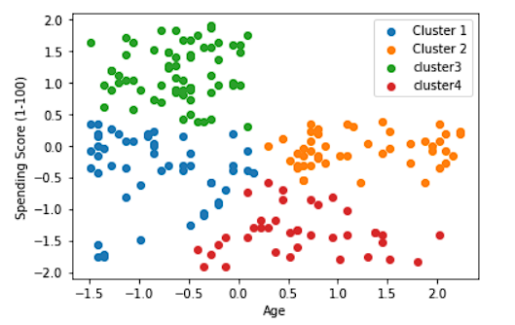

Cluster for Age and Annual Income

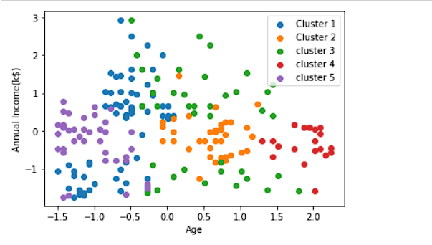

Cluster for Annual Income and Spending Score

