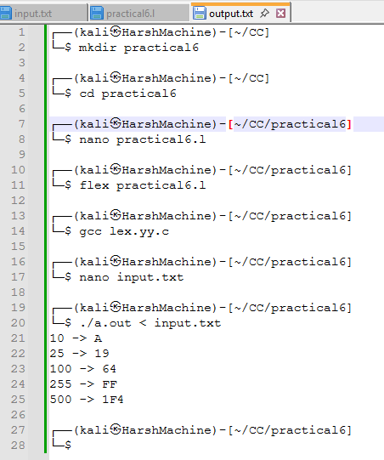
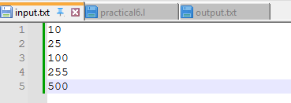
Practical 6,
Name: Harsh Kumar
PRN: 24070521093, 3rd Yr, Sec-B
Date: 26/07/26

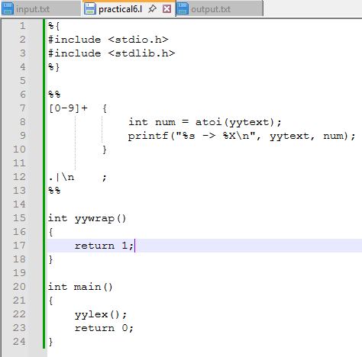
Practical 6,
Name: Harsh Kumar
PRN: 24070521093, 3rd Yr, Sec-B
Date: 26/07/26

Practical 6,
Name: Harsh Kumar
PRN: 24070521093, 3rd Yr, Sec-B
Date: 26/07/26

