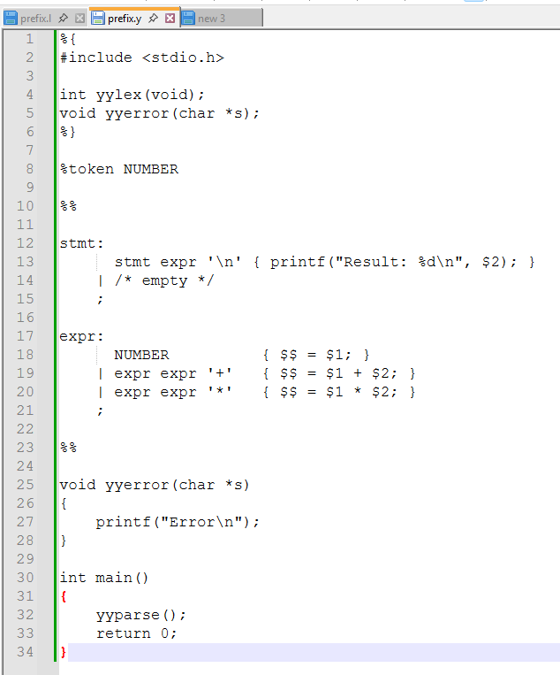
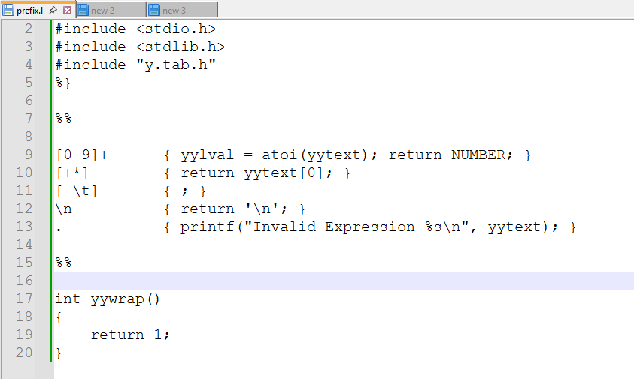
Practical 8,
Name: Harsh Kumar
PRN: 24070521093, 3rd Yr, Sec-B
Date: 15/09/26

Practical 8,
Name: Harsh Kumar
PRN: 24070521093, 3rd Yr, Sec-B
Date: 15/09/26

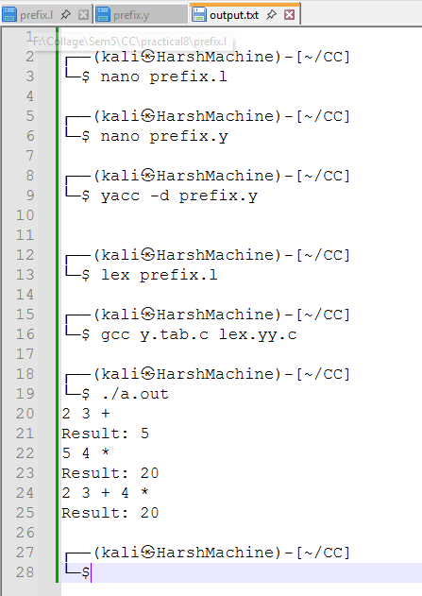

Practical 8,
Name: Harsh Kumar
PRN: 24070521093, 3rd Yr, Sec-B
Date: 15/09/26

