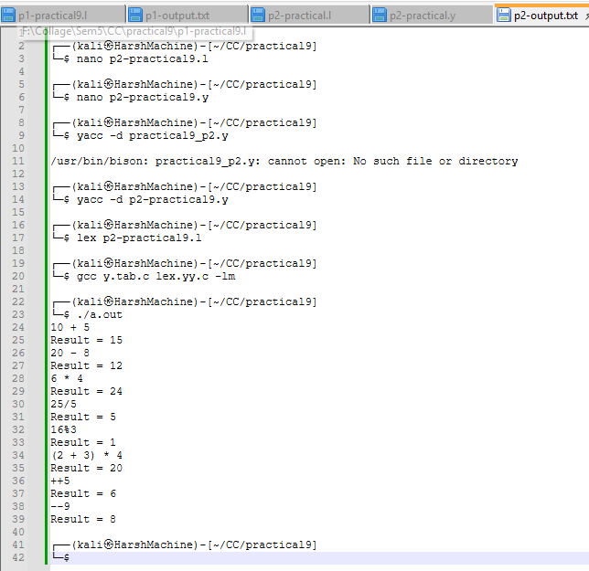
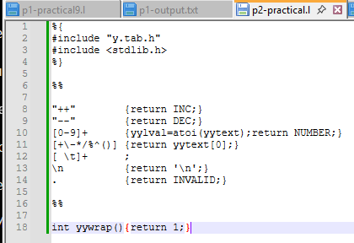
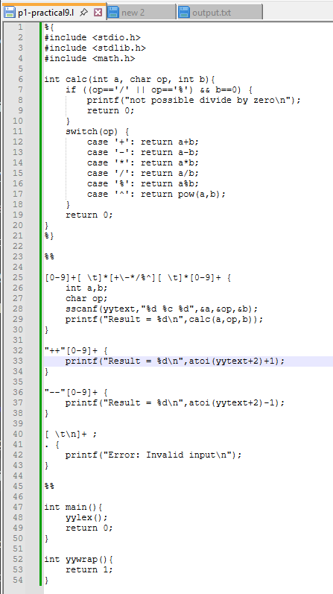
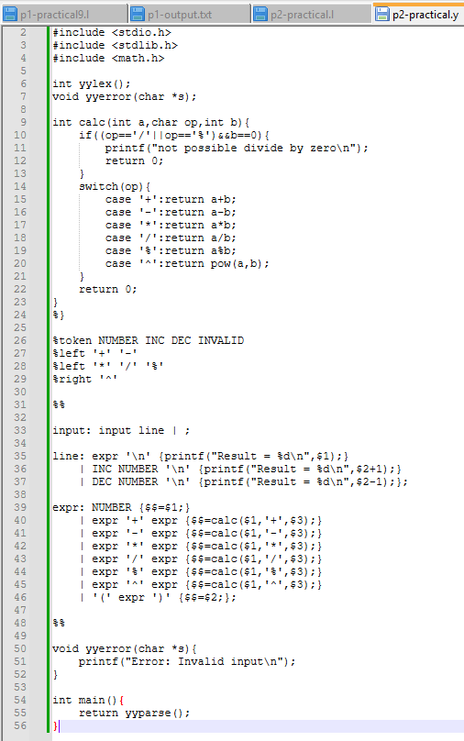
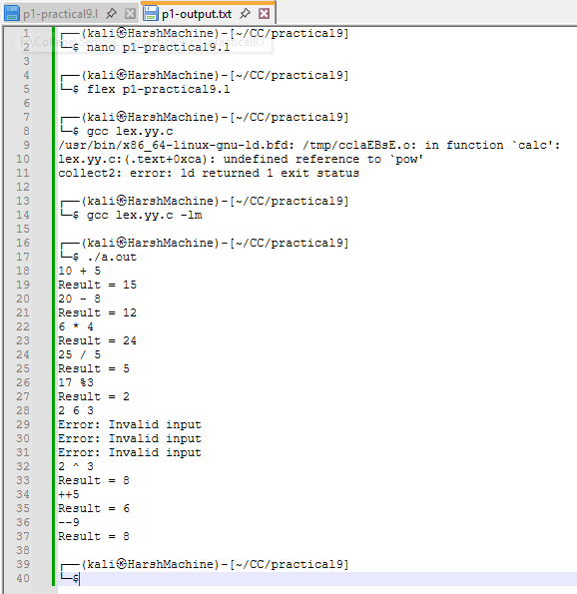
Practical 9 (program 2),
Name: Harsh Kumar
PRN: 24070521093, 3rd Yr, Sec-B
Date: 22/09/26

Practical 9 (program 2),
Name: Harsh Kumar
PRN: 24070521093, 3rd Yr, Sec-B
Date: 22/09/26

Practical 9 (program 1),
Name: Harsh Kumar
PRN: 24070521093, 3rd Yr, Sec-B
Date: 22/09/26

Practical 9 (program 1),
Name: Harsh Kumar
PRN: 24070521093, 3rd Yr, Sec-B
Date: 22/09/26

