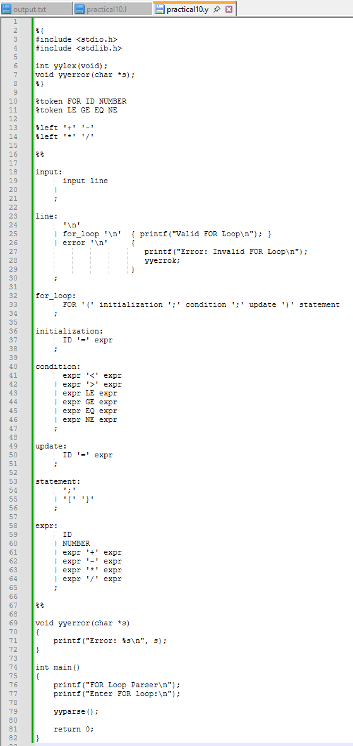
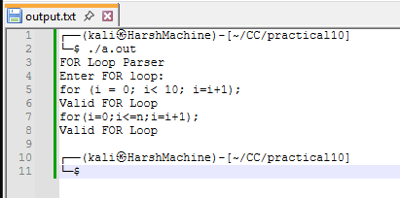
Practical 10
Name: Harsh Kumar
PRN: 24070521093, 3rd Yr, Sec-B
Date: 29/09/26

Practical 10
Name: Harsh Kumar
PRN: 24070521093, 3rd Yr, Sec-B
Date: 29/09/26

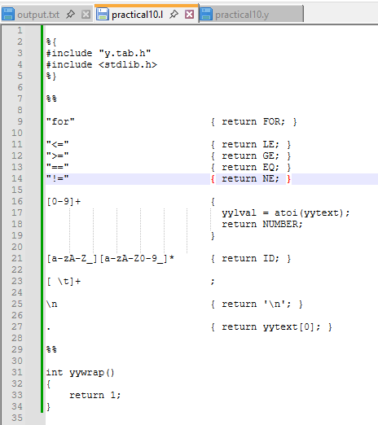
Practical 10
Name: Harsh Kumar
PRN: 24070521093, 3rd Yr, Sec-B
Date: 29/09/26

