Practical 1, (Program 1 - Identify the Word pen)
Name: Harsh Kumar
PRN: 24070521093, 3rd Yr, Sec-B
Date: 15/07/25

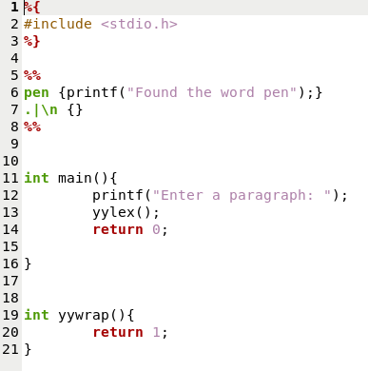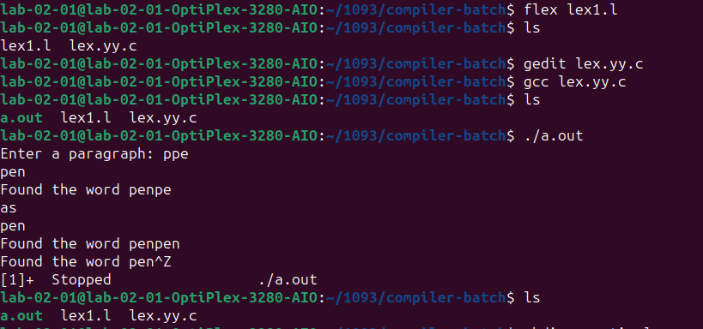
Practical 1, (Program 2 - Count the Frequency of the Word pen)
Name: Harsh Kumar
PRN: 24070521093, 3rd Yr, Sec-B
Date: 15/07/25

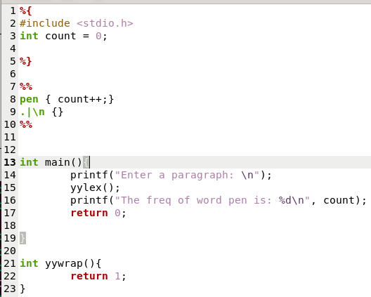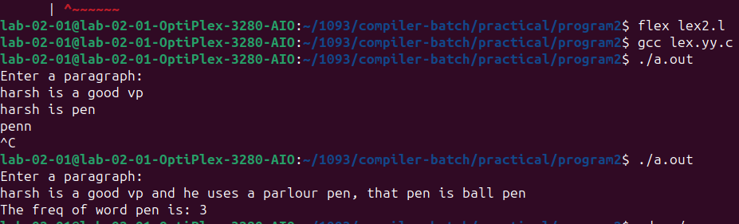
Practical 1, (Program 2 - Count Single-Line Comments in C Code)
Name: Harsh Kumar
PRN: 24070521093, 3rd Yr, Sec-B
Date: 15/07/25

