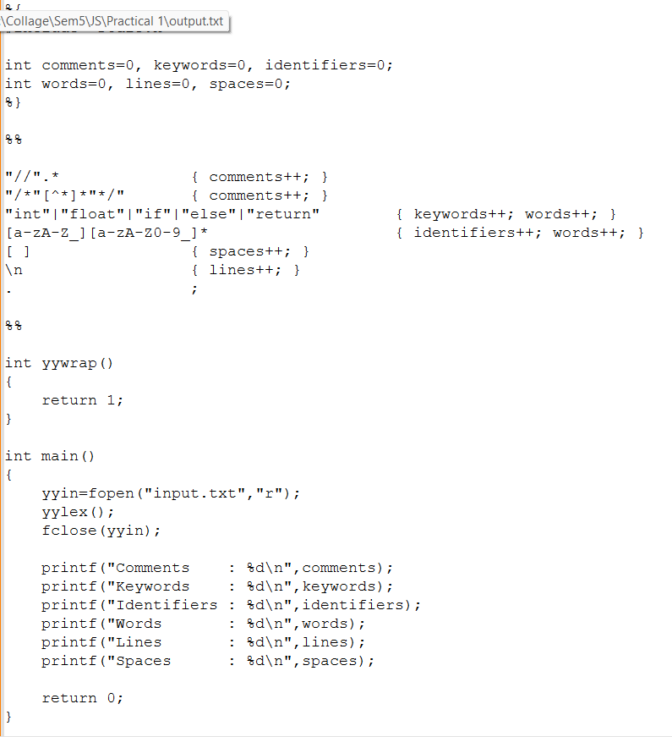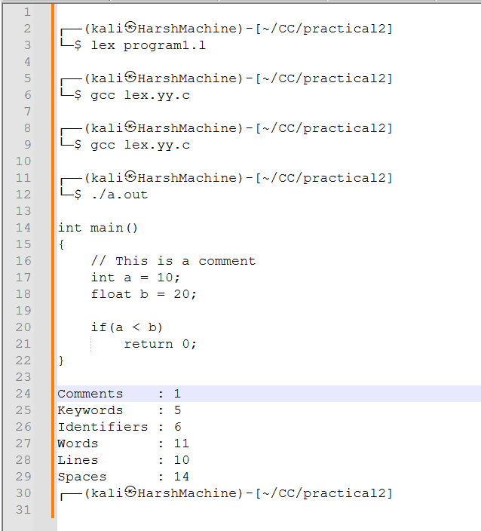
Practical 2,
Name: Harsh Kumar
PRN: 24070521093, 3rd Yr, Sec-B
Date: 28/07/26

Practical 2,
Name: Harsh Kumar
PRN: 24070521093, 3rd Yr, Sec-B
Date: 28/07/26

Practical 1, (Program 1 - Identify the Word pen)
Name: Harsh Kumar
PRN: 24070521093, 3rd Yr, Sec-B
Date: 15/07/25

