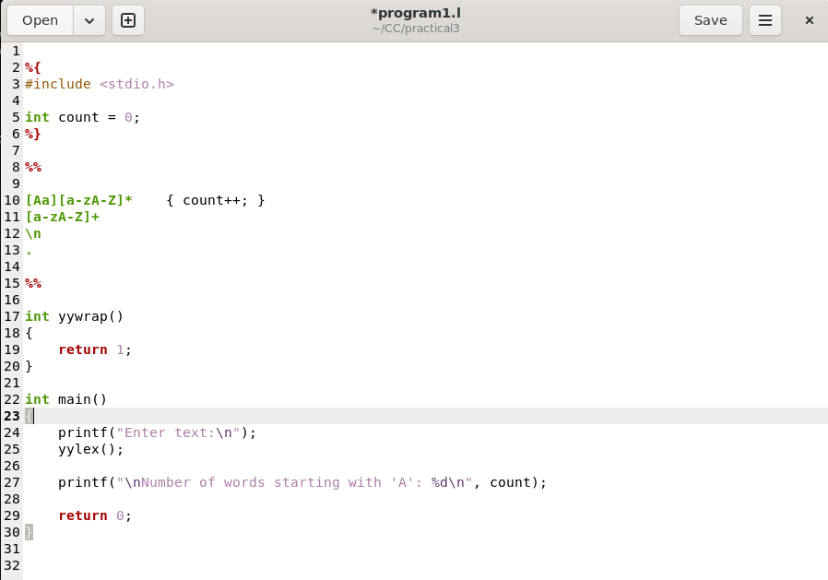
Practical 3, (Count number of words starting with “A”.)
Name: Harsh Kumar
PRN: 24070521093, 3rd Yr, Sec-B
Date: 04/08/26

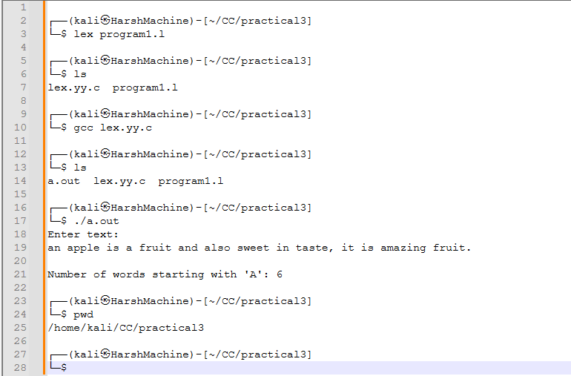
Practical 3, (Count number of words starting with “A”.)
Name: Harsh Kumar
PRN: 24070521093, 3rd Yr, Sec-B
Date: 04/08/26

