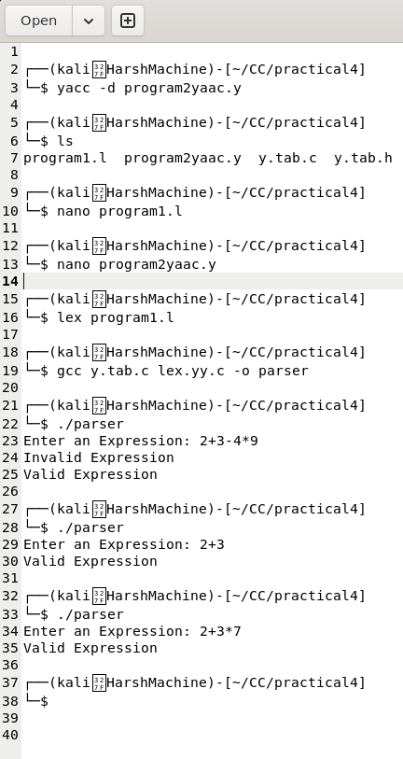
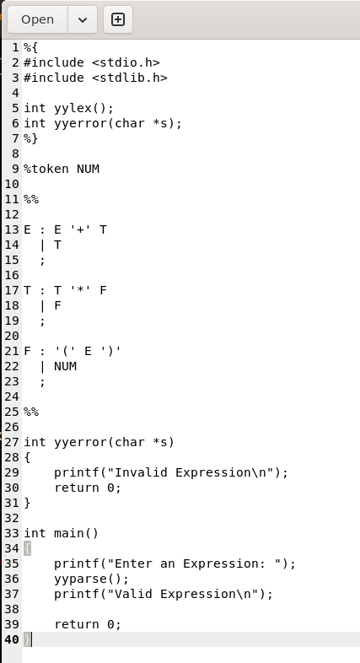
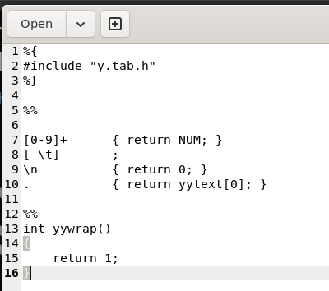
Practical 4,
Name: Harsh Kumar
PRN: 24070521093, 3rd Yr, Sec-B
Date: 11/08/26

Practical 4,
Name: Harsh Kumar
PRN: 24070521093, 3rd Yr, Sec-B
Date: 11/08/26

Practical 4,
Name: Harsh Kumar
PRN: 24070521093, 3rd Yr, Sec-B
Date: 11/08/26

