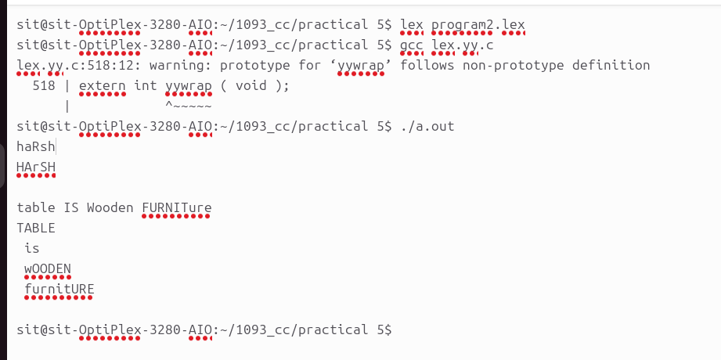
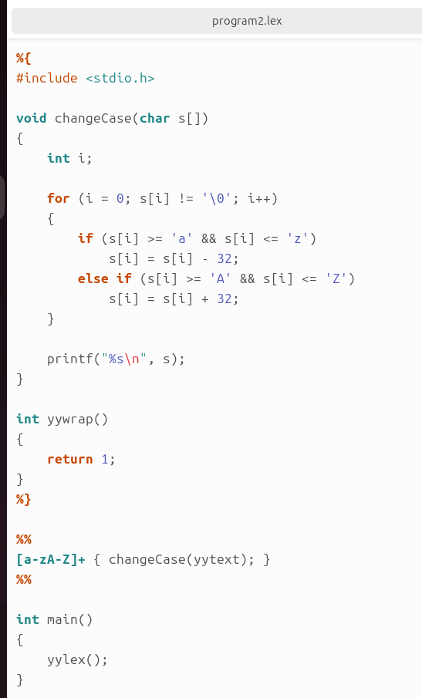
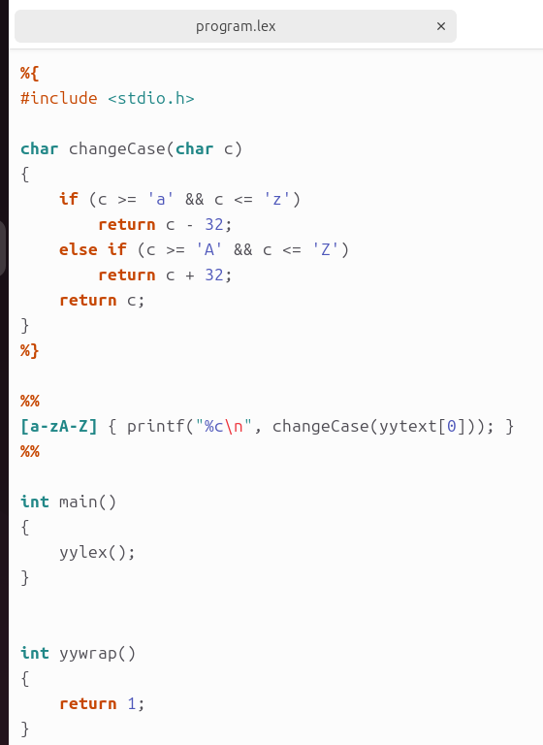
Practical 5,
Name: Harsh Kumar
PRN: 24070521093, 3rd Yr, Sec-B
Date: 18/08/26

Practical 5,
Name: Harsh Kumar
PRN: 24070521093, 3rd Yr, Sec-B
Date: 18/08/26

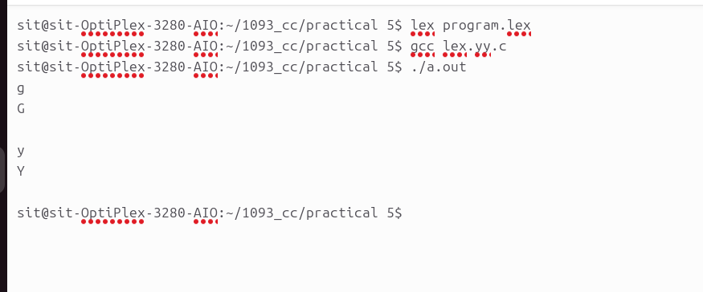
Practical 5,
Name: Harsh Kumar
PRN: 24070521093, 3rd Yr, Sec-B
Date: 18/08/26

Practical 5,
Name: Harsh Kumar
PRN: 24070521093, 3rd Yr, Sec-B
Date: 18/08/26

